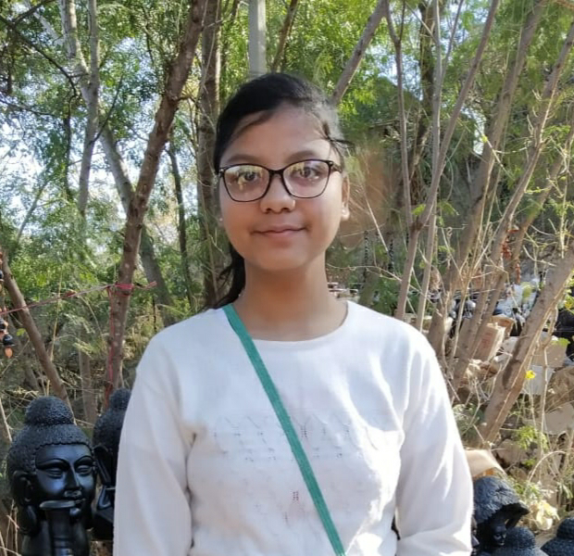

**ANKITA AGRAWAL**

* Anand dham Mathura, 281001.
* ankita.agrawal_cs19@gla.ac.in
* +91 9084616002

# EDUCATION

**Btech Computer Science**

**GLA University ( Mathura )**

**Intermediate** May 2019

**High School** May2017

**PROJECT / INTERNSHIP :**

* Water management system ( DCS )
* All in one ( Android app ) ( Netcamp )

# SKILLS

**Technical**

* *HTML*
* *CSS*
* *Android ( Android studio)*
* *C*
* *JAVA*
* *PYTHON*
* *C++*

*Writing skills in pen_and_dairy, mein ayodhya*

*Working on website*

* ***Udaaan.org***

**Professional**

* Effective Analytical Skills
* Ability to identify and solve problems
* Great team work

# Extra/Co-Curricular Activities

* Coordinated PRATIBHA_MANCH(talent hunter, GLA)
* Coordinated UDAAAN_AASMA_TAK ( Foundation work for social welfare )
* Coordinated

E-cell ( GLA )

* Coordinated

Abacus Club ( GLA )

* Coordinated

Website designing ( Udaaan, GLA )

* Coordinated

Literario Club ( Writing, GLA )

* workshop on Iot platform, cyber security, business development, coding session .
* Attended seminar of self development .

# Declaration

I hereby declare that all the above mentioned information is true and correct to the best of my knowledge.