**PRN :- 250240520011**

**CDAC Mumbai**

**PG-DAC February25 Batch (Juhu & Kharghar) Database Technologies**

**Time : 1hr 30 min Marks: 40**

**Answers**

Create Database system for Restaurant - 40Marks

1.Create minimum 5 tables without any Key constraints(5)

**Ans :-**

**i. CREATE TABLE CUSTOMER(CustomerID int,Name VARCHAR(100),Phone varchar(15),Address vasrchar(255));**

**ii. create table menu(Menu_id int, Name varchar(100),Category varchar(50),price Decimal(10,2));**

**iii.** **create table orders(orderID int,customerID int,orderDate date,totalAmount decimal(10,2));**

**iv.** **create table orderDetails(orderDetailsID int,orderID int,menuID int,Quantity int);**

**v. create table employees(EmployeeID int,Name varchar(100),Position varchar(50),Salary decimal(10,2));**

**Scren Shot Ans :-**

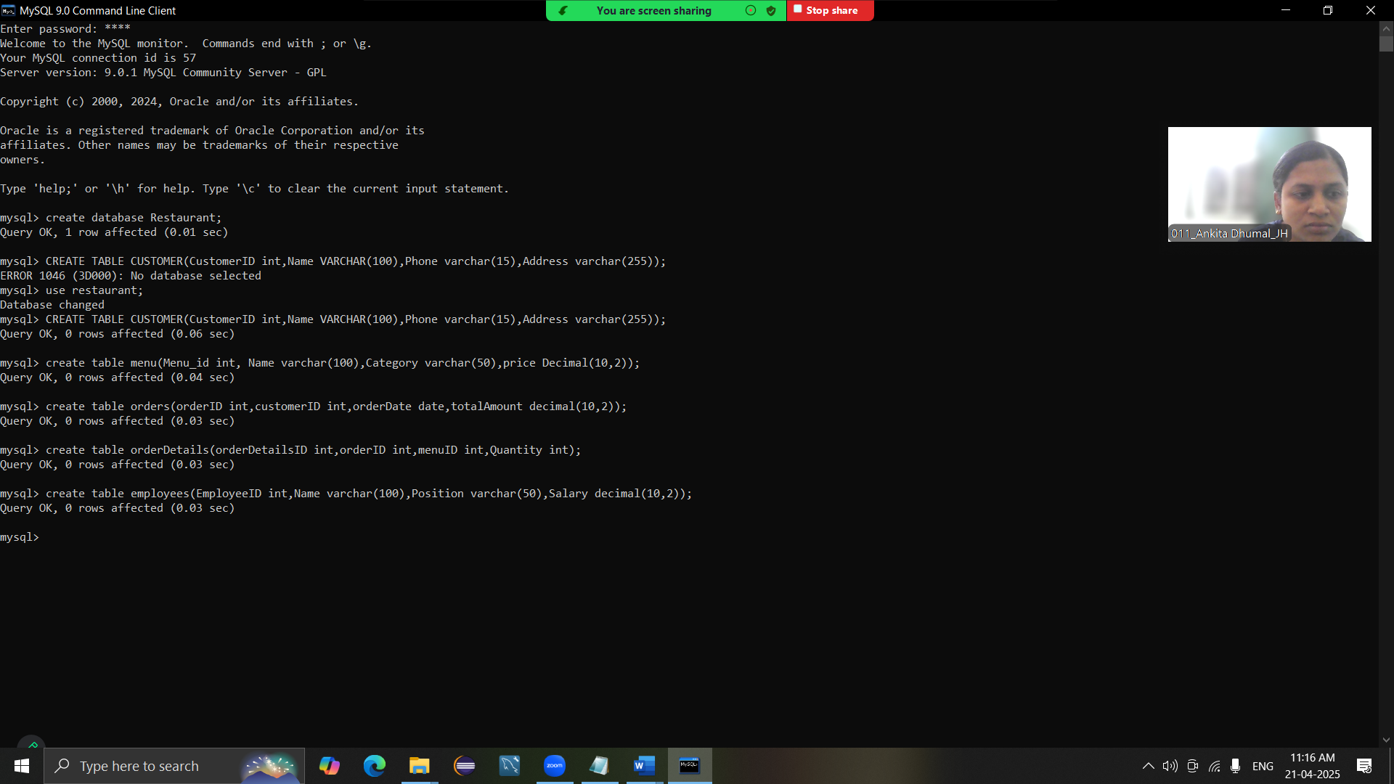

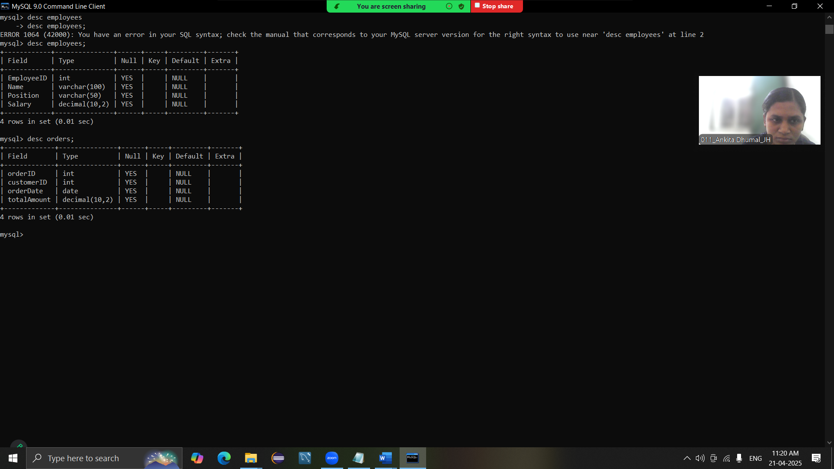

2.Add Primary Key to each table(3.5)

**Ans :-**

1. **alter table CUSTOMER ADD PRIMARY KEY (CustomerID);**
2. **Alter table menu ADD PRIMARY KEY (Menu_id );**
3. **alter table orders ADD PRIMARY KEY(orderID);**
4. **Alter table orderDetails ADD PRIMARY KEY (orderDetailsID );**
5. **alter table employees add primary key (EmployeeID );**

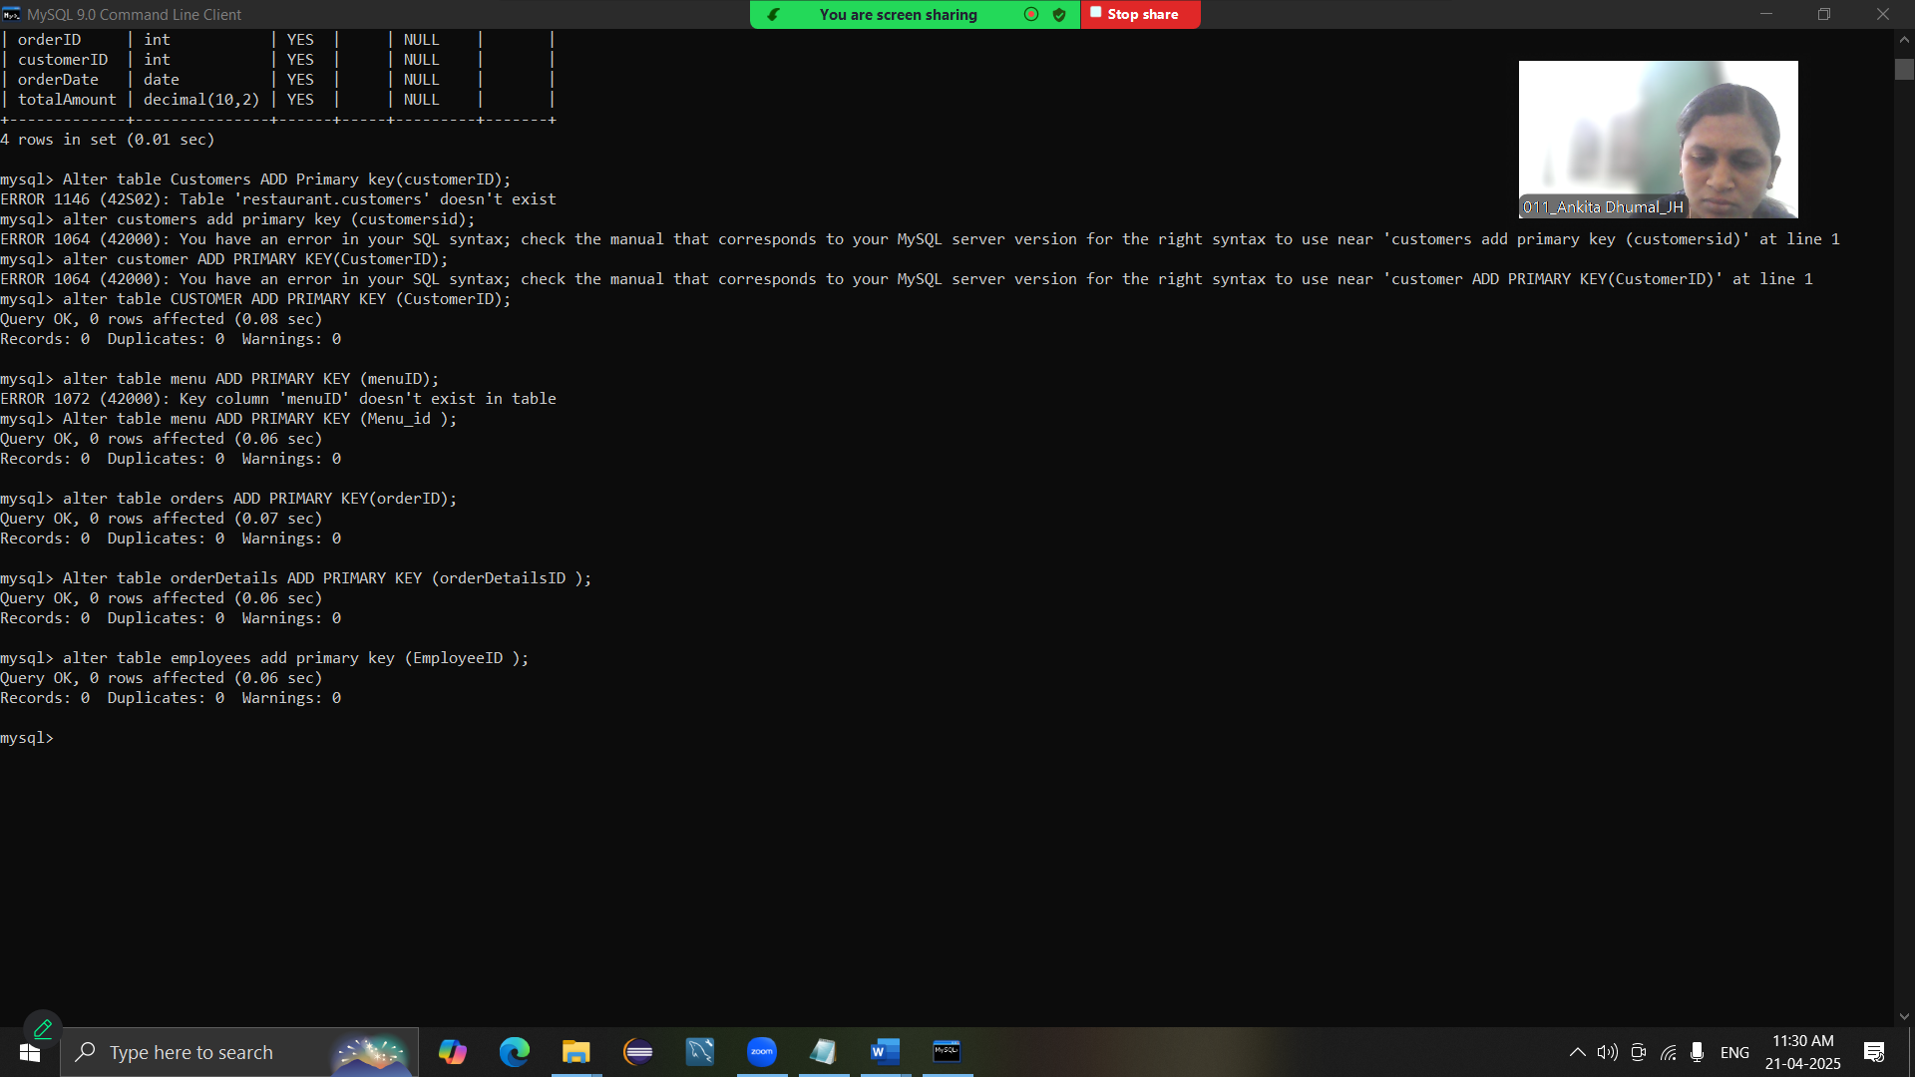

3.Connect atleast 3 tables using Foreign Key(2)

**Ans :-**

1. **alter table orders ADD FOREIGN KEY(customerID ) REFERENCES customer(CustomerID);**
2. **alter table orderDetails ADD FOREIGN KEY (OrderID) REFERENCES Orders(OrderID);**
3. **alter table orderDetails ADD FOREIGN KEY (menuID ) REFERENCES Menu(Menu_id);**

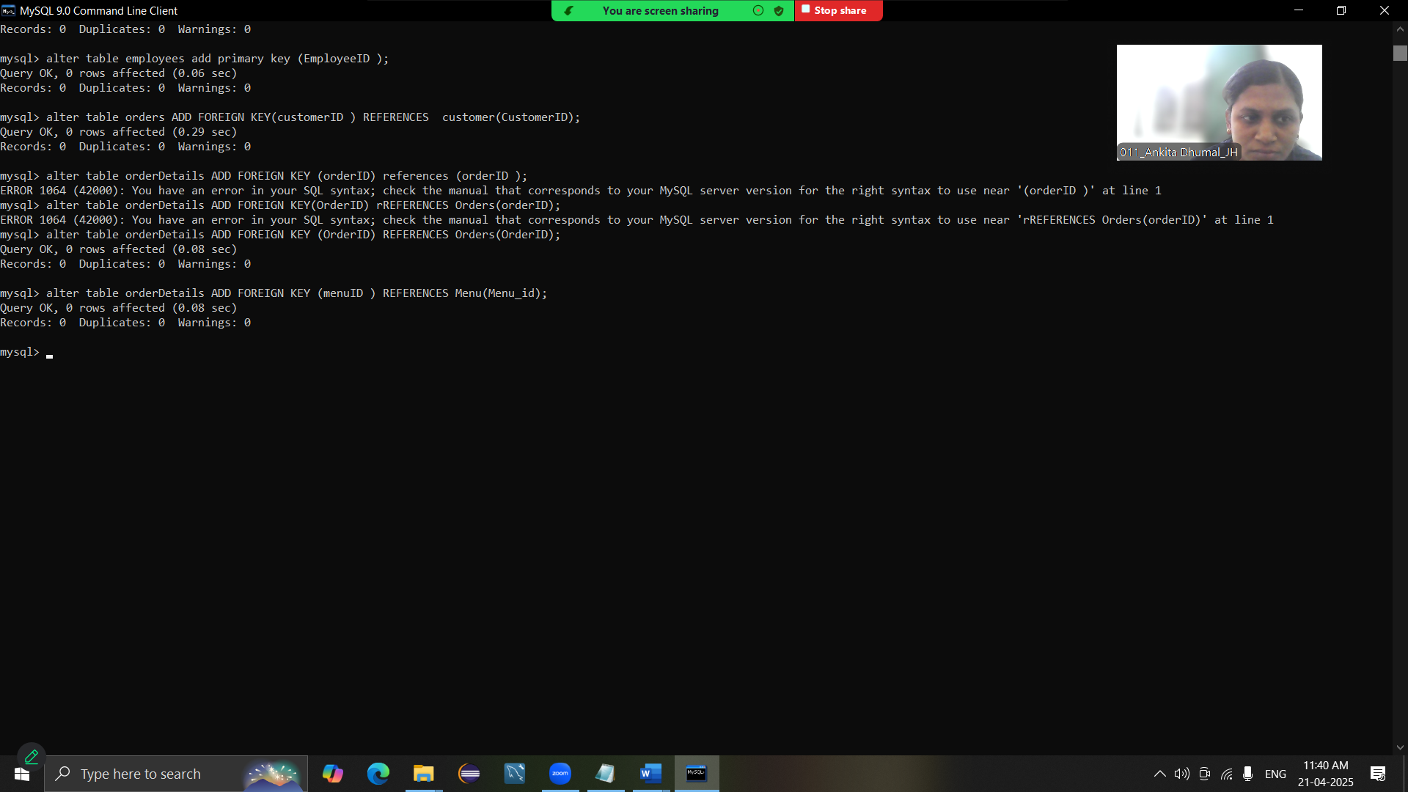

4.Insert minimum five records in each of the table(3.5)

**Ans :-**

**i) insert into customer(CustomerID,Name,phone, Address) values**

**-> (1,'John doe','9888675646','123 street, Mumbai'),**

**-> (2,'Alice Smith','5867456798','456 Avenu, Mumbai'),**

**-> (3,'Ankita dfhg','4455667788','101 Lane, Mumbai'),**

**-> (4,'Mary Brown','1243235667', '202 Boulevard, Mumbai');**

**insert into customer(customerID,Name,Phone,Address)values**

**-> (5,'Devid white','3456456788','101 Lane,Pune');**

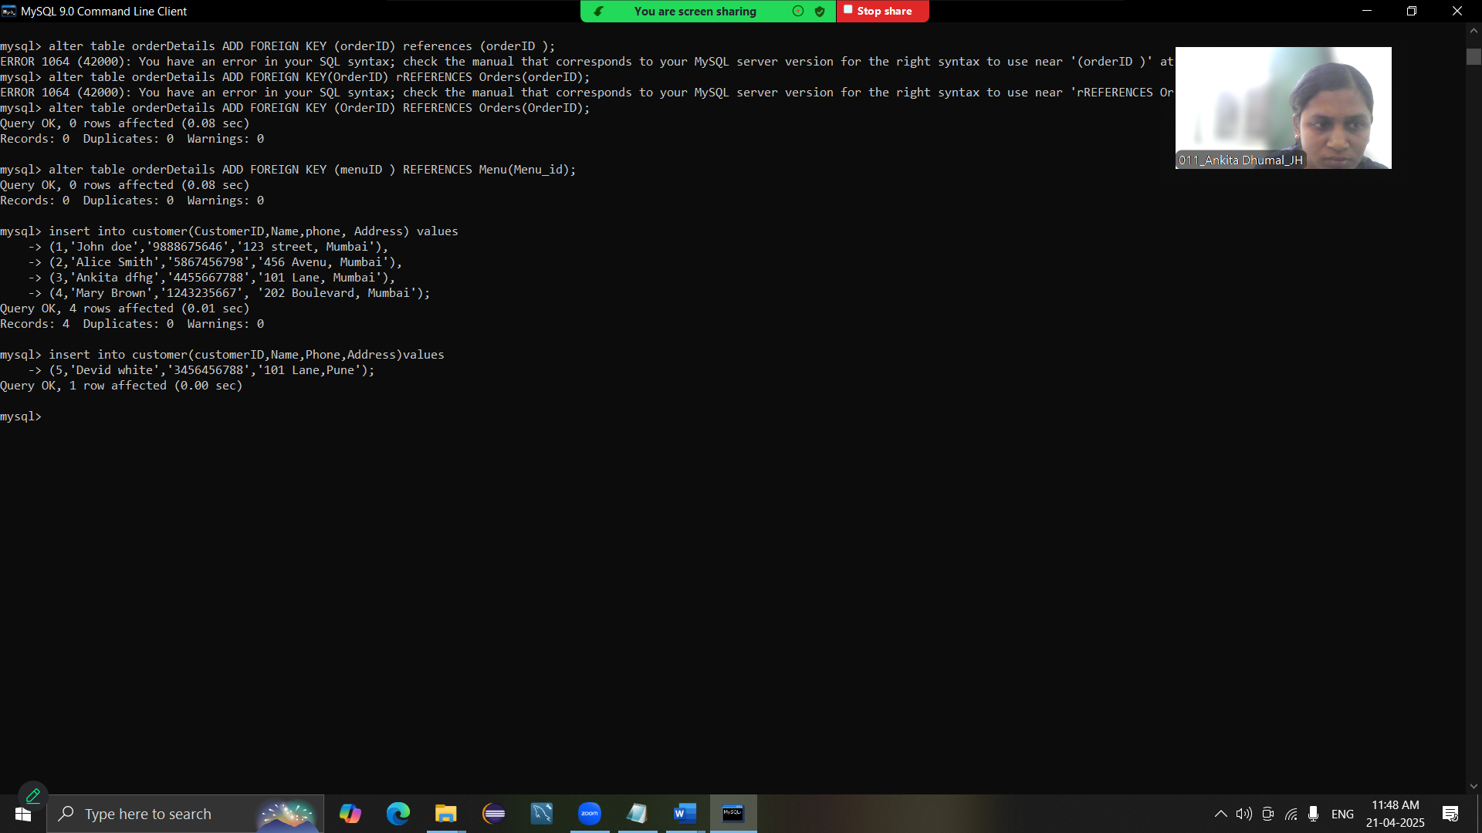

**ii) INSERT INTO Menu (MenuID, Name, Category, Price) VALUES(1, 'Pizza', 'Italian', 500.00),(2, 'Pasta', 'Italian', 300.00),(3, 'Sushi', 'Japanese', 700.00),(4, 'Chowmein', 'Chinese', 150.00),(5, 'Burger', 'American', 200.00);**

**ERROR 1054 (42S22): Unknown column 'MenuID' in 'field list'**

**INSERT INTO Menu (Menu_ID, Name, Category, Price) VALUES(1, 'Pizza', 'Italian', 500.00),(2, 'Pasta', 'Italian', 300.00),(3, 'Sushi', 'Japanese', 700.00),(4, 'Chowmein', 'Chinese', 150.00),(5, 'Burger', 'American', 200.00);**

**iii) INSERT INTO Orders (OrderID, CustomerID, OrderDate, TotalAmount) VALUES(1, 1, '2025-04-21', 800.00),(2, 2, '2025-04-22', 1000.00),(3, 3, '2025-04-23', 450.00),(4, 4, '2025-04-24', 550.00),(5, 5, '2025-04-25', 350.00);**

**iv) INSERT INTO OrderDetails (OrderDetailID, OrderID, MenuID, Quantity) VALUES(1, 1, 1, 1),(2, 1, 2, 2),(3, 2, 3, 1),(4, 3, 4, 3),(5, 5, 5, 2);**

**ERROR 1054 (42S22): Unknown column 'OrderDetailID' in 'field list'**

**INSERT INTO OrderDetails (OrderDetailsID, OrderID, MenuID, Quantity) VALUES(1, 1, 1, 1),(2, 1, 2, 2),(3, 2, 3, 1),(4, 3, 4, 3),(5, 5, 5, 2);**

**v) INSERT INTO Employees (EmployeeID, Name, Position, Salary) VALUES(1, 'Sarah Lee', 'Manager', 50000),(2, 'Mark Tan', 'Chef', 30000),(3, 'Emily Clark', 'Waiter', 20000),(4, 'Michael Johnson', 'Cleaner', 15000),(5, 'Sophia Patel', 'Accountant', 25000);**

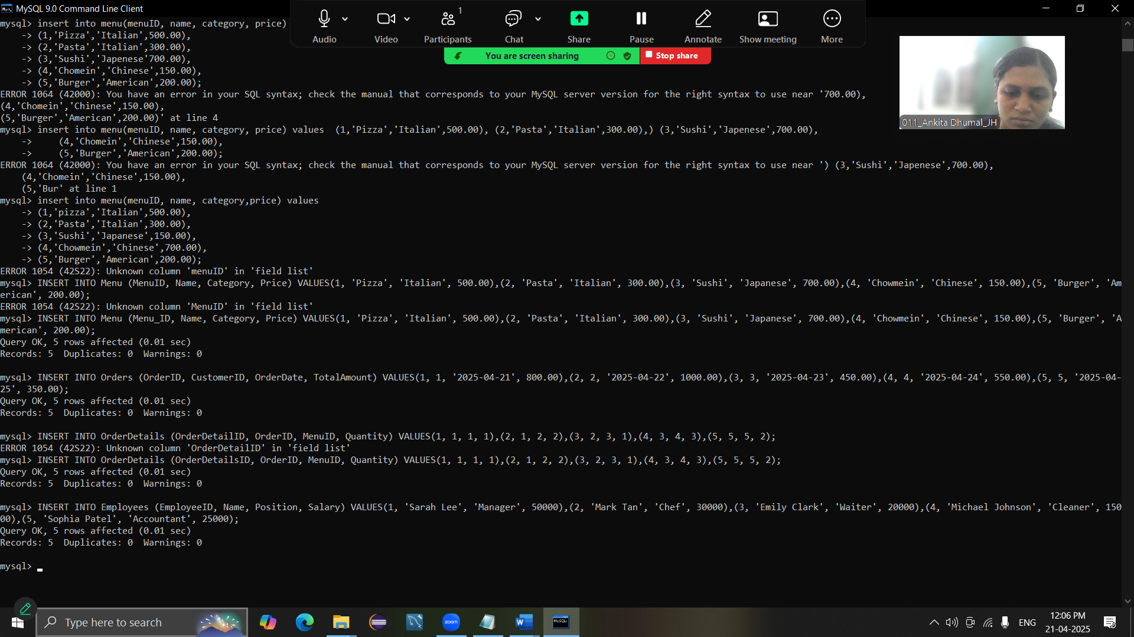

5.Write an appropriate command to Use of Where with OR clause (2)

**Ans:-**

**select * from menu where category = 'Italian' or category = 'Chinise';**

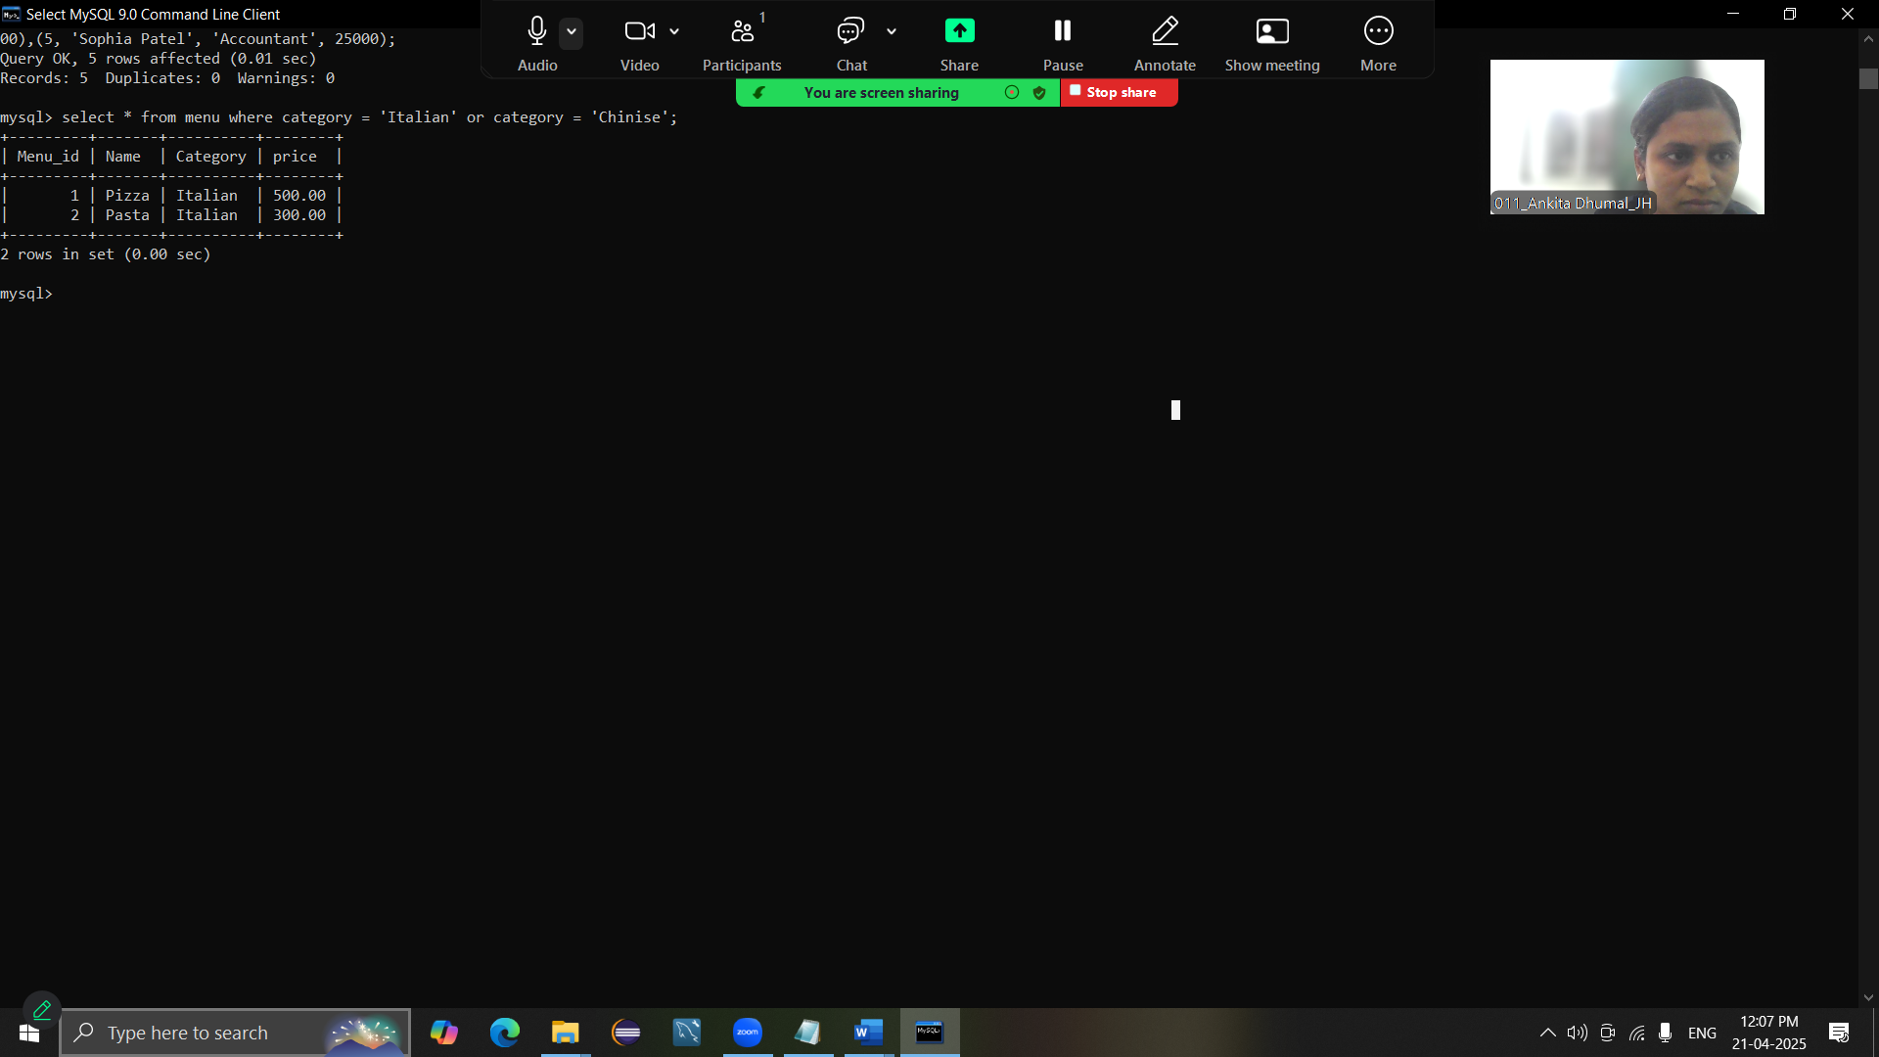

6.Write a command to show first five records from any one table (2)

**Ans :- select * from Menu Limit 5;**

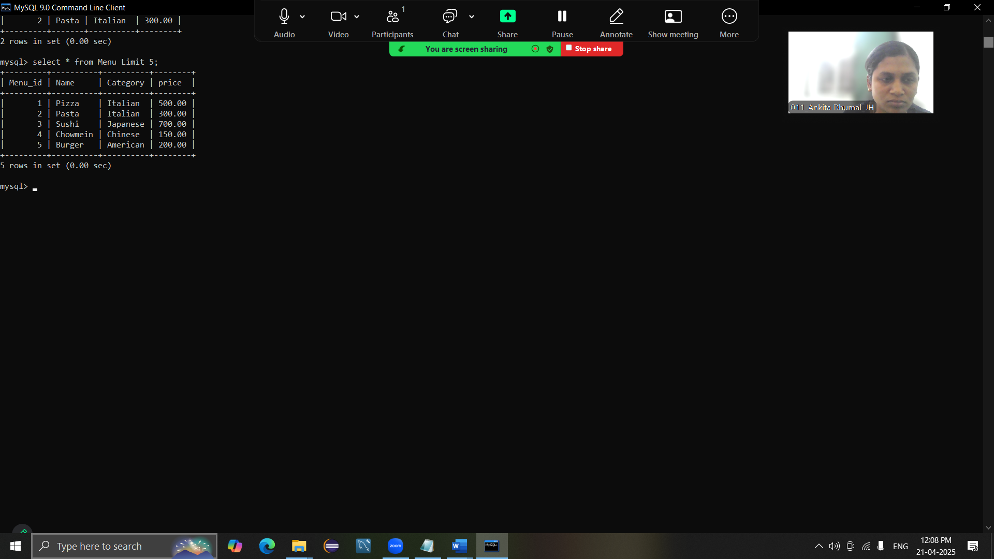

7.Write a command for appropriate and logical use of Group By clause(2)

**Ans :- select category,AVG(Price) from Menu Group BY Category;**

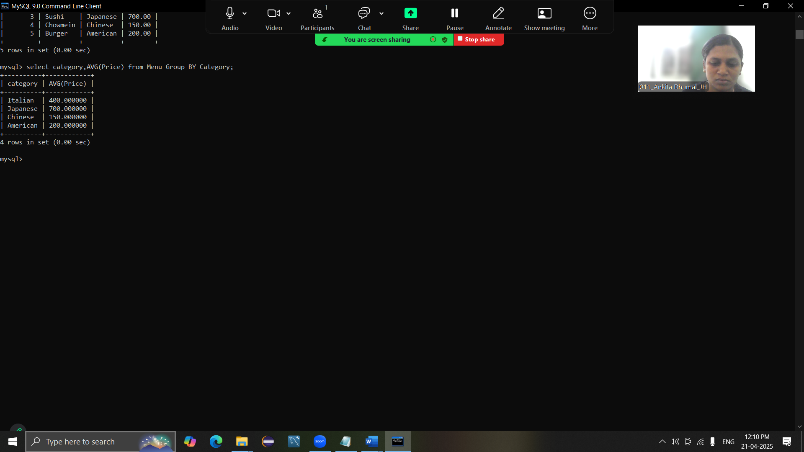

8.Write a query to show the name of 2nd costliest Menu along with its cost(2)

**Ans :- mysql> select name,price from menu order by price DESC LIMIT 1 OFFSET 1;**

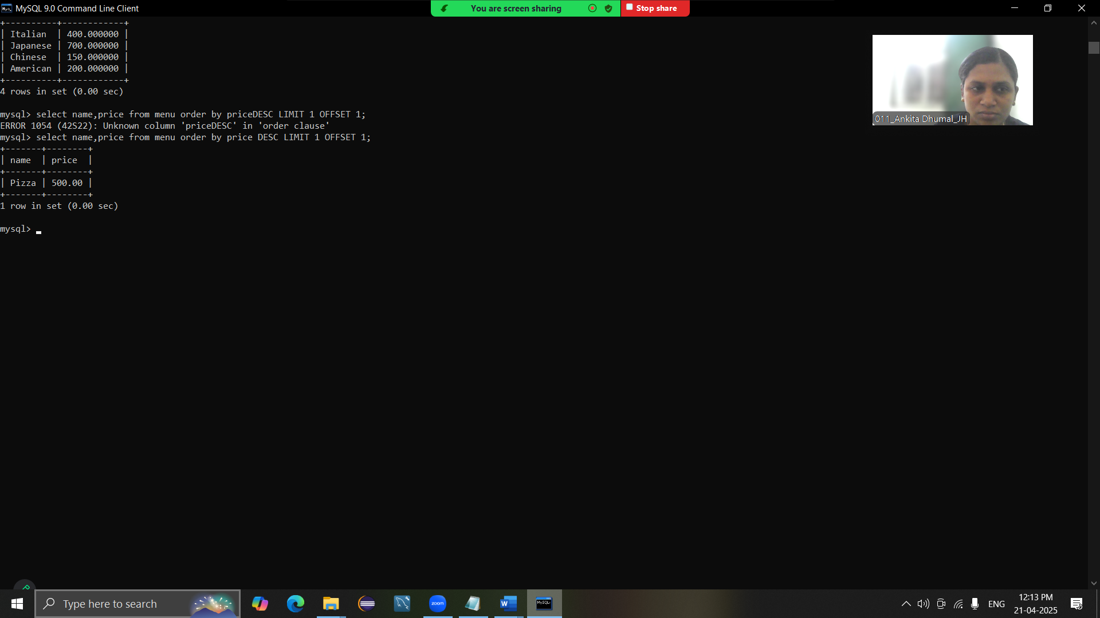

9.Create ONE simple view using any of the created table and update the data from view to reflect in base table (2)

**Ans :-**

**i)** **create view EmployeeSalary AS select EmployeeID, name, salary from Employees;**

**ii) update EmployeeSalary set salary = 55000 where EmployeeID = 1;**

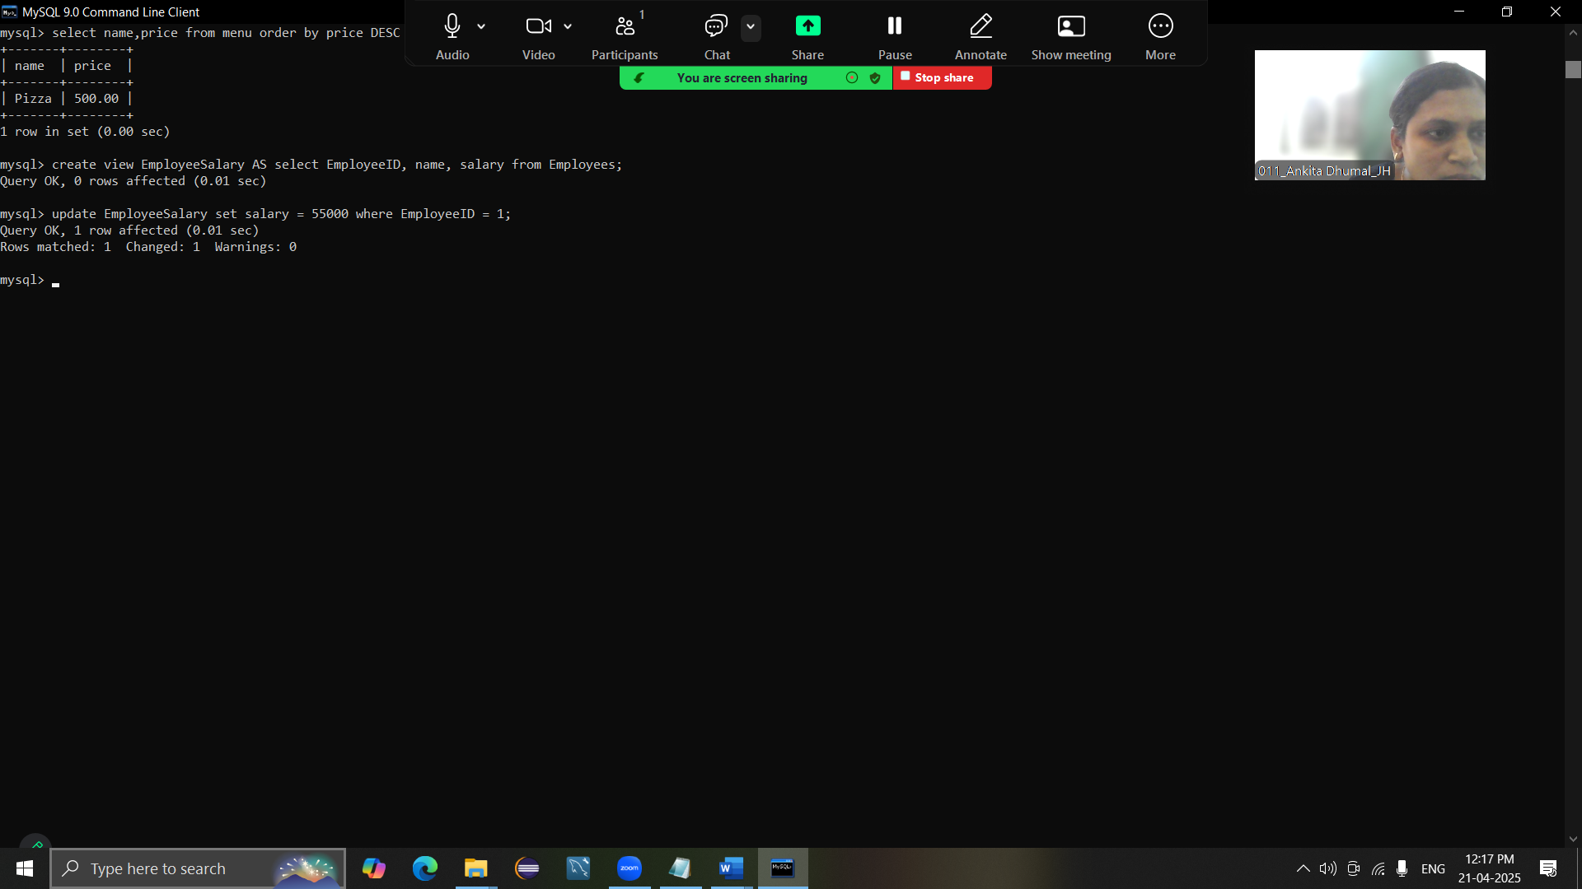

10.Write a command to use LEFT JOIN (2)

**Ans:- select Orders.orderID , customer.name, orders.totalAmount from orders LEFT JOIN customer on orders.customerID = customer.CustomerID;**

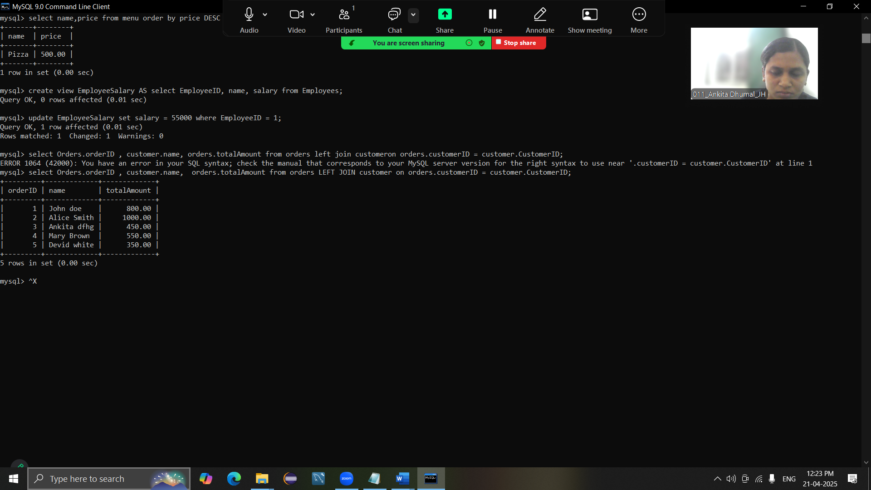

11. Create the temporary table showing only menu of 'Chinese'. How to remove this table permnantly? (2)

**Ans :-**

**i)create TEMPORARY TABLE ChineseMenu AS SELECT * FROM Menu where Category = 'Chinese';**

**ii) drop TEMPORARY TABLE ChineseMenu;**

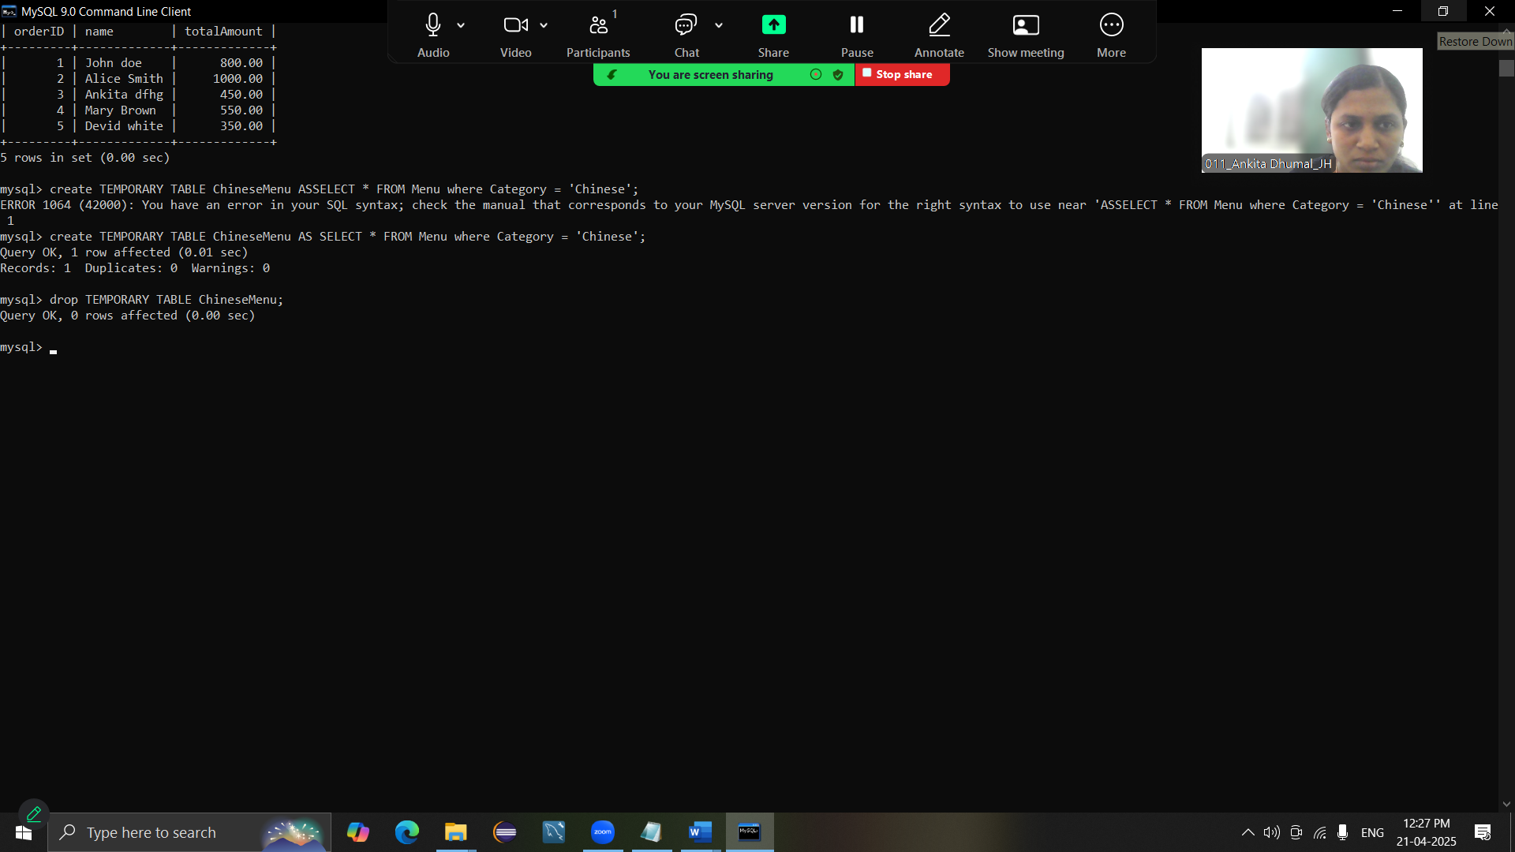

12.Create at least one procedure (with one INPUT and one OUTPUT parameter) based on the created tables with appropriate utility (4)

**Ans :-**

**DELIMITER //**

**CREATE PROCEDURE GetTotal(**

**IN input_OrderID INT,**

**out output_TotalAmount Decimal(10,2))**

**BEGIN**

**SELECT TotalAmount INTO output_TotalAmount**

**from Orders**

**where OrderId = input_OrderID;**

**END //**

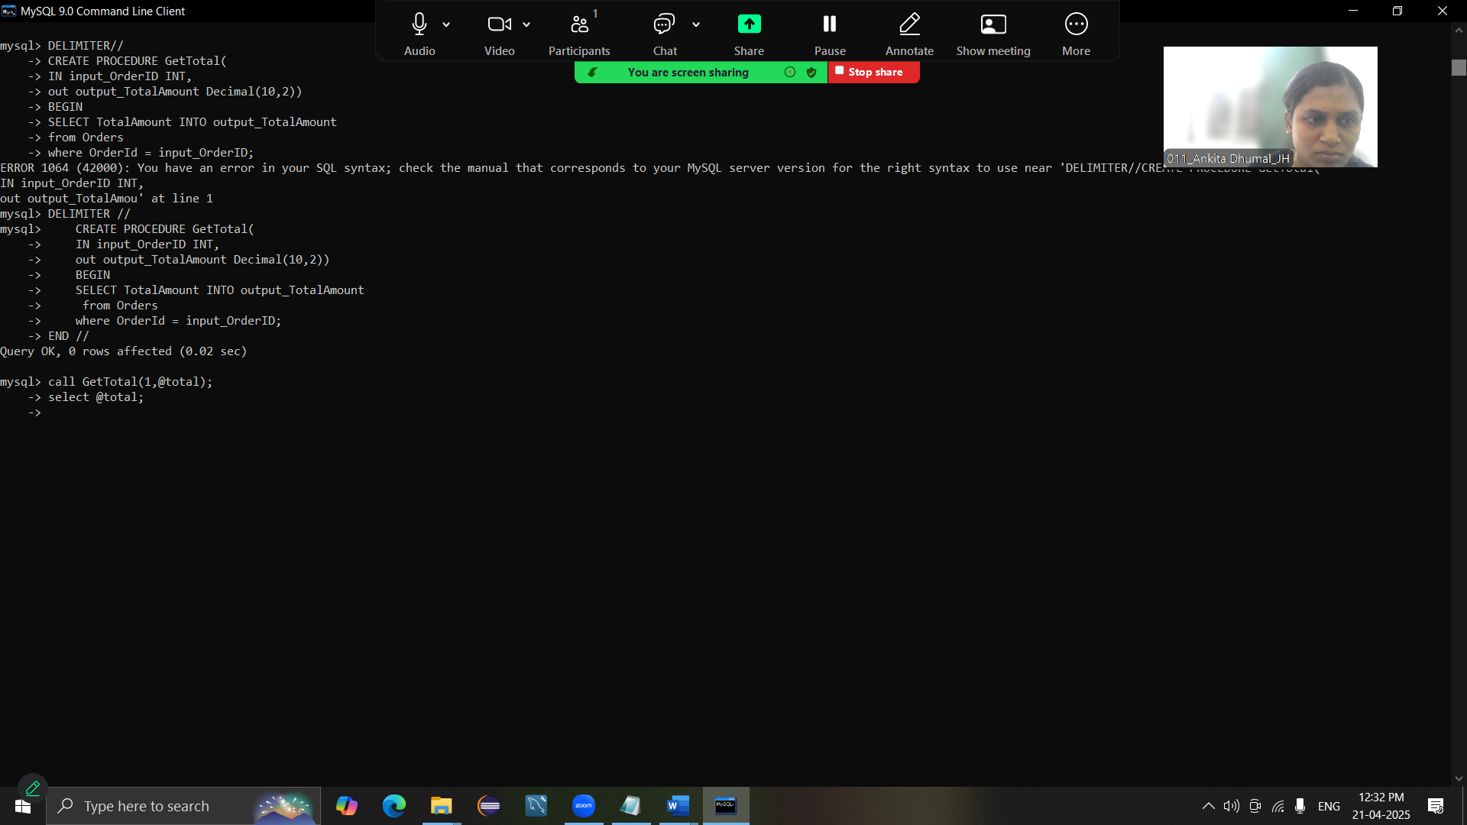

13.Write a program to display first 5 even numbers using any one of the looping structure of MySQL(4)

**Ans :- CREATE PROCEDURE DISPLAYeVEN()**

**-> BEGIN**

**-> declare num int default 2;**

**-> declare counter int default 1;**

**-> loop**

**-> select num;**

**-> se**

14.Create a stored function name DISC_CALC that takes two parameters:- ORIGINAL_PRICE and DISCOUNT_PERCENTAGE. The function should calculate the discounted price based on the original price and the discount percentage. The function should return the discounted price.(4)