
Excel With Copilot
Assignment

Q1. Use Copilot to identify and summarize missing values in the dataset.
Answer: =COUNTBLANK(Table1[Region]) OR =COUNTBLANK(A1:J351) = 40
Use Copilot prompt: Identify all missing values in the dataset and summarize them by column.
Expected output: list of columns with blank/null cells and count of missing records.

Q2. Use Copilot to fill missing values in the Region & Category Columns.
Answer: =IF(B2="", "West", B2) & then drag down till Row 351 & =IF(D2="", "Beverages", D2) then drag down till Row 351
(this is because West is the most frequent region & Beverage is the most frequent Category.
Use Copilot prompt: Fill missing values in the Region and Category columns using the most frequent value (mode) or nearby records.
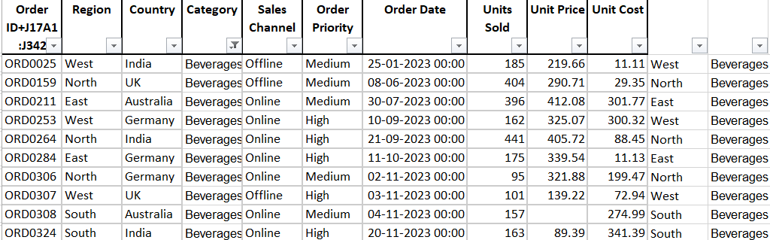

Q3. Fill missing numeric values in the Units Sold and Unit Price Columns.
Answer: Units sold: =IF(H2="",AVERAGE($H$2:$H$351),H2), drag down till row 351
Unit Price: =IF(I2="",AVERAGE($I$2:$I$351),I2), drag down till row 351
Use Copilot prompt: Fill missing numeric values in Units Sold and Unit Price using average/median values.
Formula option:
Units Sold = AVERAGE(range)
Unit Price = AVERAGE(range)

Q4. Create a new calculated column Total Revenue.
Answer: Total Revenue = Units Sold × Unit Price, Formula to be used on column O =E2*F2, drag down till row 351
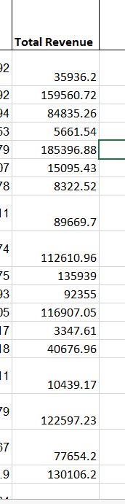

Q5. Use Copilot to find the total price of Order ID = ‘ORD0123’.
Use Copilot prompt: Find total price where Order ID = ORD0123.
Answer: Order ID = Column A, Total Revenue / Total Price = Column O, Formula: =SUMIFS(O:O,A:A,"ORD0123")
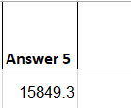

Q6. Use Copilot to generate a summary chart of average profit by region.
Answer: We will first calculate profit: Profit = (Unit Price - Unit Cost) × Units Sold OR =(I2-J2)*H2
Then insert> pivot table
  - Region - Rows
  - Profit - Values
Click Sum of Profit - Value Field Settings - Average >Click PivotTable > Go to Insert =Column Chart
Copilot prompt: Create a chart showing average Profit by Region.
Recommended chart: Column chart.

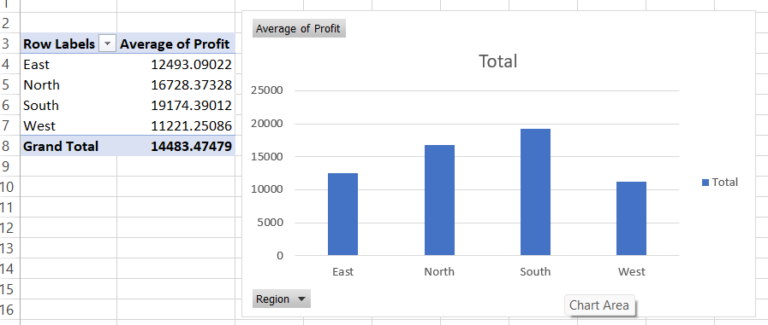

Q7. Create a pivot table summarizing total sales by category and region.
Answer: We will select the entire table> insert pivot table> In PivotTable Fields: Category -Rows, Region - Columns, Total Revenue (or Sales) -Values

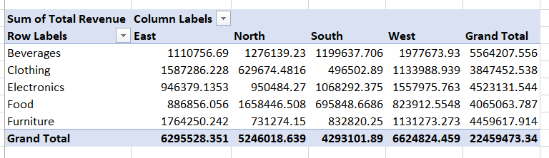

Q8. Build a dashboard combining key KPIs and charts.
Answer: We will create these from PivotTables:
1. Sales by Category
- Pivot: Category → Rows
- Revenue → Values
- Insert → Column Chart
2. Sales by Region
- Pivot: Region → Rows
- Revenue → Values
- Insert → Bar Chart
3. Average Profit by Region
- Pivot: Region → Rows
- Profit → Values → change to Average
- Insert → Column Chart
4. Add Slicers (Filters)
- Click any PivotTable
- Go to Insert → Slicer
- Select:
  - Region
  - Category

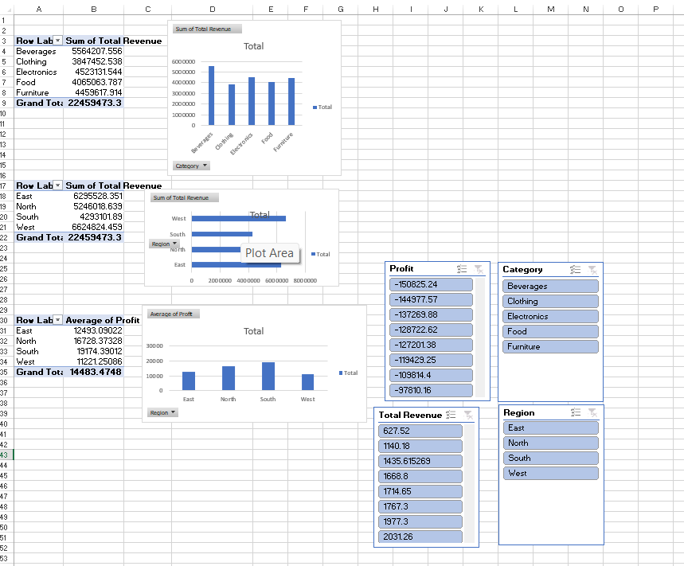

Q9. Use Copilot to generate a summary report.
Answer: Insert pivot table rows: region, column: summary and write the summary and hide gridlines:
Copilot prompt: Generate a summary report of dataset trends, top regions, top categories, & revenues.

