**Submitted To: Submitted By:**

**Dr. Seng Loke Team R**

**Ibrahim Habbal (17503372)**

**Ankita Kapoor (18358877)**

**MOBILE & PERVASIVE COMPUTING**

**CSE4MPC 2016**

**Documentation**

**Info-Go application**

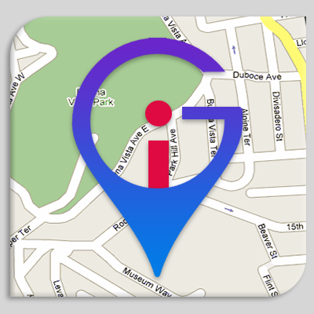

## **A detailed wireframe of Info-Go mobile application**

Info-Go application enables its user to collect information as s/he goes around and to create logs about spots/places s/he has been to. When a user is standing at a certain spot or at a certain point (as identified by a pair of GPS coordinates), the user can use the app to initiate collection of a range of information at that place. Various functionalities that a user can do with Info-Go application are described as follows:

**TASK 1 - SKELETON APP WITH LAYOUT ADAPTABLE TO MULTIPLE SCREEN SIZES AND ORIENTATION**

Info-Go application have a user interface that supports multiple device sizes including a smartphone and a tablet (landscape and portrait orientations). We have used Master/Detail Flow template, as can been in the provided screenshots. The list view contains a list of types of information the app can collect and the detail view could contain the interface related to specifying parameters for collecting information and/or contain the interface for displaying or visualising the information on a map. The following screenshot of the application shows that how our application adapt to different screen size, also the landscape and portrait orientation. We have also implemented the login and log out functionalities so that user can keep track of data for his sessions.

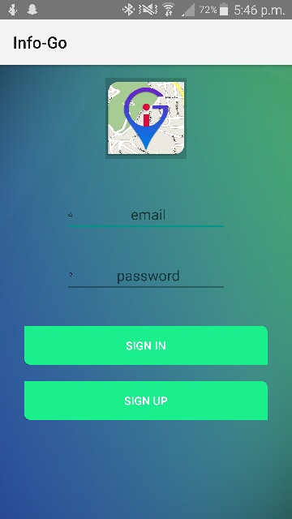 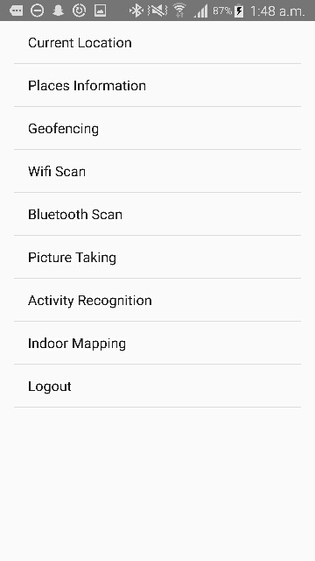

SIGN IN and SIGN OUT Portrait view

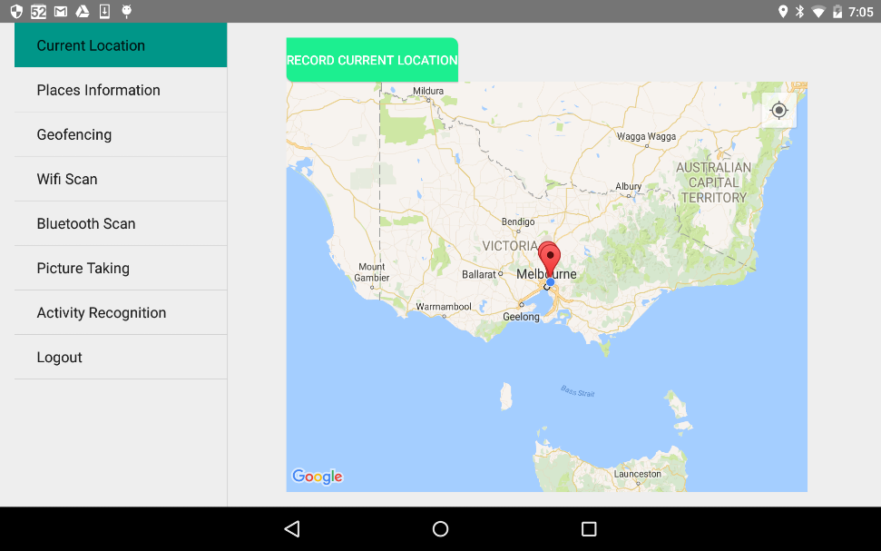

Landscape view

**TASK 2 (RECORD AND VIEW LOCATIONS)**

This functionality allows the user to collect his GPS location and store it in a database. The user should also be able view previously recorded locations on a map. The following screenshot shows that when the user clicks the RECORD CURRENT LOCATION button, the current location of the user is shown on the map with the green marker and the places that have been previously visited are marked with red marker on the map. User can click the markers to check their latitudes and longitudes of the places.

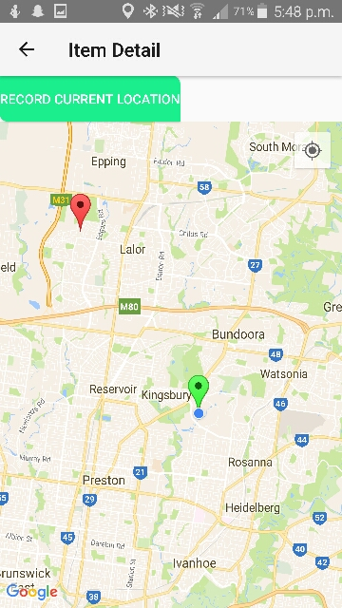 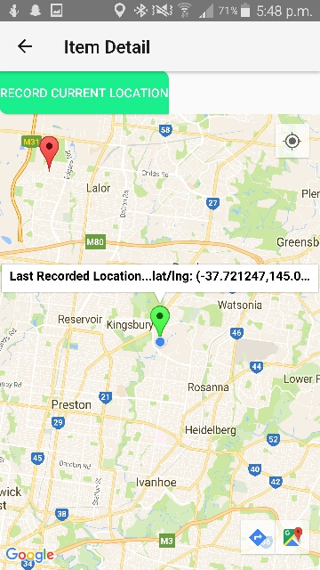

Click RECORD CURRENT LOCATION button Click marker to view detail

Green marker- current location

Red marker- previous location

**TASK 3 (RECORD AND VIEW PLACE INFORMATION)**

This functionality allows the user to get place information using the Google API and also to retrieve other places that match a given set of GPS coordinates. The following screenshot shows that when we click on SHOW PLACES button, user can view the information of the places that matches the current GPS coordinates.

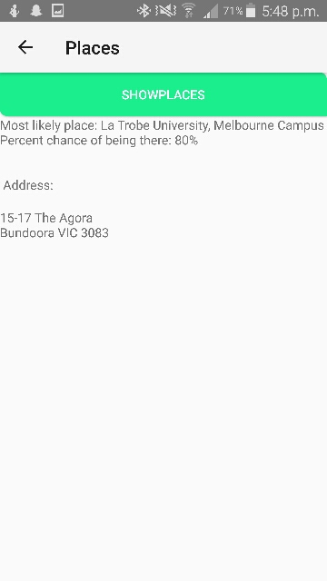

Click SHOW PLACES button to view place information

**TASK 4 (GEOFENCING AROUND HOT SPOTS)**

This functionality enables the user to mark a given place/point as “hot and get notified when s/he is within 100m of any one of the hot spots. The following screenshot shows that when we click on ADD GEOFENCES button, user can view the area on the map that is within 100m of his current location. And that area is stored as hot spot for user and he will get notification whenever he enters or leaves that area.

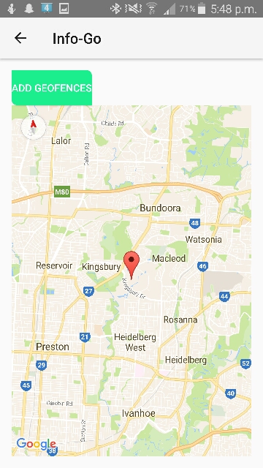 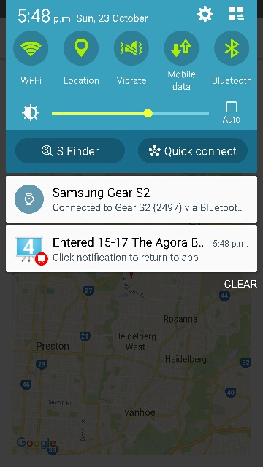

Click ADD GEOFENCES button to add hotspots Notification received when user entered hotspots

**TASK 5 (RECORD AND VIEW WIFI SCANS)**

This functionality allows the user to do a scan of the Wi-Fi hotspots at the current location where the user is and to store results of the scans and to retrieve and view that information later. As shown in following screenshot, user can view the available Wi-Fi at the current location as well as the Wi-Fi scans results from previous locations.

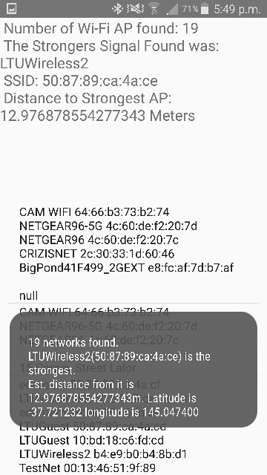

List of available Wi-Fi

**TASK 6 (RECORD AND VIEW BLUETOOTH SCANS)**

This functionality allows the user to do a scan of the Bluetooth devices in the surroundings at the current location where the user is and to store results of the scans (i.e., the findings), and to retrieve and view that information later.

As shown in the following screenshot, user can view the available Bluetooth at the current location as well as the Bluetooth scans results from previous locations. The application will prompt the user to switch on the Bluetooth first (if not already ON) and then perform the scan.

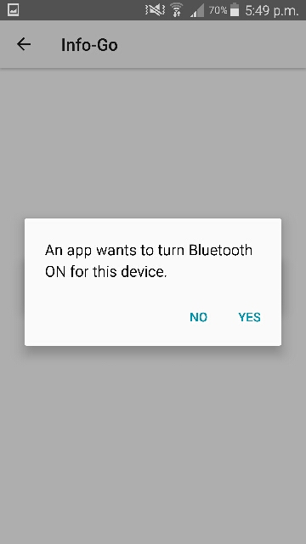 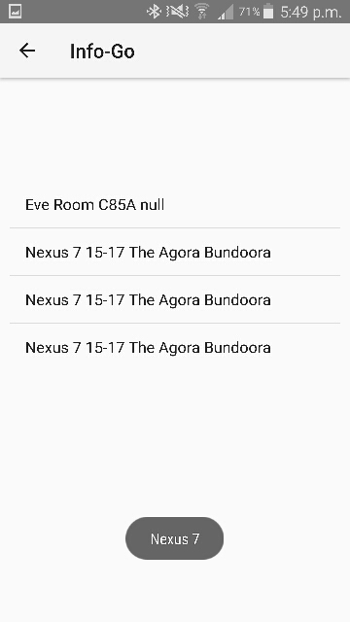

Prompt to turn ON Bluetooth of your device List of available Bluetooth

**TASK 7 (ENABLE PICTURE TAKING AND VIEWING OF GEO-TAGGED PICTURES)**

This functionality enables the user to take a photo and to store it, together with a textual description entered by the user and the location where the photo was taken, and later to retrieve that location or view them on a map. When a user clicks ADD IMAGE button, application will prompt the user to select option to choose image from gallery or open camera to click new picture. User can choose the image and then all the clicked pictures can be seen in a list. By clicking any picture, user can add description to it and also can delete it. By clicking VIEW ALL IMAGES ON MAP, user can view all the images on the map according to the location where image has been taken.

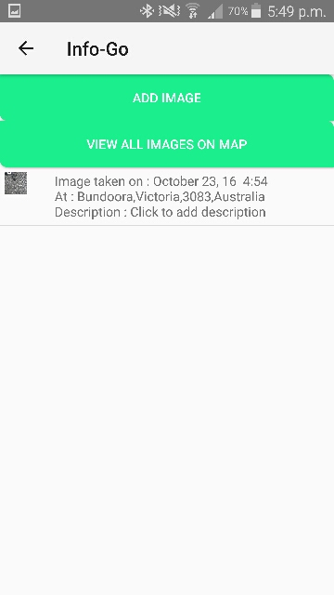 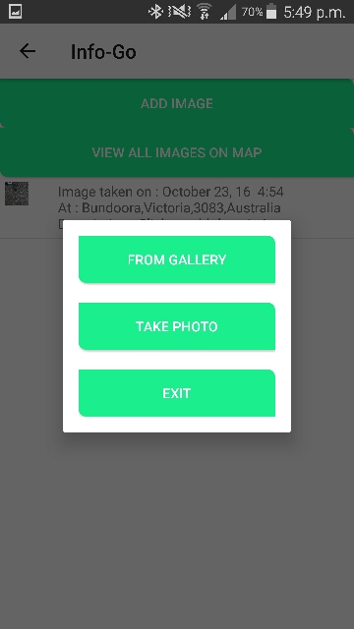 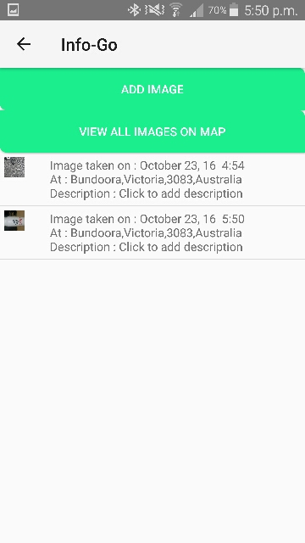

Click ADD IMAGE button Choose source of Image List of all images taken

(Gallery or Camera)

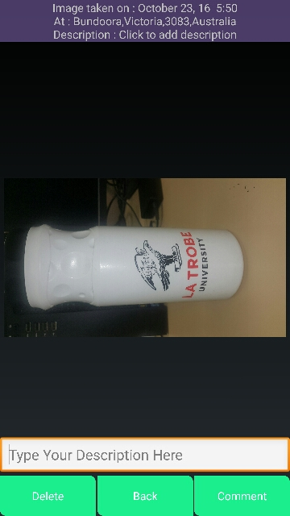 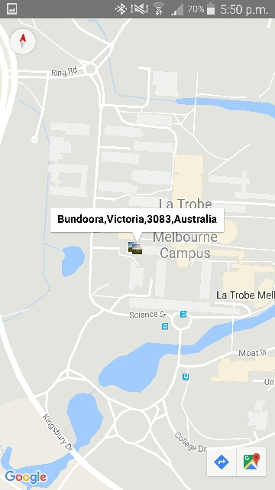

Click image to enter description Click VIEW ALL IMAGES ON MAP to view images

Click COMMENT button to save description on map with their details

Click DELETE button to delete image

**TASK 9 (RECORD INDOOR POSITIONS)**

This functionality enables the user to record indoor locations, instead of using GPS. Have a button “START TRACKING” for the user to start tracking and another button “STOP TRACKING” for the user to stop tracking, to create a history of indoor paths or locations visited by the user. Following table shows the SSID related to the Wi-Fi available in 3 BG rooms (detected from every corner of the room).

|  |  |  |
| --- | --- | --- |
| Room | Wi-Fi Name | SSID |
| 114 | eduroam | c4:0a:cb:a0:f0:d0 |
|  | eduroam | c4:0a:cb:a0:f0:d0 |
|  | Eduroam | c4:0a:cb:a0:e7:80 |
|  | Eduroam | c4:0a:cb:88:33:60 |
|  |  |  |
| 115 | eduroam | c4:0a:cb:a0:e7:80 |
|  | NewToLTU | c4:0a:cb:88:33:6c |
|  | NewToLTU | c4:0a:cb:a0:e0:43 |
|  | NewToLTU | c4:0a:cb:a1:08:43 |
|  |  |  |
| 116 | eduroam | c4:0a:cb:a1:08:40 |
|  | Eduroam | a4:18:75:50:b9:2f |
|  | LTUWireless2 | c4:0a:cb:a1:24:f1 |
|  | Eduroam | c4:0a:cb:a1:24:f0 |

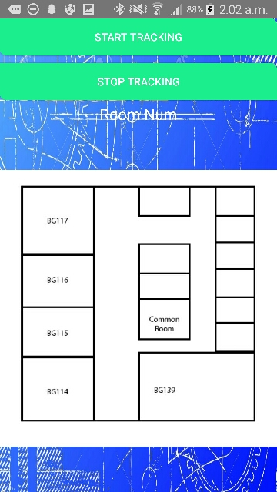

Click on START TRACKING to be located

Only works in BG 114, 115 and 116

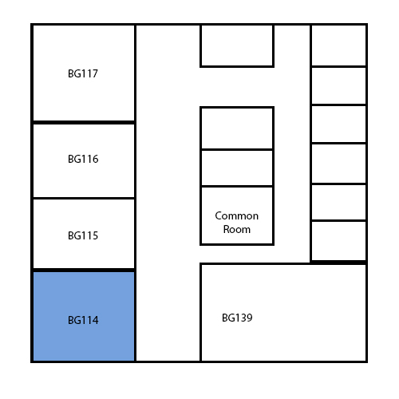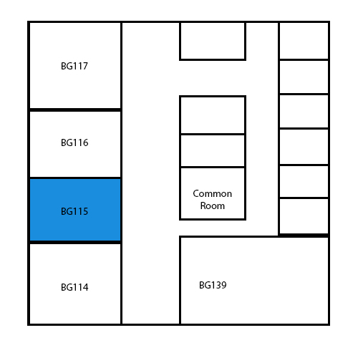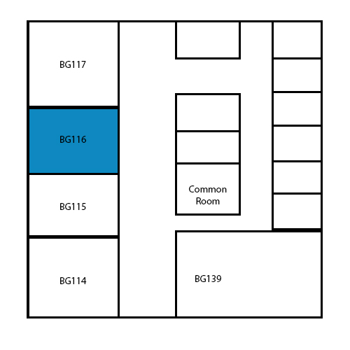

The app will do a Wi-Fi triangulation by obtaining a list of nearby access points and recording their SSID, and then it will highlight the room that contain these Aps with the given SSIDs.

**TASK 10 (ACTIVITY RECOGNITION)**

This functionality enables the user to track the path as the user walks. Have a button “start tracking” for the user to start tracking and another button “stop tracking” for the user to stop tracking. User can click START TRACKING button and start walking and clicks STOP TRACKING button once reached at destination. Then user can view the path as the user walked.

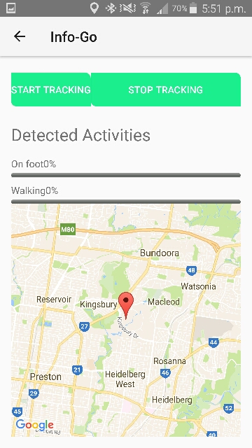 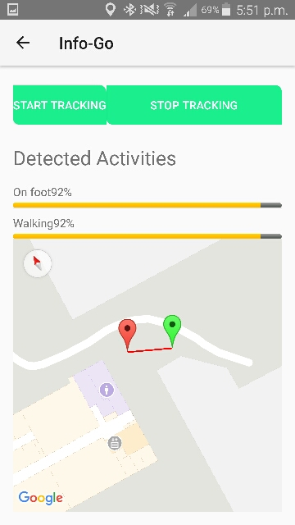

Click START TRACKING button and start walking Path can be seen as user walks

Click STOP TRACKING when you reach

## **Explanation of Multithreading used in our application**

As for multithreading, according to Android Developer’s website (2016), it is the fastest and the most efficient way of having multiple tasks within an android application; while having a mobile device that runs Android on multiple processing cores. It involves running different threads at the same time.

There are a number of techniques to be used in order to apply multithreading, such as using AsyncTasc or ThreadPost. However, infoGo uses a different kind of multithreading which is called Fragmentation; which basically divides the main activity to two main sections, the list of option wanted to be picked by the user and the options themselves.

For example, while initiating the Record Current Location feature of infoGo, the application opens the fragment and loads it, if the user wanted to use a different feature, they can simply go back and use another feature, for example the WiFi scan. After doing so, if they go back to the “Record Current Location” feature, it will not load again, as it has already been loaded from before. As mentioned before, this would save processing time as well as energy, as this particular feature (and others in infoGo) uses GPS as well as internet connection, which would consume large portions of energy everytime it has to start from scratch.

In other words, fragments will not be eliminated (destroyed) after leaving them, they would stay preloaded. On the other hand, some features of infoGo requires a fresh start such as “WiFi Scan”; the app requirements specify that the app should do a fresh scan everytime this feature is clicked. Therefore, multithreading will not be too useful in this particular feature. This also applies for the “Bluetooth Scan” feature.

## **How this app might be extended to a Treasure Hunt Game**

In order to have a full picture of this application’s capabilities and how relevant it is to become a fully functioning treasure hunt application, an overall functionality summary needs to be under consideration. After that, the application would need extra features to be implements in order to have an optimised treasure hunt application for public use as Info-Go still lacks several points in that regard.

**Existing Functionalities:**

* **Users’ Login**

Info go already has an online database (Firebase) implemented which firstly allows users to have their own credentials and can log in using their own devices or someone else’s.

**How can it be beneficial for a treasure hunting app?**

It actually is a primary functionality for such application as users will need their own profiles (even though profiles are not implemented in Info-Go but they need credentials to be) to personalise their achievements and history and other features.

* **Record Current Location**

Info-Go allows users to record their current location, as well as view previous visited locations (that has been recorded).

**How can it be beneficial for a treasure hunting app?**

Logically, treasures will need to be hidden somewhere and users would need to find them. Recording current locations of users can allow track their history and avoid places they have already been, or they may record the place that they found a treasure in, which might be used for reference for other users to view.

* **Place Information Prediction**

Using GPS coordinates and the help of Google Maps API, Info-Go predicts the nearest place and displays Text Based information to the user after extracting it from Google, giving them an idea of what is near them.

**How can it be beneficial for a treasure hunting app?**

This feature may come very handy when players walk and they come across a place that has multiple undiscovered treasures. For instance, the app could show to the user “Predicted place: Ancients Tree” and then a small hint can show up saying “This tree is 120 years old and has housed several animals. On the trunk, you might find your next clue.”

* **Geofencing**

The app allows the user to mark down “Hot” areas and notifies the user whenever they are within a certain distance from it.

**How can it be beneficial for a treasure hunting app?**

This feature may be the most important feature when it comes to Treasure Hunting; a traditional hunt would contain “clues” delivered in the form of notes or signs. Info-Go already has the ability to send the user a notification whenever they are about a 100 meters from a previously recorded geo fence location, having that already implemented, users can now be notified when they are “warmer” meaning they are getting closer to the treasure, or “colder” meaning they are moving away from the treasure. It is a matter of calculating the distance between the user and the recorded area.

* **Wi-Fi & Bluetooth Scans**

The device does a quick look up and searches for nearby devices using either Bluetooth or Wi-Fi signals and then present them to the user, and stores them in a database to be viewed later.

**How can it be beneficial for a treasure hunting app?**

These features can be used as communication methods for user to communicate with each other and send clues/hints.

* **Picture Taking**

Allows the user to take a photo in a certain place that is retrieved using GPS coordinates, and stores it alongside with information about the picture. The app also retrieves previously taken pictures.

**How can it be beneficial for a treasure hunting app?**

Users can take pictures from places where they found treasures for a later view. Additionally, this feature can be used to get “Extra Points”, meaning if one of the challenges is to get a picture of a monument (e.g. La Trobe Statue), an evidence would be needed, and a picture would suffice.

* **Activity Recognition**

Info-Go starts drawing a path and tracks the user’s movement based on their GPS location. When the user clicks “Stop Tracking”, the app stops drawing the path.

**How can it be beneficial for a treasure hunting app?**

Seeing where a user has been can be very useful when, especially if they wanted to check the amount of activity they have achieved and if they wanted to check whether they have been through a certain path or not. As an advanced feature, users can have the ability of viewing “popular” or “common” paths that other users have taken to find a certain treasure, however this hasn’t been implemented in Info-Go yet.

* **Indoor Tracking**

GPS may not work properly in closed spaces, therefore Info-Go has implemented a way to track user’s movement within a building, providing a given map. This is done using Wi-Fi triangulation by scanning nearby access points, and then pinpointing the device’s location using the distance from each point as a reference point.