**Microservices Advanced Session 2- Assignment**

* Ankita Khurana
* 3148515

**Source Code:** <https://github.com/AnkitaKhurana/Microservices_Advanced_2>

The repo contains

1. Services (User, order, aggregated) – (Node.js)

2. Deployment yml files for persistence volume claim, mysql deployment

**Docker Hub image links:**

1. User-service Image: <https://hub.docker.com/r/ankitakhurana25/service-user>

2. Order-service image: <https://hub.docker.com/r/ankitakhurana25/service-order>

3. Aggregator-service image: <https://hub.docker.com/r/ankitakhurana25/service-aggregator>

**Deployment using Kubernetes**

* The three services are deployed for this assignment. User and order service are accessible within the cluster using cluster-ip service type and aggregator service is exposed to the internet using load balance service type.
* User service uses mysql database using PVC.
* Distributed tracing is done using Jaeger, jaeger-client package is used for client -agent communication.

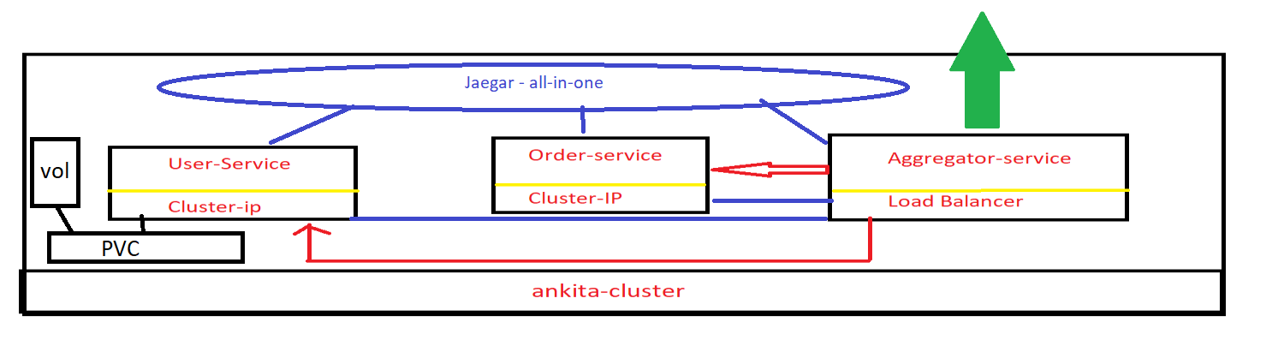

JAEGER UI

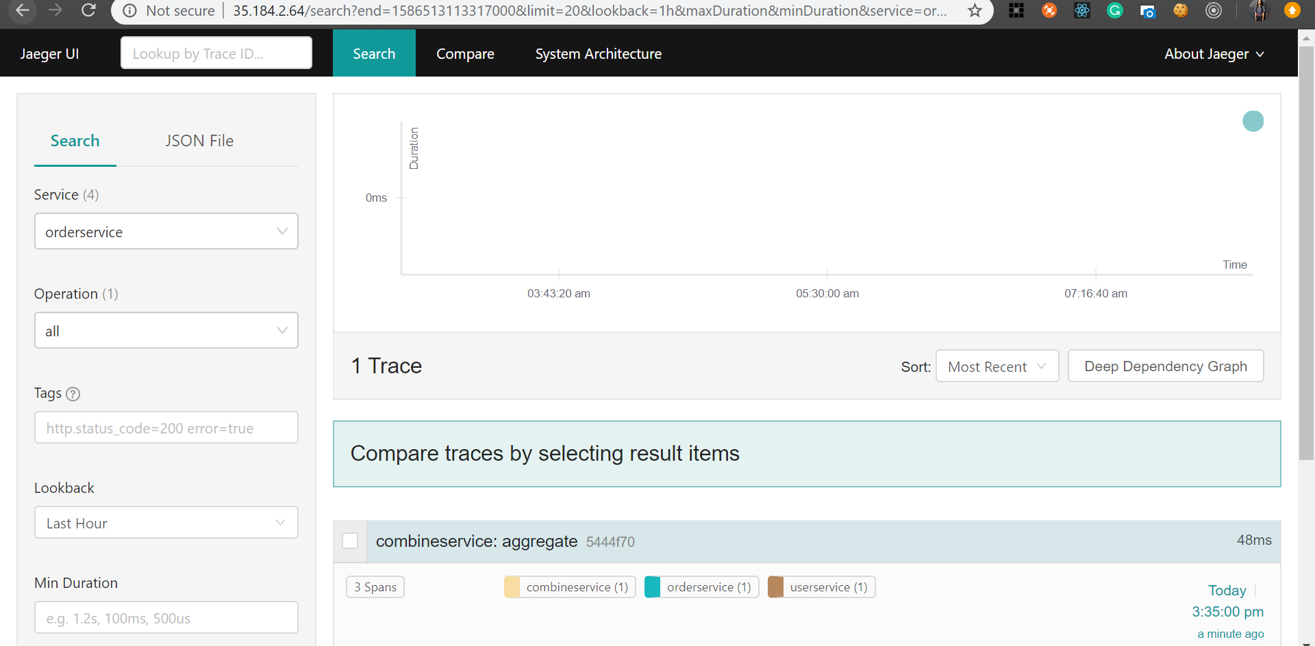

JAEGER UI – Aggregator service call

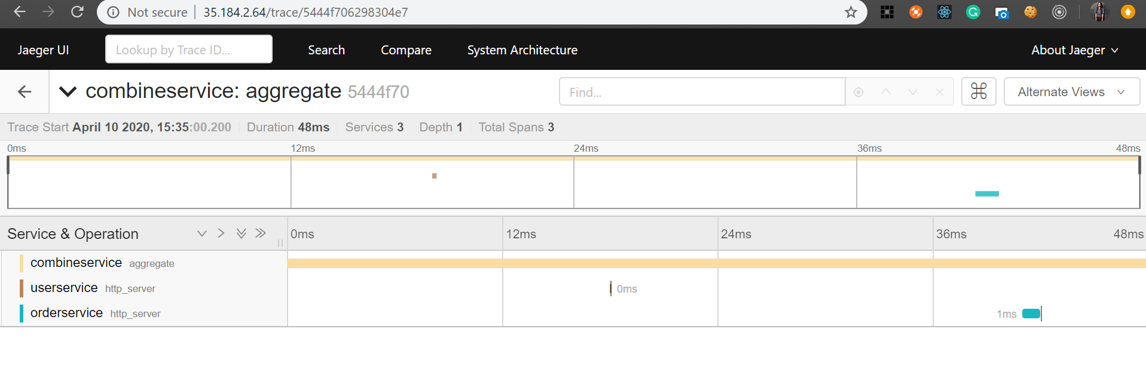

Deployments in Cluster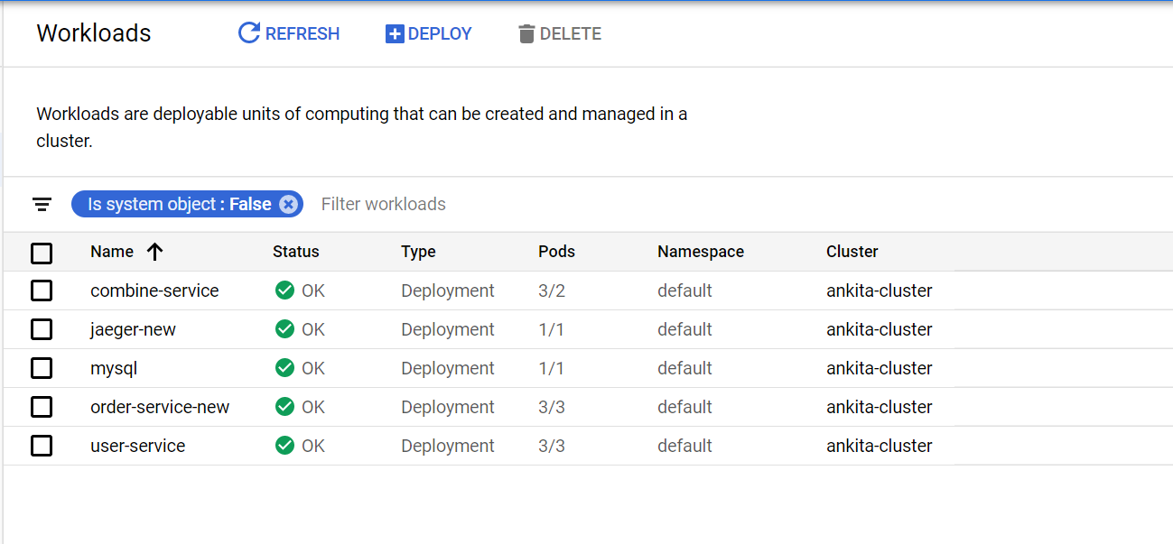

Aggregator Service Call

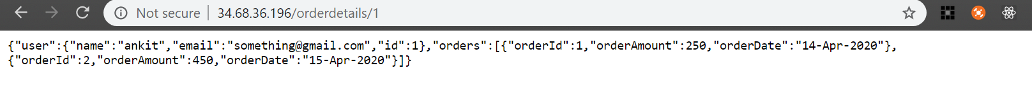

Cluster Services

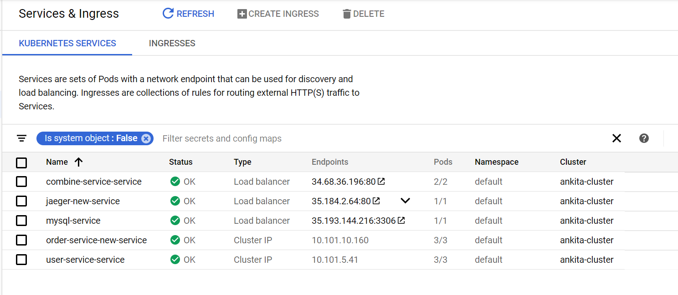

Cluster Persistent Volume Claims

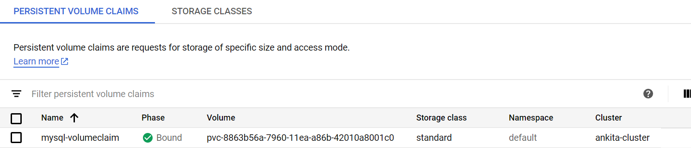

Cluster Configurations

