**Microservices in Kubernetes**

* Ankita Khurana
* 3148515

**Source Code:**

<https://github.com/AnkitaKhurana/Kubernetes_Microservices_Assignment>

The repo contains

1. Services (User, order, aggregated)
2. Deployment yml files for services

**Docker Hub image links :**

1. User-service Image : <https://hub.docker.com/r/ankitakhurana25/user-service>
2. Order-service image: <https://hub.docker.com/r/ankitakhurana25/order-service>
3. Aggregator-service image: <https://hub.docker.com/r/ankitakhurana25/aggregator-service>

**Deployment using Kubernetes**

The three services are deployed with two pods each (replicas). Three nodes are present in the cluster for handling them. User and order service are accessible within the cluster using cluser-ip service type and aggregator service is exposed to the internet using load balance service type.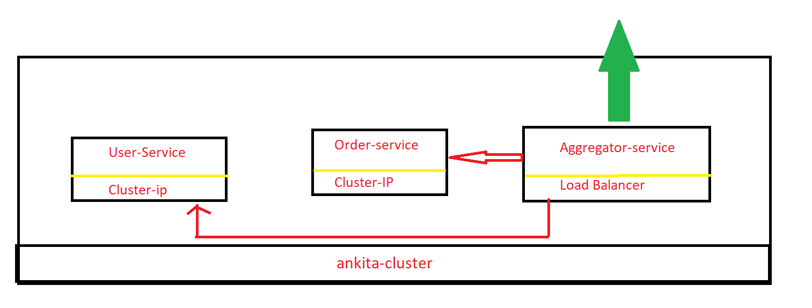

Service deployment diagram

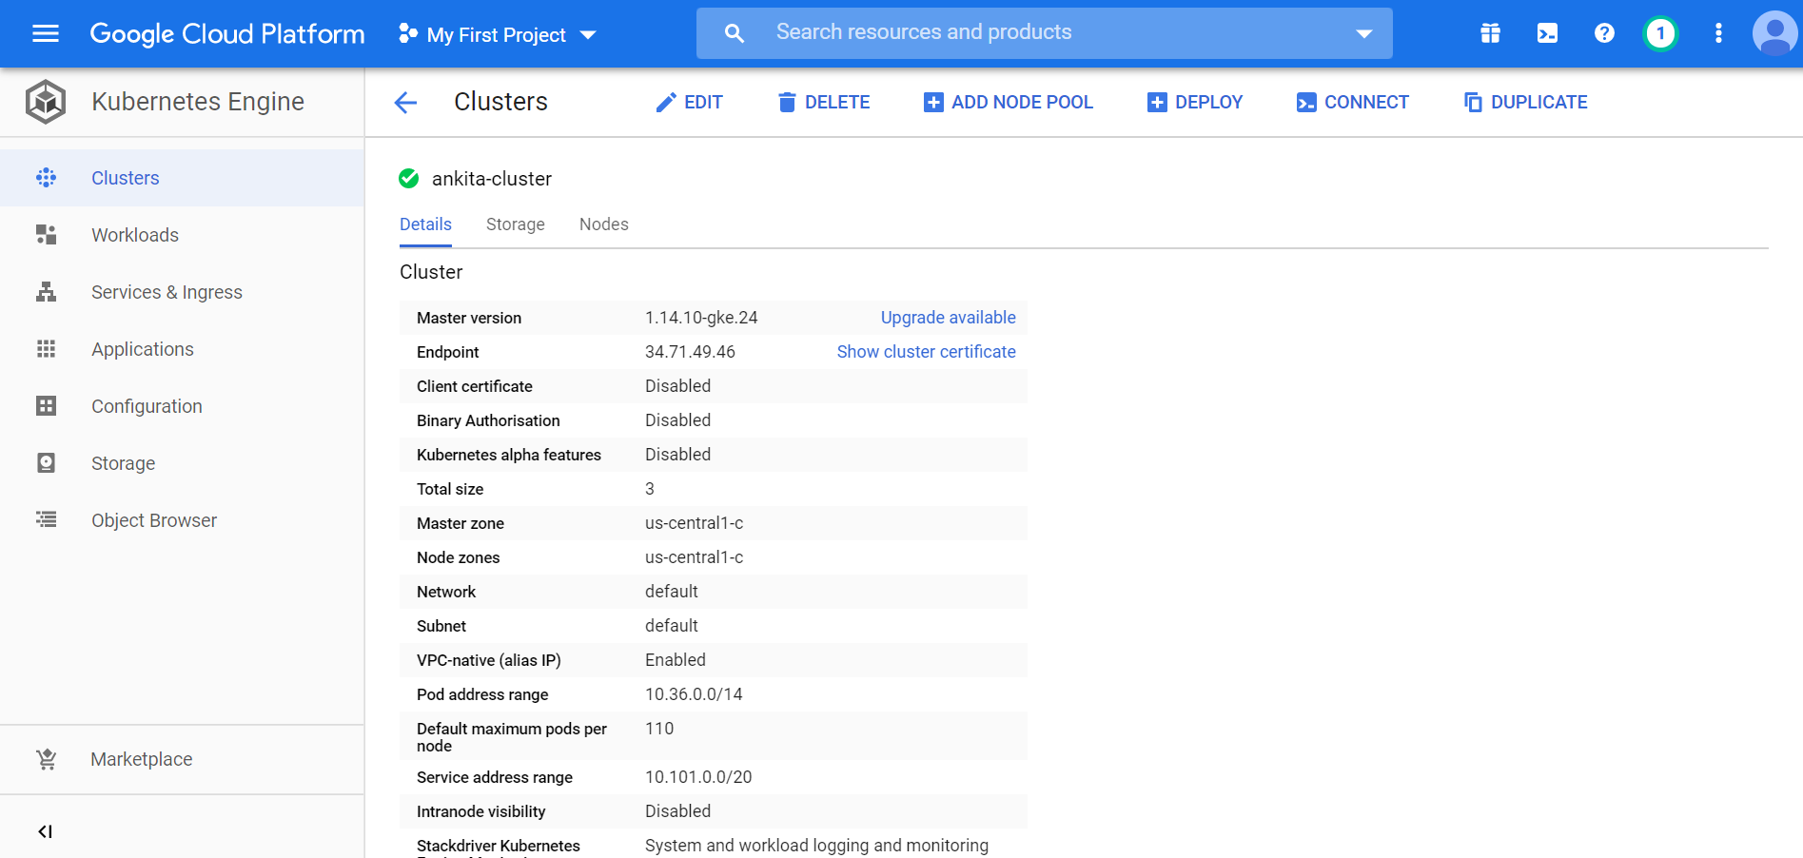

ankita-cluster



Deployment-user.yml apply example, yml file deployment

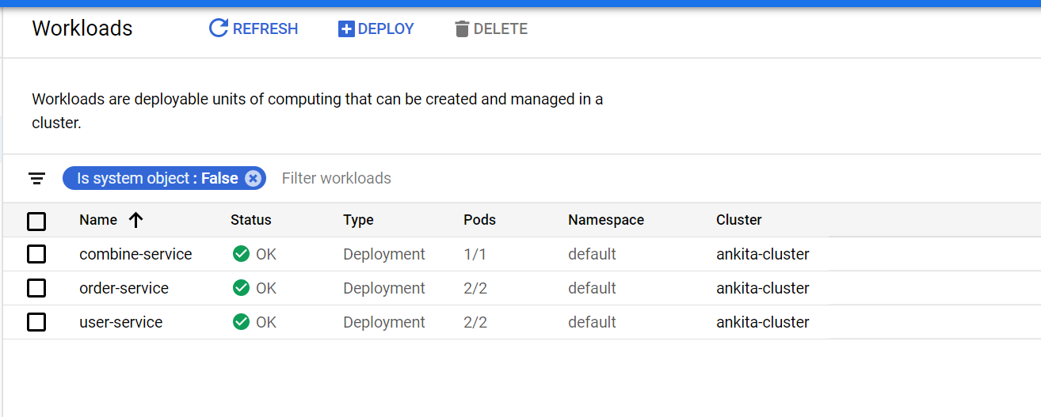

Workloads

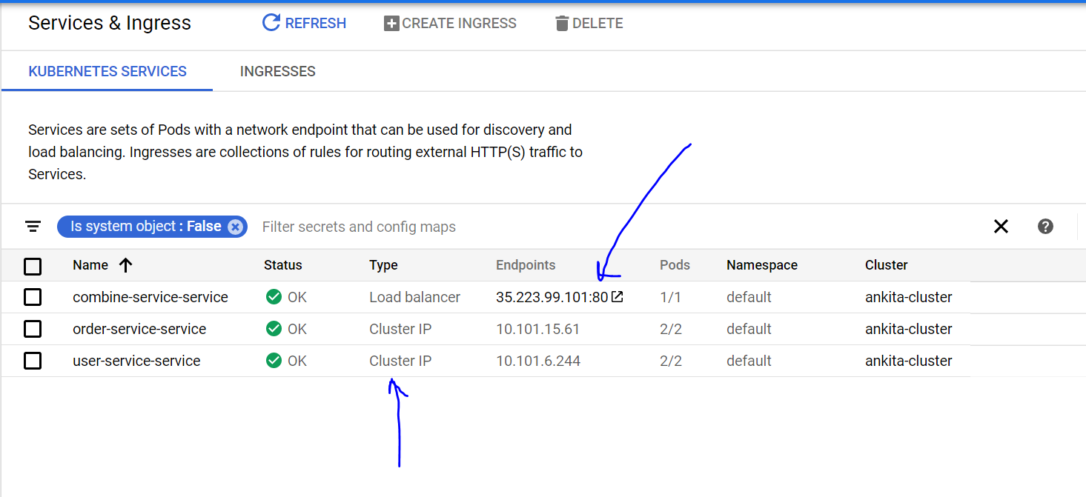

Services for the deployments

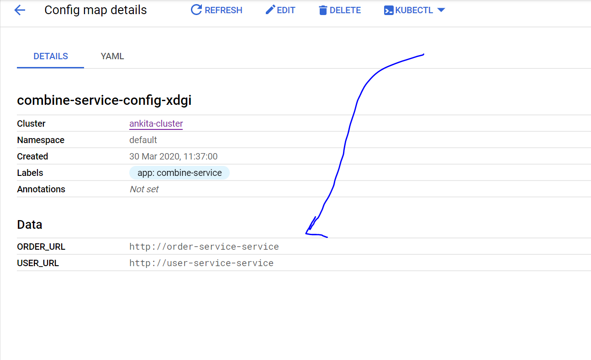

Config map details used by aggregator service to internally use the .env variables for order/user service

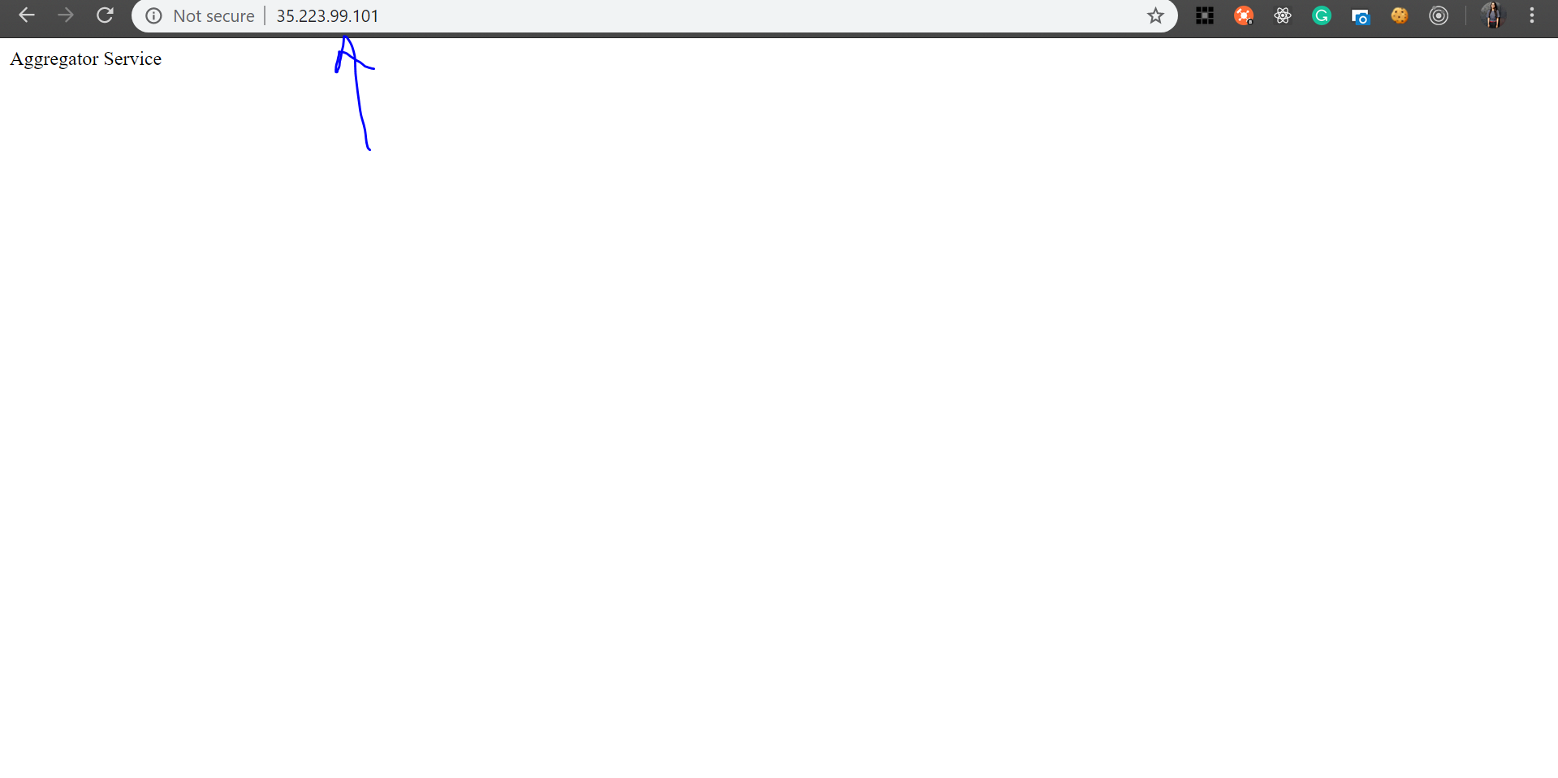

Aggregator service - / hit

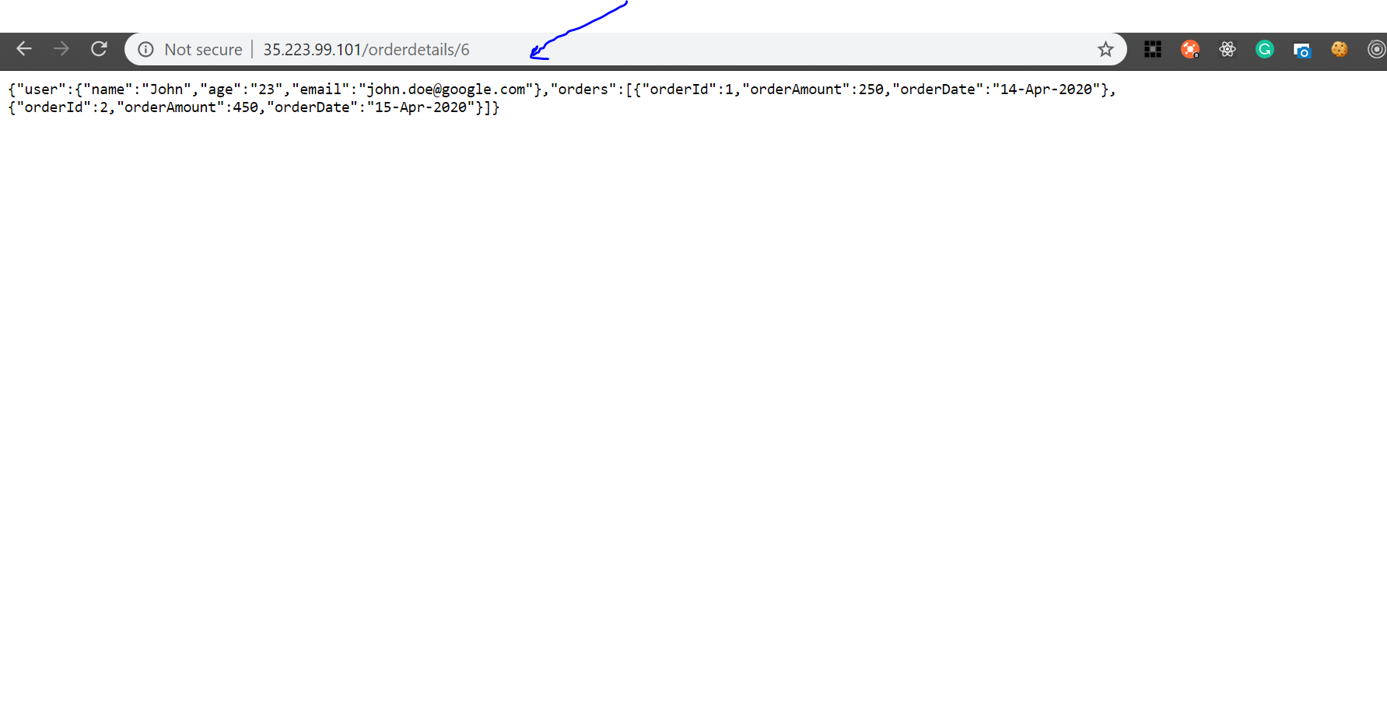 Aggregator service - /orderdetails/:id hit