1. Load data and create a Spark data frame
scala> val df=spark.read.format("csv").option("header","true").option("inferSchema","true").option("delimiter",",").load("/user/ankitapmodi_gmail/Bank.csv")
df: org.apache.spark.sql.DataFrame = [age: int, job: string ... 15 more fields]
2.Give marketing success rate (No. of people subscribed / total no. of entries)
scala> val totalcount = df.count().toDouble
totalcount: Double = 45211.0
scala> val subscription_count= df.filter($"y" === "yes").count().toDouble
subscription_count: Double = 5289.0
scala> val success = subscription_count/totalcount
success: Double = 0.11698480458295547
3. Give the maximum, mean, and minimum age of the average targeted customer
scala> df.select(max($"age"), avg($"age"), min($"age")).show
+--------+-----------------+--------+
|max(age)| avg(age)|min(age)|
+--------+-----------------+--------+
| 95|40.93621021432837| 18|
+--------+-----------------+--------+
4.Check the quality of customers by checking average balance, median balance of customers
scala> df.registerTempTable("portbankdetails")
warning: there was one deprecation warning; re-run with -deprecation for details
scala> spark.sqlContext.sql("select percentile(balance,0.5) as median ,avg(balance) as average from portbankdetails").show
+------+------------------+
|median| average|
+------+------------------+
| 448.0|1362.2720576850766|
+------+------------------+
5. Check if age matters in marketing subscription for deposit
scala> df.groupBy("y").agg(avg($"age")).show
+---+------------------+
| y| avg(age)|
+---+------------------+
| no| 40.83898602274435|
|yes|41.670069956513515|
+---+------------------+
Yes, age matters
6.Check if marital status mattered for a subscription to deposit
scala> df.groupBy("y").agg(count($"marital")).show
+---+--------------+
| y|count(marital)|
+---+--------------+
| no| 39922|
|yes| 5289|
+---+--------------+
Marital status affects the subscription
7.Check if age and marital status together mattered for a subscription to deposit scheme
scala> df.groupBy("marital","y").count().sort($"count".desc).show
+--------+---+-----+
| marital| y|count|
+--------+---+-----+
| married| no|24459|
| single | no|10878|
|divorced| no| 4585|
| married |yes| 2755|
| single |yes| 1912|
|divorced|yes| 622|
+--------+---+-----+
scala> df.groupBy("age","marital","y").count().sort($"count".desc).show
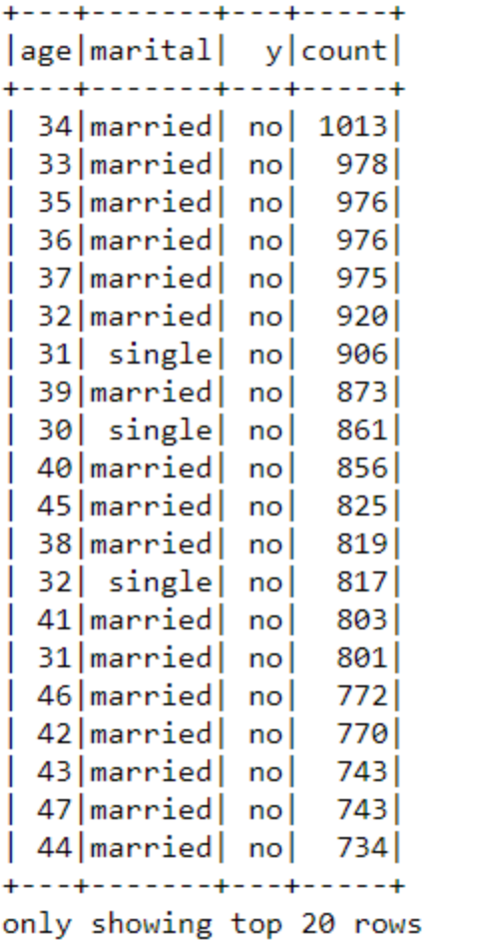
Do Feature engineering for age column and find right age effect on campaign
scala> df.groupBy("age","y").count().sort($"count".desc).show
+---+---+-----+
|age| y|count|
+---+---+-----+
| 32| no| 1864|
| 31| no| 1790|
| 33| no| 1762|
| 34| no| 1732|
| 35| no| 1685|
| 36| no| 1611|
| 30| no| 1540|
| 37| no| 1526|
| 39| no| 1344|
| 38| no| 1322|
| 40| no| 1239|
| 41| no| 1171|
| 42| no| 1131|
| 45| no| 1110|
| 43| no| 1058|
| 46| no| 1057|
| 44| no| 1043|
| 29| no| 1014|
| 47| no| 975|
| 48| no| 915|
+---+---+-----+
only showing top 20 rows
scala> import org.apache.spark.sql.functions.udf
import org.apache.spark.sql.functions.udf

scala> def ageCategory = udf((age:Int) => {age match {case t if t < 20 => "Teen" case t if t > 55 => "Old" case t if (t >= 20 && t <= 32)=>"Young" case t if (t > 32 && t <= 55)=>"MiddleAged" }})
ageCategory: org.apache.spark.sql.expressions.UserDefinedFunction

Add a new column.
scala> val df1 = df.withColumn("agecategory",ageCategory(df("age")))
df1: org.apache.spark.sql.DataFrame = [age: int, job: string ... 16 more fields]

scala> df1.groupBy("agecategory","y").count().sort($"count".desc).show
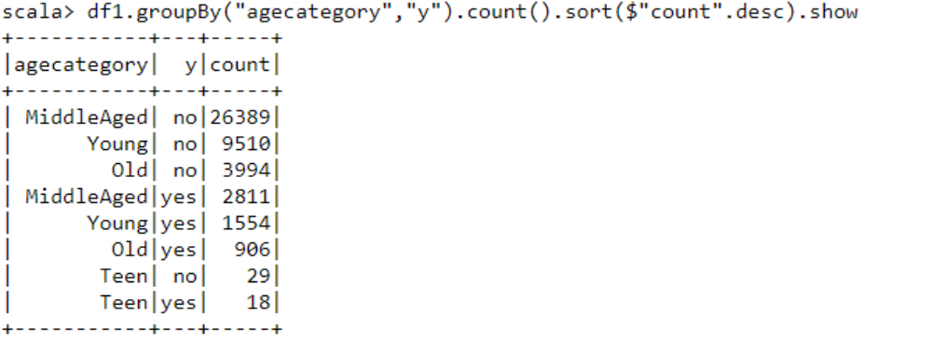
Middle age impact is more.

