

**Name: Ankita Mondal**

**Roll No.: RD2441A31**

**Registration No: 12404320**

**Topic: Relationship between Academic Pressure and Mental Health**

**Submitted to: Jasleen Kaur Paintal ma’am**

1. **Data Acquisition: Import data from diverse sources (Excel, CSV, SQL, APIs) with accuracy.**

**Import data from diverse sources (Excel, CSV, SQL, APIs) with accuracy:**

***Dataset 1: Dataset 2:***

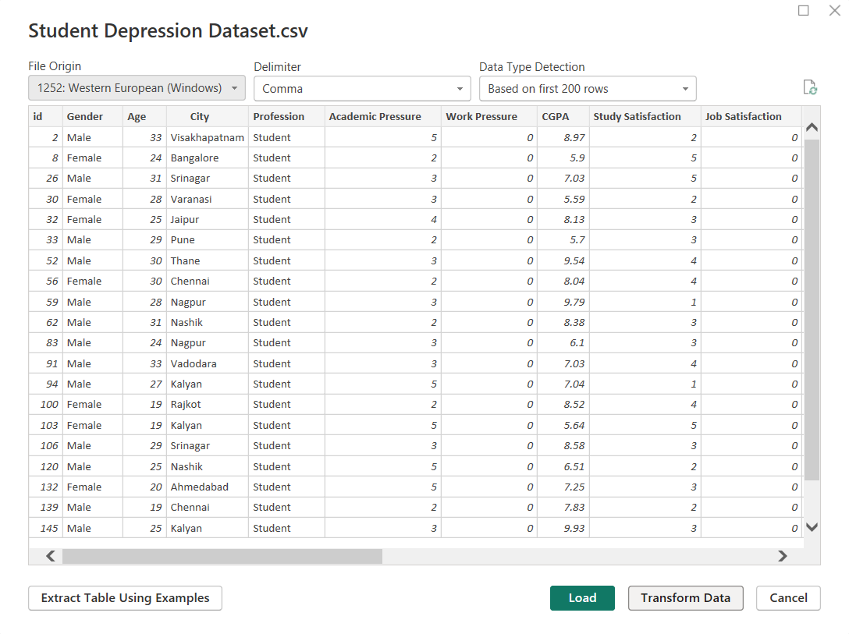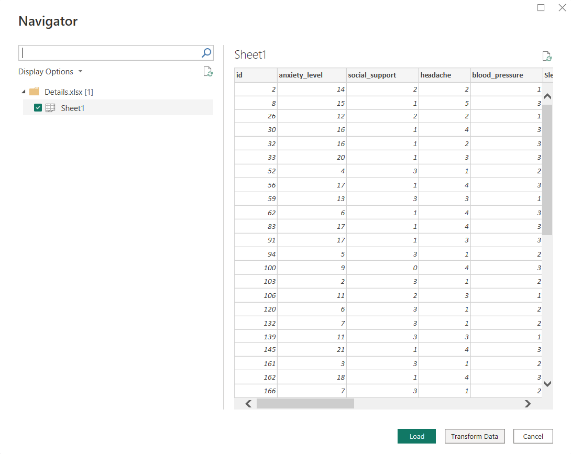

1. **Data Cleaning:**

* **Handles missing values (imputation, removal) appropriately.**

***Dataset 1:***

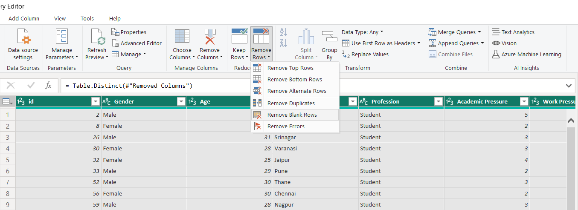

***Dataset 2:***

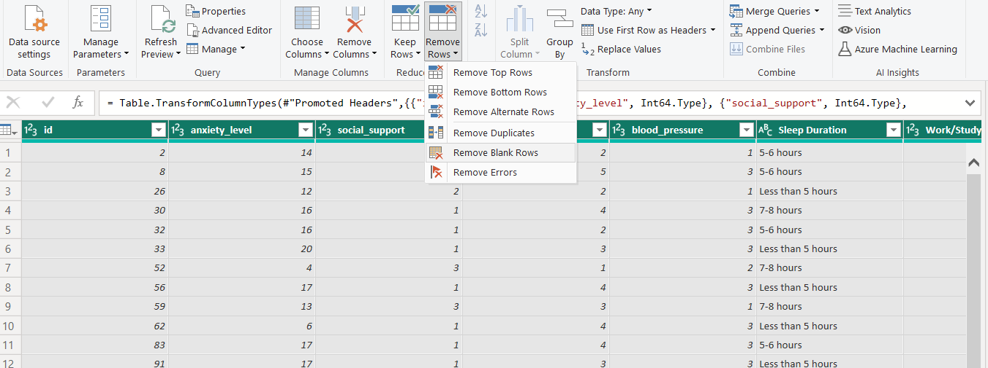

* **Removes duplicates and irrelevant data.**

***Dataset 1:***

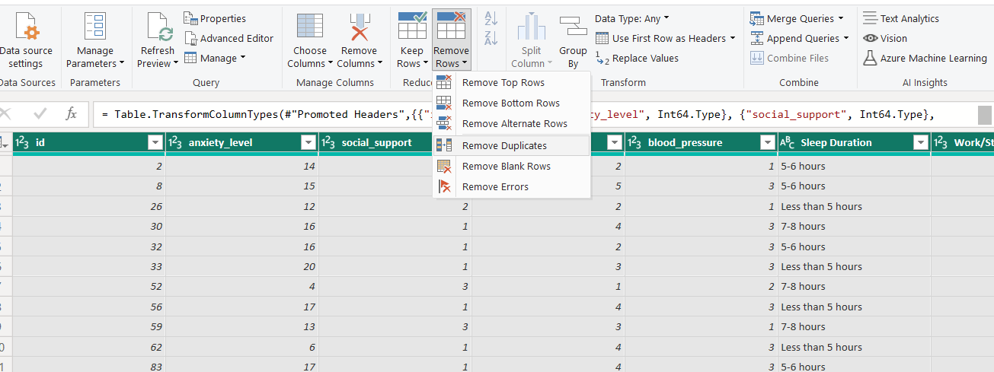

***Dataset 2:***

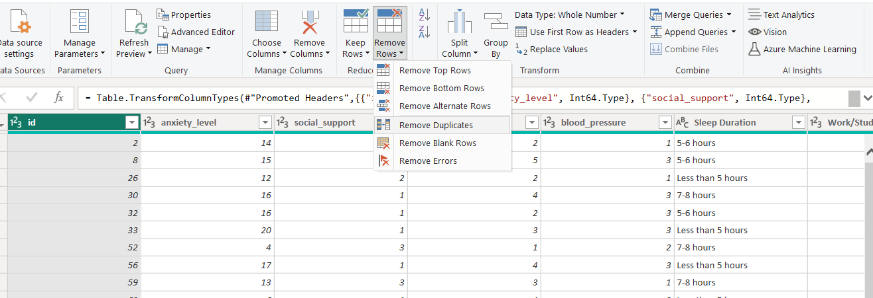

* **Corrects inconsistencies (e.g., date formats, spelling).**

***Dataset 1:***

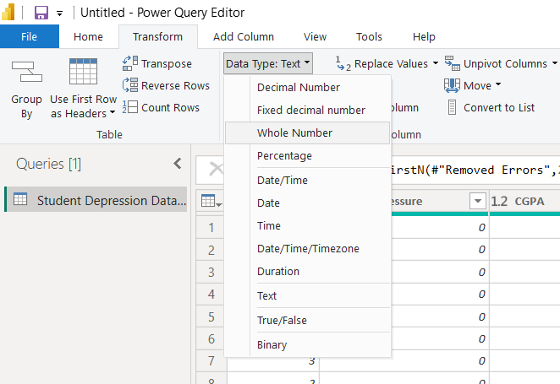

***Dataset 2:***

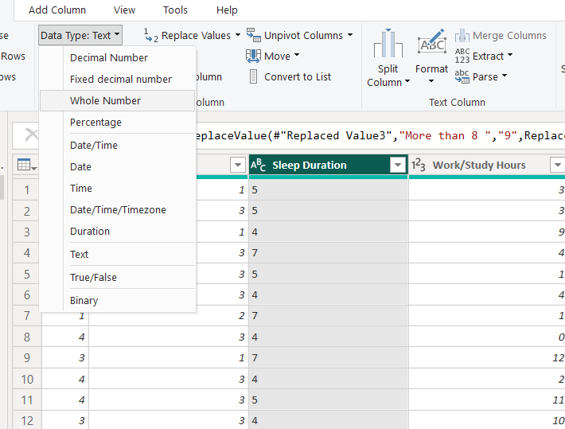

1. **Data Transformation:**

* **Applies Power Query steps like filtering, sorting, and grouping.**

***Dataset 1:***

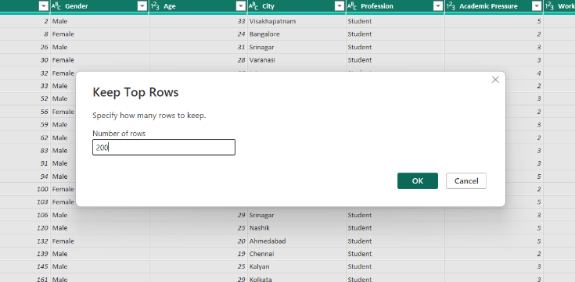

***Dataset 2:***

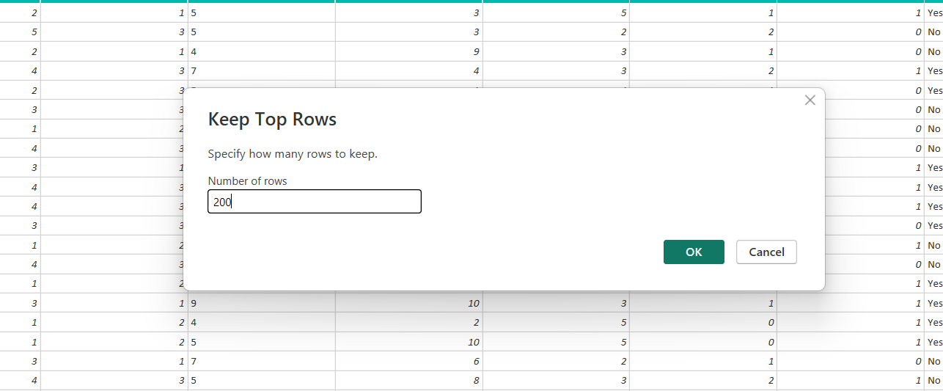

* **Uses appropriate calculations and transformations (e.g., calculated columns, measures).**

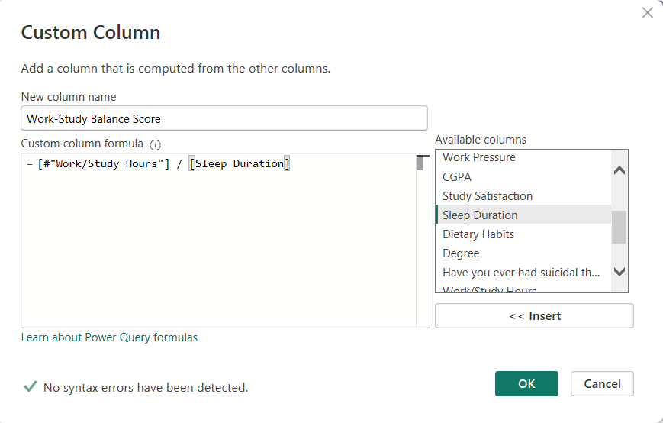

1. **Data Integration:**

* **Demonstrates logical relationships between tables.**

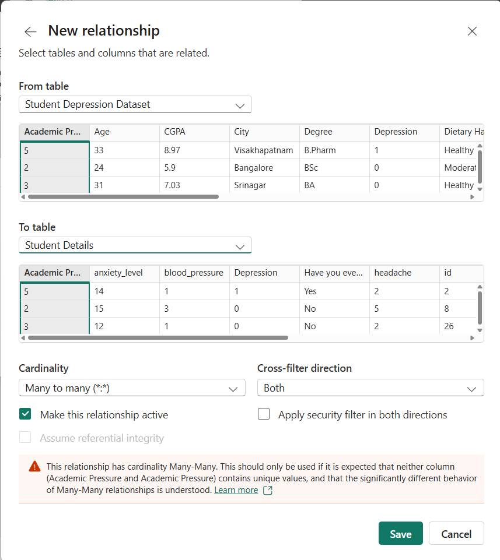

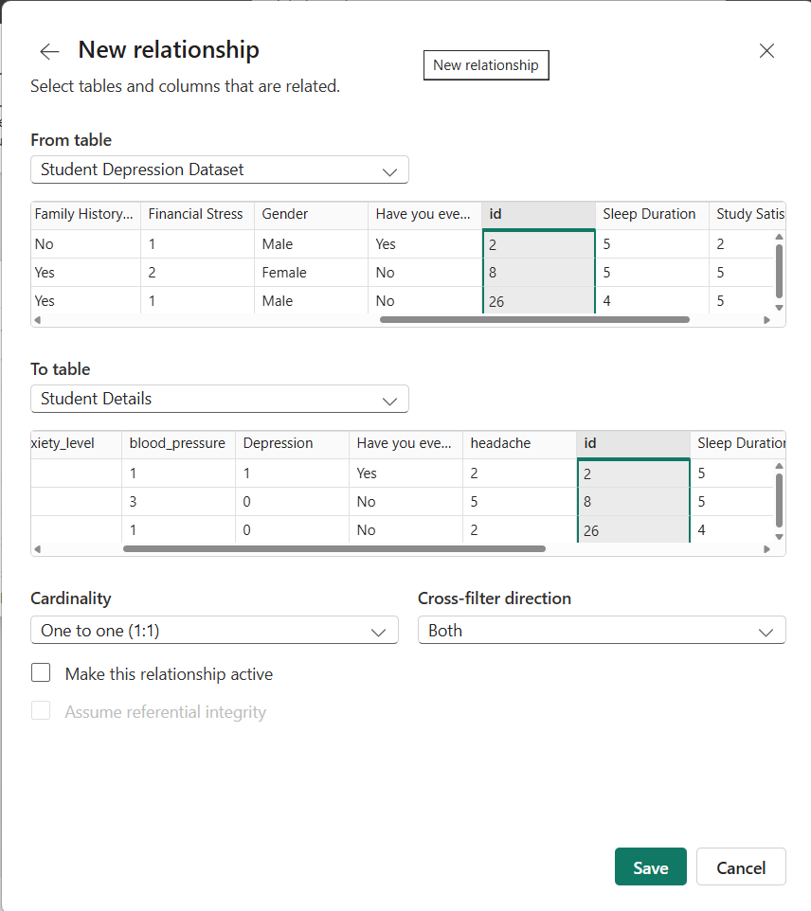

1. **Data Validation:**

* **Validates the integrity of data post-preprocessing.**

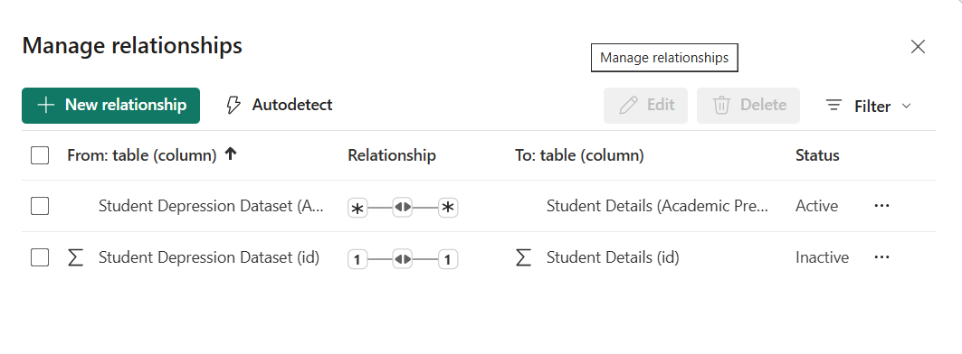

1. **Power BI Model Set-up:**

* **Sets up relationships with correct cardinality**

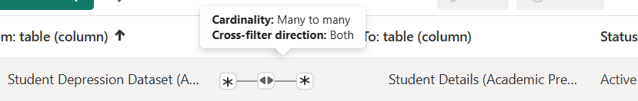

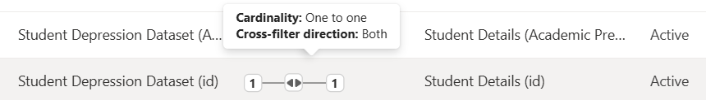

1. **Provides clear, concise documentation of preprocessing steps:**

* ***Dataset 1: Dataset 2:***

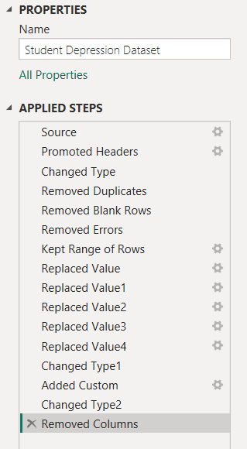 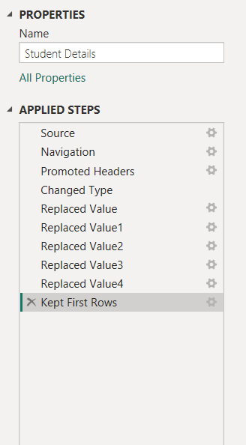

1. **Visualisation for Validation:**

