ANKITA MUNI 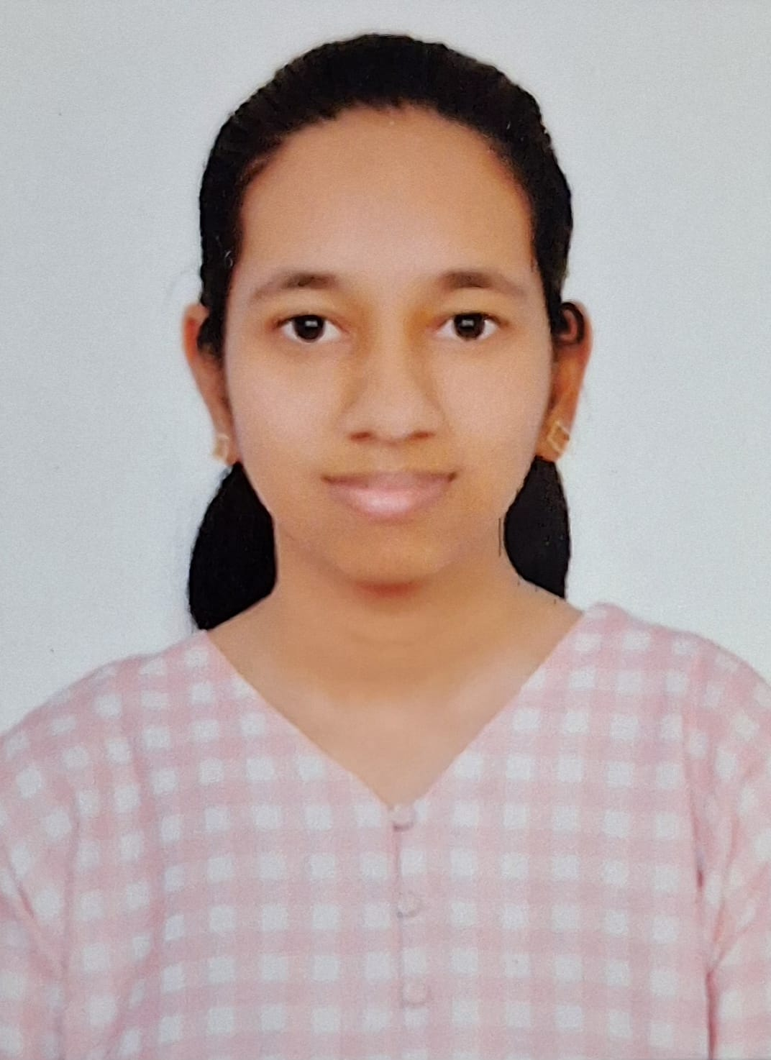
Student

PROFILE
Dedicated and responsible B. Tech Computer Science student with a CGPA of 7.89. Strong soft skills including teamwork, leadership, and critical thinking combined with technical expertise in programming and data analysis. Actively looking forward to gain real-world work experience and contribute to automation, digitalization and innovative projects.

EDUCATION

PES University (RR Campus)
Bachelor of Technology in Computer Science and Engineering (2023-27)
- CGPA: 7.89
Lake Montfort School
- 12th CBSE Board (2022-23): 84.8%
- 10th CBSE Board (2020-21): 91.3%

TECHNICAL SKILLS
- Programming Languages: Python, C, SQL, R (basic), MATLAB (basic)
- Web Development: HTML, CSS, JavaScript
- Tools & Technologies: Data analysis, blockchain fundamentals, Cisco Packet Tracer, Streamlit, VS Code, Google Colab, Jupyter

COURSES & CERTIFICATIONS

- Analytics Edge: Data Science Unleashed
- Master Course in Generative AI
- Introduction to Blockchain and MetaMask
- SQL for Beginners
- Introduction to Image Processing
- Computer Vision 101
- Storytelling with Data: Tableau & Power BI

PROJECTS
1. Virtual Piano using Arduino: Developed a virtual piano using Arduino and Python.
2. Disaster Tweet Classifier: Built a machine learning model to classify tweets related to disasters.
3. Distributed Real Time Drawing Board: Raft board is a distributed real-time drawing application built using the Raft Consensus algorithm.
4. Safar Travel Guide: Designed an interactive travel guide platform for exploring destinations.
5. API Rate Limiter: A middleware or service that can be used to enforce rate limits on API endpoints to prevent abuse.
6. Her Health: A comprehensive, data-driven web application built with Python and Flask, designed to help users track their menstrual cycles, log health data, and gain insights through personalized predictions and data visualizations.
7. Cracking Captcha and ReCAPTCHA: Developed algorithms for solving CAPTCHA challenges.
8. Secure Encryption Messaging App: A secure Python chat application using AES encryption over sockets for private text communication.
9. Dynamic Content Stream with Kafka: A real-time, adaptive streaming platform that utilizes a database control plane to enable dynamic Kafka topic lifecycle management without requiring manual system reconfiguration.
10. Bioacoustic AI for Sustainability: leverages a real-time Apache Kafka data pipeline to monitor and analyze forest audio streams for immediate detection of illegal logging activities.
11. VerifyAI: Autonomous AI agents that audit research papers, repositories, and reproducibility claims with scientific transparency and real-time intelligence.

LINKS

- GitHub: AnkitaMuni (ANKITA MUNI)
- LinkedIn: www.linkedin.com/in/ankita-muni-66512331a

SOFT SKILLS

- Time Management
- Effective Communication
- Leadership
- Teamwork
- Problem Solving

LANGUAGES
- Proficient in: English, Hindi, Odiya

HOBBIES
- Listening Western Music, Reading Fantasy Novels, Writing Diary, Building Personal Projects

CONTACT

- Phone: 8970900660
- Email: ankitamuni2005@gmail.com
- Permanent Address: Flat No. G4, Pruthvi Residency, MLA Layout, Kalena Agrahara, BG Road, Bengaluru-83
- Temporary Address: Vasundhara Kritika, Flat No. A 704, Outer Ring Rd, Banashankari 3rd Stage, Bengaluru-85

“I hereby declare that the information provided above is true to the best of my knowledge.”

