1. **START THE SPRINGBOOT APPLICATION.**

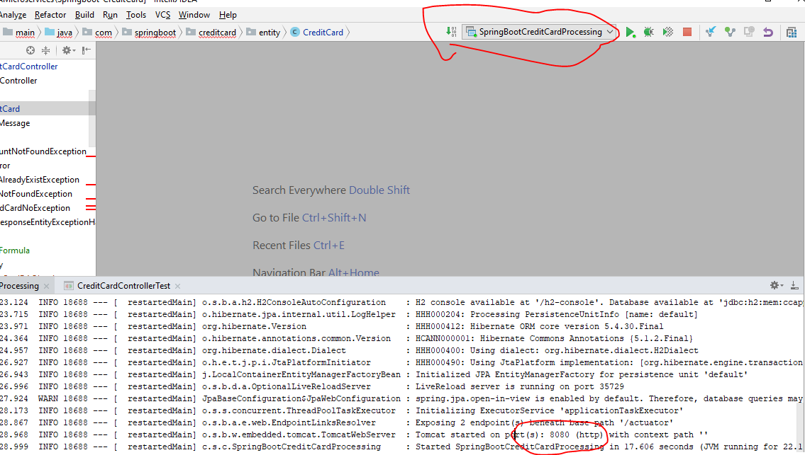

1. **INSERT THE NEW RECORD / HAPPY FLOW**

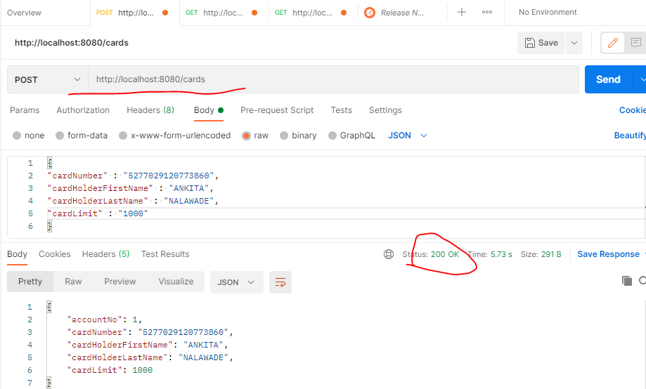

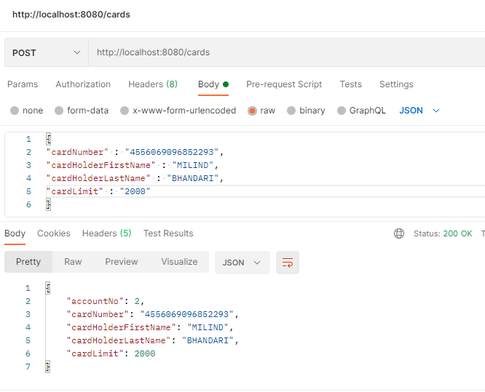

1. **FETCH ALL CARDS**

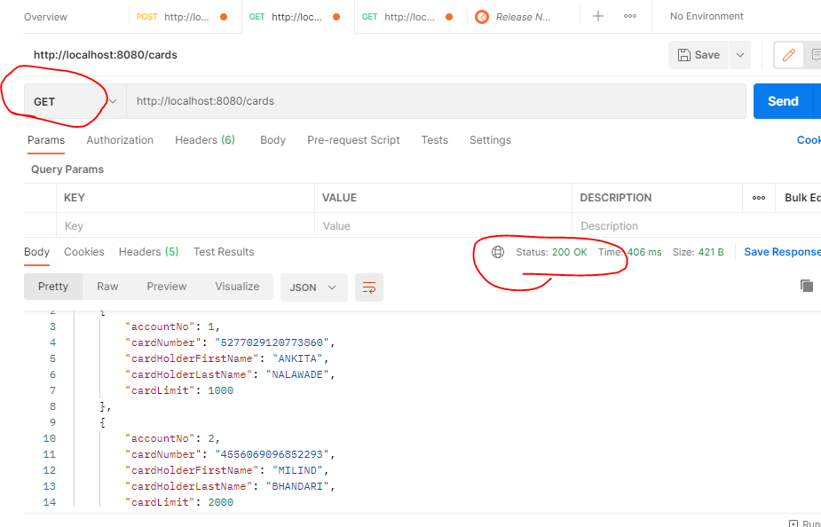

1. **FETCH BY ID**

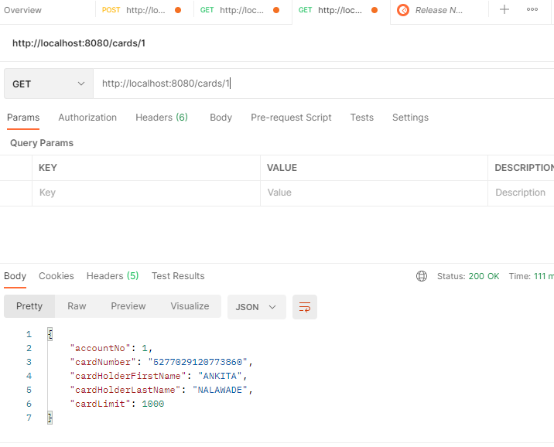

1. **VALIDATIONS** 
   1. **CREDIT CARD CANNOT BE NULL**

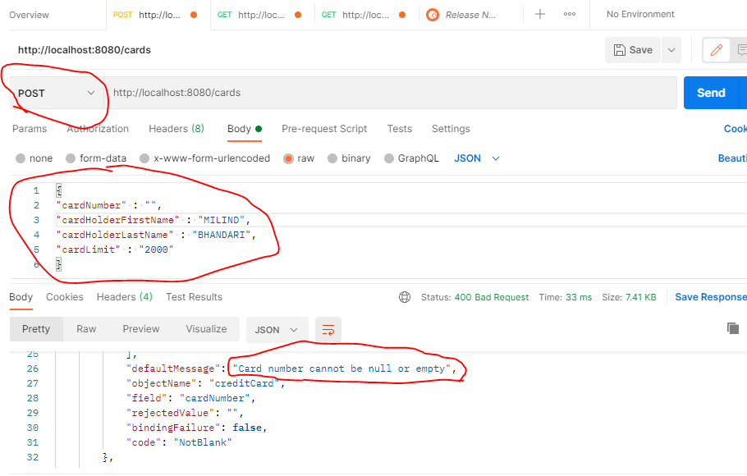

* 1. **FIRST NAME / LAST NAME CANNOT BE NULL**

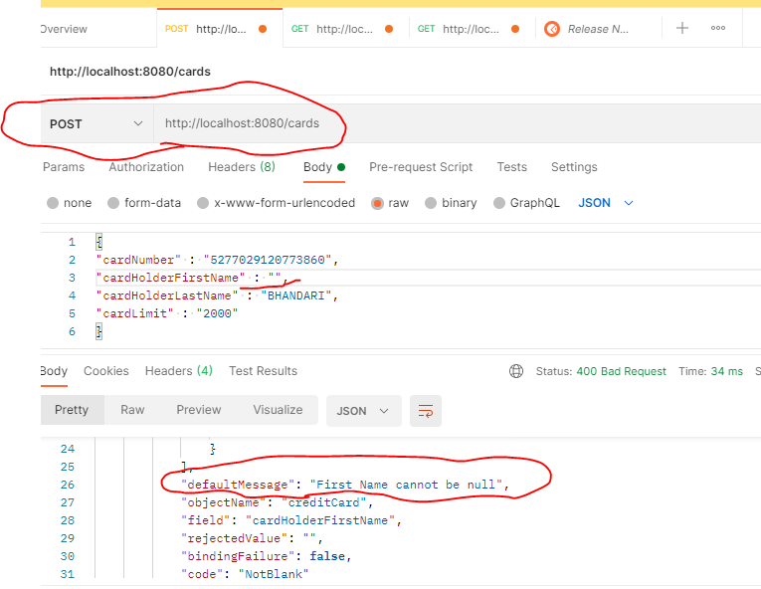

* 1. **LIMIT CANNOT BE NULL**

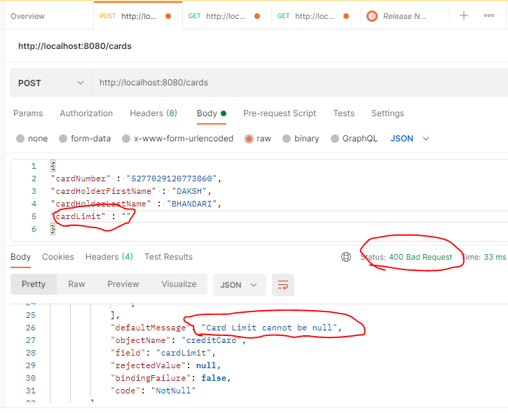

* 1. **CARD NUMBER SIZE / LENGTH SHOULD NOT EXCEED 19 DIGITS**

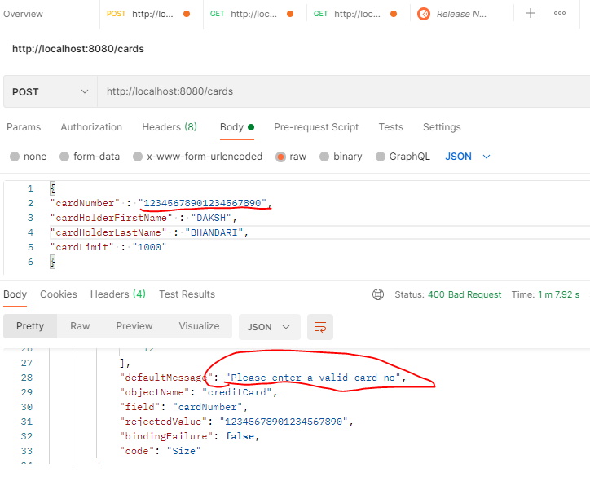

* 1. **CARD MUST BE A NUMBER ONLY**

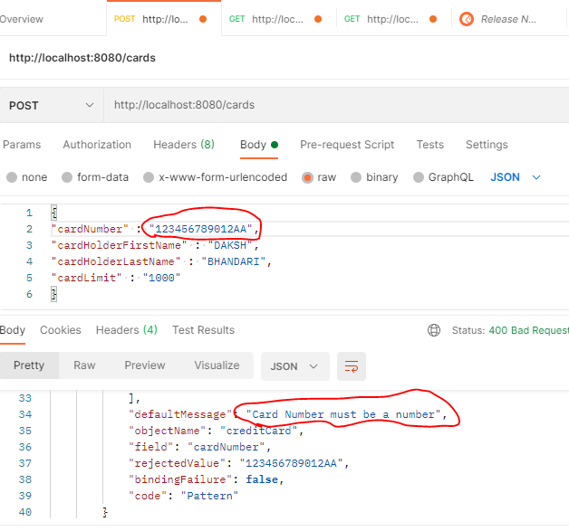

* 1. **APPLIED UNIQUE CONSTRAINT IN ORDER TO AVOID DUPLICATE ENTRIES GETTING ADDED. *(@Column(name = "CARD_NUMBER", unique = true, nullable = false, length = 19))***

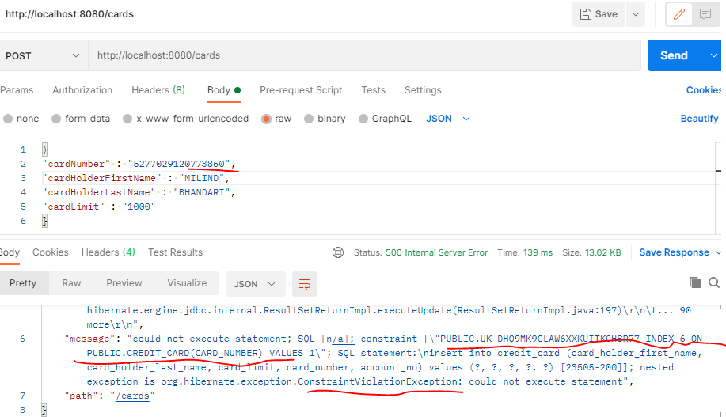

1. **LUHN FORMULA TEST**

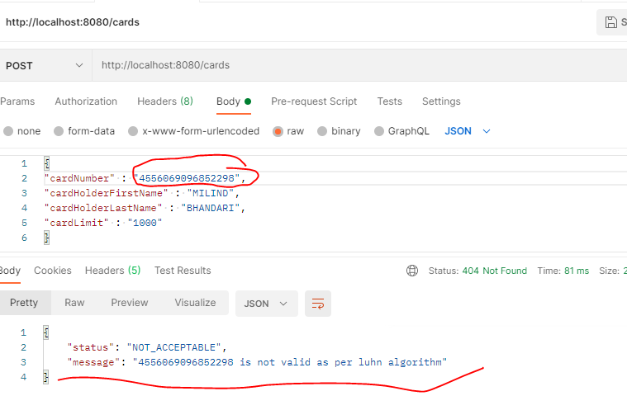

1. **H2-IN MEMORY DATABASE**

