**Task 3: SQL for Data Analysis**

1. **SELECT**

Select * from categories

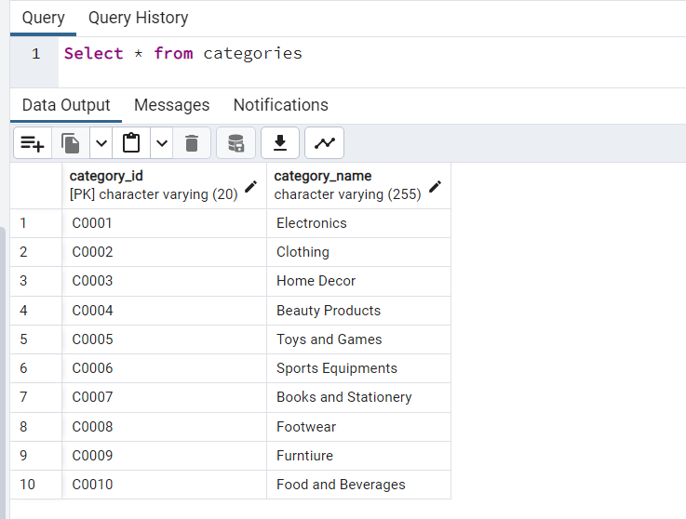

1. **WHERE**

Select * from payment where amount < 80;

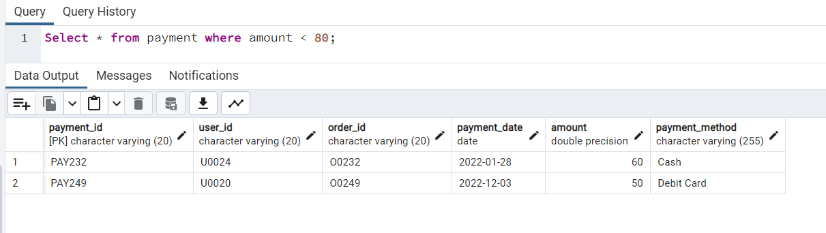

1. **COUNT**

Select count(*) from payment where amount < 800;

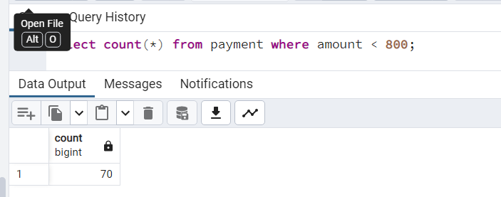

1. **ORDER BY**

Select distinct(state), pin_code from address order by pin_code;

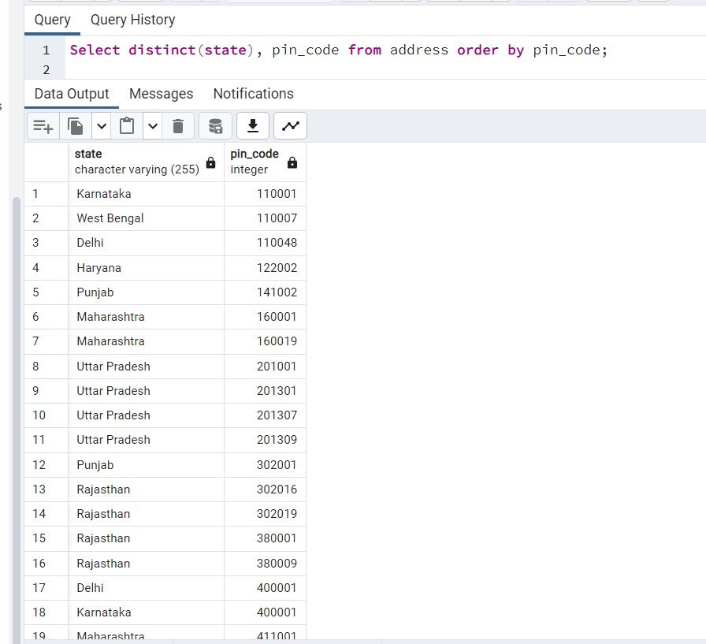

1. **GROUP BY**

Select count(*), payment_method from payment group by payment_method

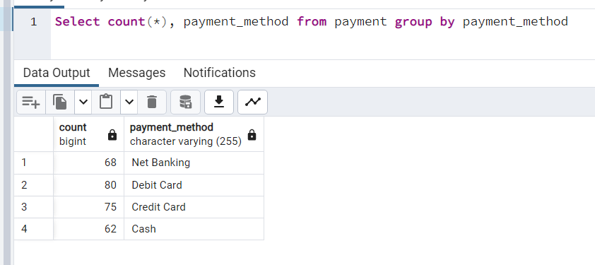

1. **INNER JOIN**

*Users who have placed orders. Returns only users details who have placed at least one order.*

SELECT u.user_id, u.user_name, o.order_id, o.order_date FROM users u INNER JOIN orders o ON u.user_id = o.user_id;

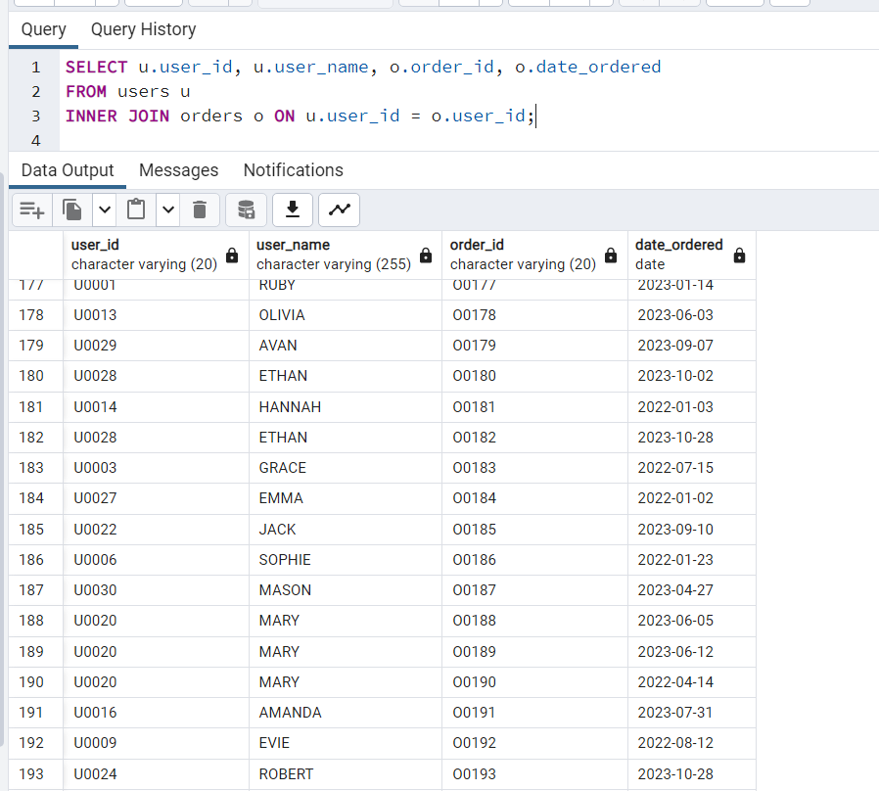

1. **LEFT JOIN**

*All users and their payment status (if any). Shows all users, including those who haven’t made any payment. If there’s no payment, the related fields will be NULL.*

SELECT u.user_id, u.user_name, p.payment_id, p.amount, p.payment_method FROM users u LEFT JOIN orders o ON u.user_id = o.user_id LEFT JOIN payment p ON o.order_id = p.order_id;

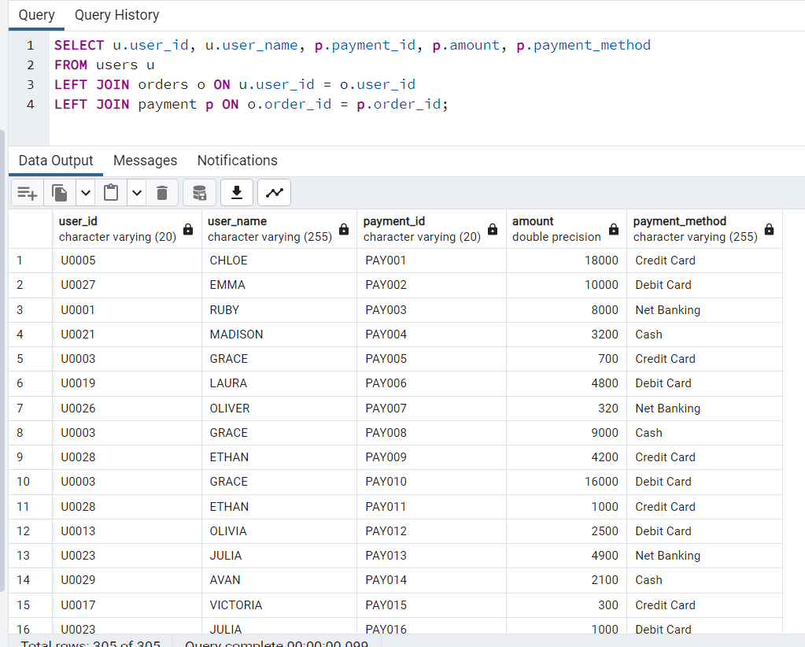

1. **RIGHT JOIN**

*Products that have been reviewed (and their reviewers). Shows all products that have reviews. If a product has no review, it still shows up with NULL in review fields (though here it’s a RIGHT JOIN from review to product, emphasizing product visibility).*

SELECT r.review_id, r.rating, p.product_name , u.user_name AS reviewer FROM reviews r RIGHT JOIN product p ON r.product_id = p.product_id LEFT JOIN users u ON r.user_id = u.user_id;

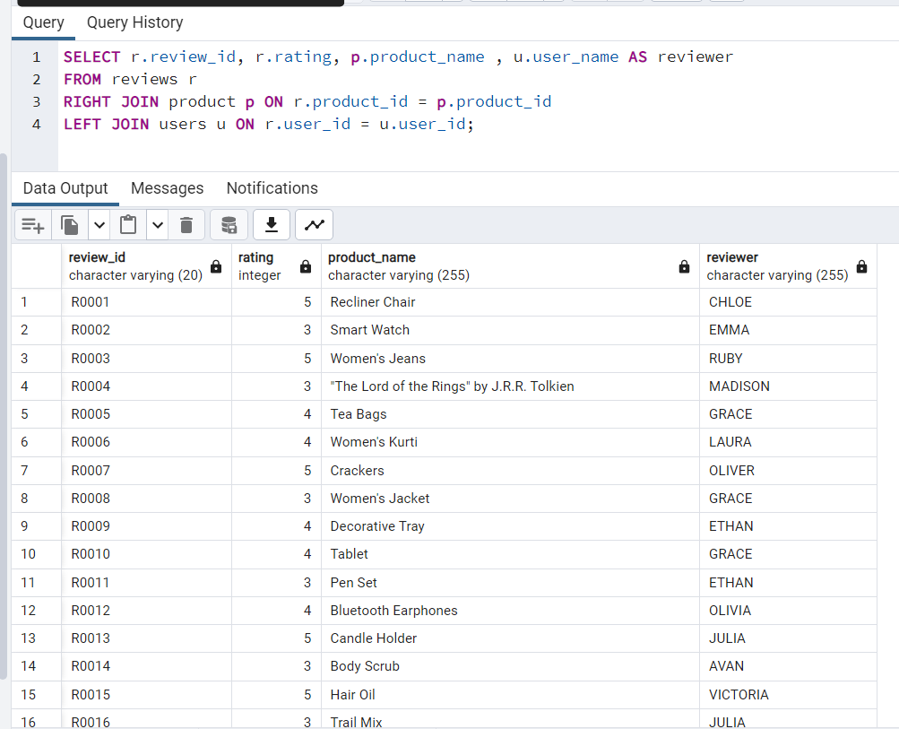

1. **SUBQUERY**

SELECT user_name, email FROM users WHERE user_id IN (SELECT user_id FROM orders);

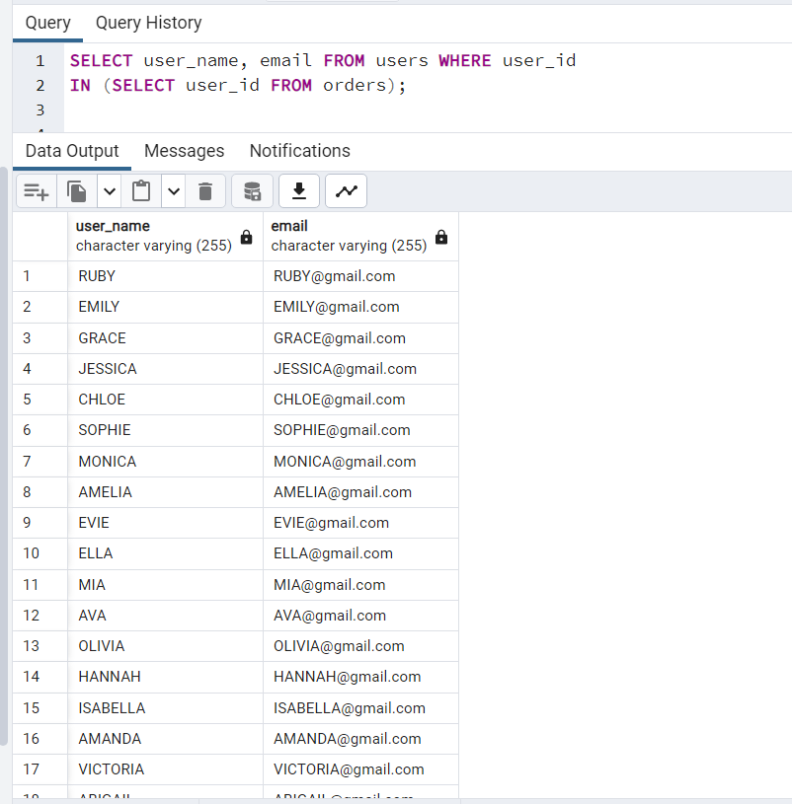

1. **AGGREGATE (SUM)**

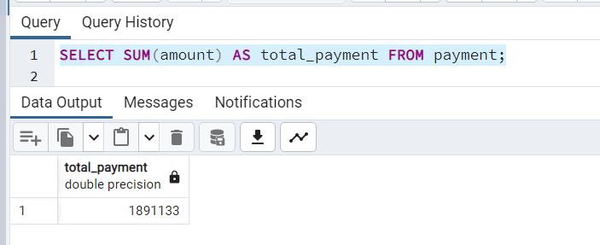

1. **AGGREGATE (AVG)**

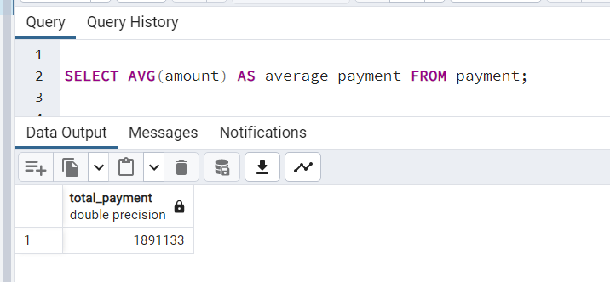

1. **VIEW**

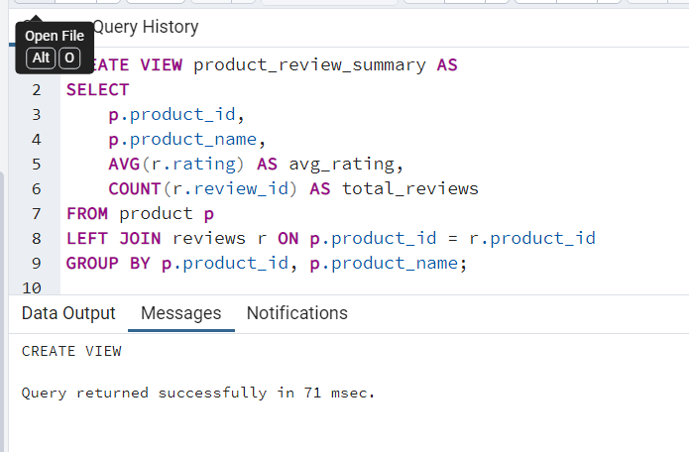

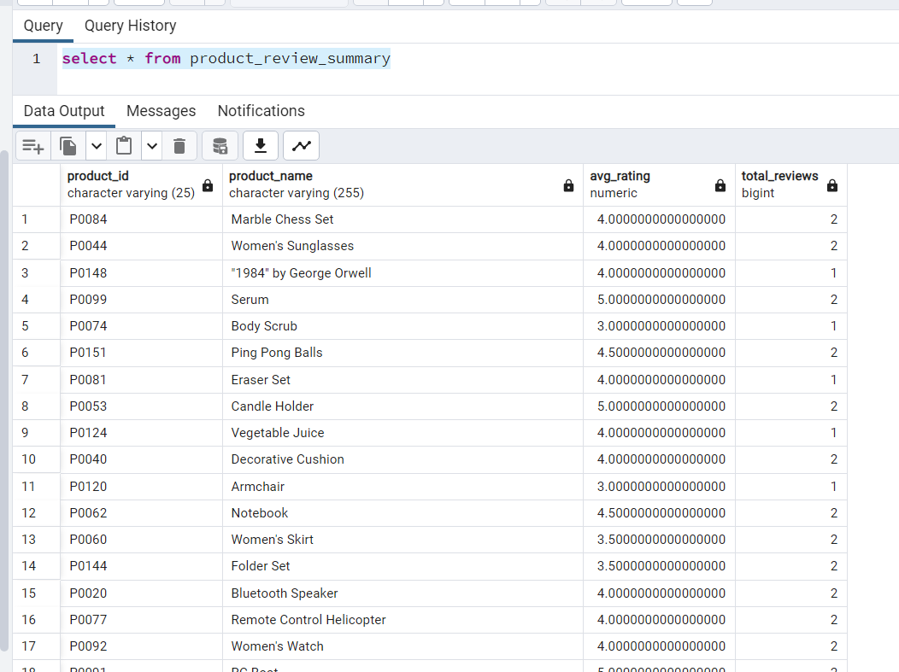

1. **INDEX**

