**1) Design Patterns and Principles**

**Exercise 1: Implementing the Singleton Pattern**

class Logger {

private static Logger onlyLogger;

private Logger() {

System.out.println("Logger created");

}

public static Logger getInstance() {

if (onlyLogger == null) {

onlyLogger = new Logger();

}

return onlyLogger;

}

public void log(String message) {

System.out.println("LOG: " + message);

}

}

public class Main {

public static void main(String[] args) {

Logger l1 = Logger.getInstance();

Logger l2 = Logger.getInstance();

l1.log("This is the first log message");

l2.log("This is the second log message");

if (l1 == l2) {

System.out.println("Only one Logger exists!");

} else {

System.out.println("Different Loggers exist!");

}

}

**OUTPUT:**

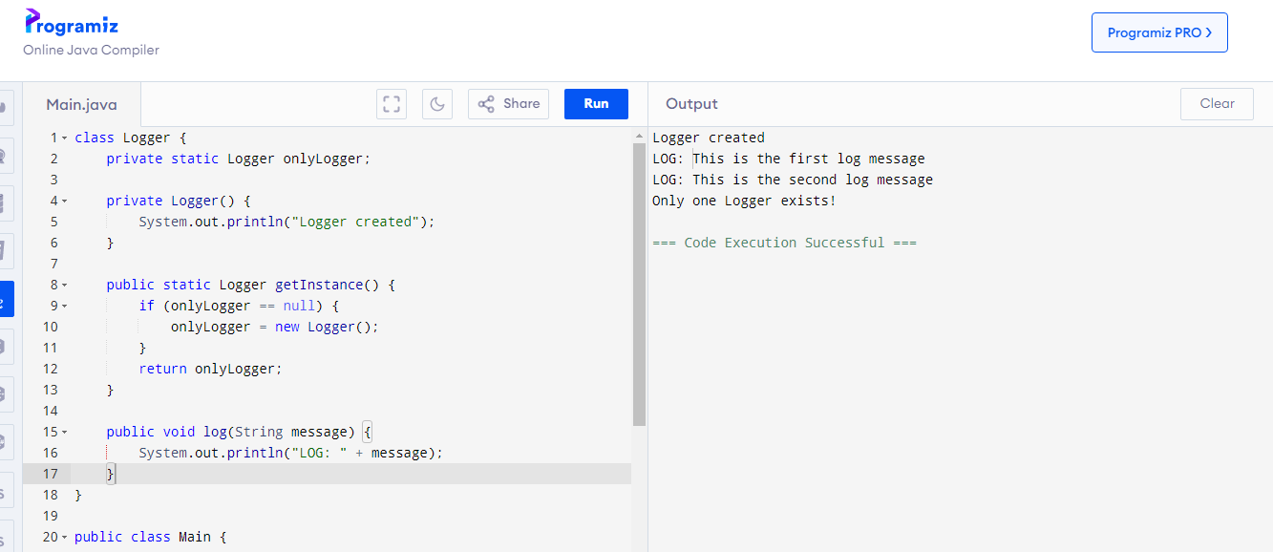

**Exercise 2: Implementing the Factory Method Pattern**

interface Document {

void open();

}

class WordDocument implements Document {

public void open() {

System.out.println("Opening Word Document");

}

}

class PdfDocument implements Document {

public void open() {

System.out.println("Opening PDF Document");

}

}

class ExcelDocument implements Document {

public void open() {

System.out.println("Opening Excel Document");

}

}

abstract class DocumentFactory {

public abstract Document createDocument();

}

class WordFactory extends DocumentFactory {

public Document createDocument() {

return new WordDocument();

}

}

class PdfFactory extends DocumentFactory {

public Document createDocument() {

return new PdfDocument();

}

}

class ExcelFactory extends DocumentFactory {

public Document createDocument() {

return new ExcelDocument();

}

}

public class Main {

public static void main(String[] args) {

DocumentFactory wordFactory = new WordFactory();

Document wordDoc = wordFactory.createDocument();

wordDoc.open();

DocumentFactory pdfFactory = new PdfFactory();

Document pdfDoc = pdfFactory.createDocument();

pdfDoc.open();

DocumentFactory excelFactory = new ExcelFactory();

Document excelDoc = excelFactory.createDocument();

excelDoc.open();

}

}

