**PLSQL_EXERCISES**

**Exercise 1: Control Structures**

* Table Creation and Data Insert

BEGIN

EXECUTE IMMEDIATE 'DROP TABLE loans';

EXECUTE IMMEDIATE 'DROP TABLE customers';

EXCEPTION

WHEN OTHERS THEN NULL;

END;

/

CREATE TABLE customers (

customer_id NUMBER PRIMARY KEY,

customer_name VARCHAR2(100),

age NUMBER,

balance NUMBER(10,2),

is_vip VARCHAR2(5) DEFAULT 'FALSE'

);

CREATE TABLE loans (

loan_id NUMBER PRIMARY KEY,

customer_id NUMBER,

loan_amount NUMBER(10,2),

interest_rate NUMBER(5,2),

due_date DATE,

FOREIGN KEY (customer_id) REFERENCES customers(customer_id)

);

INSERT INTO customers VALUES (1, 'John Smith', 65, 15000.00, 'FALSE');

INSERT INTO customers VALUES (2, 'Mary Johnson', 45, 8500.00, 'FALSE');

INSERT INTO customers VALUES (3, 'Robert Brown', 72, 25000.00, 'FALSE');

INSERT INTO customers VALUES (4, 'Sarah Davis', 55, 12000.00, 'FALSE');

INSERT INTO customers VALUES (5, 'Michael Wilson', 68, 7500.00, 'FALSE');

INSERT INTO loans VALUES (1, 1, 50000.00, 5.5, DATE '2025-07-15');

INSERT INTO loans VALUES (2, 2, 30000.00, 6.0, DATE '2025-07-20');

INSERT INTO loans VALUES (3, 3, 75000.00, 5.0, DATE '2025-08-10');

INSERT INTO loans VALUES (4, 4, 40000.00, 5.8, DATE '2025-07-25');

INSERT INTO loans VALUES (5, 5, 20000.00, 6.2, DATE '2025-07-05');

COMMIT;

* **PL/SQL Code for All Scenarios**

Scenario 1: Interest Discount

BEGIN

DBMS_OUTPUT.PUT_LINE('=== Interest Rate Discount for Customers Above 60 ===');

FOR rec IN (

SELECT c.customer_id, c.customer_name, c.age, l.loan_id, l.interest_rate

FROM customers c

JOIN loans l ON c.customer_id = l.customer_id

WHERE c.age > 60

) LOOP

UPDATE loans

SET interest_rate = interest_rate - 1

WHERE loan_id = rec.loan_id;

DBMS_OUTPUT.PUT_LINE('Customer: ' || rec.customer_name ||

', Loan ID: ' || rec.loan_id ||

', New Rate: ' || (rec.interest_rate - 1));

END LOOP;

COMMIT;

END;

/

Scenario 2: Promote VIP

BEGIN

DBMS_OUTPUT.PUT_LINE(CHR(10) || '=== Promoting Customers to VIP (Balance > $10,000) ===');

FOR rec IN (SELECT customer_id, customer_name, balance FROM customers WHERE balance > 10000) LOOP

UPDATE customers SET is_vip = 'TRUE' WHERE customer_id = rec.customer_id;

DBMS_OUTPUT.PUT_LINE('Customer: ' || rec.customer_name ||

' promoted to VIP (Balance: $' || TO_CHAR(rec.balance, '999,999.00') || ')');

END LOOP;

COMMIT;

END;

/

Scenario 3: Payment Reminders

BEGIN

DBMS_OUTPUT.PUT_LINE(CHR(10) || '=== Loan Payment Reminders (Due within 30 days) ===');

DBMS_OUTPUT.PUT_LINE('Current Date: ' || TO_CHAR(SYSDATE, 'DD-MON-YYYY'));

FOR rec IN (

SELECT l.loan_id, c.customer_name, l.loan_amount, l.due_date,

(l.due_date - SYSDATE) AS days_until_due

FROM loans l JOIN customers c ON l.customer_id = c.customer_id

WHERE l.due_date BETWEEN SYSDATE AND SYSDATE + 30

ORDER BY l.due_date

) LOOP

DBMS_OUTPUT.PUT_LINE(CHR(10) || 'REMINDER: Dear ' || rec.customer_name || ',');

DBMS_OUTPUT.PUT_LINE('Your loan of $' || TO_CHAR(rec.loan_amount, '999,999.00') ||

' is due on ' || TO_CHAR(rec.due_date, 'DD-MON-YYYY') ||

' (' || ROUND(rec.days_until_due) || ' days remaining)');

IF ROUND(rec.days_until_due) <= 7 THEN

DBMS_OUTPUT.PUT_LINE('*** URGENT - Due within a week! ***');

END IF;

END LOOP;

END;

/

**OUTPUT:**

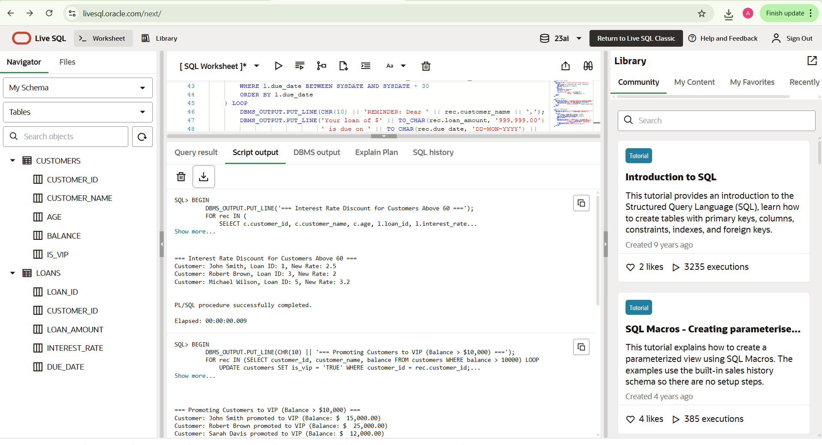

**Exercise 3: Stored Procedures**

* Table Creation and Data Insert

CREATE TABLE accounts (

account_id NUMBER PRIMARY KEY,

customer_name VARCHAR2(100),

account_type VARCHAR2(20),

balance NUMBER(10,2)

);

CREATE TABLE employees (

emp_id NUMBER PRIMARY KEY,

emp_name VARCHAR2(100),

department VARCHAR2(50),

salary NUMBER(10,2)

);

INSERT INTO accounts VALUES (1, 'John Smith', 'Savings', 10000);

INSERT INTO accounts VALUES (2, 'Mary Johnson', 'Savings', 12000);

INSERT INTO accounts VALUES (3, 'Robert Brown', 'Current', 8000);

INSERT INTO accounts VALUES (4, 'Sarah Davis', 'Savings', 15000);

INSERT INTO employees VALUES (101, 'Alice', 'Sales', 50000);

INSERT INTO employees VALUES (102, 'Bob', 'Sales', 55000);

INSERT INTO employees VALUES (103, 'Charlie', 'HR', 48000);

COMMIT;

* **PL/SQL Code for All Scenarios**

CREATE OR REPLACE PROCEDURE ProcessMonthlyInterest AS

BEGIN

DBMS_OUTPUT.PUT_LINE('=== Monthly Interest Process ===');

FOR acc IN (SELECT account_id, balance FROM accounts WHERE account_type = 'Savings') LOOP

UPDATE accounts

SET balance = balance + (balance * 0.01)

WHERE account_id = acc.account_id;

DBMS_OUTPUT.PUT_LINE('Interest added to Account ID: ' || acc.account_id);

END LOOP;

COMMIT;

END;

/

CREATE OR REPLACE PROCEDURE UpdateEmployeeBonus (

dept_name IN VARCHAR2,

bonus_percent IN NUMBER

) AS

BEGIN

DBMS_OUTPUT.PUT_LINE('=== Employee Bonus Update ===');

FOR emp IN (SELECT emp_id FROM employees WHERE department = dept_name) LOOP

UPDATE employees

SET salary = salary + (salary * bonus_percent / 100)

WHERE emp_id = emp.emp_id;

DBMS_OUTPUT.PUT_LINE('Bonus applied to Employee ID: ' || emp.emp_id);

END LOOP;

COMMIT;

END;

/

CREATE OR REPLACE PROCEDURE TransferFunds (

from_acc_id IN NUMBER,

to_acc_id IN NUMBER,

amount IN NUMBER

) AS

from_balance NUMBER;

BEGIN

SELECT balance INTO from_balance FROM accounts WHERE account_id = from_acc_id;

IF from_balance < amount THEN

RAISE_APPLICATION_ERROR(-20001, 'Insufficient balance in source account');

ELSE

UPDATE accounts SET balance = balance - amount WHERE account_id = from_acc_id;

UPDATE accounts SET balance = balance + amount WHERE account_id = to_acc_id;

DBMS_OUTPUT.PUT_LINE('Transferred ₹' || amount || ' from A/c ' || from_acc_id || ' to A/c ' || to_acc_id);

END IF;

COMMIT;

END;

/

BEGIN

DBMS_OUTPUT.PUT_LINE('=== RUNNING ALL 3 SCENARIOS ===');

ProcessMonthlyInterest;

UpdateEmployeeBonus('Sales', 10);

TransferFunds(1, 3, 2000);

DBMS_OUTPUT.PUT_LINE('=== ALL SCENARIOS COMPLETED ===');

END;

/

**OUTPUT:**

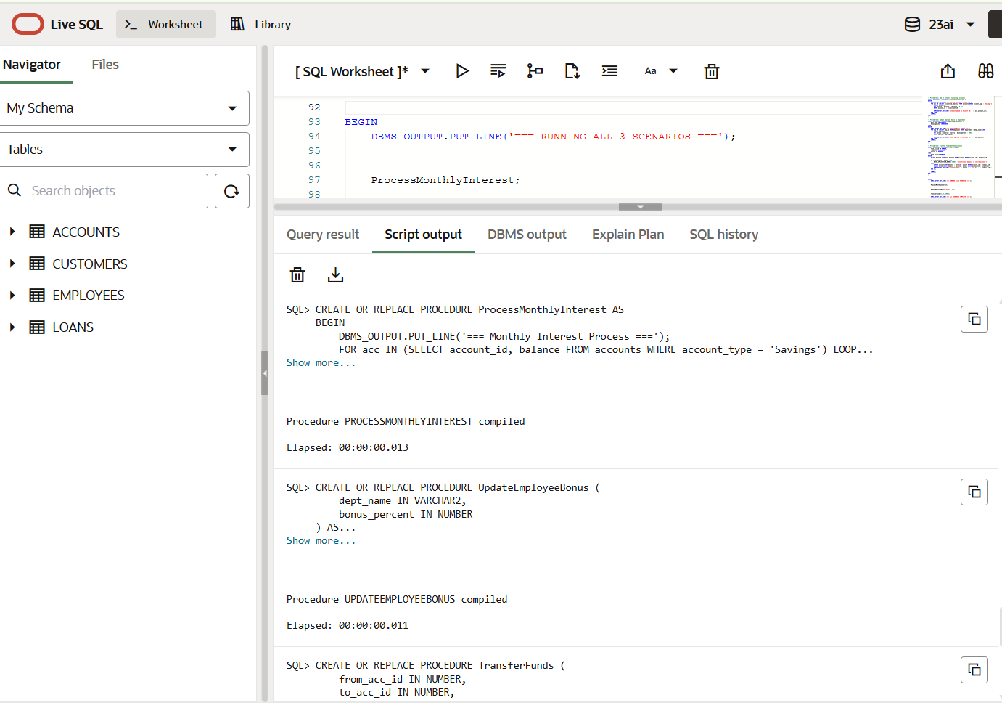

Ankita S Patil

Email: [ankitaaapatil21@gmail.com](mailto:ankitaaapatil21@gmail.com)