**1. Spring-rest-hands-on**

**Create a Spring Web Project using Maven**

**Folder Structure:**

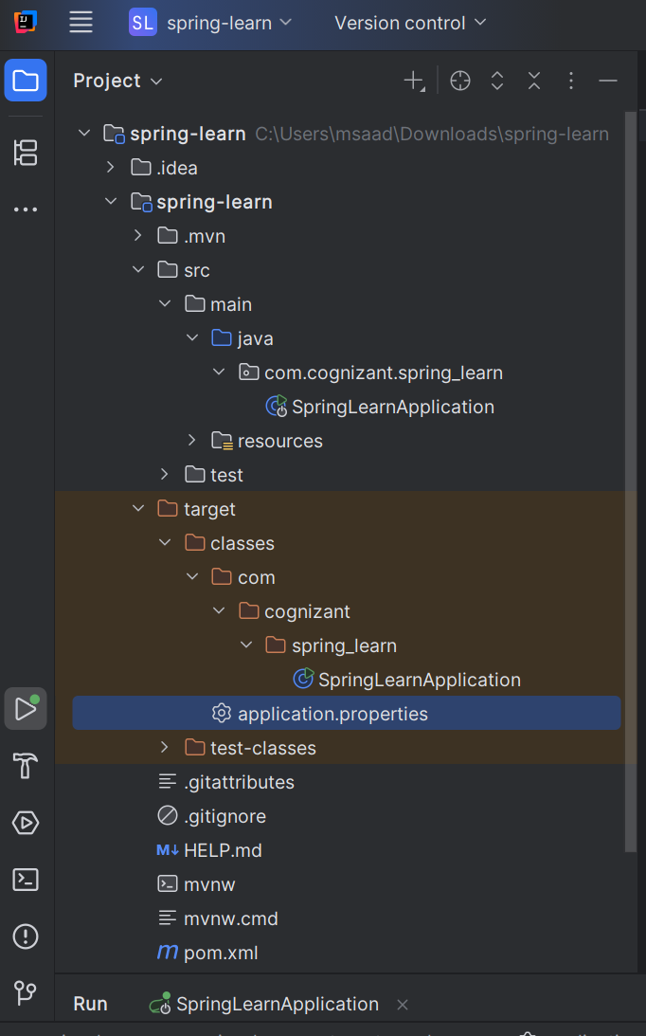

**Spring Initializr:**

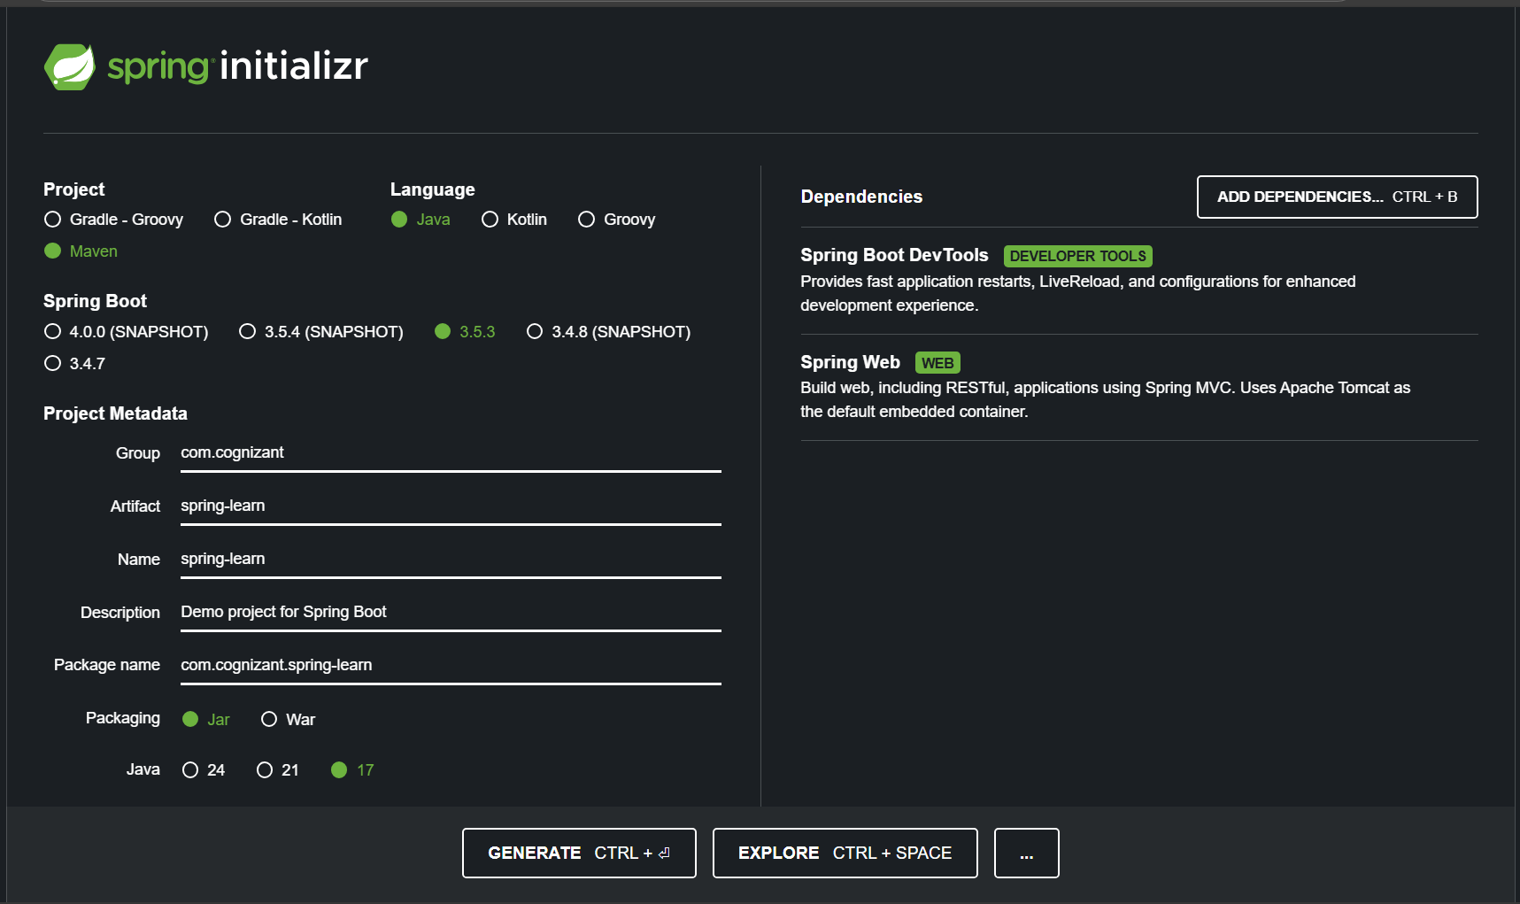

**Pom.xml:**

<?xml version="1.0" encoding="UTF-8"?>  
<project xmlns="http://maven.apache.org/POM/4.0.0" xmlns:xsi="http://www.w3.org/2001/XMLSchema-instance"  
 xsi:schemaLocation="http://maven.apache.org/POM/4.0.0 https://maven.apache.org/xsd/maven-4.0.0.xsd">  
 <modelVersion>4.0.0</modelVersion>  
 <parent>  
 <groupId>org.springframework.boot</groupId>  
 <artifactId>spring-boot-starter-parent</artifactId>  
 <version>3.5.3</version>  
 <relativePath/> <!-- lookup parent from repository -->  
 </parent>  
 <groupId>com.cognizant</groupId>  
 <artifactId>spring-learn</artifactId>  
 <version>0.0.1-SNAPSHOT</version>  
 <name>spring-learn</name>  
 <description>Demo project for Spring Boot</description>  
 <url/>  
 <licenses>  
 <license/>  
 </licenses>  
 <developers>  
 <developer/>  
 </developers>  
 <scm>  
 <connection/>  
 <developerConnection/>  
 <tag/>  
 <url/>  
 </scm>  
 <properties>  
 <java.version>17</java.version>  
 </properties>  
 <dependencies>  
 <dependency>  
 <groupId>org.springframework.boot</groupId>  
 <artifactId>spring-boot-starter-web</artifactId>  
 </dependency>  
  
 <dependency>  
 <groupId>org.springframework.boot</groupId>  
 <artifactId>spring-boot-devtools</artifactId>  
 <scope>runtime</scope>  
 <optional>true</optional>  
 </dependency>  
 <dependency>  
 <groupId>org.springframework.boot</groupId>  
 <artifactId>spring-boot-starter-test</artifactId>  
 <scope>test</scope>  
 </dependency>  
 </dependencies>  
  
 <build>  
 <plugins>  
 <plugin>  
 <groupId>org.springframework.boot</groupId>  
 <artifactId>spring-boot-maven-plugin</artifactId>  
 </plugin>  
 </plugins>  
 </build>  
  
</project>

**SpringLearnApplication.java**

package com.cognizant.spring_learn;  
  
import org.springframework.boot.SpringApplication;  
import org.springframework.boot.autoconfigure.SpringBootApplication;  
import org.slf4j.Logger;  
import org.slf4j.LoggerFactory;  
  
@SpringBootApplication  
public class SpringLearnApplication {  
  
 private static final Logger *LOGGER* = LoggerFactory.*getLogger*(SpringLearnApplication.class);  
  
 public static void main(String[] args) {  
 *LOGGER*.info("START");  
 SpringApplication.*run*(SpringLearnApplication.class, args);  
 *LOGGER*.info("END");  
 }  
}

**application.properties :**

spring.application.name=spring-learn

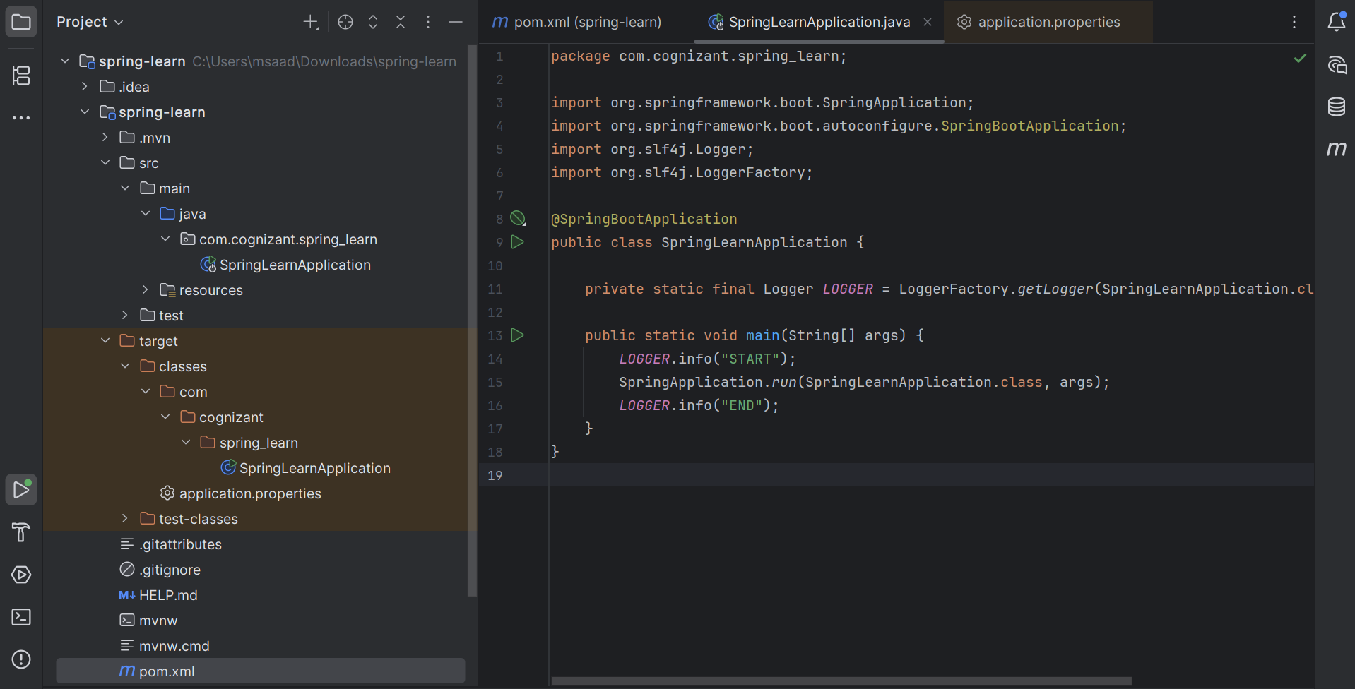

***Output:***

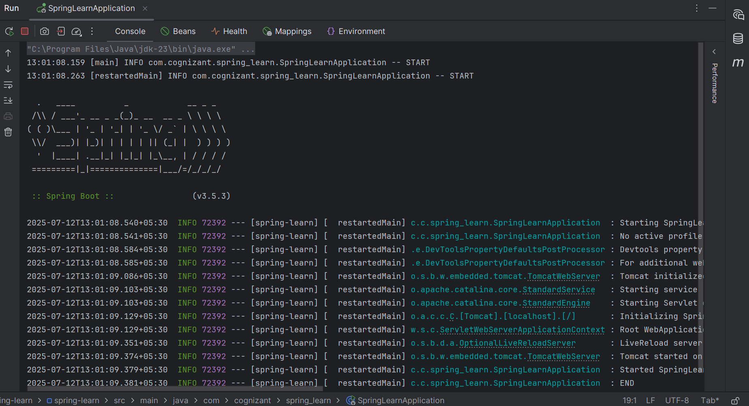

**Spring Core – Load Country from Spring Configuration XML**

An airlines website is going to support booking on four countries. There will be a drop down on the home page of this website to select the respective country. It is also important to store the two-character ISO code of each country. 

|  |  |
| --- | --- |
| **Code** | **Name** |
| US | United States |
| DE | Germany |
| IN | India |
| JP | Japan |

Above data has to be stored in spring configuration file. Write a program to read this configuration file and display the details.

**Folder Structure:**

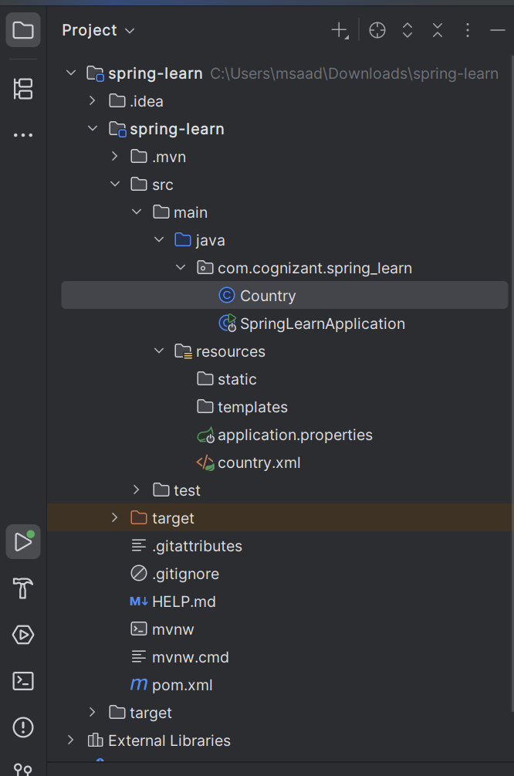

**Country.java**

package com.cognizant.spring_learn;  
  
import org.slf4j.Logger;  
import org.slf4j.LoggerFactory;  
  
public class Country {  
 private static final Logger *LOGGER* = LoggerFactory.*getLogger*(Country.class);  
  
 private String code;  
 private String name;  
  
 public Country() {  
 *LOGGER*.debug("Inside Country Constructor.");  
 }  
  
 public String getCode() {  
 *LOGGER*.debug("Inside getCode()");  
 return code;  
 }  
  
 public void setCode(String code) {  
 *LOGGER*.debug("Inside setCode()");  
 this.code = code;  
 }  
  
 public String getName() {  
 *LOGGER*.debug("Inside getName()");  
 return name;  
 }  
  
 public void setName(String name) {  
 *LOGGER*.debug("Inside setName()");  
 this.name = name;  
 }  
  
 @Override  
 public String toString() {  
 return "Country [code=" + code + ", name=" + name + "]";  
 }  
}

**country.xml (src/main/resources)**

<?xml version="1.0" encoding="UTF-8"?>  
<beans xmlns="http://www.springframework.org/schema/beans"  
 xmlns:xsi="http://www.w3.org/2001/XMLSchema-instance"  
 xsi:schemaLocation="http://www.springframework.org/schema/beans  
 https://www.springframework.org/schema/beans/spring-beans.xsd">  
  
 <bean id="country" class="com.cognizant.spring_learn.Country">  
 <property name="code" value="IN"/>  
 <property name="name" value="India"/>  
 </bean>  
  
</beans>

**application.properties (src/main/resources)**

spring.application.name=spring-learn  
logging.level.com.cognizant.spring_learn=DEBUG

**SpringLearnApplication.java**

package com.cognizant.spring_learn;  
  
import org.springframework.boot.SpringApplication;  
import org.springframework.boot.autoconfigure.SpringBootApplication;  
import org.slf4j.Logger;  
import org.slf4j.LoggerFactory;  
import org.springframework.context.ApplicationContext;  
import org.springframework.context.support.ClassPathXmlApplicationContext;  
  
@SpringBootApplication  
public class SpringLearnApplication {  
  
 private static final Logger *LOGGER* = LoggerFactory.*getLogger*(SpringLearnApplication.class);  
  
 public void displayCountry() {  
 *LOGGER*.info("START");  
 ApplicationContext context = new ClassPathXmlApplicationContext("country.xml");  
 Country country = context.getBean("country", Country.class);  
 *LOGGER*.debug("Country : {}", country.toString());  
 *LOGGER*.info("END");  
 }  
  
 public static void main(String[] args) {  
 *LOGGER*.info("START");  
 SpringApplication.*run*(SpringLearnApplication.class, args);  
  
 SpringLearnApplication app = new SpringLearnApplication();  
 app.displayCountry();  
  
 *LOGGER*.info("END");  
 }  
}

**pom.xml**

<?xml version="1.0" encoding="UTF-8"?>  
<project xmlns="http://maven.apache.org/POM/4.0.0" xmlns:xsi="http://www.w3.org/2001/XMLSchema-instance"  
 xsi:schemaLocation="http://maven.apache.org/POM/4.0.0 https://maven.apache.org/xsd/maven-4.0.0.xsd">  
 <modelVersion>4.0.0</modelVersion>  
 <parent>  
 <groupId>org.springframework.boot</groupId>  
 <artifactId>spring-boot-starter-parent</artifactId>  
 <version>3.5.3</version>  
 <relativePath/> <!-- lookup parent from repository -->  
 </parent>  
 <groupId>com.cognizant</groupId>  
 <artifactId>spring-learn</artifactId>  
 <version>0.0.1-SNAPSHOT</version>  
 <name>spring-learn</name>  
 <description>Demo project for Spring Boot</description>  
 <url/>  
 <licenses>  
 <license/>  
 </licenses>  
 <developers>  
 <developer/>  
 </developers>  
 <scm>  
 <connection/>  
 <developerConnection/>  
 <tag/>  
 <url/>  
 </scm>  
 <properties>  
 <java.version>17</java.version>  
 </properties>  
 <dependencies>  
 <dependency>  
 <groupId>org.springframework.boot</groupId>  
 <artifactId>spring-boot-starter-web</artifactId>  
 </dependency>  
  
 <dependency>  
 <groupId>org.springframework.boot</groupId>  
 <artifactId>spring-boot-devtools</artifactId>  
 <scope>runtime</scope>  
 <optional>true</optional>  
 </dependency>  
 <dependency>  
 <groupId>org.springframework.boot</groupId>  
 <artifactId>spring-boot-starter-test</artifactId>  
 <scope>test</scope>  
 </dependency>  
 </dependencies>  
  
 <build>  
 <plugins>  
 <plugin>  
 <groupId>org.springframework.boot</groupId>  
 <artifactId>spring-boot-maven-plugin</artifactId>  
 </plugin>  
 </plugins>  
 </build>  
  
</project>

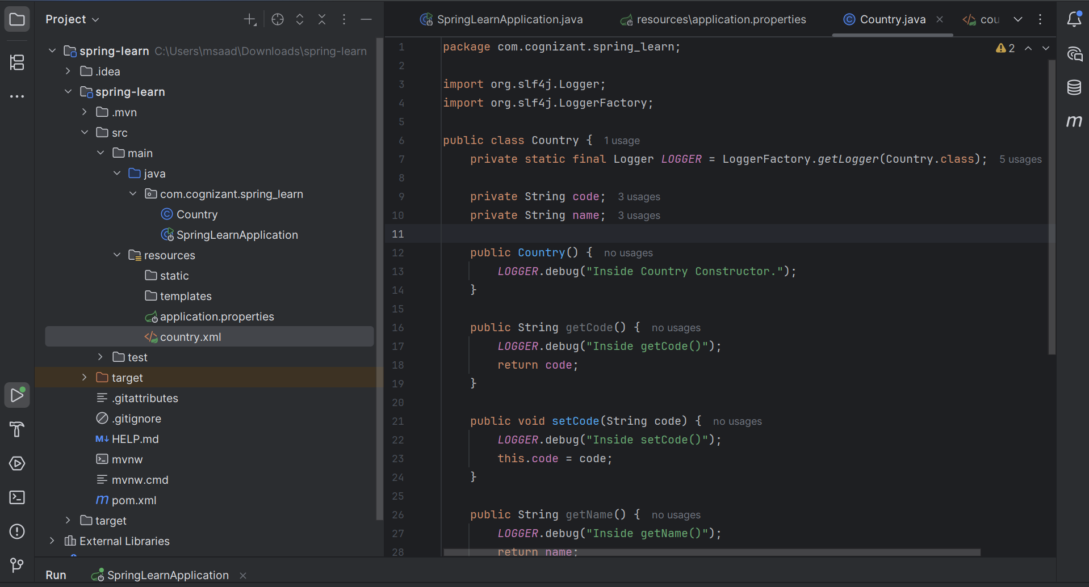

***Output:***

