This document is written to outline the details of Ankita Roychoudhury’s Spring 2020 BE 98 enrollment for 6 units with Professor Richard Murray.

**ATP Regeneration in Synthetic Cells**

The research problem we have chosen to tackle involves the metabolic processes and energy lifetime of synthetic cells. We aim to extend the lifetimes of synthetic cells derived from liposomes. Since their only source of energy is from the initial cell extract provided, the lifetimes of these artificial cells range from 4-6 hours [6, 8]. We would ideally like to increase this lifetime to 10-12 hours.

We aim to show that synthetic cells, constructed from liposomes, are capable of generating greater absolute amounts of protein when the TX/TL system is in the presence of a molecular rheostat that maintains ATP levels. We want to show that, with added molecular machinery, we can extend the lifetime and increase the rate of TX/TL activity. We also aim to identify a set of robust, efficient parameters for longer-lasting energy production.

First, we will have to implement a system into liposomes that requires energy, such as the TX/TL system. We will use the output of this system (protein production) to quantify activity and lifetime. Further, we plan on using ATP rheostat machinery developed by Opgenworth et al. to create a functioning metabolic pathway that works alongside the TX/TL system in liposomes [7]. See Figure 1 for a schematic of the TX/TL system in conjunction with the ATP regeneration pathway. It is able to selectively choose different metabolic pathways depending on the amount of phosphate present in the reaction environment. At low Pi concentrations, ATP levels are high, so the GapN pathway is preferred. The GapN pathway does not make any additional ATP. At higher Pi concentrations, ATP levels are low, so the mGAPDH-PGK pathway is preferred. This pathway allows for the regeneration of ATP [7].

Due to the nature of online and remote research, we will attempt to model and simulate a synthetic cell that contains our desired properties. We will also try to replicate various experiments that we would have liked to conduct in the wet lab. First, it will be crucial to replicate the modelling done in the Opgenworth et al. paper to make sure we have a thorough understanding and an appropriate modelling system. This will be done with both COPASI and BioSCRAPE, two software applications created for the simulation and analysis of biochemical networks and interactions. Next, after we are familiar with these modelling packages, we will try to model energy usage in liposomes and be able to characterize how long reactions can run. We will attempt to perform perturbations or add mitigating approaches related to energy usage to try to understand the possible reasons the reaction may stop running. Then, we will see if our proposed model, shown in Figure 1 below, can truly result in an extended lifetime. If we see that the lifetime is not extended, we will reevaluate and attempt other approaches for energy regeneration.

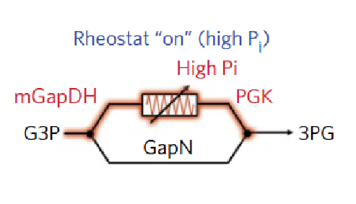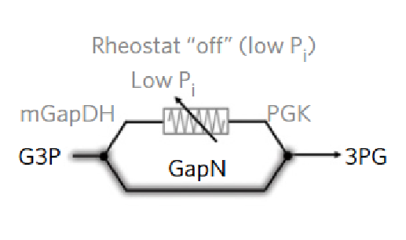

TX

-

TL

System



*Figure*

*1*

Simplified

schematic of

our proposed

liposome

design

. The TX

-

TL

system will be the metabolic process using ATP and the ATP rheostat

machinery

will be able to re

-

energize the system.

Image of the ATP rheostat

machinery a

dapted from Opgenworth et al.

[7]



ATP



A

D

P

# **References**

1. Arbor Biosciences. The myTXTL system is a comprehensive solution for protein engineering and synthetic biology applications. *myTXTL – Cell-Free Expression*, 2014.

1. Build-A-Cell website.

http://buildacell.io/

1. E. Altamura, P. Albanese, R. Marotta, F. Milano, M. Fiore, M. Trotta, P. Stano, and Fabio Mavelli. Light-driven ATP production promotes mRNA biosynthesis inside hybrid multicompartment artificial protocells. *Biorxiv*, 2020.

1. K. P. Adamala, D. A. Martin-Alarcon, K. R. Guthrie-Honea, and E. S Boyden. Engineering genetic circuit interactions within and between synthetic minimal cells. *Nature Chemistry*, 2016.

DOI 10.1038/nchem.2644.

1. M. Takahashi, J. Chappell, C. A. Hayes, Z. Z. Sun, J. Kim, V. Singhal, K. J. Spring, S, AlKhabouri, C. P. Fall, V. Noireaux, R. M. Murray, and J. B. Lucks. Rapidly Characterizing the

Fast Dynamics of RNA Genetic Circuitry with Cell-Free Transcription-Translation (TX-TL) Systems*. ACS Synthetic Biology*, 2014.

[6]Ortega. Biocircuits TX TL Life Extension Project Presentation. June 2018.

1. P. H. Opgenworth, T. P. Korman, L. Iancu, and J. U. Bowie. A molecular rheostat maintains ATP levels to drive a synthetic biochemistry system. *Nature Chemical Biology*, 2017.

1. R. M. Murray. Genetically-Programmed Artificial Cells and Multi-Cellular Machines.

*Vannevar Bush Faculty Fellow Program*, 2017.

1. R. M. Murray. SURF 2020: Genetically Programmed Synthetic Cells and Multi-Cellular Machines.

https://www.cds.caltech.edu/~murray/wiki/SURF_2020:_Synthetic_Cell

1. SEED 2019 – Build-a-Cell Conference. *Springer Nature*, 2019.

https://bioengineeringcommunity.nature.com/users/105679-ross-cloney/posts/50784-seed-2019build-a-cell