**Modeling ATP Life Extension in Synthetic Cells by an ATP Rheostat and ATP Synthase Mechanism**

Ankita Roychoudhury (SURF student), Richard M. Murray (mentor)

27 July 2020

*Keywords: synthetic biology, TX/TL system, ATP regeneration, rheostat, ATP synthase*

**Modelling Progress/Observations**

Over the last month, progress has focused on further analysis of the ATP rheostat model, the advancement of an ATP synthase model, the development of an NADPH regeneration model, and collaboration with other students to combine simulations.

For the ATP rheostat pathway, we had adapted a reconsidered modelling approach where we analyze a full model, a reduced model, and a minimal model. The full model is entirely made up of chemical reaction networks (CRNs) with mass action kinetics. There are a large amount of rate parameters in this model, all of which cannot be determined. Thus, we began to examine a reduced model. This reduced model includes assumptions, such as time scale separation (quasi-steady state assumption), conservation laws, and perhaps more general rate parameters (as opposed to specific rates for binding and unbinding). This reduced model is also more relevant to experimental data. The autoReduce software tool is designed for this functionality [15]. We also consider a minimal model, which is coarse grained and has lumped parameters. Rate constants for this model are extracted directly from experimental data. A schematic of this modeling approach is shown in Figure 1.

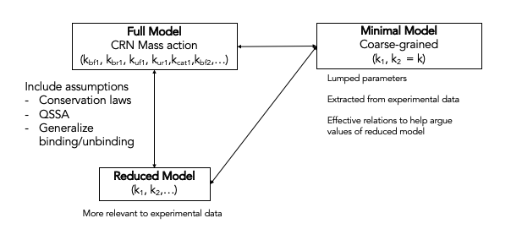

Figure 1 Schematic of the reconsidered modeling approach. By extracting data for the minimal and reduced model, we hope to be able to understand the full model in greater detail.

Before proper investigation of the reduced model, software development was required. We used autoReduce - a Python-based tool that is used for model reduction of input-controlled biological circuits [15]. This tool helps with parameter extraction and analysis that is relevant to biological experiments. To use the ATP rheostat model with autoReduce, we had to develop a method that would take a file of type Systems Biology Markup Language (SBML) from other packages (such as BioCRNPyler) and explicitly write out the ordinary differential equations (ODEs) for each species, the parameters, and the initial conditions. This is an important addition to simplify the simulation and analysis of larger and detailed models with autoReduce. This code was written, checked, and added to the autoReduce software (file available at [16]). To check that this functions works as desired, we compared the original plot from BioCRNPyler to the simulation after exporting it to SBML and using the written function. We observed that the plots were identical (Figure 2), as expected, so we were able to move forward with our analysis.

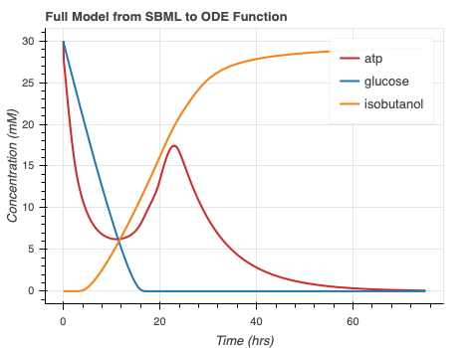

Figure 2 Checking the SBML to ODE function. The left plot is from the original simulation of the model. The right plot is after using the written function. They are incredibly similar, so we moved forward and implemented it into the autoReduce software.

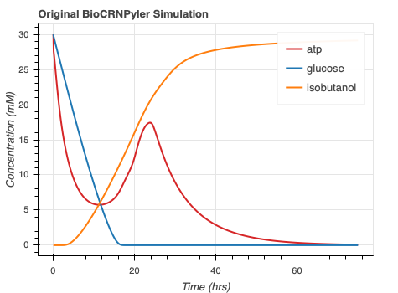

Next, we used autoReduce to investigate some proposed reduced models. Recall that the mechanism by which all enzymatic steps occur is: Fuel + Substrate + Enzyme ↔ Fuel:Substrate:Enzyme 🡪Waste:Product:Enzyme ↔ Waste + Product + Enzyme. We will refer to Fuel:Substrate:Enzyme and Waste:Product:Enzyme as *complexes*. The studied reduced models are as follows: (1) Remove all complexes, (2) Remove all Fuel:Substrate:Enzyme complex, (3) Remove only 1 complex (control), (4) Remove all species except metabolites, isobutanol, glucose, enzymes. Note: ‘Remove’ means we are studying a model without those particular species either because we believe they reach steady state quick enough to be approximated or because they have minimal effects on the transient ATP dynamics. The plots for these models are shown in Figure 3. Note that there is no plot for reduced model 4 because too many species were removed and autoReduce’s algorithm was not able to calculate a sensible reduced model. As we can see, reduced model 3 is most similar to the full model, which makes sense because only one complex, near the end, was approximated. Reduced model 1 has suppressed dynamics. This is most likely due to the fact that the complexes contributed to the timescale of steady-state approach. When these complexes are removed, the entire system reaches steady state quicker. When we only remove ½ of the complexes, most of the dynamics are similar because the Waste:Product:Enzyme complexes are still retained.

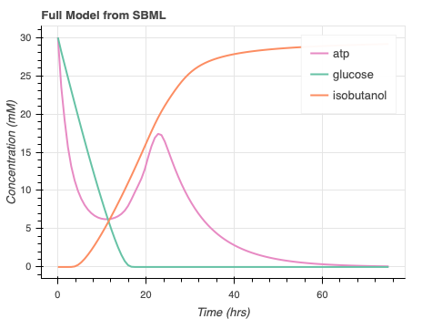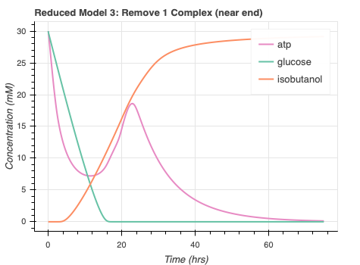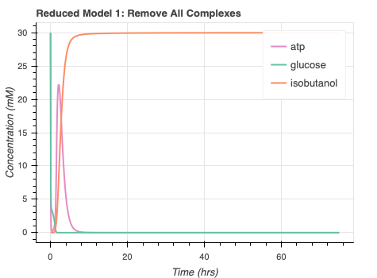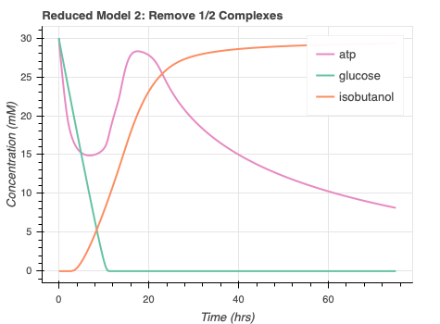

Figure 3 Outputs of reduced models.

We observed that none of the initially proposed reduced models resulted in a sufficient compromise between curves that are close to the full model while also reducing the amount of species, and corresponding parameters, required. Going forward, we analyzed reduced model 1 further. We took a look at a full model simulation of the species we chose to remove in reduced model 1, and the results are shown in Figure 4.

Figure 4 Simulation from a Full model. Only plot the species to be removed in Reduced Model 1.

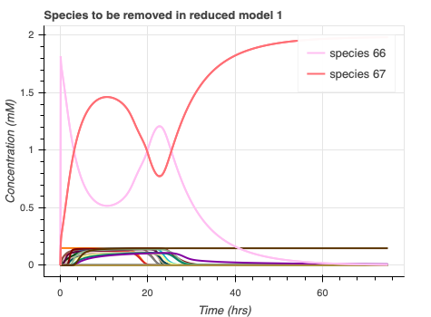

As we can see, species 66 and 67 (red and pink curves) do not reach steady state quickly and thus should not be removed from the model. These are the complexes involved in the use of ATP. Thus, we propose reduced model 5, where we remove all complexes except 66 and 67. The plot is shown in Figure 5. We see that this ATP simulation is a bit closer to the full model.

Figure 5 Output from reduced model 5. Retain species that do not reach steady state quickly.

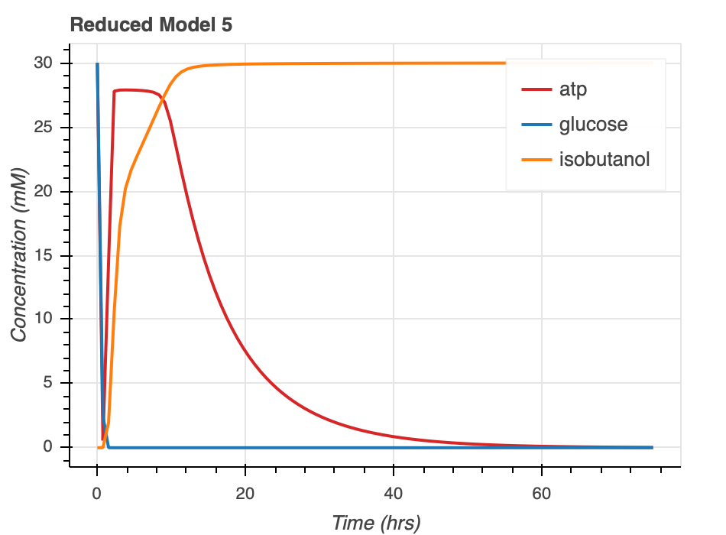

The SBML model used for these simulations can be found at [17]. The notebooks used to create the plots for Figures 3, 4, and 5 can be found at [18] and [19].

We also proceeded to analyze a minimal model using data from the original rheostat paper from Bowie Lab (UCLA) [7]. Given glucose and isobutanol experimental concentrations over time, we attempted to look at a simple set of ODEs. The proposed equations, curves, and rate parameters are shown in Figure 6. This gives us a guide on the timescale of glucose consumption and isobutanol production but this minimal model seems disconnected from the underlying dynamics since it is only considering two species. This information may help if we are able to derive a sensible reduced model with fewer species but, for now, the minimal model is limited by experimental data.

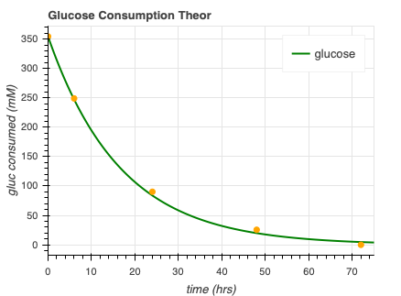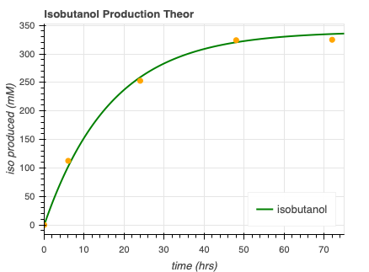

⌀

Figure 6 Minimal Model extracted from Bowie Lab experimental data [7]

To continue, using the full model of the ATP rheostat, we attempted to combine the simulation with Agrima Deedwania’s, an undergraduate in Murray Lab studying single-stranded DNA export and vesicle fusion. In her model, she wants to express protein VirE2 in the membrane. An initial issue was that our ATP regeneration was on the timescale of about 50 hours while Agrima’s process was modeled on the order of one minute. For this reason, when the models were initially combined, there was no effect on the amount or rate of bound VirE2. Once the timescale of our model was lowered, so ATP regeneration would happen quicker, we were able to see effects in Agrima’s model. The results are shown in Figure 7. We see that without the rheostat, we are able to get 30 mM of bound VirE2 and steady state is reached at around 100 seconds. With the rheostat, steady state is reached a bit later, ~125 seconds, but we are able to get almost 60 mM of bound VirE2.

Figure 7 Simulation of Agrima’s model with the rheostat.

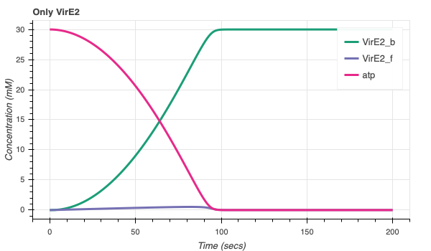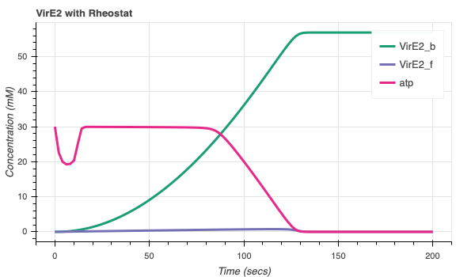

We have also worked on the creation and development of an ATP synthase model. This model is independent of the ATP rheostat model and is another mechanism by which ATP life extension can be achieved. The schematic is shown in Figure 8. If the pH outside of the liposome is less than 8, we expect there to be an influx of protons and thus ATP synthesis. We also account for the case where the pH outside the liposome is greater than 8, in which case there will be an outflux of protons and ATP hydrolysis.

ADP + Pi

ATP

H+



TX/TL

ADP + Pi

ATP

H+



TX/TL

If pH outside <= 8 v

If pH outside > 8

Figure 8 Schematic of ATP Synthase Regeneration Model

As a first attempt at simulating this, we assume that we can control when and how much H+ can be added to the surrounding environment. We also include gene expression, protein folding, and membrane integration of ATP synthase in the model. The simulation is shown in Figure 9. We can see that there is a slight delay before ATP consumption starts (around 6 hours) because that is the estimated time it takes for the ATP synthase to be expressed and functional. This parameter estimate comes from a similar setup with an MsbA protein (data provided from Zoila Jurado, Murray Lab). We have also provided a ‘No ATP Synthase Control’ graph to show what the system without ATP synthase would look like. We can see that ATP is used by ~ 20 hours. However, with ATP synthase and H+, an ATP supply can last up until ~70 hours. Slightly arbitrary parameters are used. The code for these simulations can be found at [20].

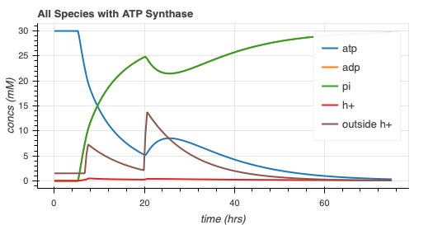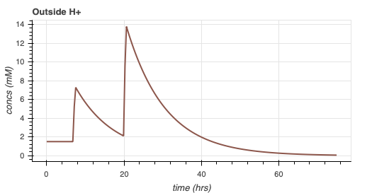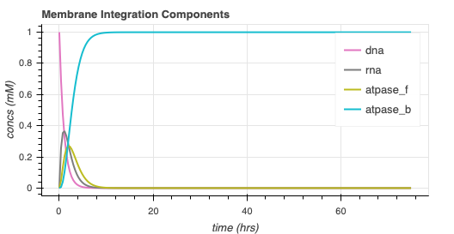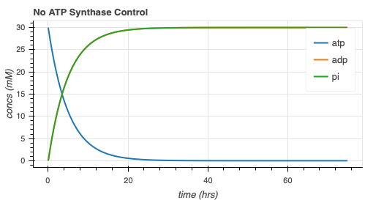

Figure 9 ATP Synthase Model Simulation with Gene Expression/Membrane Integration

Further, we have developed an NADPH regeneration model to use in conjunction with Albert Anis’ (SURF student in Murray Lab) metabolic export model. This NADPH regeneration model was adapted from another Bowie Lab paper [21]. The pathway was incorporated into BioCRNPyler with the same enzymatic mechanism as before. The simulation with and without the regeneration is shown in Figure 10. As we can see, the lifetime of NADPH goes from ~15 hours to ~25 hours.

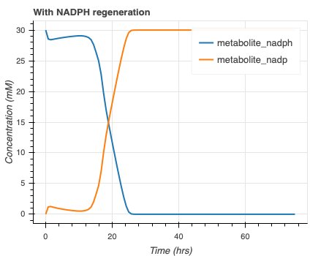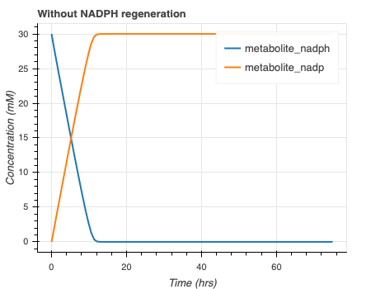

Figure 0 NADPH regeneration simulation

In Figure 11, we have shown the effect of this regeneration mechanism on Albert Anis’ metabolic export model. In his model, violacein (V) and deoxy-violacein (DV) are the products. As we can see, we are able to get more production of V and DV with the NADPH regeneration pathway. These simulations can be found at [22].

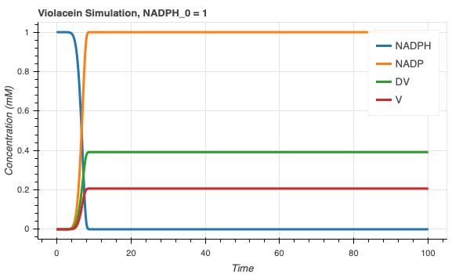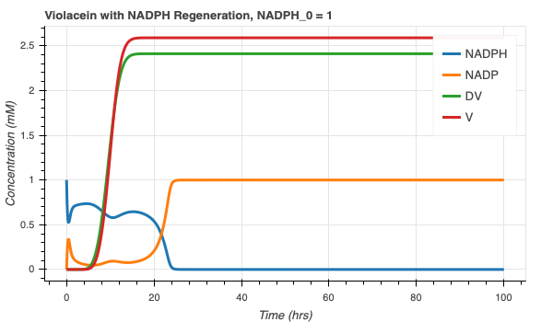

Figure 11 Albert Anis’ simulation with and without NADPH regeneration pathway

**Problems**

The first problem encountered was when investigating the reduced models for the ATP rheostat. We quickly observed that the reduced models sacrificed the transient dynamics of the ATP curve. The source of this problem came from unfamiliarity with the model. As previously discussed, we quickly noted that not all of the removed complexes reached steady state quickly. After observing specific species and understanding that we only want to remove those that reach steady state much quicker than ATP, we were able to lower the magnitude of this problem. We also ran into a problem with extracting the ODEs from a complicated SBML model. This was solved with the aforementioned SBML to ODE function.

We initially had a problem combining the ATP rheostat model with Agrima Deedwania’s model. We were able to mitigate this issue by reducing the timescale of ATP regeneration. It will be necessary to investigate the accuracy of this change.

Another problem is the experimental plausibility of the current proposed ATP synthase model. It may not make sense to pipette H+ in at particular times. After understanding the literature, we have found some other mechanisms by which a pH gradient can be generated to ensure ATP synthesis. For example, we could add efflux pumps to the liposome membrane or carry out reactions in a buffer with a lower pH than the liposome [23, 24]. We will work to solve this problem by implementing proton gradient mechanisms and studying how vesicles may react in the different environments.

**Research Goals**

For the remainder of the project, we would like to develop and come to satisfying conclusions regarding the ATP rheostat and ATP synthase models. For the reduced model of the ATP rheostat, we will work on trying to reduce the dimensionality of reduced model 5. Some techniques can include lumping common parameter combinations together, nondimensionalizing, and other more sophisticated methods (such as principal component analysis or single value decomposition). This will help us gain an intuition of what the key species are affecting the outputs. We only want to consider the phenomena we can control or are particularly interested in. A model with lower dimensionality can be important to the scientist from a design perspective. We will then perform parameter sensitivity analysis and try to assign physical meaning to parameters.

In respect to the ATP synthase model, we will focus on adding a mechanism to maintain a positive proton gradient to ensure constant ATP synthesis. It will also be important to compare the two ATP regeneration models. We should understand and design wet lab experiments that can help complete either model. It is also useful to discern which model is more experimentally robust and can ensure optimized ATP life extension for particular functions (such as protein production) in a synthetic cell.

My original goal was simply to study the rheostat mechanism. We have now added a bit of complexity by adding an alternative proposal for ATP regeneration and an NADPH regeneration model. We hope to complete an exhaustive modeling of these systems and compare them to understand the optimal way to approach metabolite regeneration in synthetic cells.

**References**

1. Arbor Biosciences. The myTXTL system is a comprehensive solution for protein engineering and synthetic biology applications. *myTXTL – Cell-Free Expression*, 2014.

1. Build-A-Cell website.

http://buildacell.io/

1. E. Altamura, P. Albanese, R. Marotta, F. Milano, M. Fiore, M. Trotta, P. Stano, and Fabio Mavelli. Light-driven ATP production promotes mRNA biosynthesis inside hybrid multicompartment artificial protocells. *Biorxiv*, 2020.

1. K. P. Adamala, D. A. Martin-Alarcon, K. R. Guthrie-Honea, and E. S Boyden. Engineering genetic circuit interactions within and between synthetic minimal cells. *Nature Chemistry*, 2016. DOI 10.1038/nchem.2644.

1. M. Takahashi, J. Chappell, C. A. Hayes, Z. Z. Sun, J. Kim, V. Singhal, K. J. Spring, S, AlKhabouri, C. P. Fall, V. Noireaux, R. M. Murray, and J. B. Lucks. Rapidly Characterizing the Fast Dynamics of RNA Genetic Circuitry with Cell-Free Transcription-Translation (TX-TL) Systems*. ACS Synthetic Biology*, 2014.

[6]Ortega. Biocircuits TX TL Life Extension Project Presentation. June 2018.

1. P. H. Opgenworth, T. P. Korman, L. Iancu, and J. U. Bowie. A molecular rheostat maintains ATP levels to drive a synthetic biochemistry system. *Nature Chemical Biology*, 2017.

1. R. M. Murray. Genetically-Programmed Artificial Cells and Multi-Cellular Machines.

*Vannevar Bush Faculty Fellow Program*, 2017.

1. R. M. Murray. SURF 2020: Genetically Programmed Synthetic Cells and Multi-Cellular Machines.

https://www.cds.caltech.edu/~murray/wiki/SURF_2020:_Synthetic_Cell

1. SEED 2019 – Build-a-Cell Conference. *Springer Nature*, 2019.

https://bioengineeringcommunity.nature.com/users/105679-ross-cloney/posts/50784-seed-2019build-a-cell

[11] Murray, Richard, *Towards Genetically-Programmed Synthetic Cells and Multi-Cellular Machines*, July 2017. <http://www.cds.caltech.edu/~murray/talks/murray_buildacell-pasadena_24Jul17.pdf>. PowerPoint Presentation.

[12] Mark Anderson, J. Stark, C. Hodgman, and M. Jewett. Energizing Eukaryotic Cell-Free Protein Synthesis With Glucose Metabolism. *FEBS Lett.* 2015 July 8. 589(15): 1723-1727. Doi:10.1016/j.febslet.2015.05.045.

[13] Ayush Pandey, W. Poole, Z. Tuza, S. Clamons, *BioCRNPyler,* <https://github.com/BuildACell/BioCRNPyler>

[14] Anand Swaminathan, R. Murray, *bioscrape*, <https://github.com/BuildACell/bioscrape>

[15] Ayush Pandey, R. Murray, *autoReduce*, <https://github.com/ayush9pandey/autoReduce>

[16] Ankita Roychoudhury, <https://github.com/AnkitaRoychoudhury/ug_murray/blob/master/autoReduce2/sbml_to_ode2.py>

[17] Ankita Roychoudhury, <https://github.com/AnkitaRoychoudhury/ug_murray/blob/master/autoReduce2/CRN.xml>

[18] Ankita Roychoudhury, <https://github.com/AnkitaRoychoudhury/ug_murray/blob/master/autoReduce2/20200721_redmod_13_whydifft.ipynb>

[19] Ankita Roychoudhury, <https://github.com/AnkitaRoychoudhury/ug_murray/blob/master/autoReduce2/20200722_redmod_14_autoreduce.ipynb>

[20] Ankita Roychoudhury, <https://github.com/AnkitaRoychoudhury/ug_murray/blob/master/code/exploratory/20200720_atpsynthase_5_params.ipynb>

[21] Paul H Opgenorth, T. Korman, J. Bowie. A synthetic biochemistry module for production of bio-based chemicals from glucose. *Nature Chemical Biology*. 2016.

[22] Ankita Roychoudhury, <https://github.com/AnkitaRoychoudhury/ug_murray/blob/master/code/exploratory/test_metabolic_export/20200723_combine_metabolicexport_nadphregen.ipynb>

[23] Alice Verchère, M. Dezi, I. Broutin, M. Picard. *In vitro* Investigation of the MexAB Efflux Pump from *Pseudomonas aeruginosa*. *JoVE Journal Biology*. Feb 17 2014.

[24] H I Zgurskaya, H. Nikaido. Bypassing the periplasm: reconstitution of the AcrAB multidrug efflux pump of Escherichia coli. *PNAS*. 1999.