**Modeling a Glucose Metabolic Pathway and an ATP Synthase Mechanism shows ATP Life Extension in Synthetic Cells**

Ankita Roychoudhury (SURF student), Richard M. Murray (mentor)

24 August 2020

*Keywords: synthetic biology, synthetic cells, ATP regeneration, rheostat, ATP synthase*

**Abstract**

In synthetic cell protein synthesis, a potential limiting factor is the energy supply for transcription and translation. By computationally studying mathematical models of various ATP regeneration mechanisms in synthetic cells, we aim to propose experimental methods for ATP life extension. We use available software tools to study two models. These allow us to develop and study mass-action models by implementing simple chemical reaction networks. Our simulations show that a glucose metabolic pathway can extend lifetime of ATP up to about 60 hours. Integrating ATP synthase can also lengthen the lifetime of ATP to various times depending on the implemented proton gradient mechanism. These simulations will help us understand if ATP is truly the limiting factor. To ensure prolonged synthetic cell protein synthesis, either the glucose pathway or ATP synthase mechanism can be used. In the future, it will be useful to perform wet-lab experiments in order to compare our model to data.

**Background**

Synthetic biology focuses on the engineering of devices, pathways, networks, and systems that utilize tools which already exist in biology. There is a growing interest in the development and application of genetically-programmed synthetic cells, cells which do not replicate or divide, for future use. These synthetic cells can be used as environments in which more complex engineered systems can be implemented and designed [9].

When building synthetic cells, there are five main subsystems to be considered. These are: spatial organization, metabolic subsystems, sensing and signaling, regulation and computation, and actuation. The problem we have chosen to tackle involves the metabolic subsystems, specifically the power supply and energy lifetime [11]. We aim to extend the lifetimes of synthetic cells derived from liposomes by implementing an ATP life extension mechanism, as depicted in Figure 1. More specifically, we aim to explore whether ATP life extension mechanisms can function in synthetic cells with TX/TL, a transcription/translation system that creates protein from linear DNA templates [3,4,5]. See Figure 2 for a representation. This mechanism can be a biochemical ATP regeneration pathway, a directed transporter, etc. An efficient, longer-lasting method to provide energy required for internal reactions will allow us to carry out more complex, sustainable experiments. We will be able to broaden the range of possible research in synthetic cells if we can measure responses, production, etc. for longer time periods.

*Escherichia Coli*

*Synthetic Cell*

Tx

Tl



Figure 2. A depiction of a synthetic cell. The transcriptional (orange) and translational (blue) machinery from *E. Coli* is extracted and placed into a liposome with the desired DNA template.

Tx

Tl

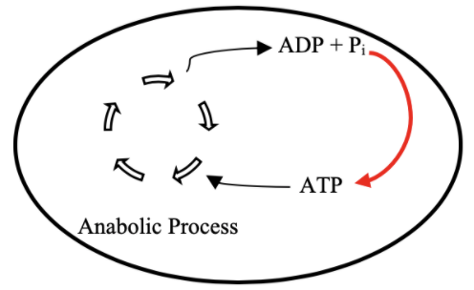

Figure 1. A diagram representing our overall goal. By implementing some mechanism (red arrow), we would like to regenerate ATP to longer support an anabolic process.

Given the success of this research, the possibilities of experiments with synthetic cells will be positively affected. We will be able to understand how to extend their lifetimes. By discerning what components are crucial for energy regeneration, we can understand how metabolism truly works in cells. We can also understand if energy is the limiting factor for many existing experiments. Longer lifetimes will allow for more synthesis of bio-compatible materials, accurate environmental monitoring and remediation, self-assembly of complex multi-cellular machines, etc. [8].

The two mechanisms studied are a glucose metabolic pathway and an ATP synthase model. The glucose metabolic pathway is also known as the rheostat, which was published by James Bowie Lab (UCLA) [7]. The rheostat is able to maintain ATP concentration for up to 70 hours in buffer. We want to explore whether the rheostat can extend ATP levels in synthetic cells with TX/TL. See Figure 3 for an image of the rheostat pathway. The pathway is able to selectively choose different pathway depending on the amount of free phosphate (Pi) present in the reaction environment. At low Pi concentrations, ATP levels are high, so the GapN pathway is preferred. The GapN pathway does not make any additional ATP. At higher Pi concentrations, ATP levels are low, so the mGapDH-Pgk pathway is preferred. This pathway allows for the selective regeneration of ATP [7].

The second proposed model involves ATP synthase, a membrane protein that makes ATP from ADP and Pi when there is an influx of hydrogen ions (H+). This model is independent of the ATP rheostat model and is another mechanism by which we propose ATP life extension can be achieved. A diagram is shown in Figure 4. A proton pump is included in this model to maintain a proton gradient that is necessary for ATP synthesis.

Figure 4. ATP Synthase (purple) model schematic. We include a proton pump (green) to maintain the proton gradient necessary for ATP synthesis.

Figure 3. Entire Rheostat Pathway as shown in the Opgenorth et al. paper [7]

Additionally, there is an existing challenge to easily combine models in synthetic biology. Because ATP regeneration mechanisms will be studied *in silico*, this gives us an opportunity to link these models with others (such as DNA export or temperature sensitivity). This will allow us to better understand the effects ATP regeneration may have on these processes as well as studying methods by which model combination can be achieved easily.

In summary, we have been able to successfully simulate two mechanisms for ATP regeneration. We have noted specific parameter sets that allow for ATP life extension. We have also easily been able to combine our models with others and have noted parameter sets that cause positive effects.

**Results**

*ATP Rheostat*

In regards to the rheostat model, we were able to show that ATP life extension can be achieved. See Figure 5 for the simulations results and chosen parameters. After implementing our desired enzymatic mechanism (Fig 6) in BioCRNpyler, we were able to investigate outputs based on parameters for enzymatic binding, unbinding, etc. The enzymatic mechanism was chosen from three options, all outlined in Figure 6.

5c

5a

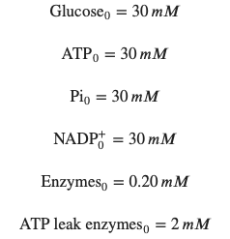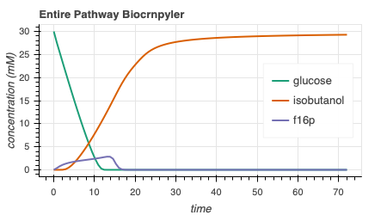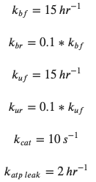

5b

**Figure 5**. Simulations of the ATP rheostat pathway. We see stoichiometric production of isobutanol (5a) and extended ATP production with the rheostat (5b). Parameters that result in these plots are written in 5c.

Figure 6. Three proposed enzymatic models. The implemented mechanism is outlined in blue.

*ATP Synthase*

The ATP synthase model is made up of various components, all of which are outlined in Figure 7. As we can see, there is transcription, translation, and membrane integration of ATP synthase and a proton pump. ATP synthesis through the ATP synthase and proton gradient maintenance via the proton pump is also included. Note that some ATP is needed to power the proton pump. Finally, ATP use is modelled to represent the energy used by transcription and translation in a synthetic cell.

ATP Synthase Transcription & Translation

ATP Synthase Membrane Integration

ATP Synthesis through ATP Synthase

Proton Pump Transcription & Translation

Proton Pump Membrane Integration

Proton movement through Proton Pump

ATP Use

ATP Synthesis

Maintain Proton Gradient

ATP Hydrolysis

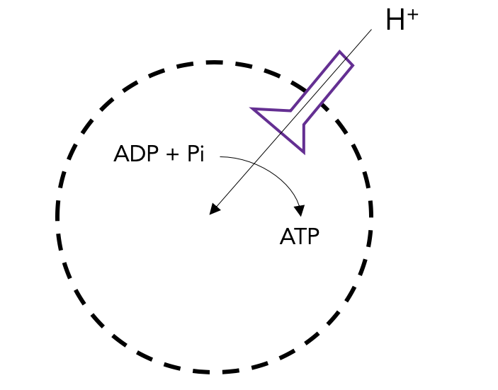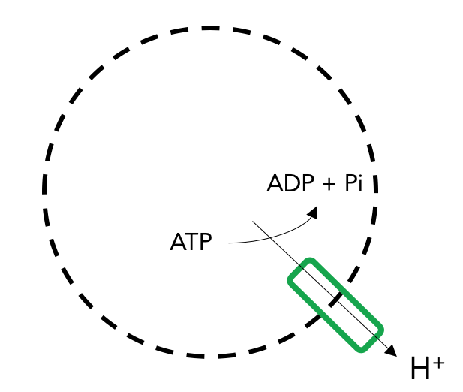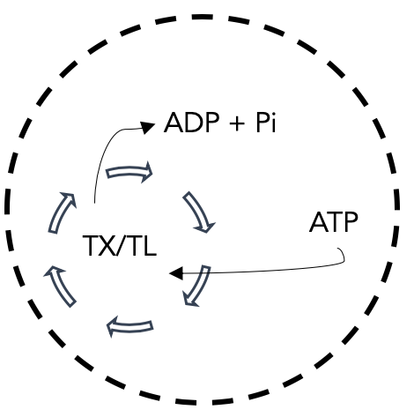

Figure 7. ATP Synthase Model Design. We include the modelling of transcription, translation, and membrane integration of both membrane proteins. We also include ATP hydrolysis to represent all ATP used by TX/TL.

When integrated together, all the parts of the ATP synthase model come together to output expected plots. When the appropriate parameters are used, we can see that there is a consistently higher proton concentration outside the liposome than inside, as desired. The simulations is shown in Figure 8. We see that it takes about 5 hours for protein membrane integration, which is seen experimentally with MsbA, another membrane protein (data collected by Zoila Jurado from Murray Lab).

**Figure 8**. ATP Synthase Simulation Output. We can see that ATP is regenerated and maintained. There is also more H+ outside than inside, maintaining the desired proton gradient. Finally, bound ATP synthase reaches steady state at 5 hours, as experimentally observed.

It is also important to show that the proton pump is necessary. When we remove the proton pump, we see that there is practically no effect on the ATP curves (Figure 9a). However, when the proton pump is implemented, we can see gradual ATP regeneration as more proton pumps bind to the membrane and preserve the proton gradient (Figure 9b).

**Discussion**

**Methods**

**References**

**Figure 9**. Proton pump is necessary to cause ATP synthesis. As the proton gradient is restored, ATP is gradually regenerated.

*Model Integration*

After getting these simulations to work, we focused our efforts on combining models.