**ATP Life Extension in Synthetic Cells**

Ankita Roychoudhury (SURF Student), Richard M. Murray (mentor)

2 June 2020

*Keywords: synthetic biology, TX/TL system, ATP regeneration, rheostat*

**Background/Motivation** (Write in some detail the motivation for your project. It should include background and an overview of the ongoing work in the research group. You should include references.)

Synthetic biology focuses on the engineering of devices, pathways, networks, and systems that utilize tools already seen in biology. There is a new movement to figure out how to create and use genetically-programmed synthetic cells for future use. These cell-free systems can be used as environments in which more complex engineered systems can be carried out and designed [9].

When building synthetic cells, there are five main subsystems that must be considered. These are: spatial organization, metabolic subsystems, sensing and signaling, regulation and computation, and actuation. The problem we have chosen to tackle involves the metabolic subsystems, specifically the power supply and energy lifetime [11]. We aim to extend the lifetimes of synthetic cells derived from liposomes. An efficient, longer-lasting method to provide energy required for internal reactions will allow us to carry out more complex, sustainable experiments. We will be able to significantly broaden the breadth of possible experiments if we can measure responses, production, etc. for longer time periods.

Given the success of this research, the possibilities of experiments with synthetic cells will be significantly affected. We will be able to understand how to extend their lifetimes. By discerning what components are crucial for energy regeneration, we can understand how metabolism truly works in cells. Longer lifetimes will allow for more synthesis of bio-compatible materials, more accurate environmental monitoring and remediation, more self-assembly of complex multi-cellular machines, etc. [8].

This project has been pursued in the Richard Murray Lab. In Murray Lab, there is a special focus on the application of feedback and control in biology. Members of Murray Lab work on improving the performance, robustness, and modularity of engineered biological circuits. Specifically, we will be involved with the group that focuses on the use of synthetic cells to study and engineer improved circuits [8, 9]. Ongoing wet lab research involving synthetic cells includes the expression of the MsbA transporter and Superfolder Green Fluorescent Protein (sfGFP), a search of different extracts from various extremophiles that may be used within synthetic cells, as well as the use of ATP synthase as a motor for synthetic cell actuation. There is also ongoing dry lab research related to modeling and simulations of synthetic biology. Various software packages, such as BioCRNPyler, bioscrape, and autoReduce are being actively developed by members of Murray Lab BioCRNPyler and bioscrape are packages that allow for simulations of chemical reaction networks [13, 14]. This software has been integral for our research. autoReduce is a Python-based tool that is used for model reduction of input-controlled biological circuits [15]. This tool will help with parameter extraction that is relevant to biological experiments with the assumptions made (such as time-scale separation with the quasi-steady state assumption). There are also other projects ongoing in Murray Lab indirectly related to synthetic cells, such as dosage control and the 3D segmentation of encapsulated cells.

**Problem** (Discuss the problem you are working on and explain how it fits into the ongoing work.)

In this project, we aim to show that synthetic cells, constructed from liposomes, are capable of generating greater absolute amounts of protein when the TX/TL system is in the presence of a pathway or system that is able to maintain ATP levels, as shown in Figure 1. TX/TL is a transcription/translation system that creates protein from linear DNA templates [1, 6, 7]. Since the only source of energy for synthetic cells is from the initial cell extract provided, the peak lifetimes of these artificial cells range from 4-6 hours [6, 8]. We would ideally like to increase this lifetime to at least 10-12 hours. This problem arises from current experimental setups seen in the literature. One of the issues to consider during the construction of these synthetic cells is metabolism [8]. We notice, from reading papers, that lifetimes of synthetic cells are limited [4, 7].

Our initial proposed mechanism for ATP lifetime extension is the rheostat machinery published from James Bowie Lab (UCLA) [7]. The rheostat is able to maintain ATP concentrations for up to 70 hours in buffer. We want to explore whether or not the rheostat can extend ATP levels in synthetic cells with TX/TL. See Figure 2 for a schematic of the TX/TL system in conjunction the rheostat pathway. It is able to selectively choose different metabolic pathways depending on the amount of free phosphate present in the reaction environment. At low Pi concentrations, ATP levels are high, so the GapN pathway is preferred. The GapN pathway does not make any additional ATP. At higher Pi concentrations, ATP levels are low, so the mGapDH-Pgk pathway is preferred. This pathway allows for the regeneration of ATP [7].

Our research fits into the ongoing work done in regard to metabolic pathways in synthetic cells. There are current efforts related to re-energizing cell-free systems as well as work on preservation of native metabolic pathways in cell-free extract [11]. There is research that has shown the use of glycolytic pathways for ATP regeneration in yeast extract [12] as well as cell-free buffer experiments [7]. Add more research topics/papers here. ?

**Progress**

Thus far, we have successfully been able to model and simulate the rheostat pathway *in silico*. Our initial modeling approach was as follows: (1) Model a simplified version of the pathway in bioscrape. Use this technique to choose an enzymatic mechanism. (2) Model the simplified pathway in BioCRNPyler by developing a new mechanism and components (objects that BioCRNPyler uses for its simulations). (3) Model the entire pathway in BioCRNPyler. The reason we choose to do it this way is multifaceted: to be able to theorize and choose an enzymatic mechanism by which we think the pathway proceeds and to simplify the coding process. By developing a new mechanism in BioCRNPyler, we were able to reduce potential repetitive code and prevent mistakes. We will now describe the steps and outputs for each step.

The entire rheostat pathway is shown in Figure 3a [7]. Figure 3b is a chemical reaction network of the simplified pathway that we decided to begin with. Note that the simplified pathway has an ATP leak reaction (ATP 🡪 ADP + Pi). This leak reaction represents ATP hydrolysis by ATPase contamination as well as ATP that is used by some anabolic process (such as transcription and translation) as a source of energy. At this point, it is important to identify an enzymatic mechanism that each step of the pathway follows. We proposed three models, shown in Figure 4. They outline different orders in which substrates, fuels (or metabolites such as ATP, ADP, NADPH), and enzymes can bind and transform to produce wastes and products. At this stage in the modeling, it was important to pick parameters for initial conditions and rate constants. We took an order-of-magnitude approach and chose parameter values that were fairly biologically relevant but perhaps not exact. We then simulated all three enzymatic mechanisms using bioscrape with the same parameters and the outputs are shown in Figure 5a. We perform two simulations; one with the simplified rheostat equations and the ATP leak step and another with only the ATP leak step. Since the ATP leak step represents ATP used by some anabolic process, like TX/TL, we would expect the curves for ATP that arise from the rheostat and ATP leak simulations to last longer. As a rule of thumb, we make sure that the parameters for the ATP leak step are set such that the ATP is completely consumed by 20 hours, which is experimentally seen. In Figure 5a, we see that glucose is consumed and isobutanol is produced, as expected. For the first model, we see that the ATP curve (rheostat & ATP leak) lasts until about 40 hours, while the ATP only curve lasts only for 20 hours. Through this model, we were able to see double the lifetime of ATP! For this reason, we choose to move forward with our modeling steps, using the first model (the 1 step model) as chosen main enzymatic mechanism.

Now, we worked to implement the simplified rheostat pathway in BioCRNPyler. It is “A modular compiler for biological chemical reaction networks” [13]. It is largely an object oriented framework made for modeling in synthetic and systems biology and can generate chemical reaction networks (CRNs) from simple descriptions. There are three main parts of the modeling framework: (1) Mixtures, which is the context or environment the CRN is simulated in (like *e. coli* extract, (2) Components, which are the parts or species of the CRN (like DNA, specific enzymes, etc), and (3) Mechanisms, which are reaction schema (such as binding and unbinding steps an enzyme might perform with its substrates). For our purpose, we designed a new BioCRNPyler mechanism and component. The mechanism (called MichalisMentenReversible) takes in a list of substrates, products, and an enzyme. It consists of a binding, catalysis, and unbinding reaction, like enzymatic model 1 in Figure 4. The component (called MultiEnzyme) uses the aforementioned mechanism and takes in the desired rate parameters. After modeling the simplified rheostat pathway in BioCRNPyler, we performed a sanity check and saw that the plots from the bioscrape and BioCRNPyler simulation with the same parameters and reactions were identical. Now, we were able to move onto modeling the entire rheostat pathway.

After modeling the entire rheostat pathway with ATP leak in BioCRNPyler, we found that adjusting some of the parameters, while remaining within the appropriate order of magnitude, could lead to more optimal dynamics. For example, in Figure 6, the initial concentration of enzymes, rate of ATP leak, and initial concentration were slightly adjusted. This caused almost double the amount of ATP regeneration. By playing with parameters, we were also able to see that the ATP regeneration ‘hump’ seen in the simulations arise from more flux through the mGapDH and Pgk enzymes in the rheostat pathway due to increased free phosphate concentration.

Thus far, we have been able to simulate the rheostat pathway and visualize the parameter set where we see desired results! Continuing on, it will be important to choose accurate biological parameters.

**Challenges/Problems**

Until now, one of the main challenges has been finding accurate biological parameters for reaction rates. For the sake of simplicity, we began by choosing slightly arbitrary values that were on the correct order of magnitude. Going forward, it is important to reconsider a modelling approach that may reveal more biologically relevant parameters. For this reason, we have come up with an adapted approach (schematic in Figure 7). Up until now, we have been working with a full model that is entirely made up of CRNs with mass action kinetics. There are a large amount of rate parameters in this model, all of which cannot be determined. Thus, we will begin to look at a reduced model. This reduced model will include assumptions, such as time scale separation (quasi-steady state assumption), conservation laws, and perhaps more general rate parameters (as opposed to specific rates for binding and unbinding). This reduced model may be more relevant to experimental data. The tool autoReduce is designed for this functionality [15]. We will also consider a minimal model, which is more course grained and has lumped parameters. Rate constants for this model can be extracted directly from experimental data. A schematic of this modeling approach is shown in Figure 7.

Some other challenges we anticipate moving forward involve adding desired functionality to software. Since many of the aforementioned software packages are still being actively developed, our progress may be limited by their current. For example, we are currently trying to develop autoReduce such that Systems Biology Markup Language (SBML) models from other packages (like BioCRNPyler) can be read and simulated easily. SBML is a tool commonly used for communicating and storing computational models in biology. This will be an important addition that will help simplify the simulation of larger and detailed models (like the rheostat pathway).

To continue, estimating enzyme kinetics without experimental data will most likely be an increasingly prevalent challenge as we move forward with the modeling. Being able to distinguish between crude and purified enzyme kinetics will be difficult but important.

# Figures

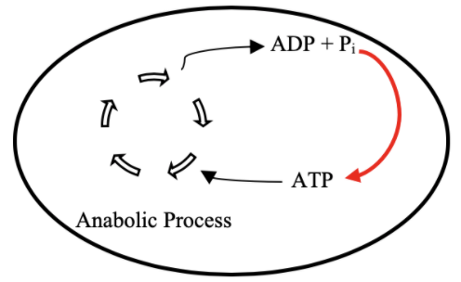

TX/TL

Figure 1 Schematic of ATP Regeneration. Ideally, we would like to develop and implement a pathway that will regenerate ATP from ADP and Pi (red line). This will allow for anabolic processes (such as transcription and translation – TX/TL) within synthetic cells to last longer.

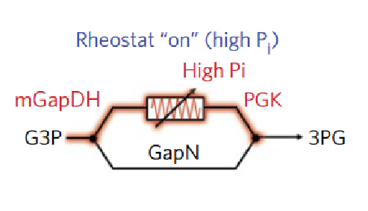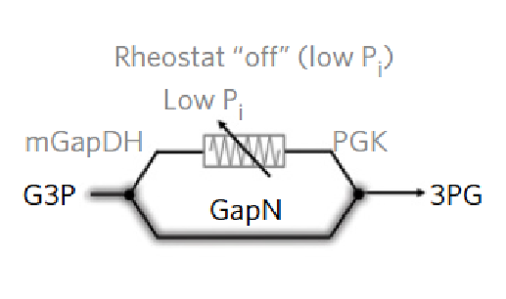

TX

/

TL

System



ATP



A

D

P

Figure 2 Simplified schematic of our proposed liposome design. The TX/TL system will be the metabolic process using ATP and the ATP rheostat machinery will be able to re-energize the system. Image of the ATP rheostat machinery adapted from Opgenorth et al. [7]

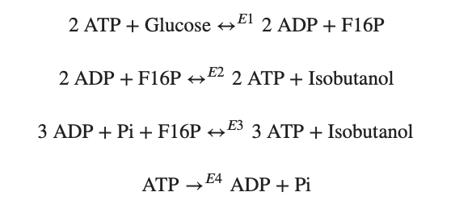

Figure 3 Rheostat Entire and Simplified Pathway. 3A - The entire rheostat pathway as shown in the Opgenorth et al. paper [7]. 3B - The simplified version of the rheostat pathway used for the beginning steps of modeling. An ATP leak reaction is incorporated.

**3A**

**3B**

enzymes


Figure 4 Three proposed enzymatic models.

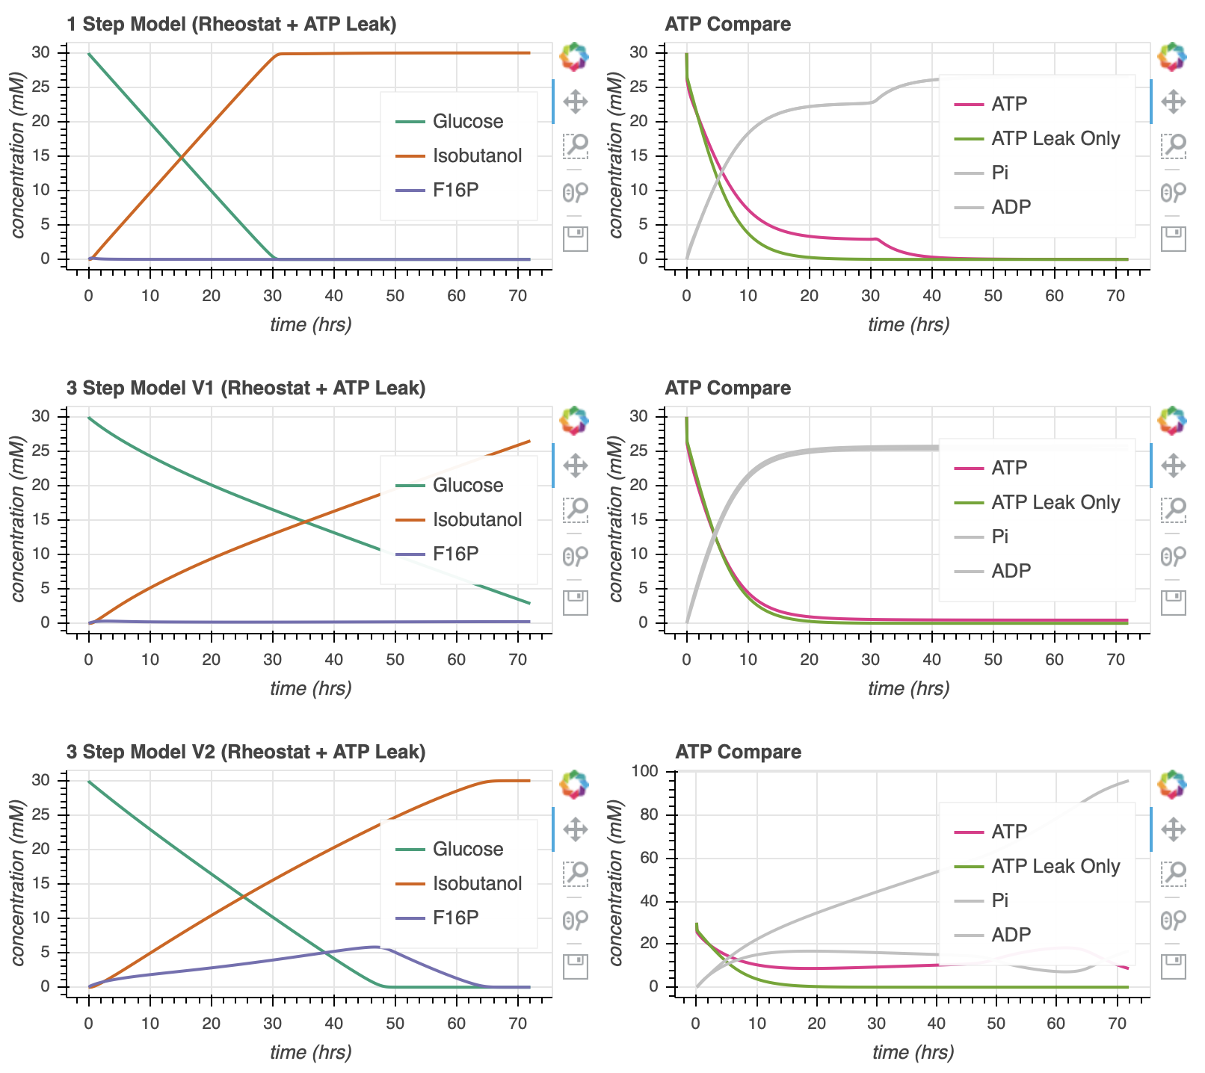

Figure 5 The simplified rheostat pathway with three different enzymatic mechanisms. The left column shows the production of glucose, consumption of isobutanol, and activity of F16P (an intermediate). The right columns, indicates the ATP comparison. The pink ‘ATP’ curves comes from the simulations with both the simplified rheostat pathway and ATP leak. The green ‘ATP Leak Only’ curves come only from the simulation with ATP leak. We see that the ‘ATP’ curve lasts almost twice as long as the ‘ATP Leak Only’ curve for model 1.

Figure 6 Parameter optimization can cause more ATP life extension. The pink numbers represent the area under the curve of the pink 'ATP' curve that arises from the simulation of the entire rheostat pathway with the ATP leak. By optimizing the initial concentration of enzymes, rate of ATP leak, and initial concentration of free phosphate, we are able to almost double the area under the curve.

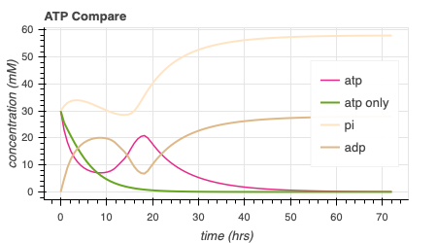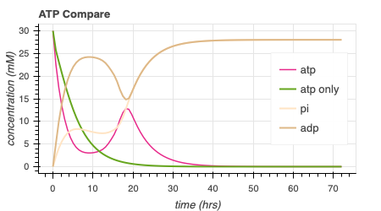

414.6

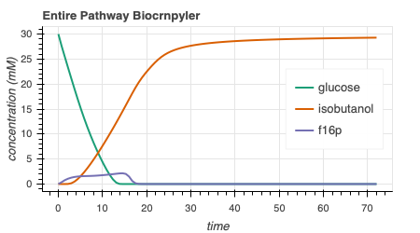

216.0

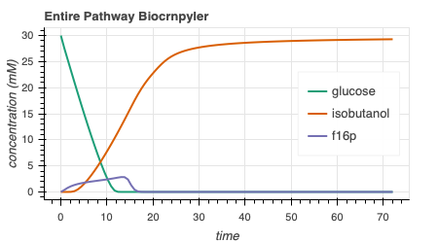

Figure 7 Schematic of the reconsidered modeling approach. By extracting data for the minimal and reduced model, we hope to be able to understand the full model in greater detail.

# References

1. Arbor Biosciences. The myTXTL system is a comprehensive solution for protein engineering and synthetic biology applications. *myTXTL – Cell-Free Expression*, 2014.

1. Build-A-Cell website.

http://buildacell.io/

1. E. Altamura, P. Albanese, R. Marotta, F. Milano, M. Fiore, M. Trotta, P. Stano, and Fabio Mavelli. Light-driven ATP production promotes mRNA biosynthesis inside hybrid multicompartment artificial protocells. *Biorxiv*, 2020.

1. K. P. Adamala, D. A. Martin-Alarcon, K. R. Guthrie-Honea, and E. S Boyden. Engineering genetic circuit interactions within and between synthetic minimal cells. *Nature Chemistry*, 2016.

DOI 10.1038/nchem.2644.

1. M. Takahashi, J. Chappell, C. A. Hayes, Z. Z. Sun, J. Kim, V. Singhal, K. J. Spring, S, AlKhabouri, C. P. Fall, V. Noireaux, R. M. Murray, and J. B. Lucks. Rapidly Characterizing the Fast Dynamics of RNA Genetic Circuitry with Cell-Free Transcription-Translation (TX-TL) Systems*. ACS Synthetic Biology*, 2014.

[6]Ortega. Biocircuits TX TL Life Extension Project Presentation. June 2018.

1. P. H. Opgenworth, T. P. Korman, L. Iancu, and J. U. Bowie. A molecular rheostat maintains ATP levels to drive a synthetic biochemistry system. *Nature Chemical Biology*, 2017.

1. R. M. Murray. Genetically-Programmed Artificial Cells and Multi-Cellular Machines.

*Vannevar Bush Faculty Fellow Program*, 2017.

1. R. M. Murray. SURF 2020: Genetically Programmed Synthetic Cells and Multi-Cellular Machines.

https://www.cds.caltech.edu/~murray/wiki/SURF_2020:_Synthetic_Cell

1. SEED 2019 – Build-a-Cell Conference. *Springer Nature*, 2019.

https://bioengineeringcommunity.nature.com/users/105679-ross-cloney/posts/50784-seed-2019build-a-cell

[11] Murray, Richard, *Towards Genetically-Programmed Synthetic Cells and Multi-Cellular Machines*, July 2017. <http://www.cds.caltech.edu/~murray/talks/murray_buildacell-pasadena_24Jul17.pdf>. PowerPoint Presentation.

[12] Mark Anderson, J. Stark, C. Hodgman, and M. Jewett. Energizing Eukaryotic Cell-Free Protein Synthesis With Glucose Metabolism. *FEBS Lett.* 2015 July 8. 589(15): 1723-1727. Doi:10.1016/j.febslet.2015.05.045.

[13] Ayush Pandey, W. Poole, Z. Tuza, S. Clamons, *BioCRNPyler,* <https://github.com/BuildACell/BioCRNPyler>

[14] Anand Swaminathan, R. Murray, *bioscrape*, <https://github.com/BuildACell/bioscrape>

[15] Ayush Pandey, R. Murray, *autoReduce*, <https://github.com/ayush9pandey/autoReduce>