**Modeling a Glucose Metabolic Pathway and an ATP Synthase Mechanism shows ATP Life Extension in Synthetic Cells**

Ankita Roychoudhury (SURF student), Richard M. Murray (mentor)

18 September 2020

*Keywords: synthetic biology, synthetic cells, TXTL, ATP regeneration, rheostat, ATP synthase*

**Abstract**

In synthetic cell protein synthesis, a potential limiting factor is the energy supply for transcription and translation. By computationally studying mathematical models of various ATP regeneration mechanisms in synthetic cells, we aim to propose experimental methods for ATP life extension. We use available software tools to study two models. These allow us to develop and study mass-action models by implementing simple chemical reaction networks. Our simulations show that a glucose metabolic pathway can extend lifetime of ATP up to about 60 hours. Integrating ATP synthase can also lengthen the lifetime of ATP to various times depending on the implemented proton gradient mechanism. These simulations will help us understand if ATP is truly the limiting factor in synthetic cell protein synthesis. To ensure prolonged protein production, either the glucose pathway or ATP synthase mechanism can be used. In the future, performing wet-lab experiments will allow us to compare our model to data.

**Background**

Synthetic biology focuses on the engineering of devices, pathways, networks, and systems that utilize tools pre-existing in biology. There is a growing interest in the development and application of genetically-programmed synthetic cells, cells which do not replicate or divide, for future use. These synthetic cells can be used as environments in which more complex engineered systems can be implemented and designed 9. By developing a programmable chassis which we understand completely, it will be easier to repurpose biochemical circuitry to do a variety of diverse tasks. It is important that the synthetic cells do not replicate or divide, since this allows us to control whether the organisms enter our biosphere. We can instead build biochemical machines that will die after performing the desired task.

When building synthetic cells, there are five main subsystems to be considered. These are: spatial organization, metabolic subsystems, sensing and signaling, regulation and computation, and actuation. The problem we have chosen to tackle involves the metabolic subsystems, specifically the power supply and energy lifetime 11. We aim to extend the lifetime of processes within cells derived from liposomes by implementing an ATP life extension mechanism, as depicted in Figure 1. ATP, or adenosine triphosphate, is an organic compound that acts as the energy source for many different processes in cells. If ATP is depleted, these processes may stop functioning. Specifically, we aim to explore whether ATP life extension mechanisms can function in synthetic cells with TXTL, a transcription/translation system that creates protein from linear DNA templates 3,4,5. See Figure 2 for a representation. TXTL is composed up of parts and proteins from *Escherichia Coli* extract that are necessary for transcription and translation. We use TXTL in vesicles so we may control the creation of desired protein from DNA templates. A natural limitation of this method of protein production may be how much energy is available. For this reason, we aim to extend the rate and timescale of TXTL in vesicles by implementing an ATP regeneration mechanism. This mechanism can be a biochemical ATP regeneration pathway, a directed transporter, etc. An efficient, longer-lasting method to provide energy required for internal reactions will allow us to carry out more complex, sustainable experiments. We will be able to broaden the range of possible research in synthetic cells if we can measure responses, production, etc. for longer time periods.

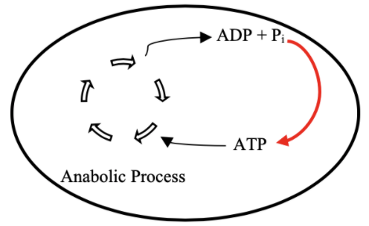

**Figure 1**. A diagram representing our overall goal. By implementing some mechanism (red arrow), we would like to regenerate ATP to longer support an anabolic process.

*Escherichia Coli*

*Synthetic Cell*

Tx

Tl



**Figure 2**. A depiction of a synthetic cell. The transcriptional (orange) and translational (blue) machinery from *E. Coli* is extracted and placed into a liposome with the desired DNA template.

Tx

Tl

Given the success of this research, the possibilities of experiments with synthetic cells will be positively affected. We will be able to understand how to extend their lifetimes. By discerning what components are crucial for energy regeneration, we can understand how metabolism truly works in cells. We can also understand if energy is the limiting factor for many existing experiments. Longer lifetimes will allow for more synthesis of bio-compatible materials, accurate environmental monitoring and remediation, self-assembly of complex multi-cellular machines, etc.8

The two mechanisms studied are a glucose metabolic pathway and an ATP synthase model. The glucose metabolic pathway is also known as the rheostat, which was published by James Bowie Lab (UCLA) 7. The rheostat is able to maintain ATP concentrations for up to 70 hours in buffer. We want to explore whether the rheostat can extend ATP levels in synthetic cells with TXTL. See Figure 3 for an image of the rheostat pathway. The pathway is able to selectively choose different pathway depending on the amount of free phosphate (Pi) present in the reaction environment. At low Pi concentrations, ATP levels are high, so the GapN pathway is preferred. The GapN pathway does not make any additional ATP. At higher Pi concentrations, ATP levels are low, so the mGapDH-Pgk pathway is preferred. This pathway allows for the selective regeneration of ATP 7.

The second proposed model involves ATP synthase, a membrane protein that makes ATP from ADP and Pi when there is an influx of hydrogen ions (H+). This model is independent of the ATP rheostat model and is another mechanism by which we propose ATP life extension can be achieved. A diagram is shown in Figure 4. A proton pump is included in this model to maintain a proton gradient necessary for ATP synthesis.

**Figure 3**. Entire Rheostat Pathway as shown in the Opgenorth et al. paper7

**Figure 4.** ATP Synthase (purple) model schematic. We include a proton pump (green) to maintain the proton gradient necessary for ATP synthesis.

Additionally, there is an existing challenge to easily combine models in synthetic biology. Because ATP regeneration mechanisms will be studied *in silico*, this gives us an opportunity to link these models with others (such as DNA export or temperature sensitivity). This will allow us to better understand the effects ATP regeneration may have on these processes as well as studying methods by which model combination can be achieved easily.

**Results**

*ATP Rheostat*

In regards to the rheostat model, we were able to show that ATP life extension can be achieved. See Figure 5 for the simulations results and chosen parameters. After implementing our desired enzymatic mechanism (Fig 6) in BioCRNpyler, we were able to investigate outputs based on parameters for enzymatic binding, unbinding, etc. The enzymatic mechanism was chosen from three options, all outlined in Figure 6.

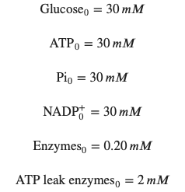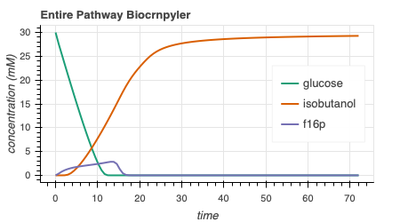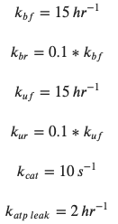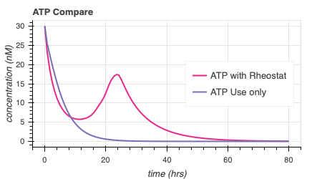

**Figure 5**. Simulations of the ATP rheostat pathway. We see stoichiometric production of isobutanol (5a) and extended ATP production with the rheostat (5b). Parameters that result in these plots are written in 5c.

5c

5a

5b

**Figure 6.** Three proposed enzymatic models. The implemented mechanism is outlined in blue.

*ATP Synthase*

The ATP synthase model is made up of various components, all of which are outlined in Figure 7. As we can see, there is transcription, translation, and membrane integration of ATP synthase and a proton pump. ATP synthesis through the ATP synthase and proton gradient maintenance via the proton pump is also included. Note that some ATP is needed to power the proton pump. Finally, ATP use is modelled to represent the energy used by transcription and translation in a synthetic cell.

ATP Synthase Transcription & Translation

ATP Synthase Membrane Integration

ATP Synthesis through ATP Synthase

Proton Pump Transcription & Translation

Proton Pump Membrane Integration

Proton movement through Proton Pump

ATP Use

ATP Synthesis

Maintain Proton Gradient

ATP Hydrolysis

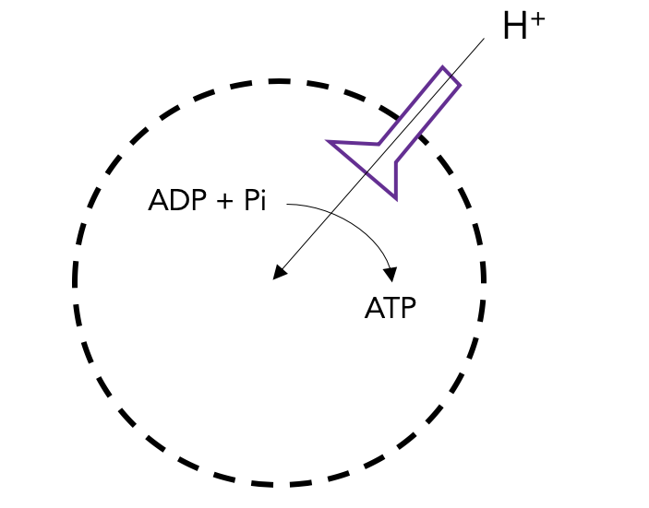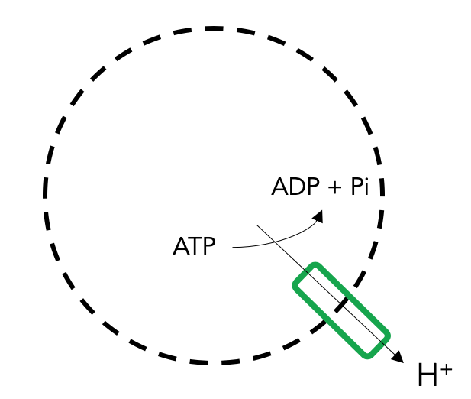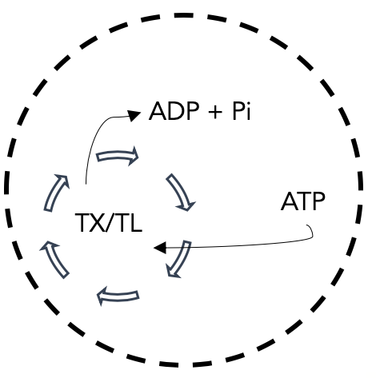

**Figure 7.** ATP Synthase Model Design. We include the modelling of transcription, translation, and membrane integration of both membrane proteins. We also include ATP hydrolysis to represent all ATP used by TXTL.

When integrated together via BioCRNpyler, all the parts of the ATP synthase model produce expected outputs. When the appropriate parameters are used, we see a consistently higher proton concentration outside the liposome than inside, as desired. The simulations is shown in Figure 8. We see that it takes about 5 hours for protein membrane integration in synthetic cells, which is observed experimentally with MsbA, another membrane protein (data collected by Zoila Jurado from Murray Lab).

**Figure 8**. ATP Synthase Simulation Output. We can see that ATP is regenerated and maintained. There is also more H+ outside than inside, maintaining the desired proton gradient. Finally, bound ATP synthase reaches steady state at 5 hours, as experimentally observed.

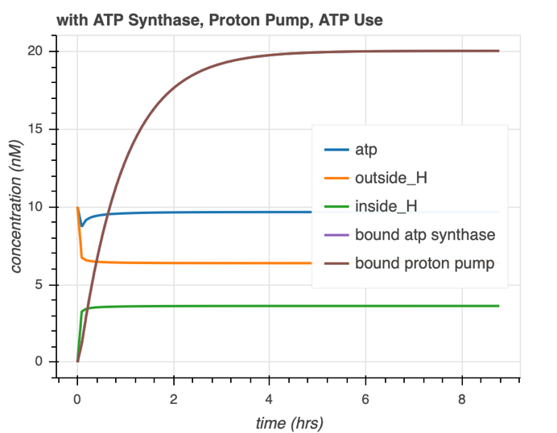

It is also important to show that the proton pump is necessary. When we remove the proton pump, we see that there is practically no effect on the ATP curves. However, when the proton pump is implemented, we can see gradual ATP regeneration as more proton pumps bind to the membrane and preserve the proton gradient (Figure 9).

**Figure 9**. Proton pump is necessary to cause ATP synthesis. As the proton gradient is restored, ATP is gradually regenerated.

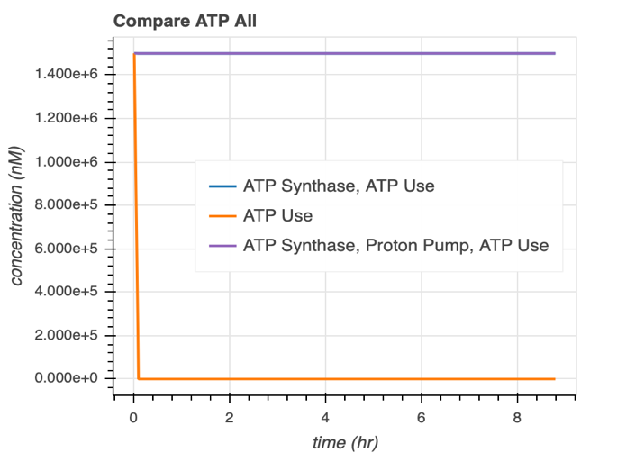

*Model Integration*

After getting these simulations to work, we focused our efforts on combining models. First, we combined both ATP rheostat and ATP Synthase models with a single-stranded DNA export (ssDNA) model developed by Agrima Deedwania (IIT Delhi) 25. Sub-SBML was used to compartmentalize and combine the models. Schematic of the export model shown in Figure 10.

**Figure 10.** VirE2 membrane integration and ssDNA export model schematic

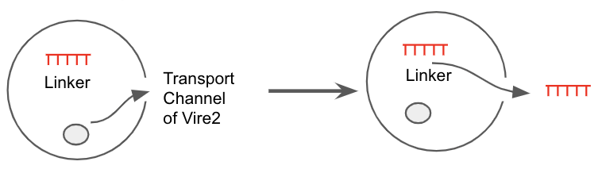

When both ATP regeneration models are separately combined with the export model, there is more bound VirE2 (membrane protein) and faster ssDNA export. These can be visualized by plots shown in Figure 11.

**Figure 11**. Combination of ssDNA export and ATP life extension models. 9a) Original ssDNA export model. 9bc) ssDNA export model with ATP Rheostat and ATP synthase model shows quicker ssDNA export and more bound VirE2.

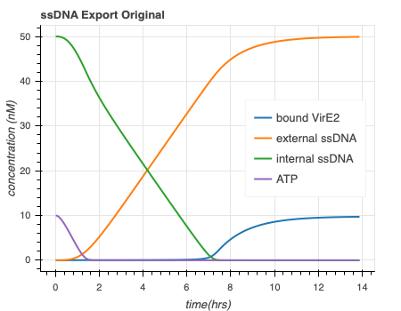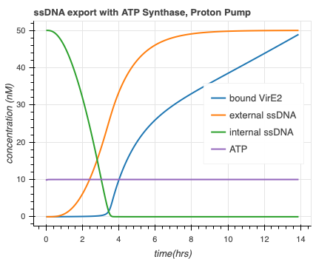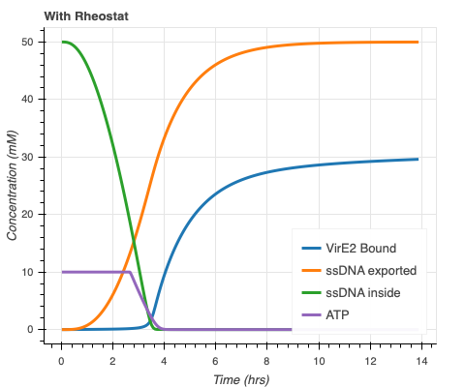

11a

11b

11c

ssDNA export original

ssDNA export with ATP Rheostat

ssDNA export with ATP Synthase and Proton Pump

Next, we studied the effects of temperature on our model as a potential method to control the rates of ATP regeneration. This was adapted from Ayush Venkatesh Bindlish’s (IIT Delhi) model (Figure 12). Simulations are shown in Figure 13. Higher temperature increase activity up until a threshold, after which detrimental effects are observed.

DNA

RNA

Protein Folding

Membrane Integration

Temperature Sensitive

**Figure 12**. The DNA to RNA step of the modelling is temperature sensitive.

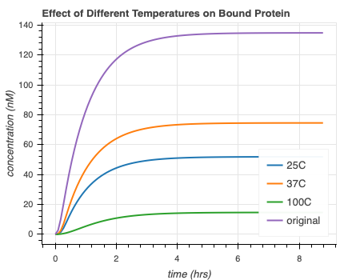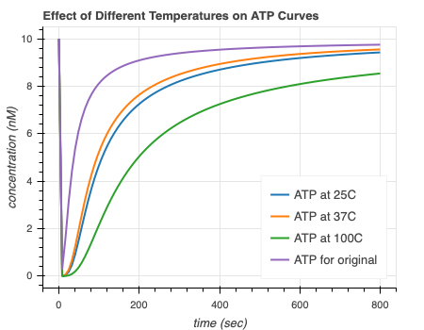

**Figure 13**. Different temperatures affects the amount of bound protein (13a) and ATP regeneration rates (13b) of the ATP synthase model.

13a

13b

**s**

In summary, we have been able to successfully simulate two mechanisms for ATP regeneration. We have noted specific parameter sets that allow for ATP life extension. We have also easily been able to combine our models with others and have noted parameter sets that cause positive effects.

**Discussion**

Moving forward, it will be crucial to validate the simulations with experimental data. There are plans in place to begin collecting data. We will start by validating that ATP is the limiting factor in protein production when using TXTL. Then, we will attempt to experimentally bound ATP synthase and a proton pump to the vesicle membrane and study the effects. Given success of these experiments, I propose to include ATP regeneration circuity in extract by either expressing all components with the synthetic DNA or modifying *E. Coli* to make extract that has the appropriate parts innately. Once data is gathered, we can improve our predictions on parameters and predict values that may result in more optimal results. Others in Murray lab have parallel goals related to this project. Graduate students have been studying ATP synthase as a mechanism for actuation, akin to our ATP synthase model for life extension.

Additionally, various members of Murray lab have been studying efficient, compatible ways to model synthetic biology. In the past, it has been challenging to quickly combine and communicate between models. Our work has shown that utilizing sub-SBML and BioCRNpyler can make the model combination process significantly easier. These software packages can allow for seamless collaboration.

In conclusion, we have been able to study two mechanisms for ATP life extension *in silico*, helping us understand the fundamental processes taking place. We have also shown that particular software packages allow for seamless model combination. By complementing this data with experiments, we will be able to validate our models.

**Methods**

*BioCRNpyler*

BioCRNpyler is a software package designed to model biochemical reactions in the form of Chemical Reaction Networks (CRNs). By providing high level specifications, the software is able to develop sophisticated biochemical models that can are outputted as SBML files. All SBML files generated in this project used BioCRNpyler.

*Systems Biology Markup Language (SBML)*

SBML is a communication and representation format written in XML. It is able to encodes various biological processes, including metabolic networks, cell signaling, etc.

*Bioscrape*

Bioscrape, or Bio-circuit Stochastic Single-cell Reaction Analysis and Parameter Estimation, is a Python package that can model and simulate CRNs. It offers stochastic and deterministic simulation capabilities. Bioscrape is able to incorporate delay, cell growth, and cell divisions. It is able to take inputs of SBML files and outputs results in a Panda’s data-frame which can be easily visualized. All simulations in this paper use Bioscrape.

*Sub-SBML*

Sub-SBML is a Python toolbox designed to create, edit, combine, and model interactions between more than one SBML files. It adds the ability to create subsystems, combine multiple subsystems, and model interactions between subsystems. In our case, we were able to model shared resources of ATP when combining the ATP rheostat and synthase models with the ssDNA export model.

**References**

1. Arbor Biosciences. The myTXTL system is a comprehensive solution for protein engineering and synthetic biology applications. *myTXTL – Cell-Free Expression*, 2014.

1. Build-A-Cell website.

http://buildacell.io/

1. E. Altamura, P. Albanese, R. Marotta, F. Milano, M. Fiore, M. Trotta, P. Stano, and Fabio Mavelli. Light-driven ATP production promotes mRNA biosynthesis inside hybrid multicompartment artificial protocells. *Biorxiv*, 2020.

1. K. P. Adamala, D. A. Martin-Alarcon, K. R. Guthrie-Honea, and E. S Boyden. Engineering genetic circuit interactions within and between synthetic minimal cells. *Nature Chemistry*, 2016. DOI 10.1038/nchem.2644.

1. M. Takahashi, J. Chappell, C. A. Hayes, Z. Z. Sun, J. Kim, V. Singhal, K. J. Spring, S, AlKhabouri, C. P. Fall, V. Noireaux, R. M. Murray, and J. B. Lucks. Rapidly Characterizing the Fast Dynamics of RNA Genetic Circuitry with Cell-Free Transcription-Translation (TX-TL) Systems*. ACS Synthetic Biology*, 2014.

[6]Ortega. Biocircuits TX TL Life Extension Project Presentation. June 2018.

1. P. H. Opgenworth, T. P. Korman, L. Iancu, and J. U. Bowie. A molecular rheostat maintains ATP levels to drive a synthetic biochemistry system. *Nature Chemical Biology*, 2017.

1. R. M. Murray. Genetically-Programmed Artificial Cells and Multi-Cellular Machines.

*Vannevar Bush Faculty Fellow Program*, 2017.

1. R. M. Murray. SURF 2020: Genetically Programmed Synthetic Cells and Multi-Cellular Machines.

https://www.cds.caltech.edu/~murray/wiki/SURF_2020:_Synthetic_Cell

1. SEED 2019 – Build-a-Cell Conference. *Springer Nature*, 2019.

https://bioengineeringcommunity.nature.com/users/105679-ross-cloney/posts/50784-seed-2019build-a-cell

[11] Murray, Richard, *Towards Genetically-Programmed Synthetic Cells and Multi-Cellular Machines*, July 2017. <http://www.cds.caltech.edu/~murray/talks/murray_buildacell-pasadena_24Jul17.pdf>. PowerPoint Presentation.

[12] Mark Anderson, J. Stark, C. Hodgman, and M. Jewett. Energizing Eukaryotic Cell-Free Protein Synthesis With Glucose Metabolism. *FEBS Lett.* 2015 July 8. 589(15): 1723-1727. Doi:10.1016/j.febslet.2015.05.045.

[13] William Poole, A. Pandey, A. Shur, Z. Tuza, R. Murray. BioCRNpyler: Compiling Chemical Reaction Networks from Biomolecular Parts in Diverse Contexts. *Biorxiv*. 2020.

[14] Anand Swaminathan, W. Poole, V. Hsiao, R. Murray. Fast and flexible simulation and parameter estimation for synthetic biology using bioscrape. *Biorxiv*. 2019.

[15] Ayush Pandey, R. Murray, *AutoReduce*, <https://github.com/ayush9pandey/autoReduce>

[16] Ankita Roychoudhury, <https://github.com/AnkitaRoychoudhury/ug_murray/blob/master/autoReduce2/sbml_to_ode2.py>

[17] Ankita Roychoudhury, <https://github.com/AnkitaRoychoudhury/ug_murray/blob/master/autoReduce2/CRN.xml>

[18] Ankita Roychoudhury, <https://github.com/AnkitaRoychoudhury/ug_murray/blob/master/autoReduce2/20200721_redmod_13_whydifft.ipynb>

[19] Ankita Roychoudhury, <https://github.com/AnkitaRoychoudhury/ug_murray/blob/master/autoReduce2/20200722_redmod_14_autoreduce.ipynb>

[20] Ankita Roychoudhury, <https://github.com/AnkitaRoychoudhury/ug_murray/blob/master/code/exploratory/20200720_atpsynthase_5_params.ipynb>

[21] Paul H Opgenorth, T. Korman, J. Bowie. A synthetic biochemistry module for production of bio-based chemicals from glucose. *Nature Chemical Biology*. 2016.

[22] Ankita Roychoudhury, <https://github.com/AnkitaRoychoudhury/ug_murray/blob/master/code/exploratory/test_metabolic_export/20200723_combine_metabolicexport_nadphregen.ipynb>

[23] Alice Verchère, M. Dezi, I. Broutin, M. Picard. *In vitro* Investigation of the MexAB Efflux Pump from *Pseudomonas aeruginosa*. *JoVE Journal Biology*. Feb 17 2014.

[24] H I Zgurskaya, H. Nikaido. Bypassing the periplasm: reconstitution of the AcrAB multidrug efflux pump of Escherichia coli. *PNAS*. 1999.

[25] Agrima Deedwania, <https://github.com/agrimadeedwania>

**Acknowledgements**

Thank you to Samuel P. and Frances Krown for funding my SURF project. Thank you to William Poole and Ayush Pandey for teaching software tools and helping with modelling and proposal editing throughout the project. Thank you to David Garcia, Manisha Kapasiawala, and Zoila Jurado for giving advice, technical feedback, and experimental data throughout the SURF. Thank you to Richard Murray for being readily available for high-level advice and directions and for letting me pursue this opportunity. And lastly, thank you to the entire Murray lab for keeping their ‘doors’ open and welcoming me so graciously!

**Appendices**

Most of the code written during this project can be found here: <https://github.com/AnkitaRoychoudhury/ug_murray>