**ATP Life Extension in Synthetic Cells**

Ankita Roychoudhury  
Supervisor: Richard Murray

In synthetic cell protein synthesis, a potential limiting factor is the energy supply for transcription and translation. By computationally studying mathematical models of various ATP regeneration mechanisms in synthetic cells, we have been able to propose experimental methods for ATP life extension. Our simulations have shown that integrating ATP synthase into the liposome membrane can lengthen ATP lifetime to various times depending on the implemented proton gradient maintenance mechanism.

The model we propose to implement experimentally involves ATP synthase, a membrane protein that makes ATP from ADP and Pi when there is an influx of hydrogen ions (H+). A diagram is shown in Figure 1. A proton pump is included in this model to maintain a proton gradient necessary for ATP synthesis. We chose this model based on our *in silico* experiments, where we were able to learn what components were sufficient for ATP life extension and the parameter sets that result in desired effects. This model can also theoretically last longer than other explored models due to its self-sufficient nature. However, the membrane integration process may be more challenging than expected in a synthetic cell.

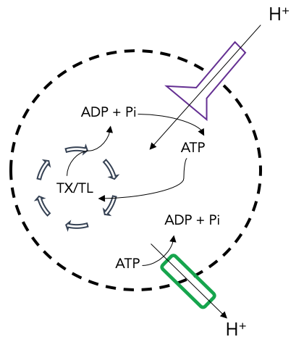

**Figure 1.** ATP Synthase (purple) model schematic. We include a proton pump (green) to maintain the proton gradient necessary for ATP synthesis.

We will start by validating that ATP is the limiting factor in protein production when using TXTL. In order to do this, we will collect control data in bulk TXTL. These controls will include a (i) positive control with DNA, energy, and extract, (ii) a negative control with extract and water to quantify background fluorescence, (iii) a sample with buffer and extract to quantify ATP depletion due to metabolic leak, (iv) a sample with DNA, extract to understand how the systems performs without energy, and (v) a sample with DNA and buffer to see how the reaction performs with only energy and no protein machinery. Next, we will add more ATP, energy mix, DNA, and other components in the start and in the middle of the reaction in attempt to understand what is the limiting factor. Our next steps will include characterizing GFP and ATP production with TXTL while encapsulated in vesicles. Lastly, we will attempt to express ATP synthase and a proton pump in our solution in hopes of integrating them into the vesicle membrane to test if ATP life extension can truly be achieved.