Display all customers.

SELECT * FROM itc_customers;
select * from itc_orders;

"order_id","customer_id","product_name","category","quantity","price","order_date"
"1","101","Laptop","Electronics","1","800.00","2026-08-01"
"2","102","Phone","Electronics","2","500.00","2026-08-02"
"3","101","Keyboard","Electronics","2","50.00","2026-08-03"
"4","103","Chair","Furniture","1","200.00","2026-08-03"
"5","104","Desk","Furniture","1","350.00","2026-08-04"
"6","102","Mouse","Electronics","3","25.00","2026-08-05"
"7","105","Laptop","Electronics","1","900.00","2026-08-06"
"8","104","Monitor","Electronics","2","250.00","2026-08-06"
"9","101","Desk","Furniture","1","300.00","2026-08-07"
"10","103","Phone","Electronics","1","600.00","2026-08-08"

Display only customer_name and city from the customers table.

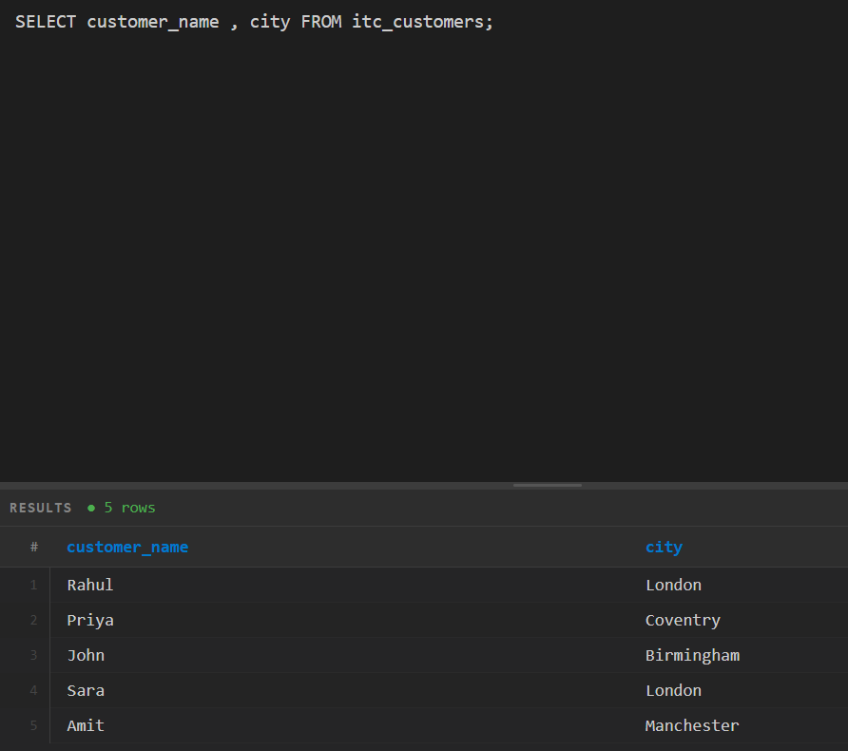

Find all customers who live in London.

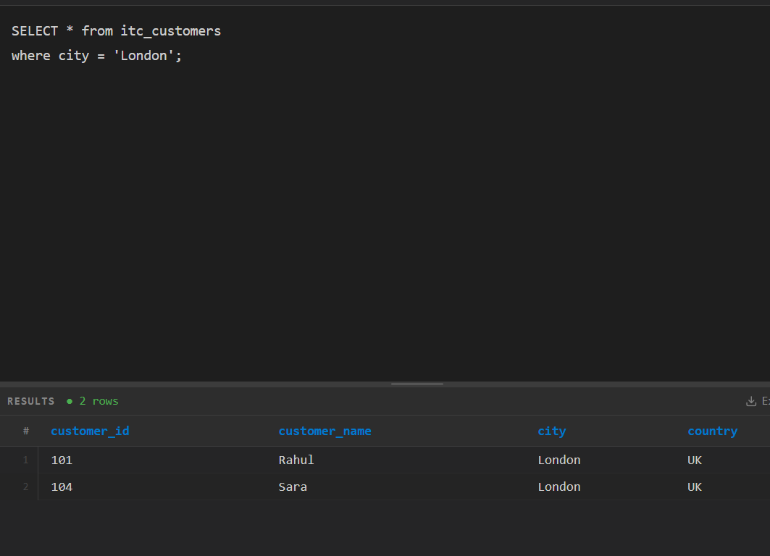

Display all orders where price is greater than 300.

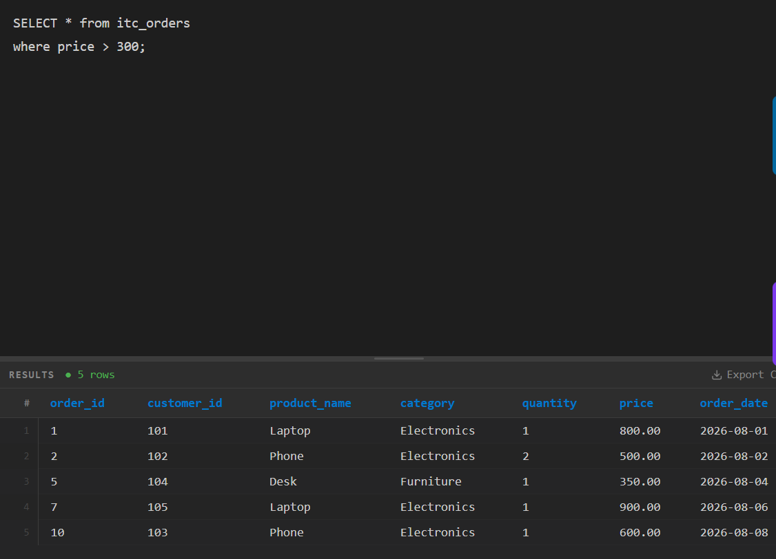

Find all orders belonging to the Electronics category.

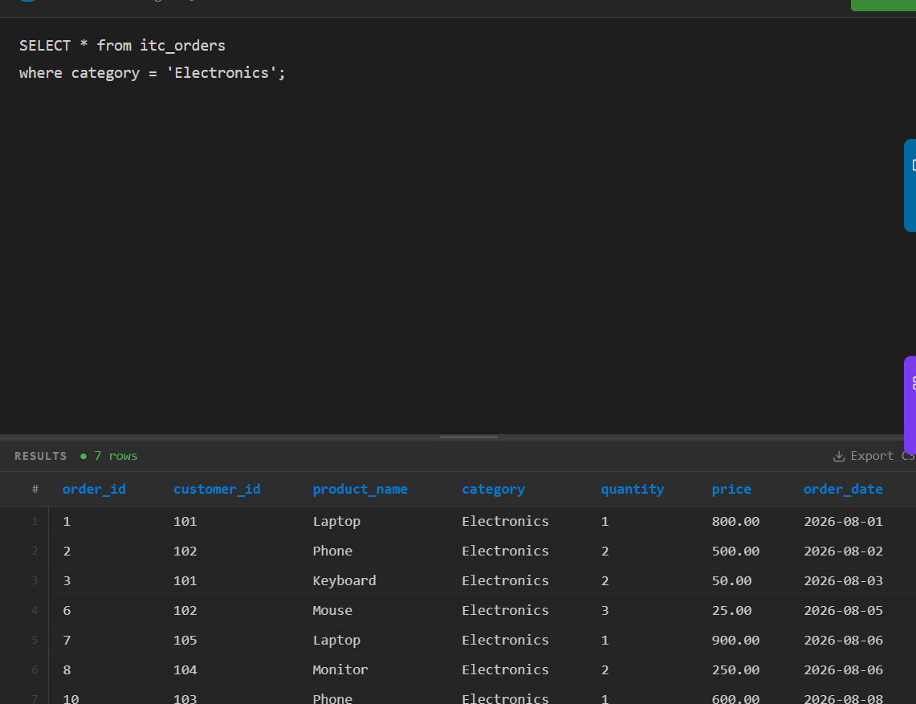

Display all orders sorted from highest price to lowest price.

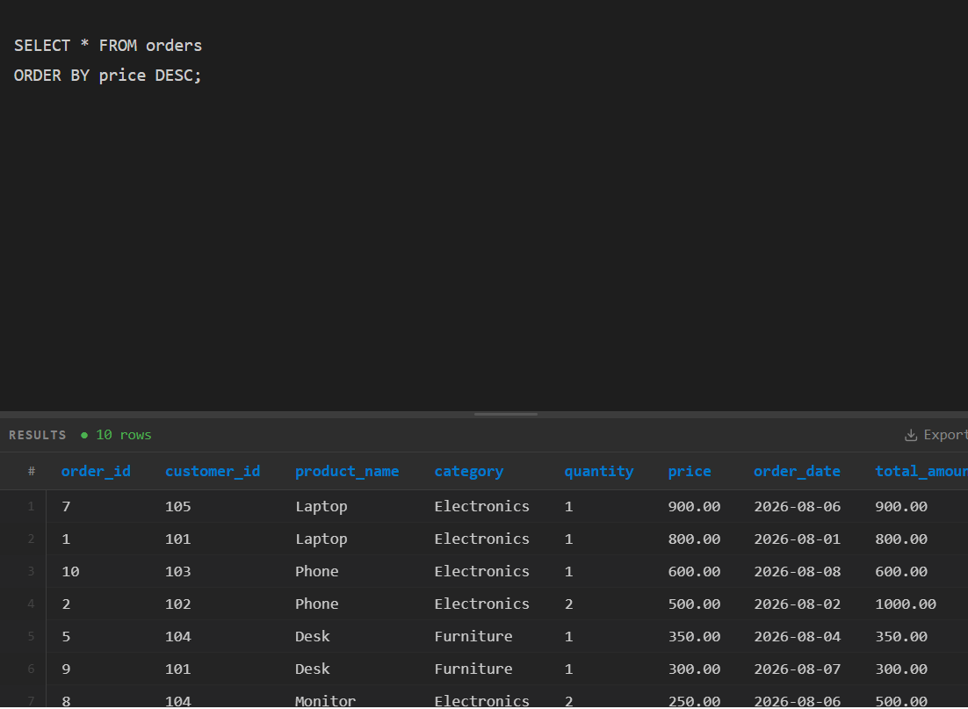

Find orders placed between 3 August 2026 and 6 August 2026

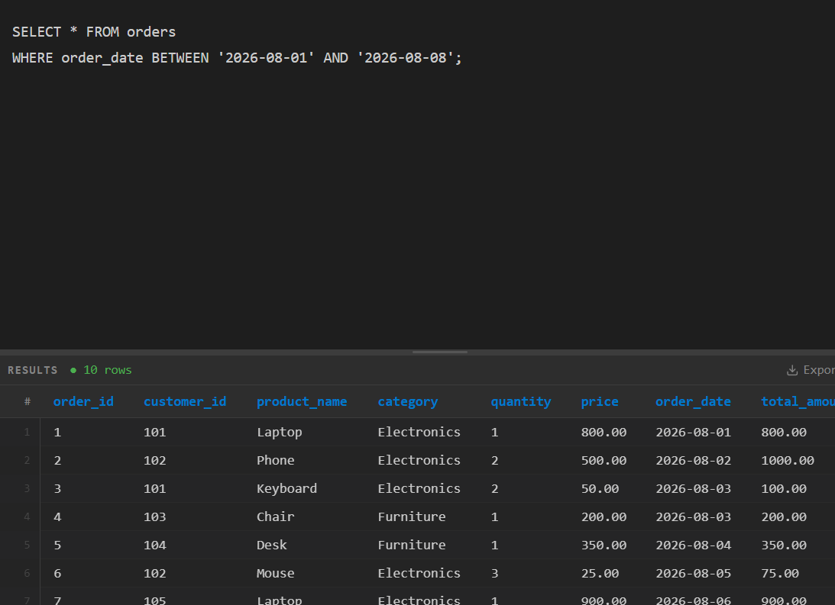

How many orders are there in total?
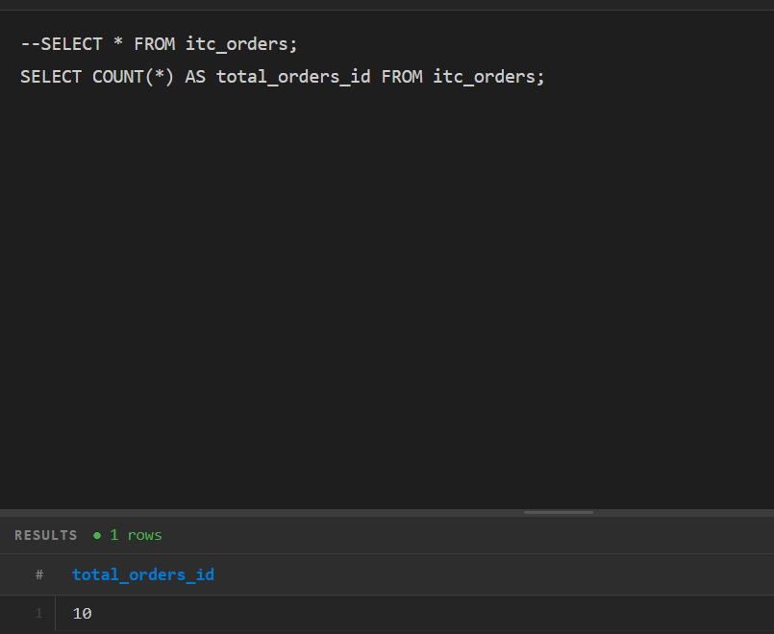

Find the maximum product price.

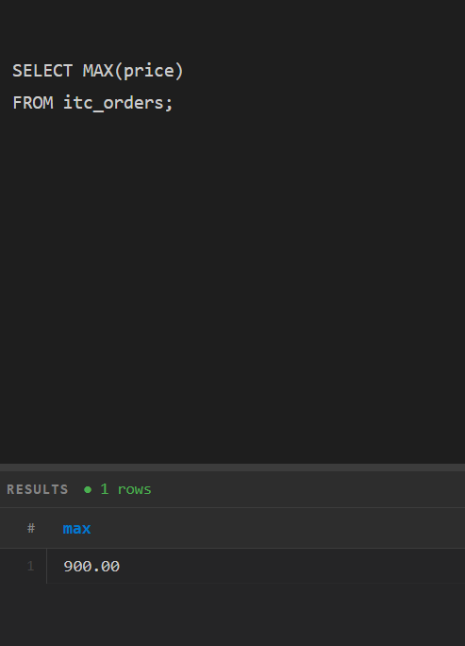

Find the minimum product price.
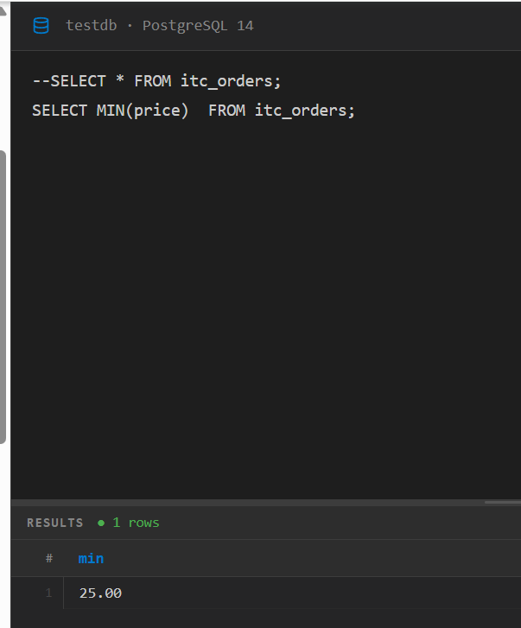

Find the average product price.

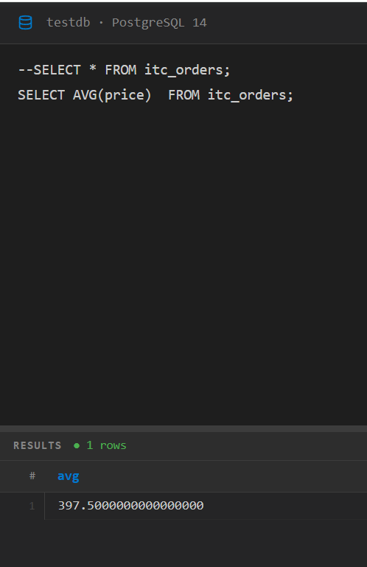

Find the total quantity of products ordered.
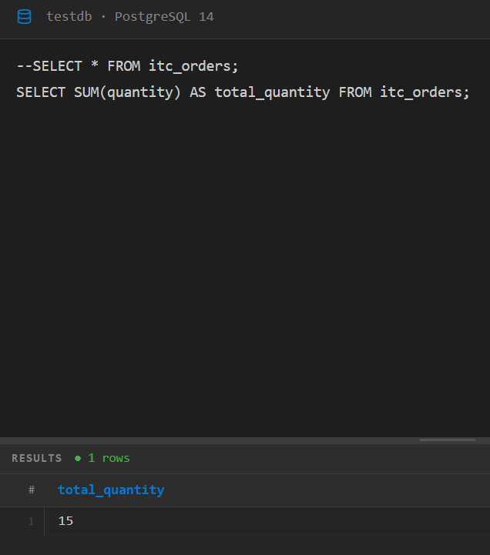
Find the number of orders for each category.
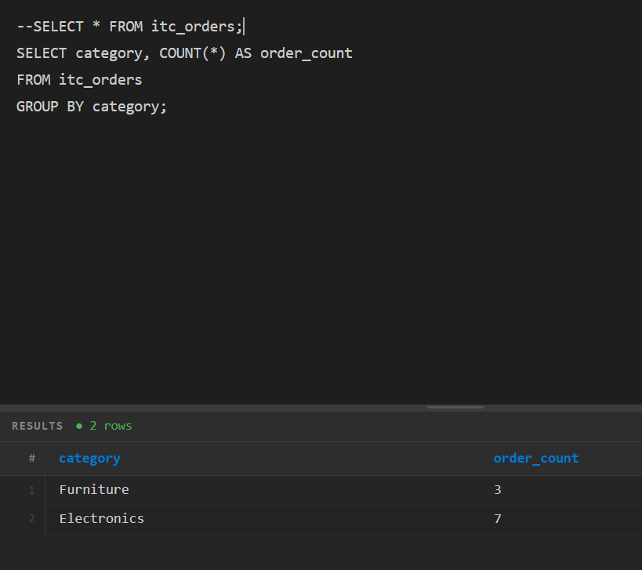

Find the average price for each category.

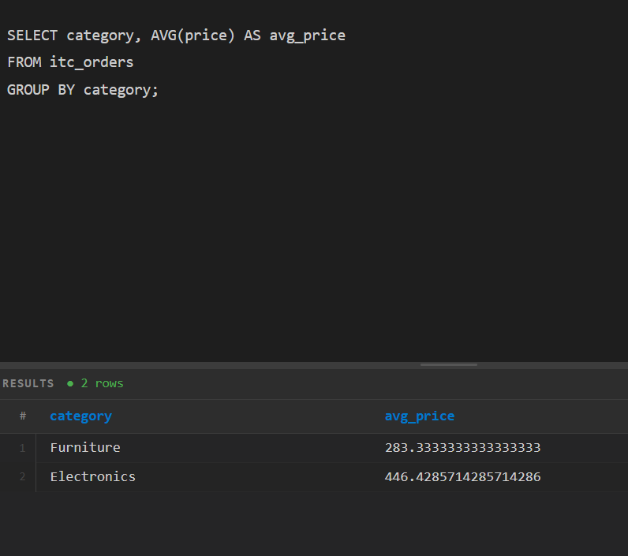

Part E - Calculated Columns
Create a calculated column called total_amount using:
total_amount = quantity x price
Then identify which order generated the highest total amount

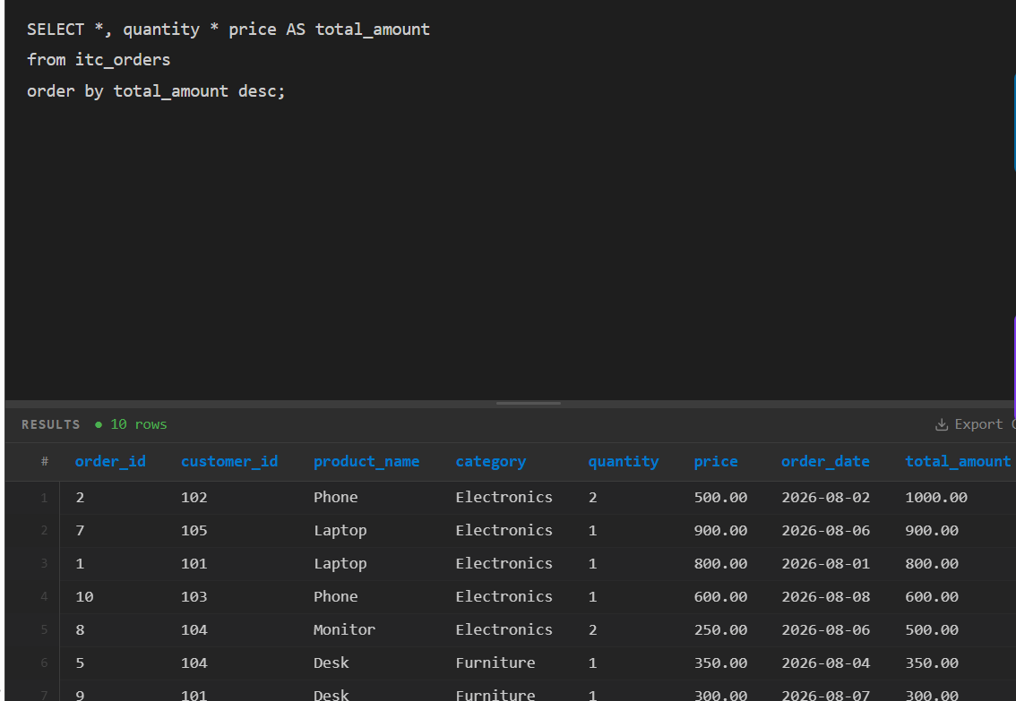

Part F - JOIN Practice
  - Join customers and orders and display customer_name, product_name, quantity and price.
  - 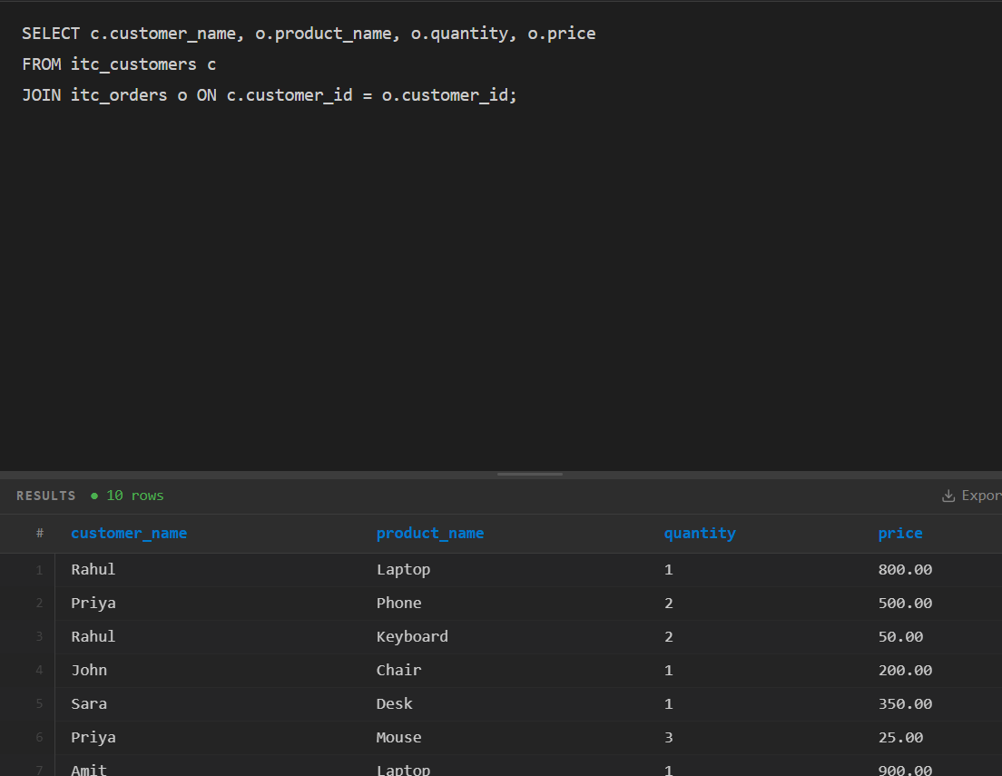
  - Find all orders placed by Rahul.
  - 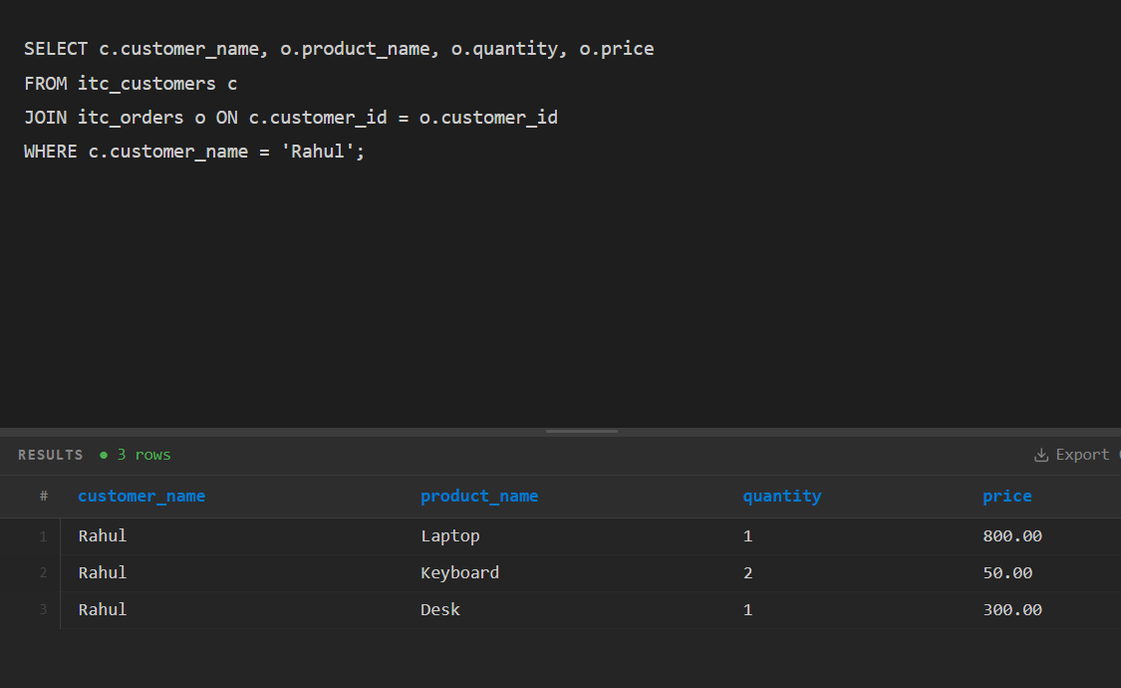
  - Find the total amount spent by each customer.
  - 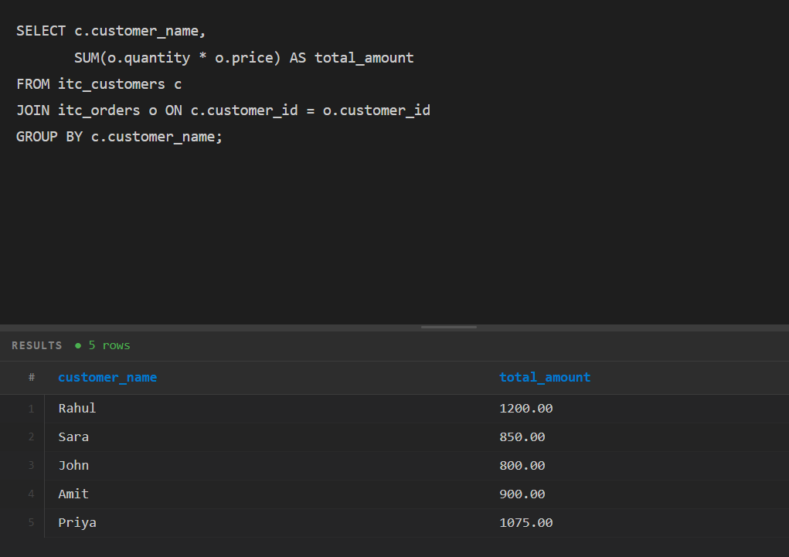

Part G - Challenge Questions
Which customer spent the most money?

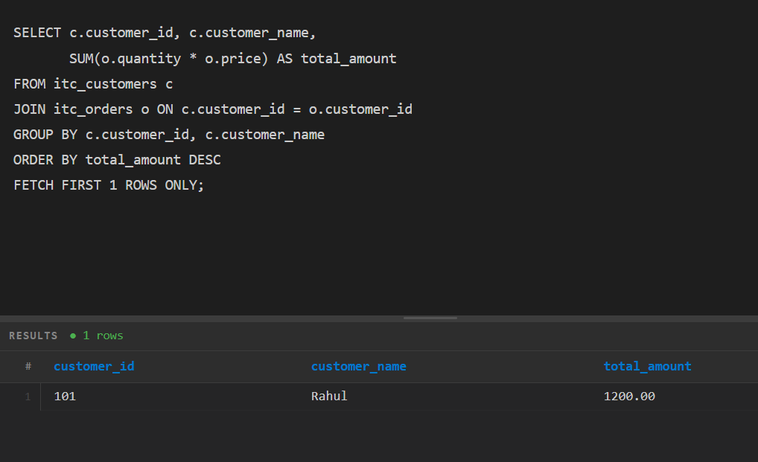
Which city generated the highest sales?
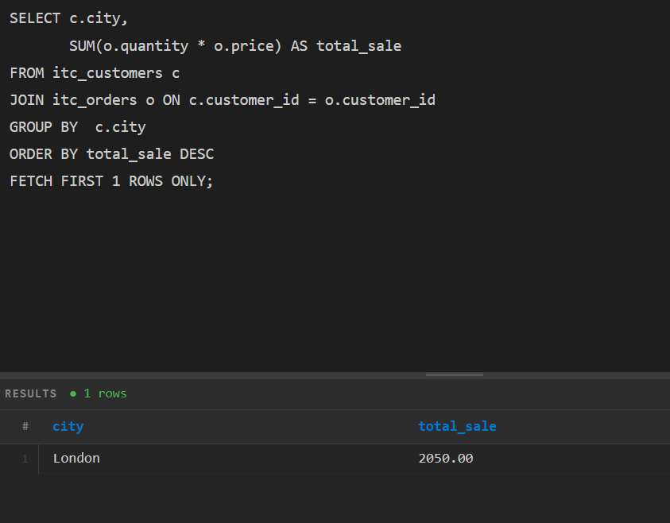
Find customers who have placed more than one order.
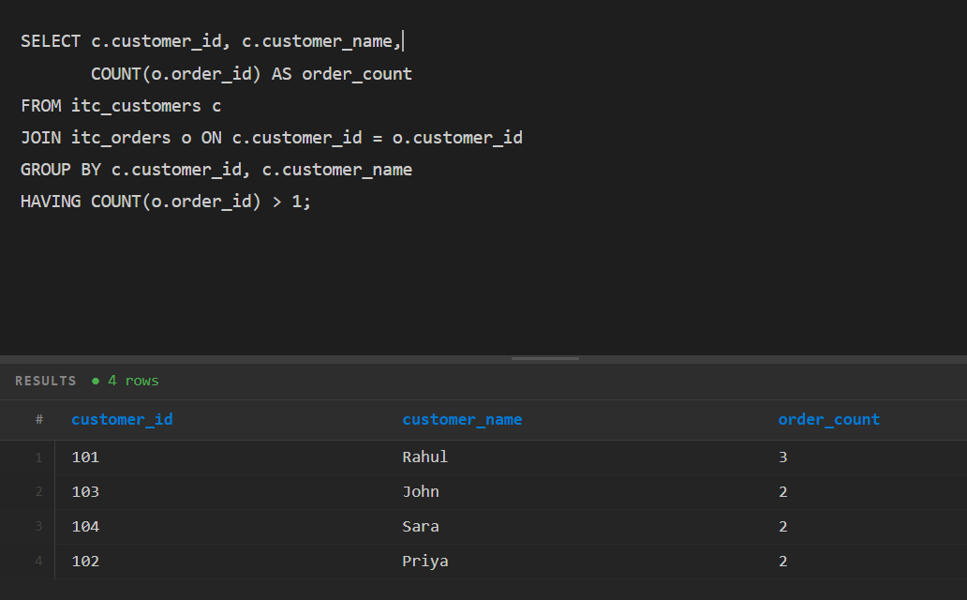
Find the total sales for each category.
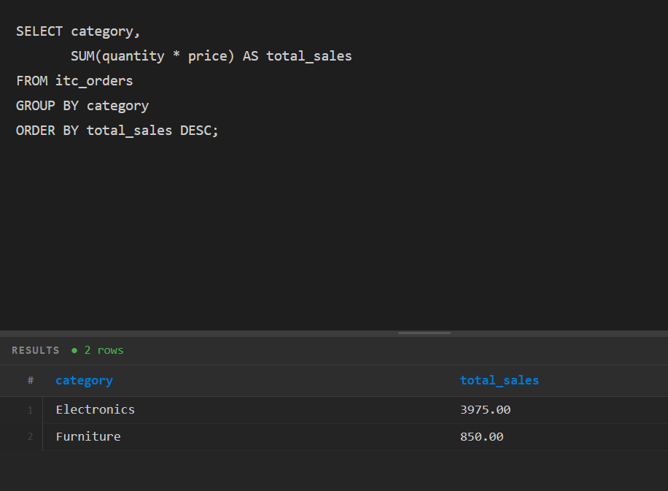

Find customers whose total spending is greater than £500.

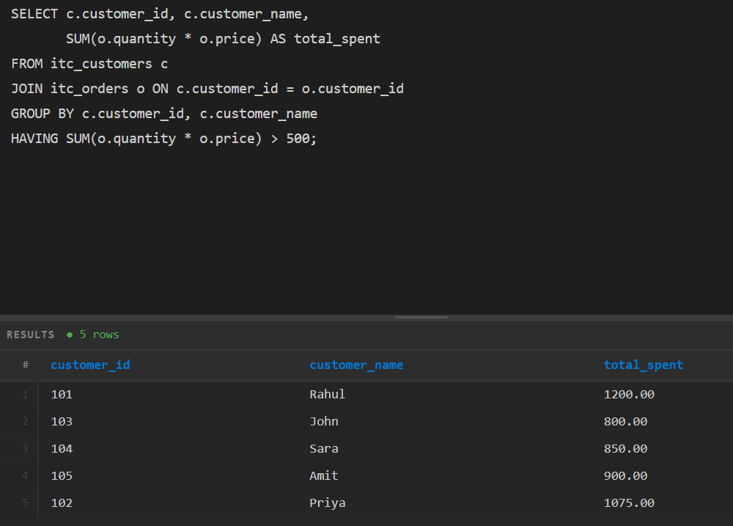
Find the top 3 customers by total spending.

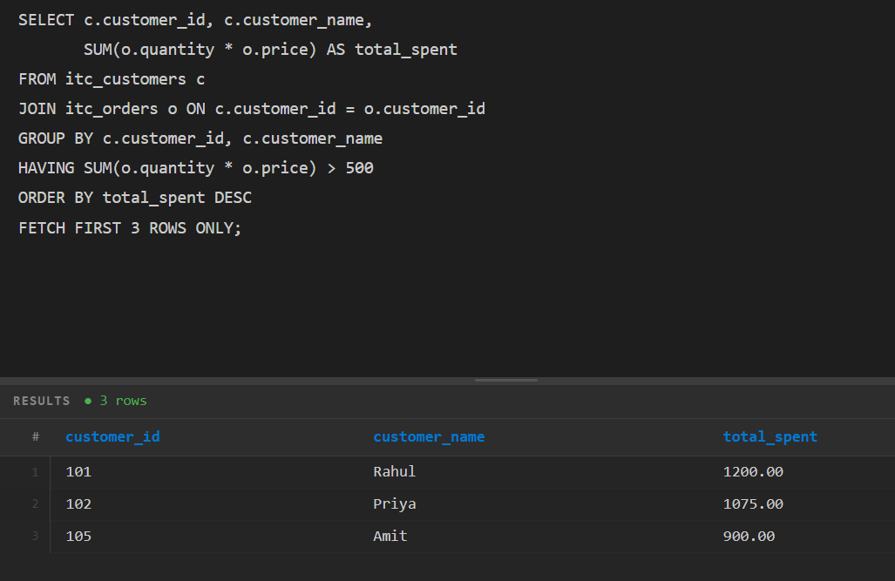

1) Write SELECT queries against cc_fraud_trans using WHERE with AND/OR, IN, and BETWEEN — filter by merchant category, amount range, and date; sort results with ORDER BY and cap output with LIMIT.

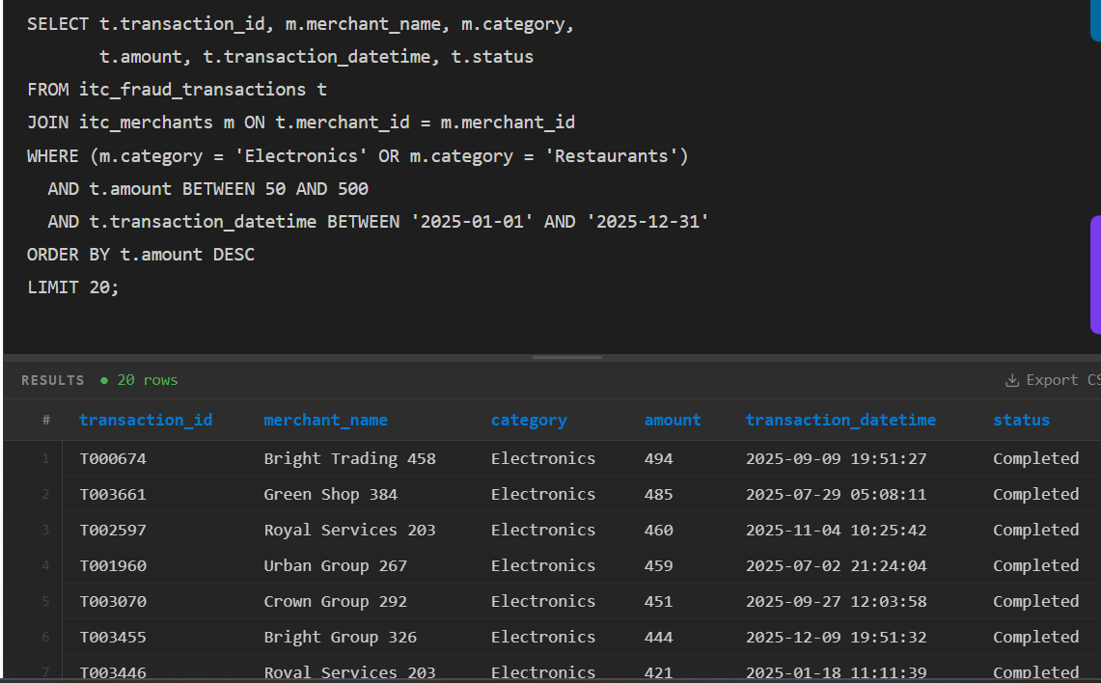

2) Compute COUNT, SUM, AVG, MIN, MAX grouped by merchant_category using GROUP BY, then filter groups with HAVING to show only categories with more than 50 transactions or average amount above $200.

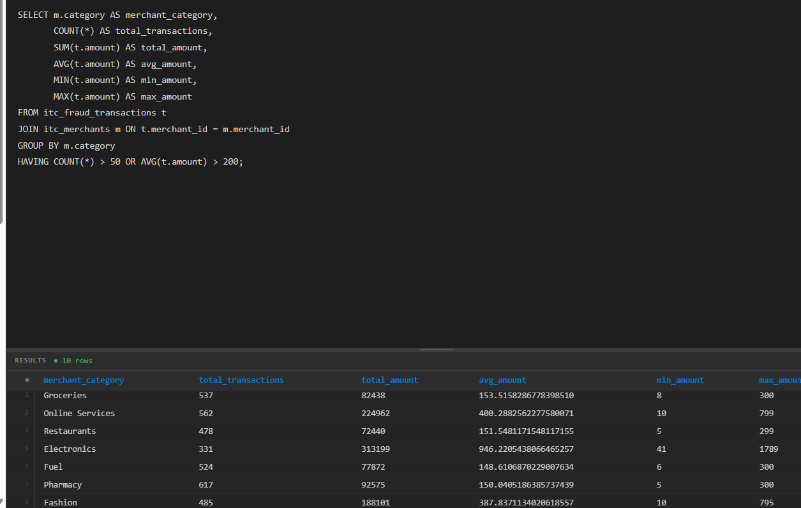

3) Join cc_fraud_trans with a merchants table using INNER JOIN and LEFT JOIN — identify which merchants have no recorded transactions.

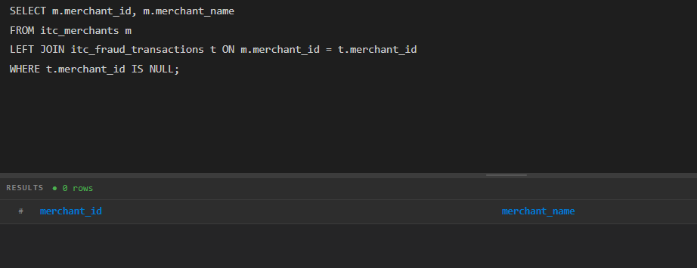

4) Write a single query that ranks the top 10 merchants by total fraudulent transaction amount using GROUP BY, SUM, a HAVING filter on is_fraud=1, and ORDER BY DESC with LIMIT.

