1354_Ankita Ugale

Assignment 6

1. Create abstract class Shape --state : x,y

Abstract Method --public double area();

public String toString() : to ret x & y

Why will area() be abstract in Shape class ?????????

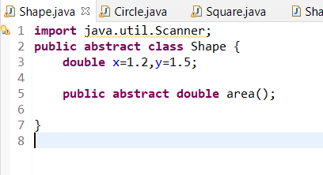

2. Circle -- x,y,radius

Concrete overriding Method --public double area() : ret area of circle

public String toString() : ret x, y & radius

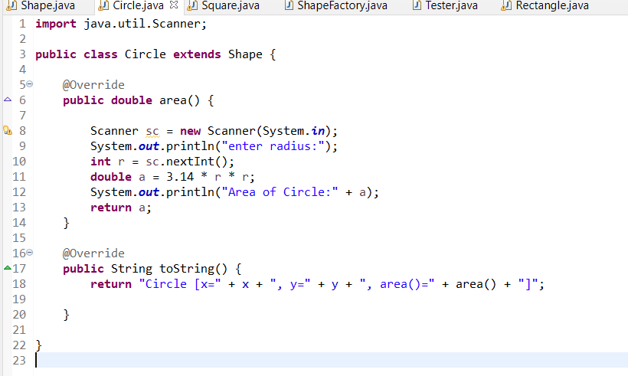

3. Rectangle -- x,y,w,h

Concrete overriding Method --public double area() : ret area of rectangle

public String toString() : ret x, y , width & height

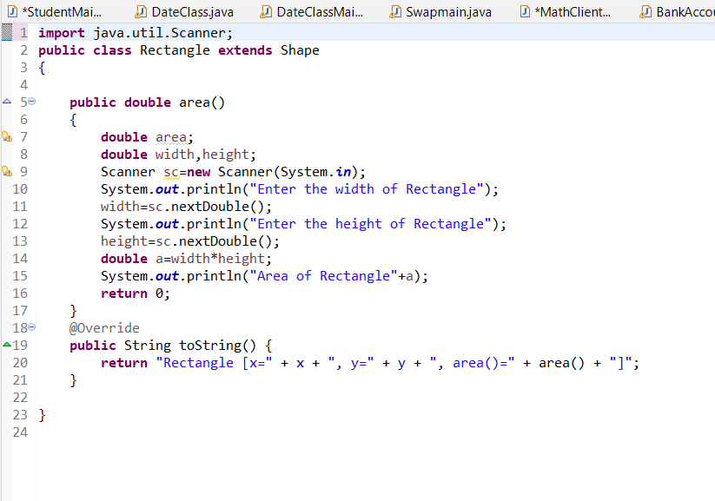

4. Square-- x,y,side

Concrete overriding Method --public double area() : ret area of square

public String toString() : ret x, y , side

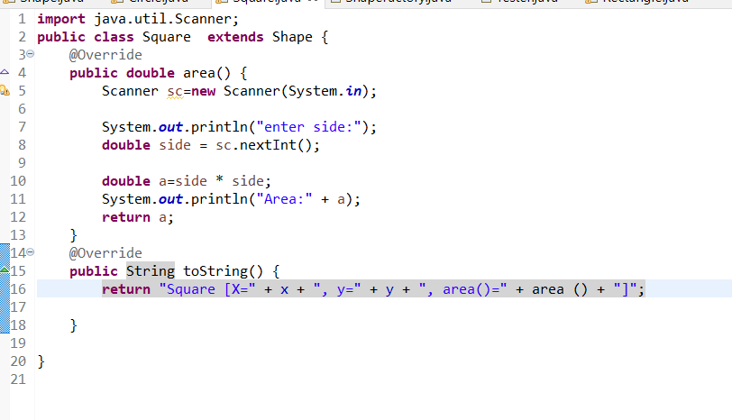

5. Create a ShapeFactory class

Add a static method(generateShape) to return randomly generated shape.

Hint : random no generator

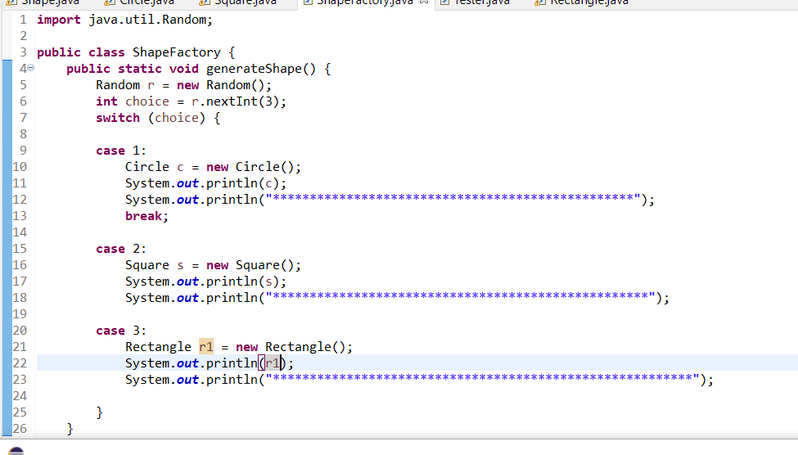

6. Create a Tester . Invoke ShapeFactory's generateShape() method , in a for-loop (5 times)

to display details & area of each shape.

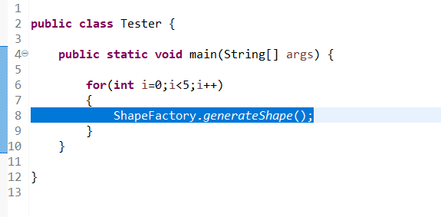

Output:

