**Project Documentation**

**Date:11-07-2022**

**Project technical details:**

- Project is created angular version V14 (14.1.0).   
- Eslint is used for checking code standard and also tsconfig.json all best code standard flag is true

- Component library is used for ng-bootstrap (ng-bootstrap/ng-bootstrap:^13.1.0).  
- Other package library also used please refer package.json file for more details inside project.  
- Theme is used for online resource and including SCSS is also online SCSS.   
- Code is proper commented so developer can understand.   
- Reusable common component is listed inside shared -> components (data-table-grid and dynamic-forms).   
- Username is admin and password is also admin to login.  
  
**Instructions for running project:**   
1. Execute npm install command  
2. Execute ng s or npm run start project running project in local environment   
  
**Note:** If error is coming and not able to run project delete .angular and node modules folder and install again.

**Dynamic-forms:**   
- Dynamic-forms is common reusable component need to pass JSON array of object, so it is created form field dynamically based on JSON configuration.

**Data-table-grid:**   
- Data-table-grid is common reusable component need to pass JSON array of object, so it is created dynamically column with data also pass width, sortable, and column setting based on input table generated dynamically.

**Data:**   
- In this project I am not using any live API JSON placeholder fake restful api is used so once page is refresh data should be reset. But all functionality is working

**UI Design Screenshot**

1. Login page with validation

2.Enter user details with login page   
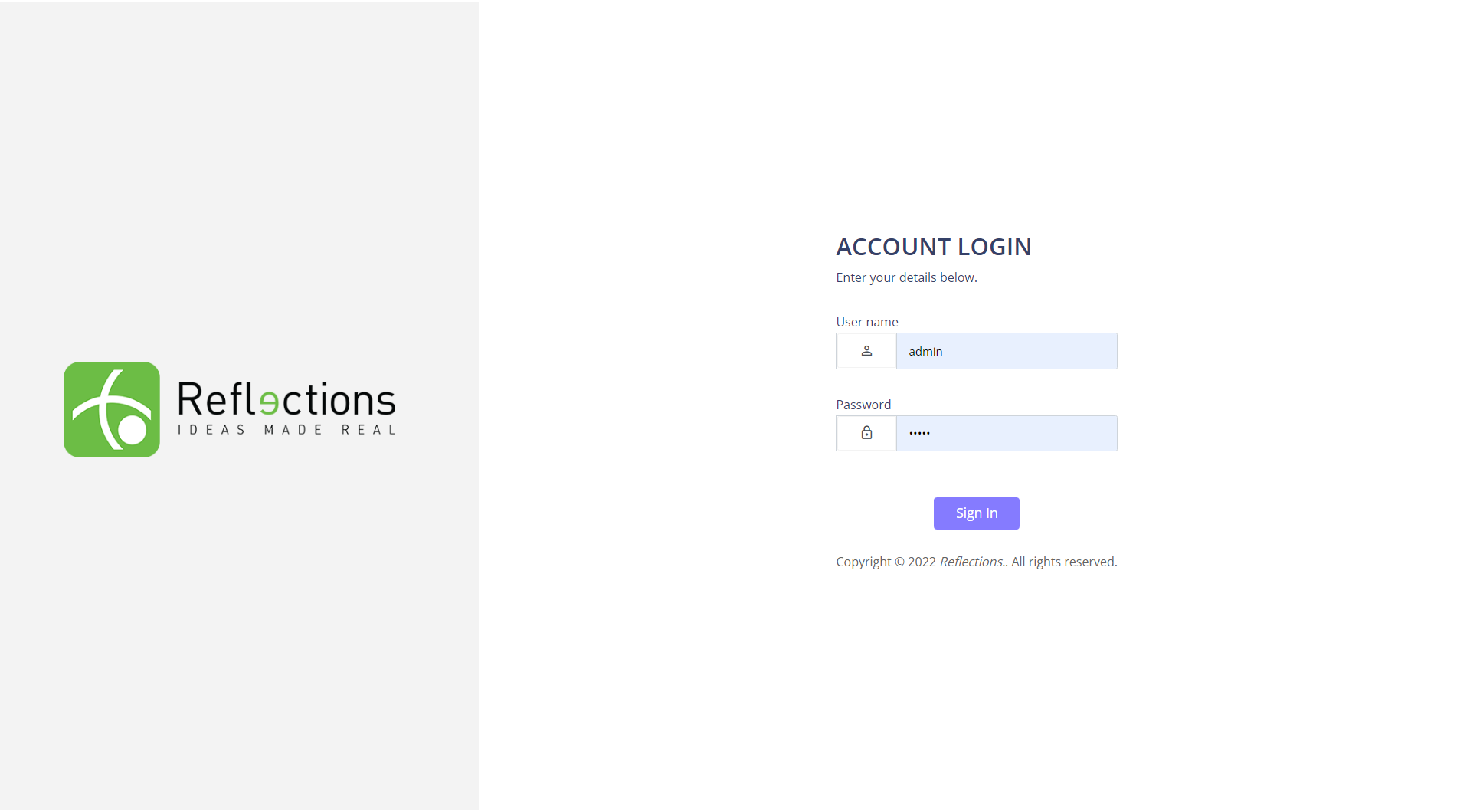

3.Dashboard screen (It is static design)

4. Crud operation screen list grid

5. Add button click popup dialog box is open  
  
6. Add dialog box popup with validation message   
7. Update data dialog box with filled data

8. Search by email with result

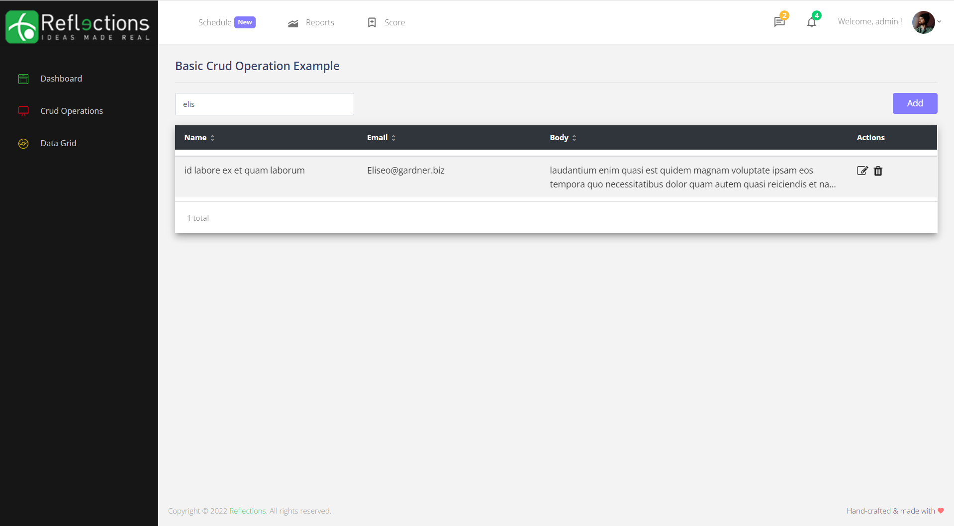

9. Data grid with pagination and total count  
  
  
10. Sign out menu clicked on user is logout

11. Page not found   
