Data Dictionary Admin App
Tool Explanation and End-to-End Flow
Streamlit UI | FastAPI Swagger APIs | SQL Server PRJ_DB | Internal S3 Export

1. Tool Overview
The Data Dictionary Admin App is an internal enterprise utility for managing PRJ Data Dictionary attributes in a controlled, role-based, and audit-enabled manner. The tool allows users to view, filter, create, edit, soft delete, reactivate, audit, and export data dictionary records without directly accessing SQL Server tables.
The application uses a Streamlit-based user interface, FastAPI Swagger APIs, Python business services, SQLAlchemy repositories, SQL Server PRJ_DB, and an internal S3-compatible bucket for downstream extracts.
Component | Purpose | Runtime / Storage
Streamlit UI | Business-facing user interface for filtering, viewing, editing, and exporting data. | http://localhost:8501
FastAPI / Swagger API | Backend APIs for filters, CRUD operations, audit search, and integration. | http://localhost:8502/docs
SQL Server PRJ_DB | Primary data store for master, target, audit, history, and prompt tables. | SQL Server
Internal S3-Compatible Bucket | Stores timestamped CSV extracts from latest active database records. | Internal object storage

2. Purpose of the Tool
The Data Dictionary is the central source of truth for PRJ attributes. These attributes are used across portfolios and downstream consumers such as Corporates, FI Banks, FI Insurance, and Zeus Downstream. The tool ensures data changes are controlled, traceable, and consistently written to master and target tables.
Consumer / Portfolio | Purpose
Corporates | Attributes required for corporate financial statement data.
FI Banks | Attributes required for financial institution banking data.
FI Insurance | Attributes required for insurance financial data.
Zeus Downstream | Attributes required by Zeus downstream systems.

3. Key Capabilities
Capability | Description
View Data Dictionary | View active Data Dictionary records in a searchable and filterable grid.
Apply Filters | Filter records by portfolio, PRJ_ID, attribute name, description, section, and overlapped attributes.
Add New Attribute | Admin users can create new PRJ attributes through a popup form.
Edit Attribute | Admin users can edit selected records. Edit forms open as read-only first and PRJ_ID remains non-editable.
Soft Delete | Admin users can mark records inactive without physically deleting them.
Reactivate Record | Admin users can reactivate previously soft-deleted records from the inactive grid.
Audit History | Users can view who changed what, when, and from which module.
S3 Export | Admin users can export latest active data from four tables to the internal S3-compatible bucket.
Swagger APIs | Backend APIs are available for filters, CRUD, and audit operations.
Performance Cache | Session cache prevents unnecessary reloads and improves modal/grid responsiveness.

4. Application Architecture
The application follows a layered architecture. Streamlit handles user interaction, FastAPI exposes service APIs, Python services manage business rules, repositories perform SQL Server operations, and database/S3 layers persist or publish the data.
User -> Streamlit UI -> FastAPI / Swagger APIs -> Python Business Services -> Repository Layer -> SQL Server PRJ_DB -> Internal S3 Bucket

5. End-to-End Flowchart
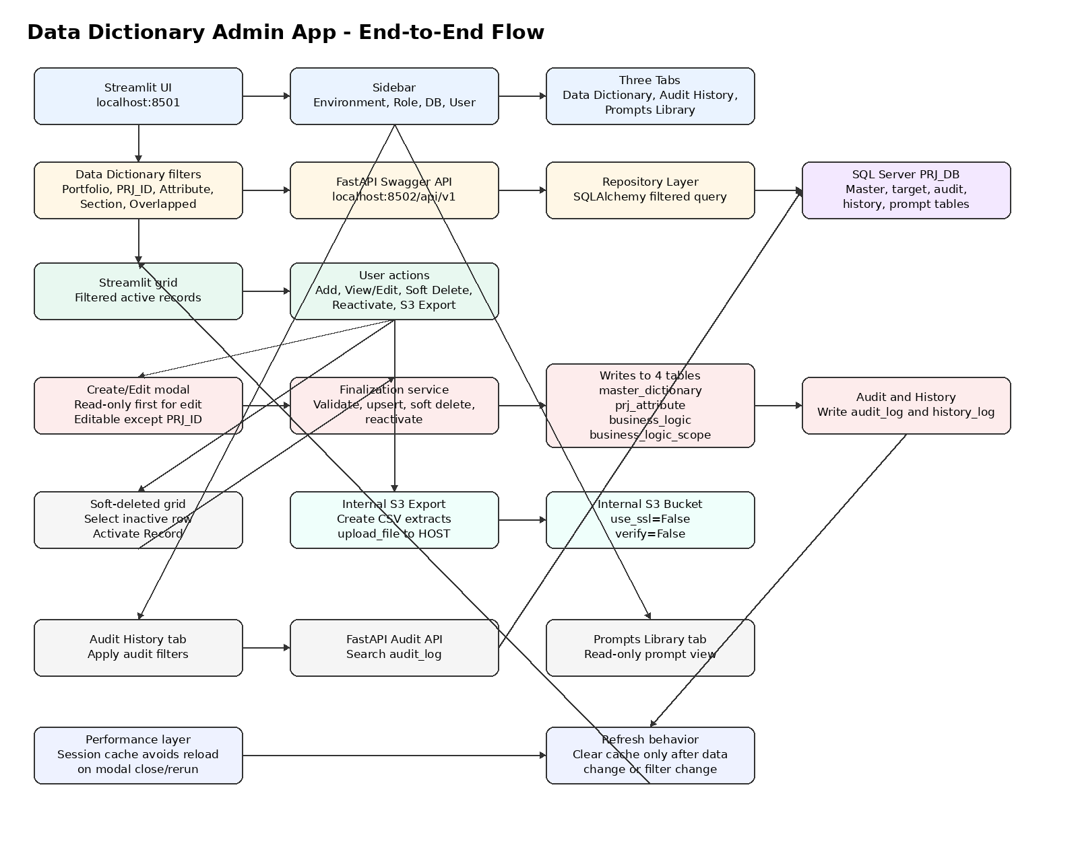
Figure 1: Data Dictionary Admin App - End-to-End Flow

6. Role-Based Access
The application provides a Role dropdown in the sidebar. Admin users can perform controlled data changes and exports, while normal users are restricted to read and filter capabilities.
Role | Access
Admin | Can add, edit, soft delete, reactivate, upload documents, and export extracts to S3.
User | Can view and filter Data Dictionary records. Admin-only sections are hidden.

7. Data Dictionary Flow
The Data Dictionary tab is the primary working area. Users apply filters and the Streamlit UI calls the FastAPI filter API. The API builds a SQLAlchemy query and fetches matching active records from SQL Server. Results are displayed in the Streamlit grid.
Filter | Description
Portfolio | Corporates, FI Banks, FI Insurance, Zeus Downstream, ALL.
PRJ_ID | Searches records by PRJ ID.
Attribute Name | Searches records by PRJ attribute name.
Attribute Description | Searches records by attribute description.
Section | Filters by where_in_financial_statement.
Overlapped Attribute | Identifies records used by more than one portfolio/sector.

8. Add New Attribute Flow
When an Admin user clicks Add New Attribute, a popup form opens. Mandatory fields are PRJ_ID, Attribute Name, and Section. After submission, the Finalization Service writes to the master and three target tables, and records audit/history entries.
Add New Attribute -> Validate mandatory fields -> Finalization Service -> master_dictionary + 3 target tables -> audit_log + history_log -> Refresh grid

9. Edit Attribute Flow
The user selects a row from the grid and clicks View/Edit. The popup opens in read-only mode. After clicking Edit, fields become editable except PRJ_ID. On upload/save, changes are persisted to master and target tables with audit/history tracking.
Select row -> View/Edit popup -> Read-only mode -> Edit -> Save -> Update DB tables -> Audit/History -> Refresh grid

10. Soft Delete and Reactivation Flow
The tool does not physically delete records. Soft delete sets is_active = 0 across the master and target tables. Reactivation sets is_active = 1 and returns the record to the active grid.
Action | Behavior
Soft Delete | Sets is_active = 0 in master_dictionary and the three target tables. The record is removed from the active grid.
Reactivate | Selects an inactive row and sets is_active = 1 in master_dictionary and the three target tables. The record appears again in the active grid.

11. Audit History Flow
The Audit History tab allows users to search audit records using business filters such as portfolio, PRJ_ID, attribute name, attribute description, section, and overlapped attribute. Audit records show user, timestamp, action type, old value, new value, source module, and batch ID.

12. Internal S3 Export Flow
Admin users can export latest active records from four tables to an internal S3-compatible bucket. The application creates timestamped CSV files and uploads them using boto3 upload_file with the configured internal endpoint.
Exported Table | Output
master_dictionary | master_dictionary.csv
prj_attribute | prj_attribute.csv
prj_attr_business_logic | prj_attr_business_logic.csv
prj_attr_business_logic_scope | prj_attr_business_logic_scope.csv

boto3 upload_file | endpoint_url = HOST | use_ssl = False | verify = False

13. Performance Improvements
Area | Improvement
Modal close | Close actions no longer trigger unnecessary full reloads.
Grid loading | Filtered data is cached in Streamlit session state.
DB connections | SQLAlchemy engine/session factory is cached and pooled.
Refresh behavior | Grid refresh happens only after filter change, manual refresh, insert, update, delete, or reactivation.
SQL Server | Additional indexes support faster filtering and audit queries.

14. Benefits
Benefit | Description
Controlled Updates | Users no longer need direct database access for standard Data Dictionary maintenance.
Auditability | Every insert, update, delete, and reactivation is traceable.
Consistency | Master and target tables are updated together through a service layer.
Role-Based Control | Admin actions are hidden from non-admin users.
Recovery Support | Soft-deleted records can be reactivated.
Downstream Readiness | Latest active records can be exported to internal S3 for downstream usage.
API-First Design | Swagger APIs enable testing and future integration.

15. One-Line Summary
The Data Dictionary Admin App is a controlled, role-based, audit-enabled Python application that allows users to manage PRJ Data Dictionary attributes through Streamlit UI and FastAPI APIs while keeping SQL Server tables, audit history, and internal S3 extracts synchronized.

