4/9/2021 clustering

### K Means

import numpy as np
import matplotlib.pyplot as plt

from sklearn.cluster import KMeans
from sklearn.datasets import make_blobs

plt . figure ( figsize = ( 12 , 12 ))

n_samples = 1500
random_state = 170
X , y = make_blobs ( n_samples = n_samples , random_state = random_state )

- Incorrect number of clusters
y_pred = KMeans ( n_clusters = 2 , random_state = random_state ) . fit_predict ( X )

plt . subplot ( 221 )
plt . scatter ( X [:, 0 ], X [:, 1 ], c = y_pred )
plt . title ( "Incorrect Number of Blobs" )

- Anisotropicly distributed data
transformation = [[ 0.60834549 , - 0.63667341 ], [ - 0.40887718 , 0.85253229 ]]
X_aniso = np . dot ( X , transformation )
y_pred = KMeans ( n_clusters = 3 , random_state = random_state ) . fit_predict ( X_aniso )

plt . subplot ( 222 )
plt . scatter ( X_aniso [:, 0 ], X_aniso [:, 1 ], c = y_pred )
plt . title ( "Anisotropicly Distributed Blobs" )

- Different variance
X_varied , y_varied = make_blobs ( n_samples = n_samples ,
cluster_std = [ 1.0 , 2.5 , 0.5 ],
random_state = random_state )
y_pred = KMeans ( n_clusters = 3 , random_state = random_state ) . fit_predict ( X_varied )

plt . subplot ( 223 )
plt . scatter ( X_varied [:, 0 ], X_varied [:, 1 ], c = y_pred )
plt . title ( "Unequal Variance" )

- Unevenly sized blobs
X_filtered = np . vstack (( X [ y == 0 ][: 500 ], X [ y == 1 ][: 100 ], X [ y == 2 ][: 10 ]))
y_pred = KMeans ( n_clusters = 3 ,
random_state = random_state ) . fit_predict ( X_filtered )

plt . subplot ( 224 )
plt . scatter ( X_filtered [:, 0 ], X_filtered [:, 1 ], c = y_pred )
plt . title ( "Unevenly Sized Blobs" )

plt . show ()

localhost:8888/nbconvert/html/Data Science/Module-16-Clustering/clustering.ipynb?download=false 1/6
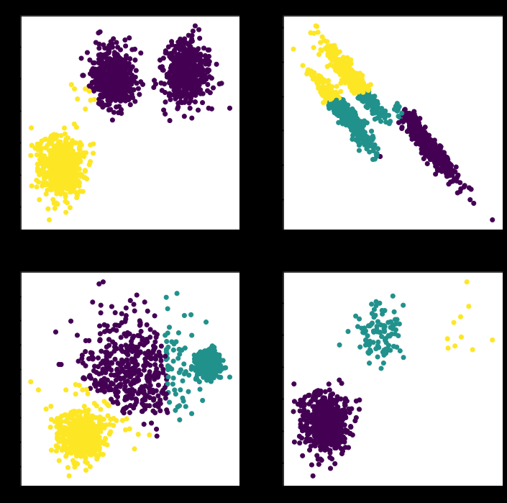
4/9/2021 clustering

from time import time

import numpy as np
from scipy import ndimage
from matplotlib import pyplot as plt

from sklearn import manifold , datasets

X , y = datasets . load_digits ( return_X_y = True )
n_samples , n_features = X . shape

np . random . seed ( 0 )

def nudge_images ( X , y ):
- Having a larger dataset shows more clearly the behavior of the
- methods, but we multiply the size of the dataset only by 2, as the
- cost of the hierarchical clustering methods are strongly
- super-linear in n_samples
localhost:8888/nbconvert/html/Data Science/Module-16-Clustering/clustering.ipynb?download=false 2/6
4/9/2021 clustering
shift = lambda x : ndimage . shift ( x . reshape (( 8 , 8 )), . 3 * np . random . normal ( size = 2 ), mod
X = np . concatenate ([ X , np . apply_along_axis ( shift , 1 , X )])
Y = np . concatenate ([ y , y ], axis = 0 )
return X , Y

X , y = nudge_images ( X , y )

#----------------------------------------------------------------------
- Visualize the clustering
def plot_clustering ( X_red , labels , title = None ):
x_min , x_max = np . min ( X_red , axis = 0 ), np . max ( X_red , axis = 0 )
X_red = ( X_red - x_min ) / ( x_max - x_min )

plt . figure ( figsize = ( 6 , 4 ))
for i in range ( X_red . shape [ 0 ]):
plt . text ( X_red [ i , 0 ], X_red [ i , 1 ], str ( y [ i ]),
color = plt . cm . nipy_spectral ( labels [ i ] / 10. ), fontdict = { 'weight' : 'bold'

plt . xticks ([])
plt . yticks ([])
if title is not None :
plt . title ( title , size = 17 )
plt . axis ( 'off' )
plt . tight_layout ( rect = [ 0 , 0.03 , 1 , 0.95 ])

#----------------------------------------------------------------------
- 2D embedding of the digits dataset
print ( "Computing embedding" )
X_red = manifold . SpectralEmbedding ( n_components = 2 ) . fit_transform ( X )
print ( "Done." )

from sklearn.cluster import AgglomerativeClustering

for linkage in ( 'ward' , 'average' , 'complete' , 'single' ):
clustering = AgglomerativeClustering ( linkage = linkage , n_clusters = 10 )
t0 = time ()
clustering . fit ( X_red )
print ( "%s :\t%.2fs" % ( linkage , time () - t0 ))

plot_clustering ( X_red , clustering . labels_ , "%s linkage" % linkage )

plt . show ()
Computing embedding
Done.
ward : 1.56s
average : 1.63s
complete : 1.34s
single : 0.20s

localhost:8888/nbconvert/html/Data Science/Module-16-Clustering/clustering.ipynb?download=false 3/6
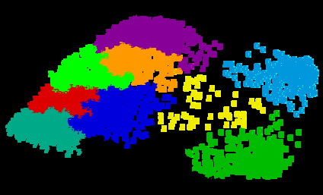
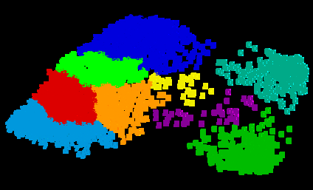
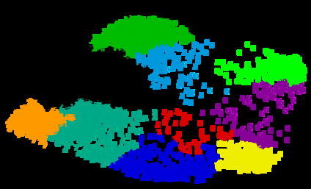
4/9/2021 clustering

localhost:8888/nbconvert/html/Data Science/Module-16-Clustering/clustering.ipynb?download=false 4/6
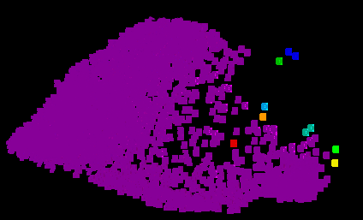
4/9/2021 clustering

DBSCAN

import numpy as np

from sklearn.cluster import DBSCAN
from sklearn import metrics
from sklearn.datasets import make_blobs
from sklearn.preprocessing import StandardScaler

- #############################################################################
- Generate sample data
centers = [[ 1 , 1 ], [ - 1 , - 1 ], [ 1 , - 1 ]]
X , labels_true = make_blobs ( n_samples = 750 , centers = centers , cluster_std = 0.4 ,
random_state = 0 )

X = StandardScaler () . fit_transform ( X )

- #############################################################################
- Compute DBSCAN
db = DBSCAN ( eps = 0.3 , min_samples = 10 ) . fit ( X )
core_samples_mask = np . zeros_like ( db . labels_ , dtype = bool )
core_samples_mask [ db . core_sample_indices_ ] = True
labels = db . labels_

- Number of clusters in labels, ignoring noise if present.
n_clusters_ = len ( set ( labels )) - ( 1 if - 1 in labels else 0 )
n_noise_ = list ( labels ) . count ( - 1 )

print ( 'Estimated number of clusters: %d' % n_clusters_ )
print ( 'Estimated number of noise points: %d' % n_noise_ )
print ( "Homogeneity: %0.3f" % metrics . homogeneity_score ( labels_true , labels ))
print ( "Completeness: %0.3f" % metrics . completeness_score ( labels_true , labels ))
print ( "V-measure: %0.3f" % metrics . v_measure_score ( labels_true , labels ))
print ( "Adjusted Rand Index: %0.3f"
- metrics. adjusted_rand_score ( labels_true , labels ))
print ( "Adjusted Mutual Information: %0.3f"
- metrics. adjusted_mutual_info_score ( labels_true , labels ))
print ( "Silhouette Coefficient: %0.3f"
- metrics. silhouette_score ( X , labels ))

- #############################################################################

localhost:8888/nbconvert/html/Data Science/Module-16-Clustering/clustering.ipynb?download=false 5/6
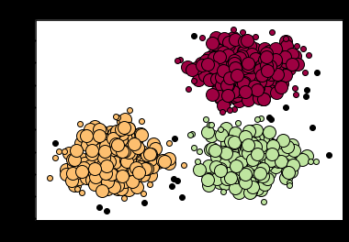
4/9/2021 clustering
- Plot result
import matplotlib.pyplot as plt

- Black removed and is used for noise instead.
unique_labels = set ( labels )
colors = [ plt . cm . Spectral ( each )
for each in np . linspace ( 0 , 1 , len ( unique_labels ))]
for k , col in zip ( unique_labels , colors ):
if k == - 1 :
- Black used for noise.
col = [ 0 , 0 , 0 , 1 ]

class_member_mask = ( labels == k )

xy = X [ class_member_mask & core_samples_mask ]
plt . plot ( xy [:, 0 ], xy [:, 1 ], 'o' , markerfacecolor = tuple ( col ),
markeredgecolor = 'k' , markersize = 14 )

xy = X [ class_member_mask & ~ core_samples_mask ]
plt . plot ( xy [:, 0 ], xy [:, 1 ], 'o' , markerfacecolor = tuple ( col ),
markeredgecolor = 'k' , markersize = 6 )

plt . title ( 'Estimated number of clusters: %d' % n_clusters_ )
plt . show ()
Estimated number of clusters: 3
Estimated number of noise points: 18
Homogeneity: 0.953
Completeness: 0.883
V-measure: 0.917
Adjusted Rand Index: 0.952
Adjusted Mutual Information: 0.916
Silhouette Coefficient: 0.626

localhost:8888/nbconvert/html/Data Science/Module-16-Clustering/clustering.ipynb?download=false 6/6

