**Aim : Matrix Multiplication using MapReduce.**

MapReduce is a technique in which a huge program is subdivided into small tasks and run parallelly to make computation faster, save time, and mostly used in distributed systems. It has 2 important parts:

Mapper : It takes raw data input and organizes into key, value pairs. For example, In a dictionary, you search for the word “Data” and its associated meaning is “facts and statistics collected together for reference or analysis”. Here the Key is Data and the Value associated with is facts and statistics collected together for reference or analysis.

Reducer : It is responsible for processing data in parallel and produce final output.

MStep 1 : Open terminal > Create two text files of matrix m1.txt and m2.txt.

[cloudera@quickstart ~]$ cd ~/Desktop

[cloudera@quickstart Desktop]$ mkdir matrix_mul

[cloudera@quickstart Desktop]$ cd matrix_mul

[cloudera@quickstart matrix_mul]$ gedit m1.txt

m1

**1 2 3**

**4 5 6**

[cloudera@quickstart matrix_mul]$ gedit m2.txt

m2

**4 5 6**

**7 8 9**

**1 2 6**

Step 2 : Create Mapper file mapper.py

[cloudera@quickstart matrix_mul]$ gedit mapper.py

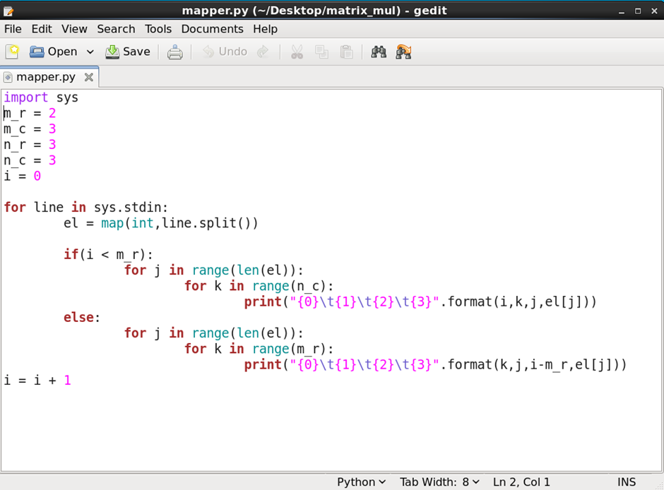

[cloudera@quickstart matrix_mul]$ cat m1.txt m2.txt | python **mapper.py Mapper Output :**

0 0 0 1

0 1 0 1

0 2 0 1

0 0 1 2

0 1 1 2

0 2 1 2

0 0 2 3

0 1 2 3

0 2 2 3

0 0 0 4

0 1 0 4

0 2 0 4

0 0 1 5

0 1 1 5

0 2 1 5

0 0 2 6

0 1 2 6

0 2 2 6

0 0 0 4

0 1 0 4

0 2 0 4

0 0 1 5

0 1 1 5

0 2 1 5

0 0 2 6

0 1 2 6

0 2 2 6

0 0 0 7

0 1 0 7

0 2 0 7

0 0 1 8

0 1 1 8

0 2 1 8

0 0 2 9

0 1 2 9

0 2 2 9

0 0 0 1

0 1 0 1

0 2 0 1

0 0 1 2

0 1 1 2

0 2 1 2

0 0 2 6

0 1 2 6

0 2 2 6

Step 3 : Create Reducer file reducer.py

[cloudera@quickstart matrix_mul]$ gedit reducer.py

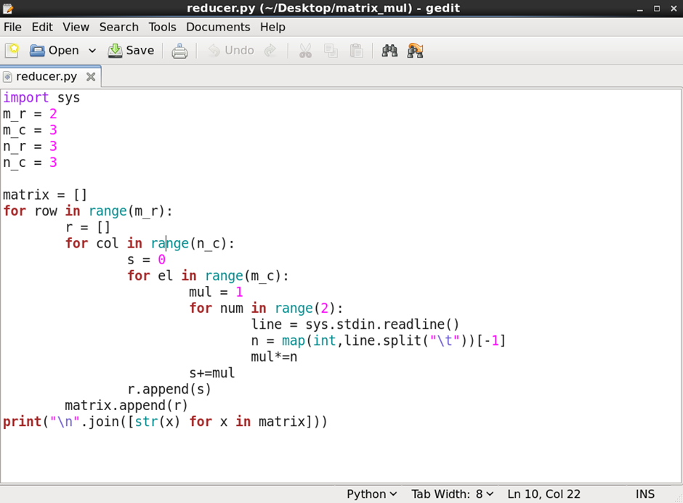

Step 4 : to get matrix multiplication :

[cloudera@quickstart matrix_mul]$ cat m1.txt m2.txt | python mapper.py | python reducer.py

**Output :**

**[7, 37, 91]**

**[61, 127, 217]**