DEPARTMENT OF COMPUTER SCIENCE & ENGINEERING (DATA SCIENCE)
ABES ENGINEERING COLLEGE (AKTU), NOIDA
SOFTWARE REQUIREMENTS
SPECIFICATION (SRS)
Project Title: AI-Based Resume Screening and Candidate Shortlisting System
Standard Academic Compliance: IEEE Std 830-1998
————————————————————————————
SUBMITTED BY:  1. Ankita Kumari (Roll No: 2400321540035)  Degree: Bachelor of Technology (B.Tech)  Academic Year: 2024-2028 | UNDER THE GUIDANCE OF:  Prof. / Dr. [Supervisor Name]  [Designation / Title]  Department of Computer Science & Engg.(Data Science)  Status: 3rd Year Project Specification  Date of Submission-[28-10-2026]

Document Revision & Approval History
Version | Date | Description / Major Changes | Prepared By | Reviewed By
0.1 | 28-Oct-2026 | Initial Draft & Scope Definition (AI-Based Resume Screening) | Ankita Kumari | Project Guide
1.0 | [DD-Mon-2026] | Final 3rd Year Mid-Term SRS Baseline | Ankita Kumari | HOD / Committee

Guidance Note: This Software Requirements Specification document conforms to the IEEE 830-1998 standard recommended practice. All sections are strictly designed for 3rd-year university lab evaluation, project reviews, and system design baselines.

1. Introduction
1.1 Purpose
The purpose of this Software Requirements Specification (SRS) document is to provide a complete, clear, and unambiguous definition of the functionality, external interfaces, performance targets, and constraints of the proposed system: 'AI-Based Resume Screening and Candidate Shortlisting System'. This specification serves as a binding reference agreement between the student developer, project evaluators, the academic supervisor, and prospective end users (recruiters and HR teams) during the 3rd-year engineering curriculum.
1.2 Scope of the System
The proposed application is designed to solve the slow, inconsistent and bias-prone manual screening of large numbers of resumes against a job description by delivering an end-to-end automated decision-support tool. Recruiters paste a job description, upload resumes, and receive a ranked shortlist with the reasons behind every score. Key boundary guidelines include:
- In-Scope Capabilities: Job-description and resume ingestion (PDF, DOCX, TXT), text extraction, anonymisation of personal details, feature engineering (TF-IDF similarity, skill overlap, experience, role match), machine-learning match scoring, ranked shortlist with matched/missing skill explanation, and CSV export.
- Out-of-Scope Boundaries: User accounts and authentication, a persistent database, OCR of scanned (image-only) resumes, integration with Applicant Tracking Systems or HR/ERP platforms, and any fully automated hiring decision. A human always makes the final decision.
- Expected Benefits: Faster first-round screening (about 0.1 s to score 6 resumes), consistent criteria for every candidate, transparent matched/missing-skill explanations, and reduced exposure of personal details (name, email, phone, links) during scoring.
1.3 Definitions, Acronyms, and Abbreviations
Category | Term / Acronym | Definition / Standard Context
Standard | SRS | Software Requirements Specification (IEEE Std 830-1998 format).
Machine Learning | TF-IDF | Term Frequency - Inverse Document Frequency; weights words by importance to convert text into numeric vectors.
Machine Learning | Cosine Similarity | Measure of similarity between the TF-IDF vectors of a resume and a job description (0 to 1).
Machine Learning | Logistic Regression | Linear classifier that outputs the probability that a candidate should be selected.
Evaluation | ROC-AUC / F1 | Metrics for classifier quality: area under the ROC curve; harmonic mean of precision and recall.
Evaluation | Precision@K | Share of the top-K ranked candidates that are truly suitable.
HR Domain | ATS | Applicant Tracking System: software used by recruiters to manage applications.
Framework | Streamlit | Python framework used to build the interactive web front end.
Data | CSV | Comma-Separated Values file used for the dataset and the exported shortlist.
Legal | DPDP Act 2023 | Digital Personal Data Protection Act, 2023 (India).
1.4 References
- IEEE Std 830-1998: IEEE Recommended Practice for Software Requirements Specifications.
- Software Engineering (10th Edition): Ian Sommerville, Pearson Education.
- Machine-Learning Library: Pedregosa, F. et al. (2011). Scikit-learn: Machine Learning in Python. Journal of Machine Learning Research, 12, 2825-2830.
- Text Weighting: Salton, G. and Buckley, C. (1988). Term-weighting approaches in automatic text retrieval. Information Processing & Management, 24(5), 513-523.
- Framework Documentation: Streamlit Documentation, https://docs.streamlit.io
- Legislation: Government of India (2023). The Digital Personal Data Protection Act, 2023.
- Project Repository: https://github.com/Ankitakumari13/AI-BASED-RESUME-SCREENING
1.5 Document Overview
The remainder of this SRS is partitioned into structural sections: Section 2 outlines the product perspective, target user personas, operational context, and design constraints. Section 3 itemizes detailed functional requirements organized into logical software modules. Section 4 specifies external interfaces (UI, Hardware, Software, Network). Section 5 defines non-functional attributes (Performance, Reliability, Security). Finally, Section 6 provides standard academic modeling diagrams.
2. Overall Description
2.1 Product Perspective
The project is a self-contained, single-process machine-learning web application consisting of a presentation layer (Streamlit, app.py), a Python screening-logic layer (screening.py) and a pre-trained scikit-learn model loaded from a .joblib file. It has no database and makes no external network calls at screening time: uploaded resumes are processed in memory, results are held in the session, and the shortlist is exported as a CSV file.
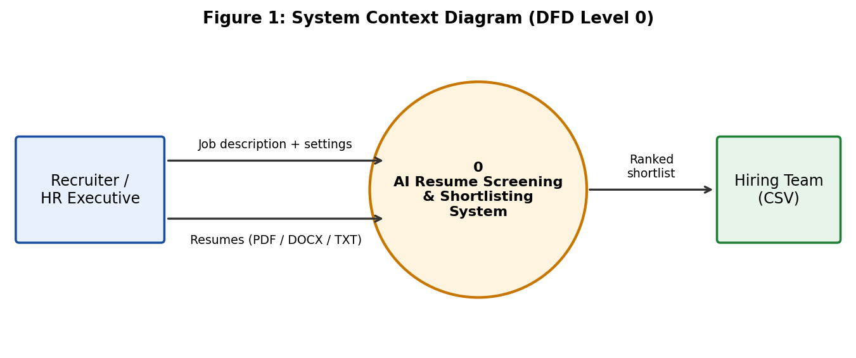

2.2 User Classes and Characteristics
The target software accommodates distinct user personas with varying access hierarchies:
User Role / Persona | Technical Proficiency | Core Responsibilities & Rights
Recruiter / HR Executive | Intermediate (general web user, no ML knowledge) | Primary user: enters the job description, uploads resumes, sets top-N and role, runs screening, reviews the ranked shortlist and explanations, downloads the CSV.
Hiring Manager / Reviewer | Basic | Reads the exported shortlist and matched/missing-skill explanations to make the final hiring decision; read-only consumer of results.
Developer / Model Maintainer | High (Python, ML) | Regenerates the dataset, retrains and evaluates models in the notebook, saves the .joblib model, deploys the app (GitHub, Streamlit Cloud).
2.3 Operating Environment
The application operates within the following software and hardware environments:
- Client Requirements: Modern web browser (Google Chrome, Mozilla Firefox, Edge, Safari); minimum display resolution 1366x768 (wide layout) with responsive view on smaller screens.
- Server Runtime Environment: Windows, Linux or macOS; Python 3.11+ with streamlit>=1.50, scikit-learn==1.8.0, pandas, NumPy, SciPy, joblib, pypdf and python-docx (see requirements.txt); or Streamlit Community Cloud.
- Database Storage Tier: Not required. The training dataset is a CSV file (10,000 rows) and the trained model is a single .joblib file.
2.4 Design and Implementation Constraints
- Academic Budget Constraint: Free-tier hosting only (local execution or Streamlit Community Cloud) and open-source libraries.
- Data Constraint: The model is trained on a synthetic dataset; scores are decision support and must be validated on real hiring data before real use.
- Technical Constraints: scikit-learn is pinned to 1.8.0 so the saved model loads correctly; only text-based resumes are supported (no OCR); skill matching uses a fixed vocabulary of 125 skills with synonym normalisation.
2.5 Assumptions and Dependencies
- Assumptions: Resumes are text-based and written in English; the job description names recognisable skills and, ideally, one of the 15 supported roles; users have a modern browser and a working Internet connection when using the hosted app.
- Dependencies: Availability of the open-source libraries (Streamlit, scikit-learn, pypdf, python-docx), GitHub for source hosting and Streamlit Community Cloud for deployment.
3. System Features and Functional Requirements
Requirements are categorized by functional subsystem modules with unique requirement identifiers (FR-x.x):
3.1 Module 1: Job Description and Resume Input
Req ID | Feature Description | Input / Validation Rule | Priority
FR-1.1 | Job Description Entry | Free-text area; error shown if empty | High
FR-1.2 | Resume Upload | Multiple files; only .pdf, .docx and .txt accepted | High
FR-1.3 | Text Extraction | pypdf (PDF), python-docx (DOCX), UTF-8 decode (TXT); empty, scanned or unreadable files skipped with a warning | High
FR-1.4 | Screening Settings and Demo | Top-N slider 1-20 (default 5); optional role from 15 roles or auto-detected from the JD; demo loader (sample JD + 6 resumes) | Medium
3.2 Module 2: Screening and Scoring Engine
Req ID | Feature Description | Input / Validation Rule | Priority
FR-2.1 | Resume Anonymisation | Removes candidate name, emails, phone numbers and links; lower-cases text before scoring | High
FR-2.2 | Feature Engineering | TF-IDF cosine similarity, skill overlap (125-skill vocabulary with synonyms), years of experience, resume/JD length, role match | High
FR-2.3 | Match Probability Prediction | Logistic Regression on TF-IDF of resume and JD plus scaled match features; output probability 0-1 | High
FR-2.4 | Ranking and Recommendation | Sort by probability (descending); "Recommend" if score >= 0.5; Shortlisted if rank <= N and recommended | High
3.3 Module 3: Results, Explanation and Export
Req ID | Feature Description | Input / Validation Rule | Priority
FR-3.1 | Summary Metrics | Candidates screened, recommended, shortlisted and average match score | Medium
FR-3.2 | Ranked Table and Chart | Rank, candidate, match score, skill match, experience, recommendation, shortlisted flag; horizontal bar chart of scores | High
FR-3.3 | Per-Candidate Explanation | Matched skills, missing skills, experience found and a 2,500-character resume preview | High
FR-3.4 | CSV Export | Download of the ranked results as shortlist.csv (UTF-8) | Medium
3.4 Module 4: Model Development and Maintenance (Offline)
Req ID | Feature Description | Input / Validation Rule | Priority
FR-4.1 | Synthetic Dataset Generation | generate_dataset.py, seed 42: 10,000 rows, 1,500 job descriptions, 15 roles, hidden weighted match score plus noise | Medium
FR-4.2 | Model Training and Evaluation | 80/20 stratified split; compare Logistic Regression, Linear SVM, Random Forest, Gradient Boosting and Naive Bayes on Accuracy, Precision, Recall, F1, ROC-AUC | High
FR-4.3 | Model Persistence and Loading | TF-IDF vectorizers, scaler and Logistic Regression saved to .joblib; loaded once per session (cached) | High
4. External Interface Requirements
4.1 User Interfaces (UI)
The interface is a single-page Streamlit web application with a settings sidebar, a two-column input area (job description and resume upload), one primary action button, and a results area. Invalid actions give immediate visual feedback (error banner for a missing job description or resume, warning for unreadable files, success banner when demo data is loaded).
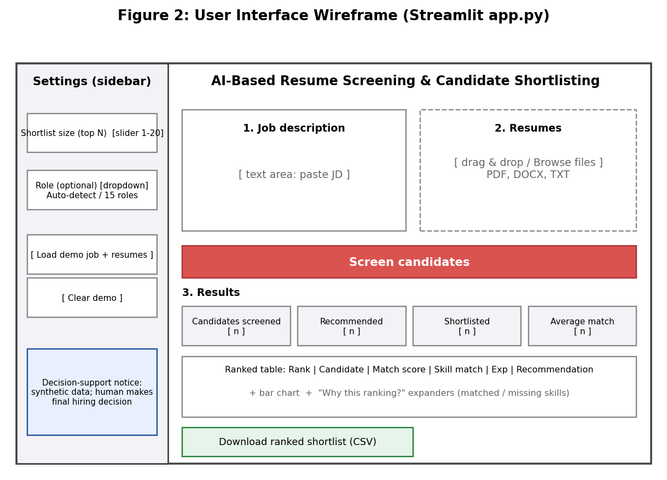

4.2 Hardware Interfaces
Specification of physical interaction points:
- Standard Deployment: Standard input/output peripherals (keyboard, mouse, display >= 720p). No special hardware is required.
- Embedded / IoT Variants: Not applicable to this project.
4.3 Software Interfaces
- Python Libraries: scikit-learn 1.8.0 (TF-IDF, Logistic Regression), SciPy, pandas, NumPy and joblib, called in-process.
- File Parsers: pypdf for PDF and python-docx for DOCX resumes; TXT read directly.
- Hosting and Version Control: GitHub repository and Streamlit Community Cloud for deployment.
4.4 Communication Interfaces
- Web Traffic Protocol: HTTP on the local Streamlit server (default port 8501) and HTTPS when hosted on Streamlit Community Cloud.
- Data Serialization: Shortlist exported as UTF-8 CSV; trained model stored as a joblib binary file; browser-server UI updates handled by Streamlit.
5. Non-Functional Requirements (NFRs)
Attribute | Target Metric / Standard | Verification & Testing Method
5.1 Performance | Scoring of 6 resumes measured at about 0.11 s; target <= 5 s for 50 resumes on a standard laptop; model loaded once per session. | Timing of Screener.score() on sample and larger resume sets.
5.2 Security and Privacy | Name, email, phone and links removed before scoring; uploaded resumes held in memory for the session only and not stored by the app; supports DPDP Act 2023 principles. | Unit checks of clean_resume(); code review of file handling.
5.3 Reliability | Unreadable, empty or scanned files skipped with a warning without crashing; scikit-learn pinned to 1.8.0 so the saved model always loads. | Negative tests with corrupt, empty and image-only files; requirements.txt install test.
5.4 Portability | Runs on Windows, Linux and macOS (Python 3.11+); works in Chrome, Edge, Firefox and Safari. | Run locally and on Streamlit Cloud; browser viewport checks.
5.5 Model Quality | Accuracy >= 85%, ROC-AUC >= 0.93 on the 20% hold-out set (achieved 85.6% and 0.936); Precision@10 per role >= 0.9 (achieved 0.973). | Classification report, confusion matrix, cross-validation and ranking evaluation in the notebook.
5.6 Transparency and Fairness | Every score shown with matched/missing skills; tool clearly labelled decision support trained on synthetic data; a human makes the final decision. | UI review; explanation expanders checked against sample resumes.
6. System Design and Analysis Models
University evaluation rubrics require standard graphical analysis models illustrating the dynamic and static behavior of the application:
Diagram Type | Objective & Scope | Deliverable Format
Use Case Diagram | Maps Recruiter, Hiring Manager and Developer actors to system functions (Figure 3). | UML use case diagram.
Data Flow Diagram (DFD) | Level 0 context (Figure 1) and Level 1 decomposition into five processes (Figure 4). | Gane-Sarson style data flow diagrams.
Entity-Relationship (ERD) | Logical data model of job descriptions, resumes, roles and screening results (Figure 5); no RDBMS is used. | ER diagram with keys and cardinalities.
Activity / Sequence Diagram | Message flow for the core "Screen candidates" feature (Figure 6). | UML sequence diagram.
6.1 Use Case Model
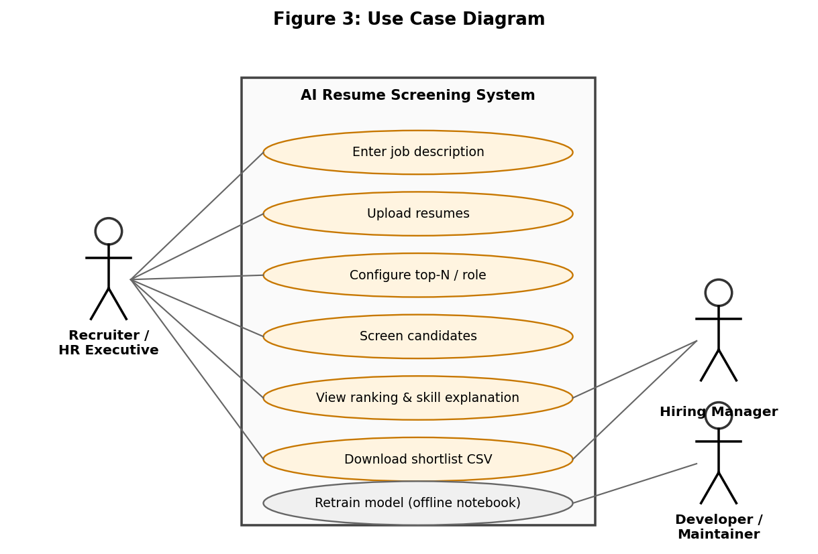
6.2 Data Flow Model (Level 1)
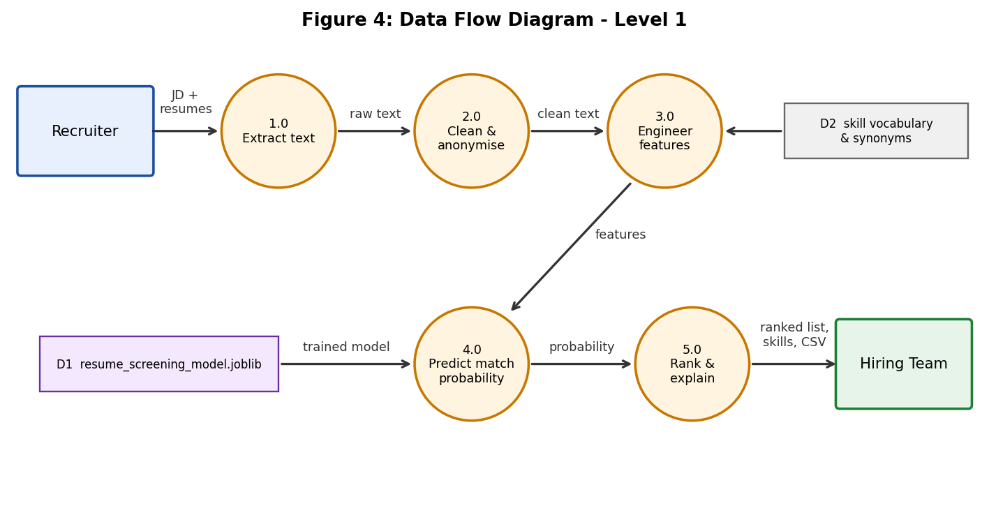
6.3 Data Model
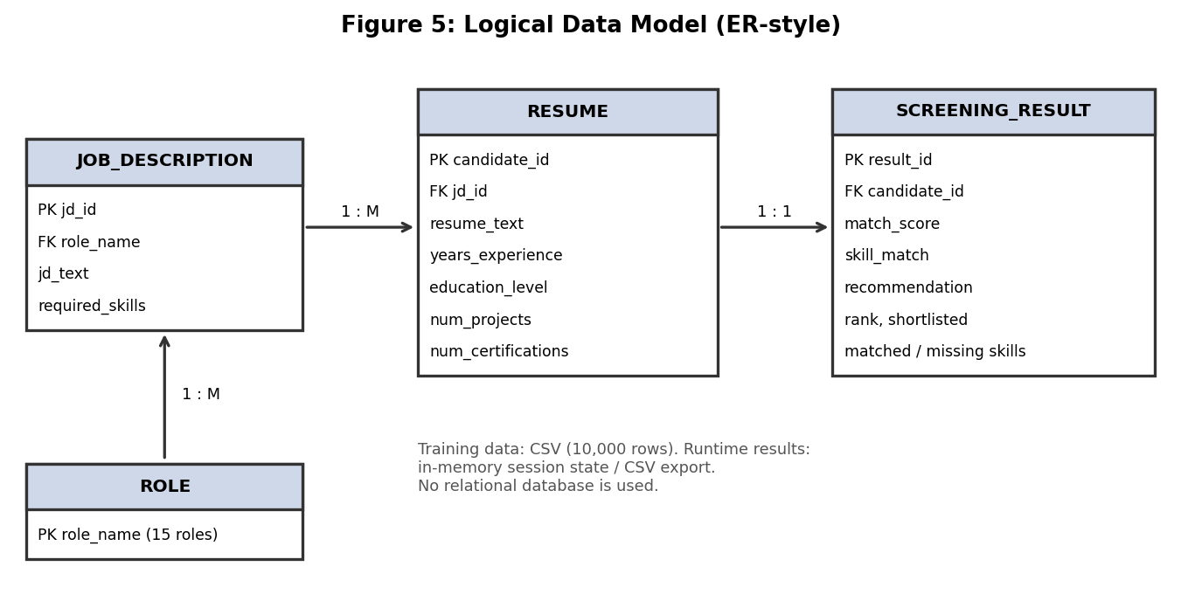
6.4 Sequence Model
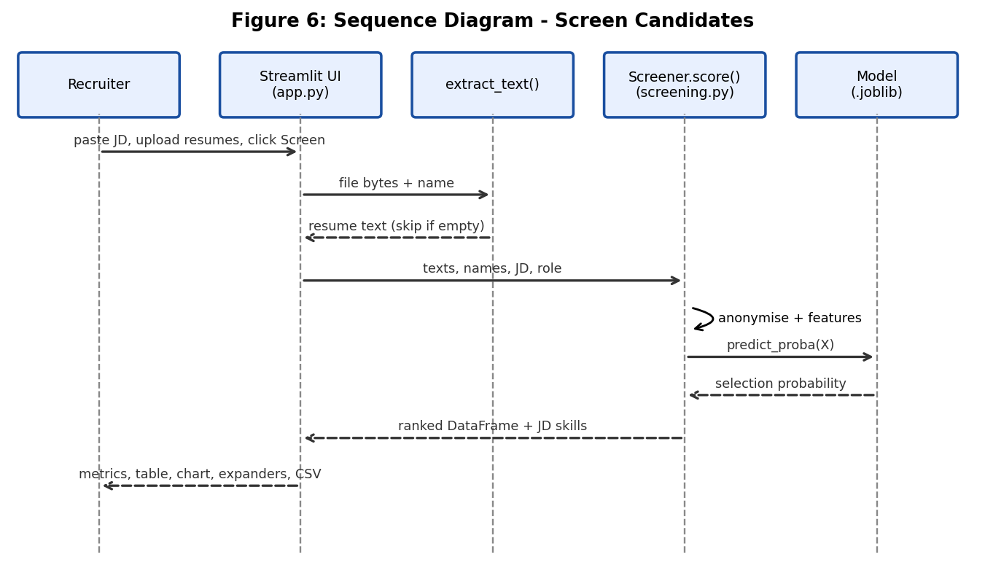
7. Academic Review & Sign-Off
This Software Requirements Specification document has been submitted and reviewed by the academic supervisory panel:
Project Coordinator / Guide | Internal Examiner | Head of Department (HOD)
Signature: __________________  Date: __________________ | Signature: __________________  Date: __________________ | Signature: __________________  Date: __________________

