Project Synopsis — Submission Template
HCLTech Career Shaper Programme | III Year Industry Project | 2025-26

Field | Details (Learner to complete)
Project Title | AI-Based Resume Screening and Candidate Shortlisting System
Project No. | 34
Domain | Digital-Data-AI / AIML
Difficulty | Advanced
Duration | 4 Weeks
Format | Individual Project
Learner Name | Ankita Kumari
Roll Number | 2400321540035
College / Campus | ABES Engineering College (AKTU), Noida
Mentor Name | [FILL IN]
Submission Date | [FILL IN]

1. Problem Statement
Recruiters and HR teams at companies of every size receive hundreds of resumes for a single opening, and screening them by hand is slow, inconsistent and prone to bias, so good candidates are often missed and hiring is delayed. This project addresses that by automatically comparing each resume against the job description and ranking candidates by how well they match, so that recruiters can concentrate on the most relevant profiles first.

2. Proposed Solution & Approach
I built an AI-based resume screening and candidate shortlisting system with a Streamlit web interface. A recruiter pastes a job description and uploads resumes (PDF, DOCX or TXT); the system extracts and anonymises the text (name, email, phone and links are removed), computes match features such as TF-IDF cosine similarity, required-skill overlap, years of experience and role match, and scores each candidate with a Logistic Regression model trained on TF-IDF text plus these features. The output is a ranked shortlist with a selection probability, the matched and missing skills for each candidate, and a downloadable CSV. Scores are intended as decision support, not as an automatic hiring decision.

3. System Architecture
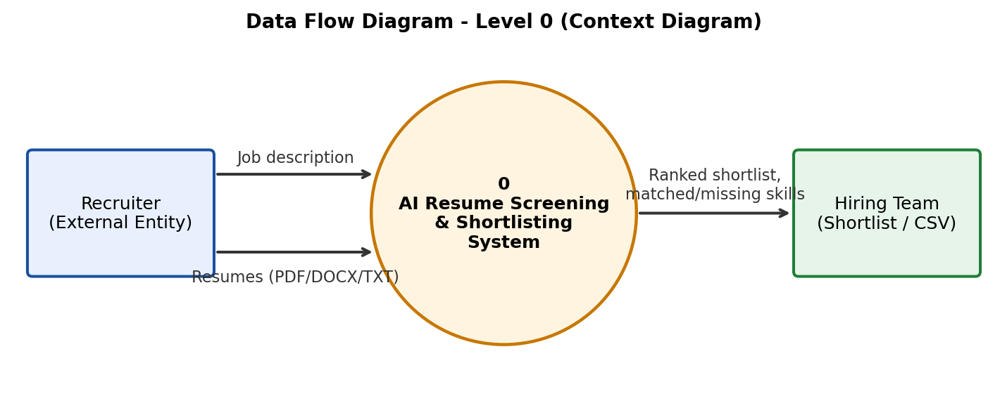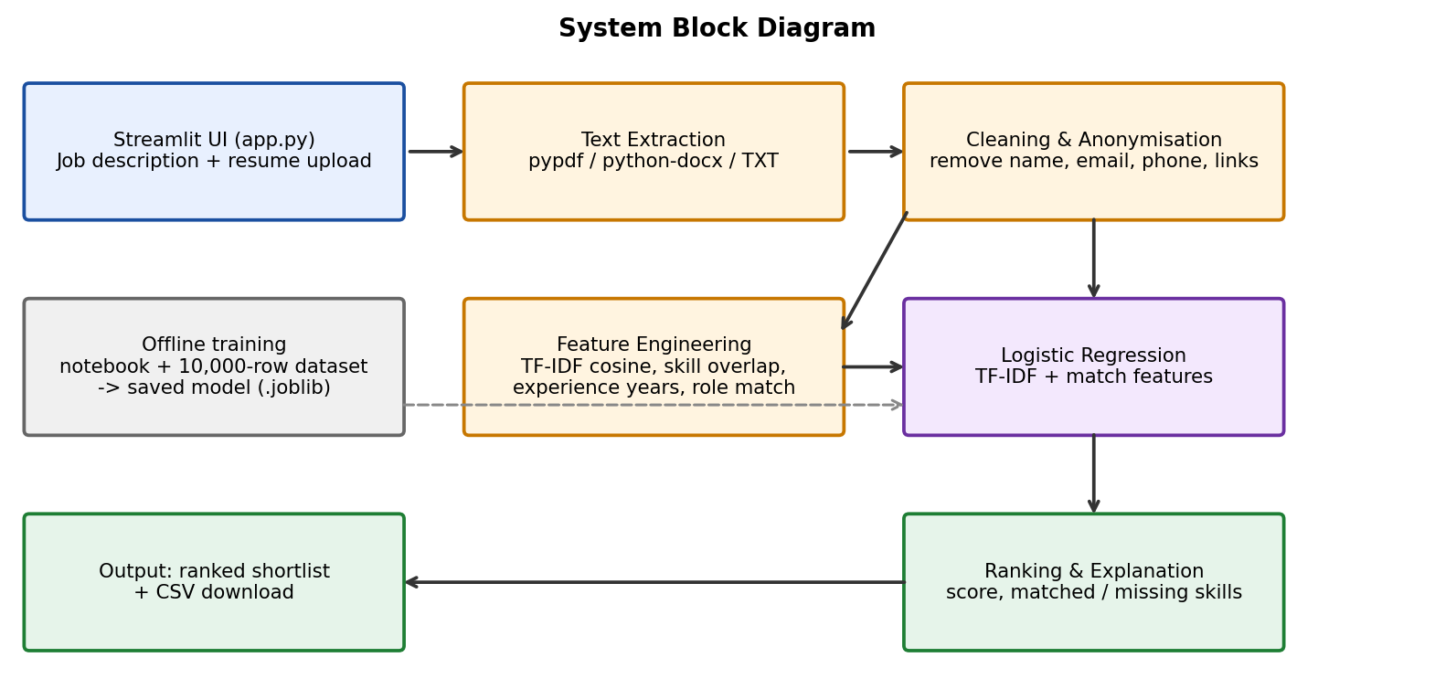

4. Technology Stack
Frontend / UI: Streamlit (app.py)
Backend / Logic: Python 3 - text extraction (pypdf, python-docx), cleaning and feature engineering (screening.py)
Database: None (CSV dataset; trained model stored as a .joblib file)
AI/ML Framework: scikit-learn (TF-IDF, Logistic Regression), SciPy, pandas, NumPy, joblib
Visualisation: Matplotlib and Seaborn in the analysis notebook; Streamlit tables in the app
Hardware: None (runs on a standard laptop / Streamlit Cloud)

5. Dataset Used
Dataset file name: resume_screening_dataset.csv (synthetic, created with generate_dataset.py)
Number of rows: 10,000
Number of columns: 10
Key columns (list 5): Resume, Job_Description, Role, Years_Experience, Decision (select / reject)
Any additional data collected: None. The other columns are Candidate_ID, Education_Level, Num_Projects, Num_Certifications and Reason_for_decision (used for analysis only, not for training). The dataset covers 15 job roles and is balanced as 4,500 select / 5,500 reject.

6. Key Results & Metrics
Metric 1: Model Accuracy - 85.6% on a held-out test set of 2,000 resumes (ROC-AUC 0.936)
Metric 2: Response Time - about 0.1 s to score and rank 6 resumes against one job description
Metric 3: F1 Score - 0.842 for the 'select' class (precision 0.833, recall 0.850); Precision@10 per role averages 0.973 against a random baseline of 0.450
Business value achieved: Reduces manual first-round screening to a ranked list with explanations of which required skills are matched or missing, making shortlisting faster, more consistent and easier to justify. Results are on a synthetic dataset, so real-world performance should be validated on actual hiring data.

7. Challenges Faced & How Resolved
Challenge 1: The Reason_for_decision column gave 100% accuracy on its own because it states the outcome (label leakage) → Resolution: excluded it from all models and used it only for analysis.
Challenge 2: Text-only models performed poorly (TF-IDF Logistic Regression about 69% accuracy) because a resume and a job description are only meaningfully compared against each other → Resolution: engineered match features (cosine similarity, skill overlap, years of experience, role match), which raised accuracy to about 86%.
Challenge 3: Resumes contain personal details and arrive in different formats → Resolution: added anonymisation (name, email, phone, links removed) before scoring and text extraction for PDF, DOCX and TXT; scanned image-only PDFs are skipped as they have no text layer.

8. References
1. Pedregosa, F. et al. (2011). Scikit-learn: Machine Learning in Python. Journal of Machine Learning Research, 12, 2825-2830.
2. Salton, G. and Buckley, C. (1988). Term-weighting approaches in automatic text retrieval. Information Processing & Management, 24(5), 513-523.
3. Streamlit Documentation. https://docs.streamlit.io
4. Government of India (2023). The Digital Personal Data Protection Act, 2023.

9. Ethical Compliance Declaration
I confirm that:
☐ All dataset usage complies with the source licence.
☐ No personally identifiable information (PII) is stored without consent.
☐ AI tools used for code/writing are disclosed in the Appendix.
☐ This project complies with the DPDP Act 2023 where applicable.
Learner Signature: _________________________ Date: ________________

Submit this file as 'Project_Synopsis_[YourName]_[RollNo].docx' | HCLTech Career Shaper Programme 2025-26

