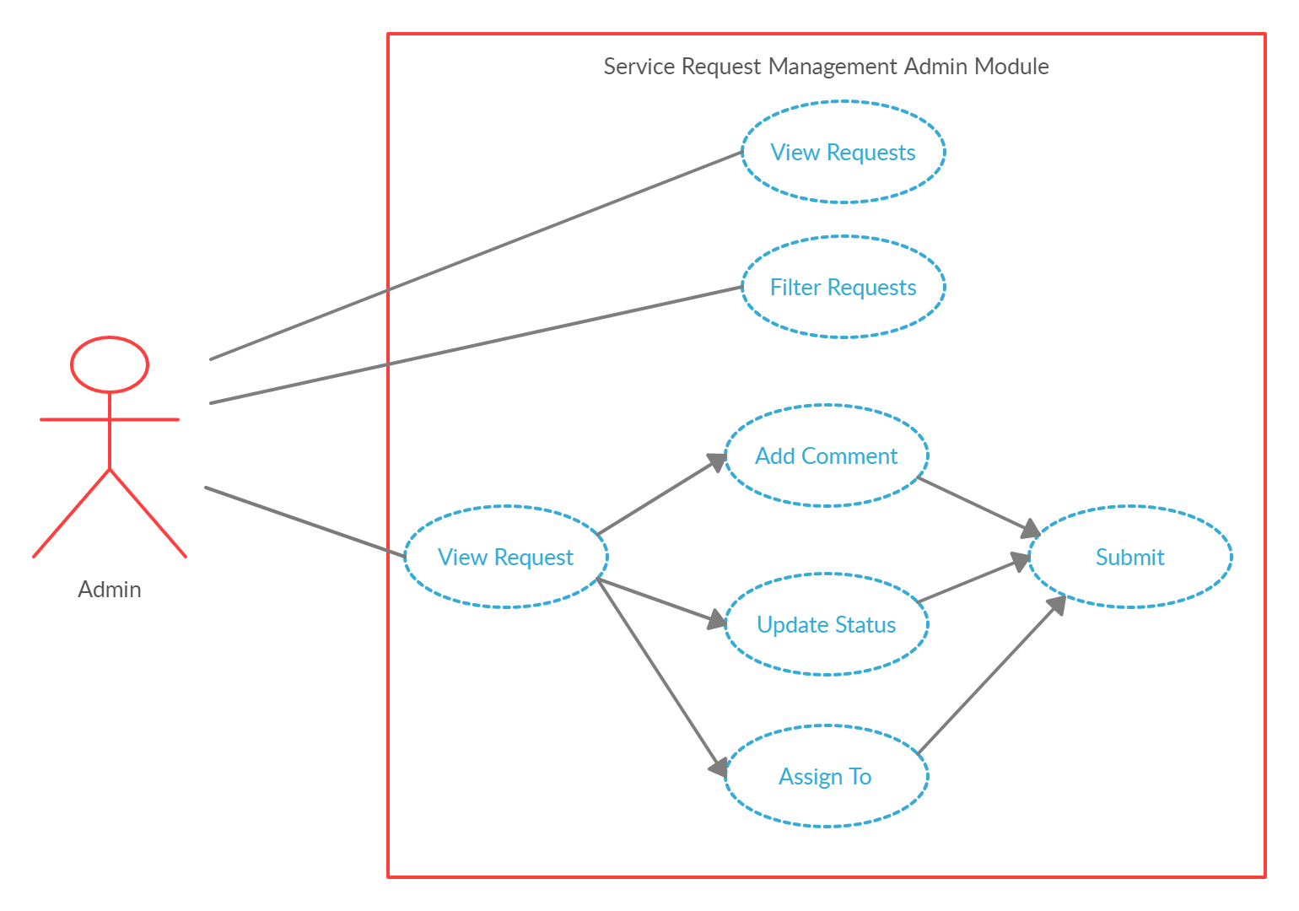

|  |  |
| --- | --- |
| **Use Cases:** | View Requests |
| **Actors:** | Admin |
| **Type:** | Primary and essential |
| **Description:** | Admin can view list of all requests which are raised by employees. List of request list contains request id, department, category, summary of requests in tabular format. |
| **Use-Case:** | None |

|  |  |
| --- | --- |
| **Use Cases:** | Filter Requests |
| **Actors:** | Admin |
| **Type:** | Secondary |
| **Description:** | Admin can filter the list of request depending upon department, category. |
| **Use-Case:** | None |

|  |  |
| --- | --- |
| **Use Cases:** | View Request |
| **Actors:** | Admin |
| **Type:** | Primary and essential |
| **Description:** | Admin can see particular request by clicking on request id which is displayed in list format. By clicking view request admin will directed to request detail page. On request detail admin can see all the details in form. |
| **Use-Case:** | View Requests |

|  |  |
| --- | --- |
| **Use Cases:** | Add comment |
| **Actors:** | Admin |
| **Type:** | Primary |
| **Description:** | Admin can add comment in request detail form regarding the request. |
| **Use-Case:** | View Request |

|  |  |
| --- | --- |
| **Use Cases:** | Update Status |
| **Actors:** | Admin |
| **Type:** | Primary |
| **Description:** | Admin can assign the status to request either in progress or competed. |
| **Use-Case:** | View Request |

|  |  |
| --- | --- |
| **Use Cases:** | Assign To |
| **Actors:** | Admin |
| **Type:** | Primary |
| **Description:** | Admin can assign the request raised by an employee to particular service provider employee form list of employee. |
| **Use-Case:** | View Request |

|  |  |
| --- | --- |
| **Use Cases:** | Submit Request |
| **Actors:** | Admin |
| **Type:** | Primary |
| **Description:** | Admin can submit the request after adding comment and status to request and also admin has to assign the request to service provider employee. After submitting request email will send to associated employees. |
| **Use-Case:** | Add Comment, Update Status, Assign To |