PYTHON_LAB_3

1. Using input() function take one number from the user and using ternary operators check whether the number is even or odd

* For Even Number

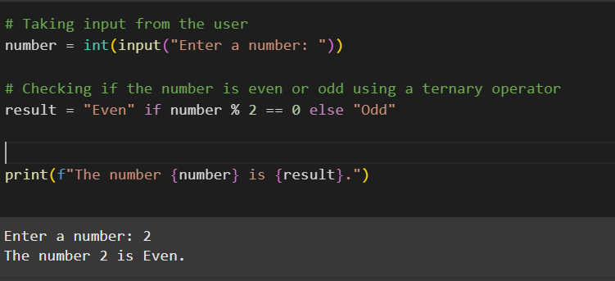

* For Odd Number

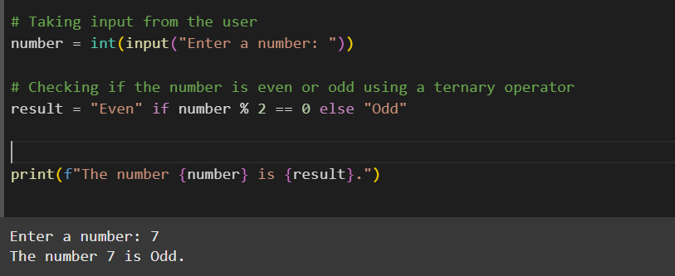

1. Using input function take two number and then swap the number

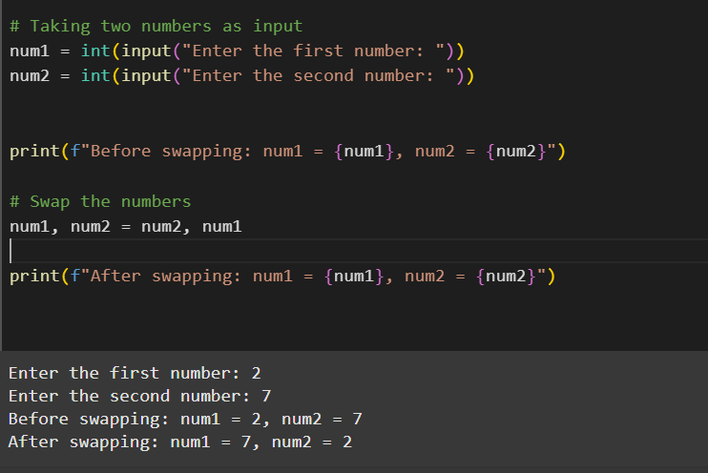

1. Write a Program to Convert Kilometers to Miles

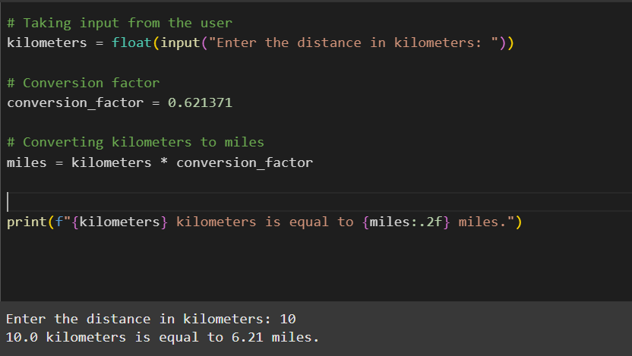

1. Find the Simple Interest on Rs. 200 for 5 years at 5% per year.

