Python_Lab_2

1. Calculate the multiplication and sum of two numbers .

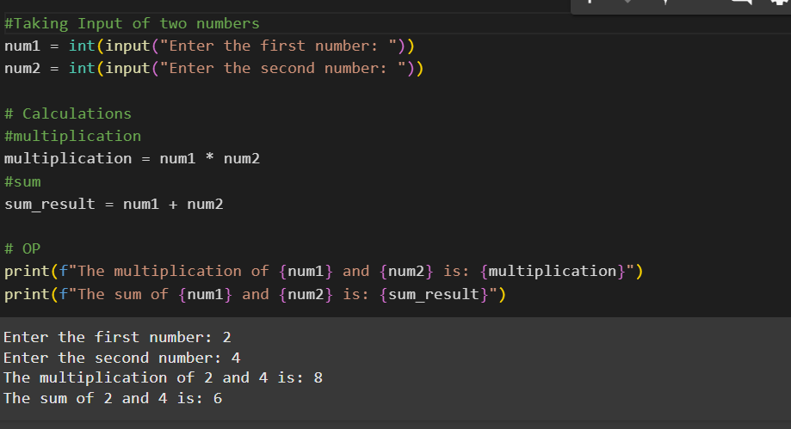

1. Declare two variables and print that which variable is largest using ternary operators .

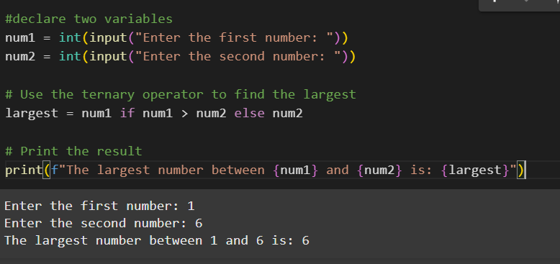

3. Python program to convert the temperature in degree centigrade to Fahrenheit.

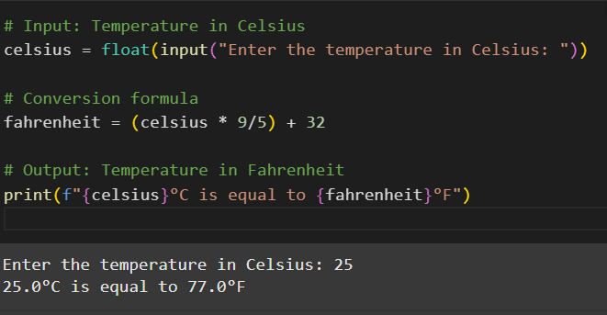

4. Python program to find the area of a triangle whose sides are given.

