Python\_Lab\_6

1. Write a python program to reverse a number using a while loop.

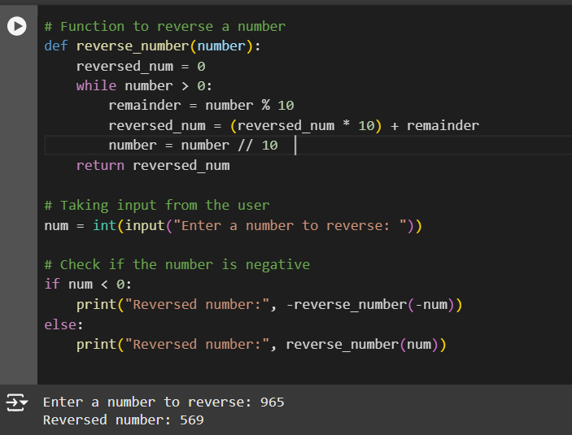



img1_c

2. Write a python program to check whether a number is palindrome or not?

* For a palindrome number:

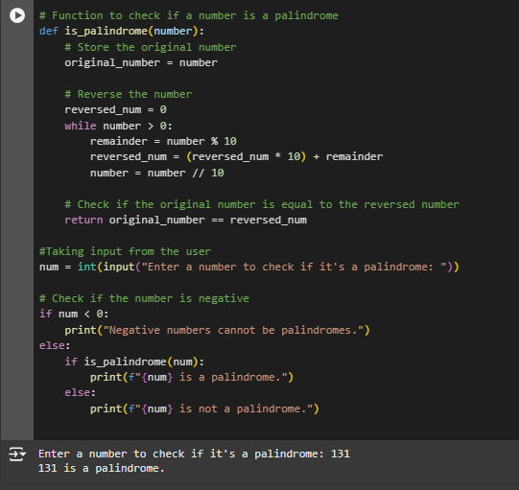

* For a non-palindrome number:

img2_b

3.Write a python program finding the factorial of a given number using a while loop.

* For Positive Number

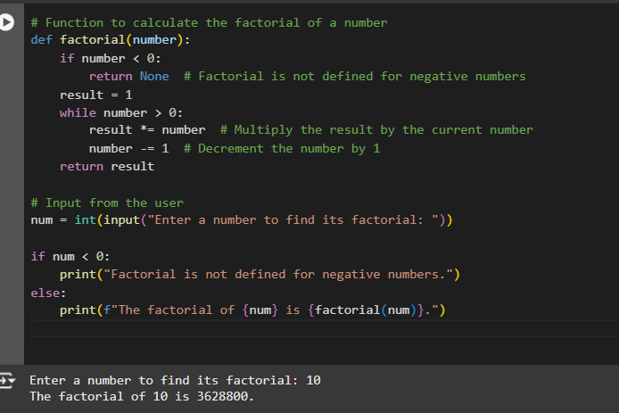

* For Zero



1. Accept numbers using input() function until the user enters 0. If user input 0 then break the while loop and display the sum of all the numbers.

