Python LAB 1

1. Installing Python on Windows

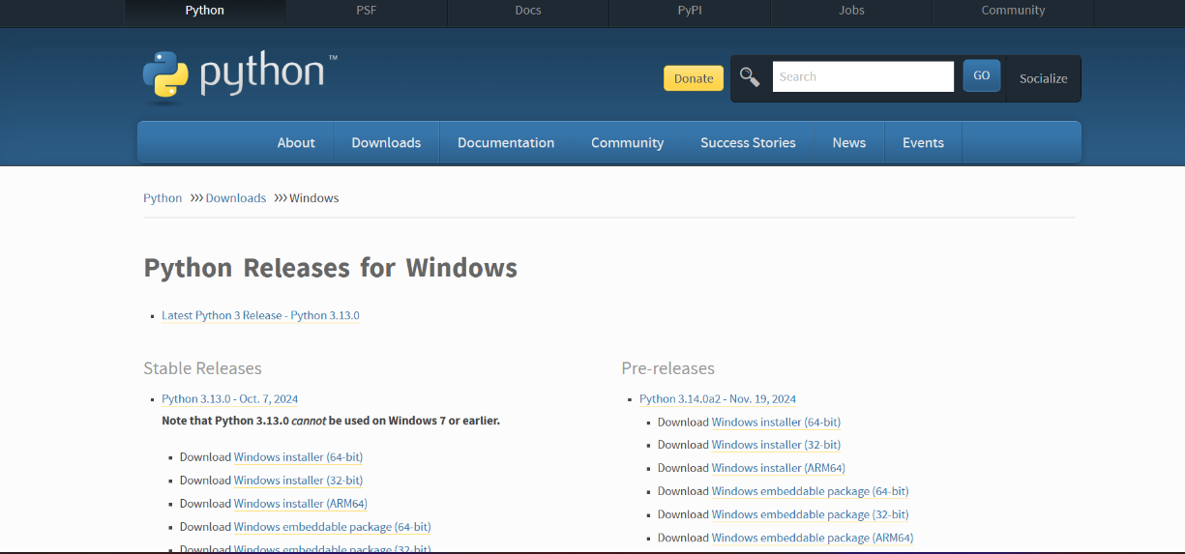

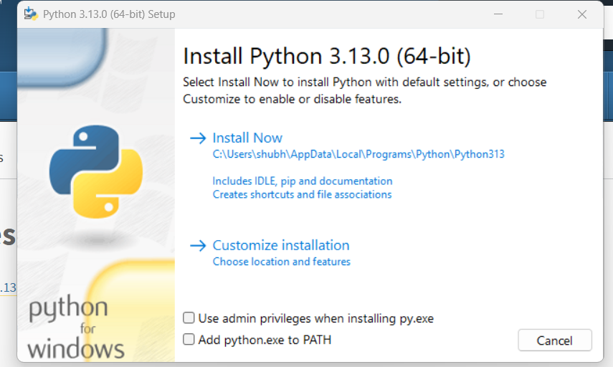

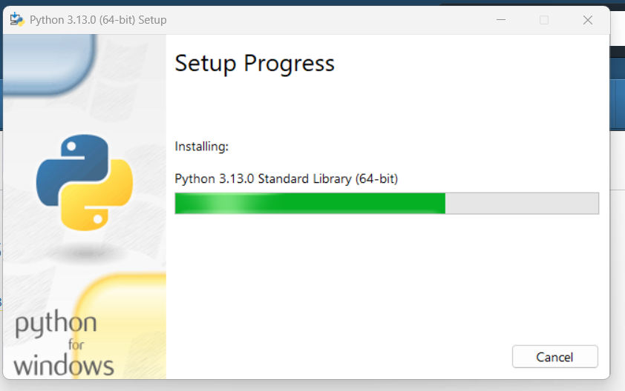

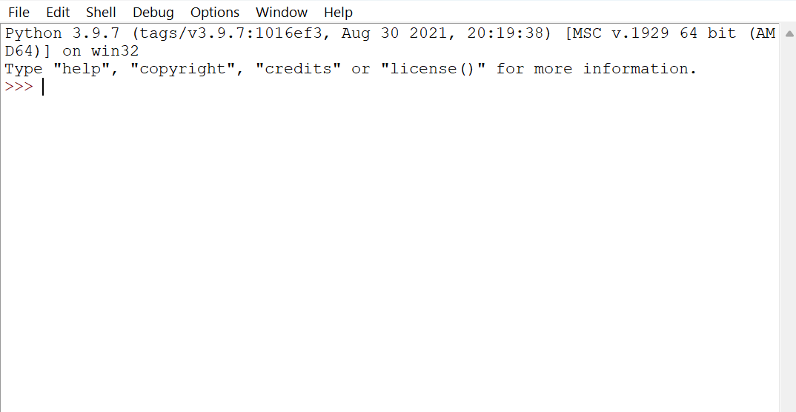

2. Demonstrate about Basics of Python Programming:

i. Running Python Interpreter:

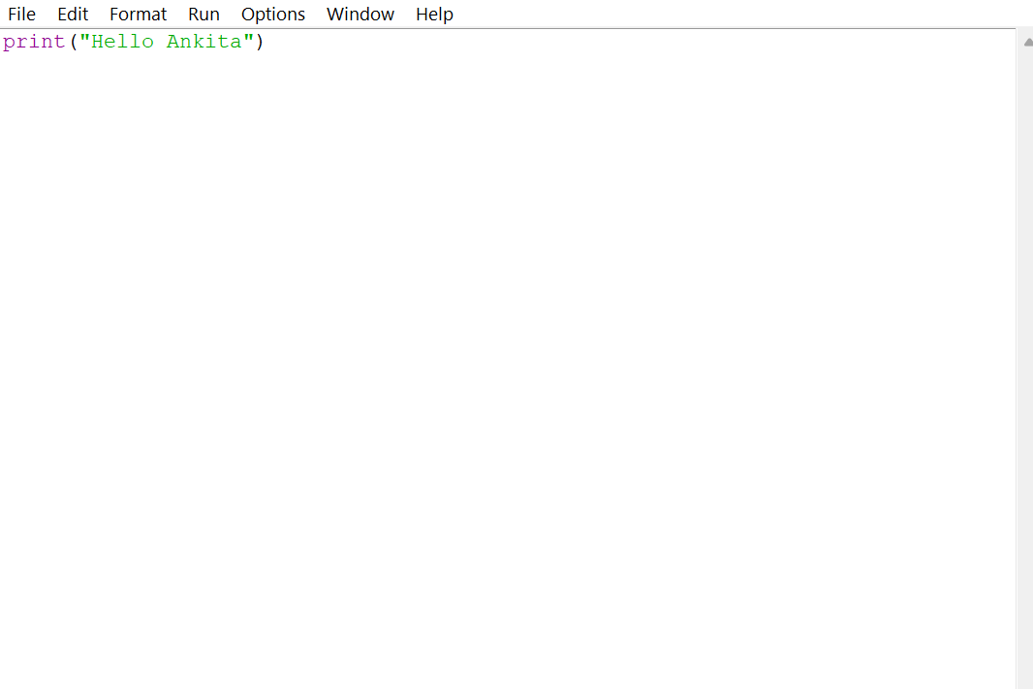

Output:

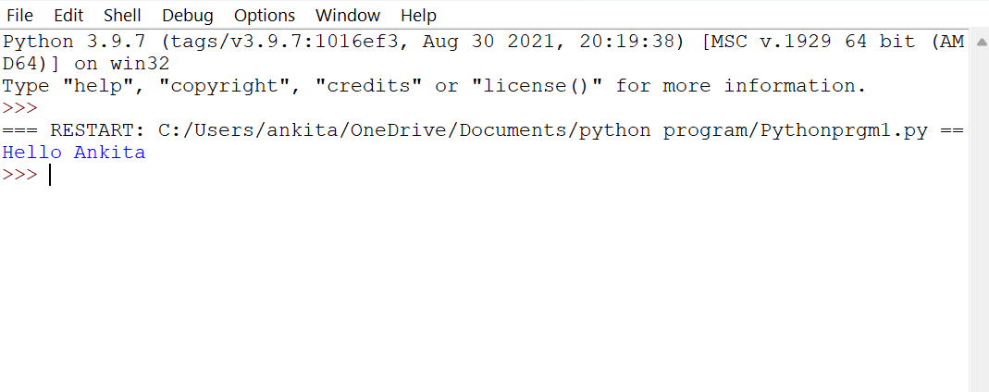

ii. Running Python Scripts in IDLE (Integrated Development and Learning Environment):

iii. Indentation.

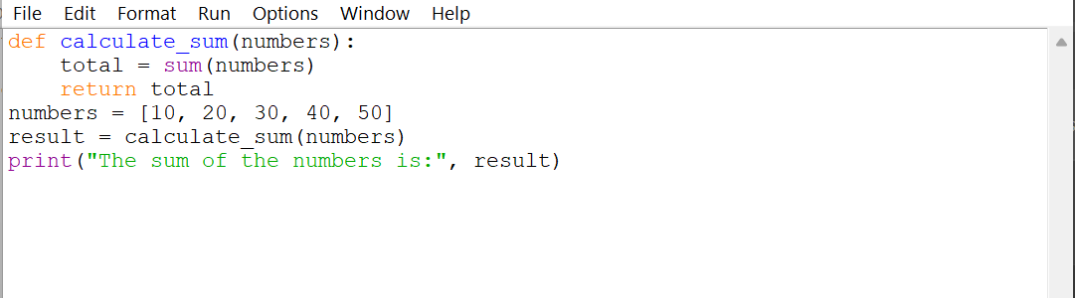

Output:

