Program :
Import csv
Import os
From datetime import datetime
FILE_NAME = “expenses.csv”
Def initialize_file():
If not os.path.exists(FILE_NAME):
With open(FILE_NAME, “w”, newline=””) as file:
Writer = csv.writer(file)
Writer.writerow([“Date”, “Category”, “Description”, “Amount”])
Def add_expense():
Date = input(“Enter date (YYYY-MM-DD) or press Enter for today: “).strip()
If date == “”:
Date = datetime.now().strftime(“%Y-%m-%d”)
Else:
Try:
Datetime.strptime(date, “%Y-%m-%d”)
Except ValueError:
Print(“Invalid date format.”)
Return
Category = input(“Enter category (Food/Travel/Bills/Other): “).strip()
Description = input(“Enter description: “).strip()
If not category or not description:
Print(“Category and description cannot be empty.”)
Return

Try:
Amount = float(input(“Enter amount in rupees: “))
If amount <= 0:
Print(“Amount must be greater than zero.”)
Return
Except ValueError:
Print(“Please enter a valid amount.”)
Return
With open(FILE_NAME, “a”, newline=””) as file:
Writer = csv.writer(file)
Writer.writerow([date, category, description, amount])
Print(“Expense added successfully!”)
Def view_expenses():
With open(FILE_NAME, “r”, newline=””) as file:
Reader = csv.DictReader(file)
Expenses = list(reader)
If not expenses:
Print(“No expenses recorded yet.”)
Return
Print(“\n========== ALL EXPENSES ==========”)
For expense in expenses:
Print(
F”Date: {expense[‘Date’]} | “
F”Category: {expense[‘Category’]} | “
F”Description: {expense[‘Description’]} | “
F”Amount: Rs. {float(expense[‘Amount’]):.2f}”
)
Def show_summary():
Category_totals = {}
Total_spending = 0.0
Count = 0
With open(FILE_NAME, “r”, newline=””) as file:
Reader = csv.DictReader(file)
For expense in reader:
Amount = float(expense[“Amount”])
Category = expense[“Category”]
Total_spending += amount
Count += 1
Category_totals[category] = (
Category_totals.get(category, 0) + amount
)
If count == 0:
Print(“No expenses available for summary.”)
Return
Print(“\n========== SPENDING SUMMARY ==========”)
Print(f”Number of expenses: {count}”)
Print(f”Total spending: Rs. {total_spending:.2f}”)
Print(“\nCategory-wise spending:”)
For category, total in category_totals.items():
Print(f”{category}: Rs. {total:.2f}”)
Print(“======================================”)
Def main():
Initialize_file()
While True:
Print(“\n===== EXPENSE TRACKER =====”)
Print(“1. Add Expense”)
Print(“2. View Expenses”)
Print(“3. Spending Summary”)
Print(“4. Exit”)
Choice = input(“Enter your choice: “).strip()
If choice == “1”:
Add_expense()
Elif choice == “2”:
View_expenses()
Elif choice == “3”:
Show_summary()
Elif choice == “4”:
Print(“Thank you for using Expense Tracker!”)
Break
Else:
Print(“Invalid choice. Please select 1 to 4.”)
If __name__ == “__main__”:
Main()

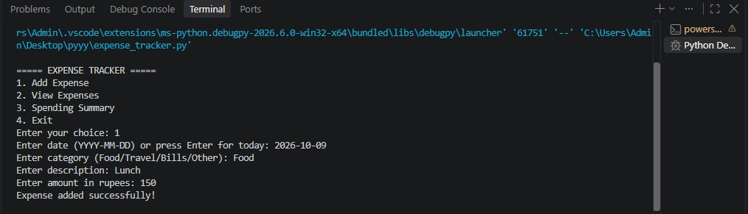
Output:

