PHP – CORE PHP

PHP Assignment

**MODULE-03**

**(Core -PHP)**

**Submitted To:-**

**Rajesh Nagar Sir**

**Submitted By:-**

**Ankita Sahu**

MODULE – 3(Core PHP)

**1) Write a PHP program to enter marks of five subjects Physics, Chemistry, Biology, Mathematics and Computer, calculate percentage and grade by if else write a PHP program for find “Thursday” in week using switch Function.**

**Code:-**

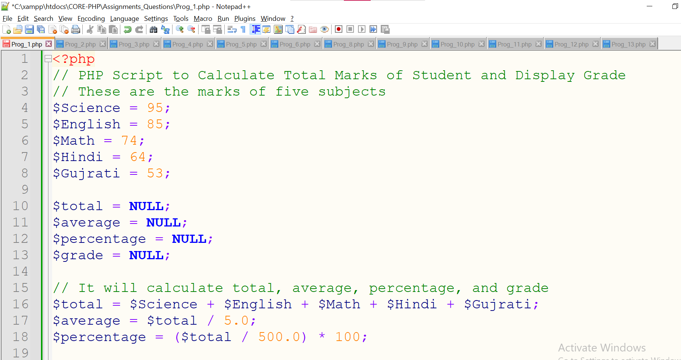

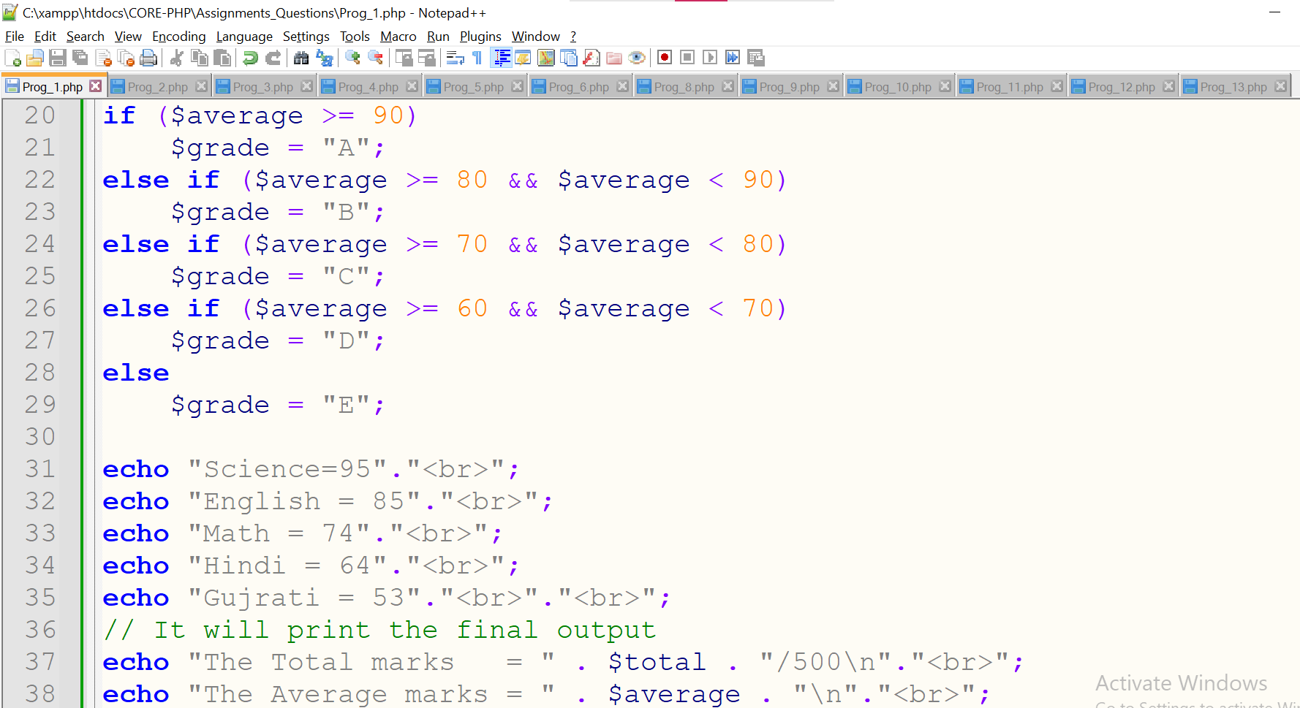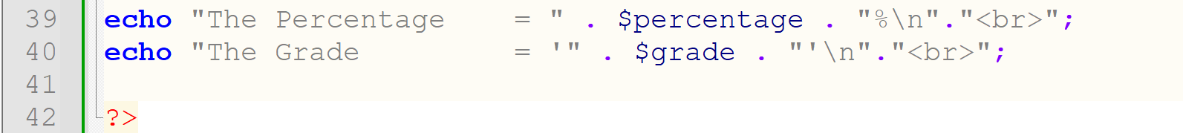

**Output:-**

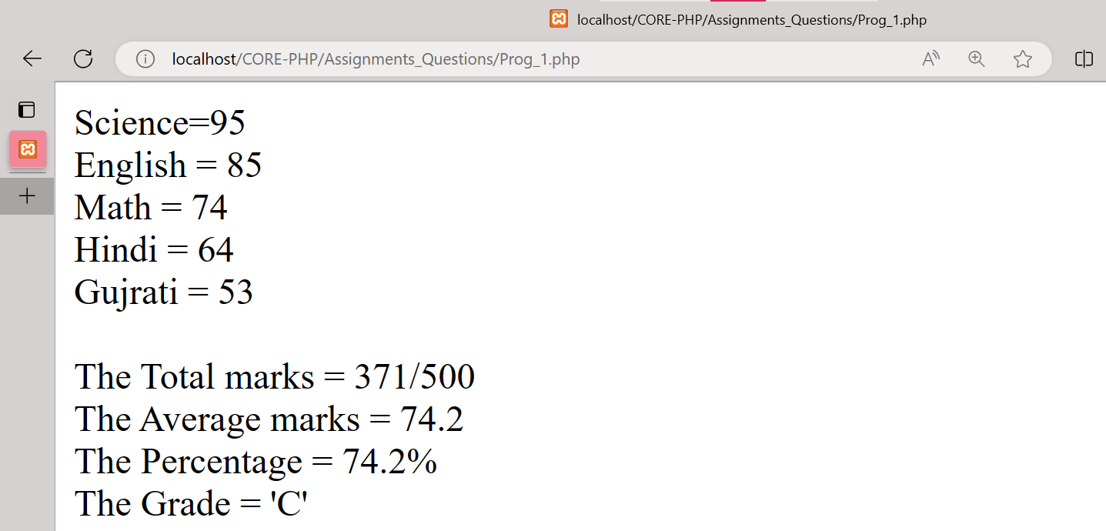

**Write a PHP program for find “Thursday” in week using switch Function.**

**Code:-**

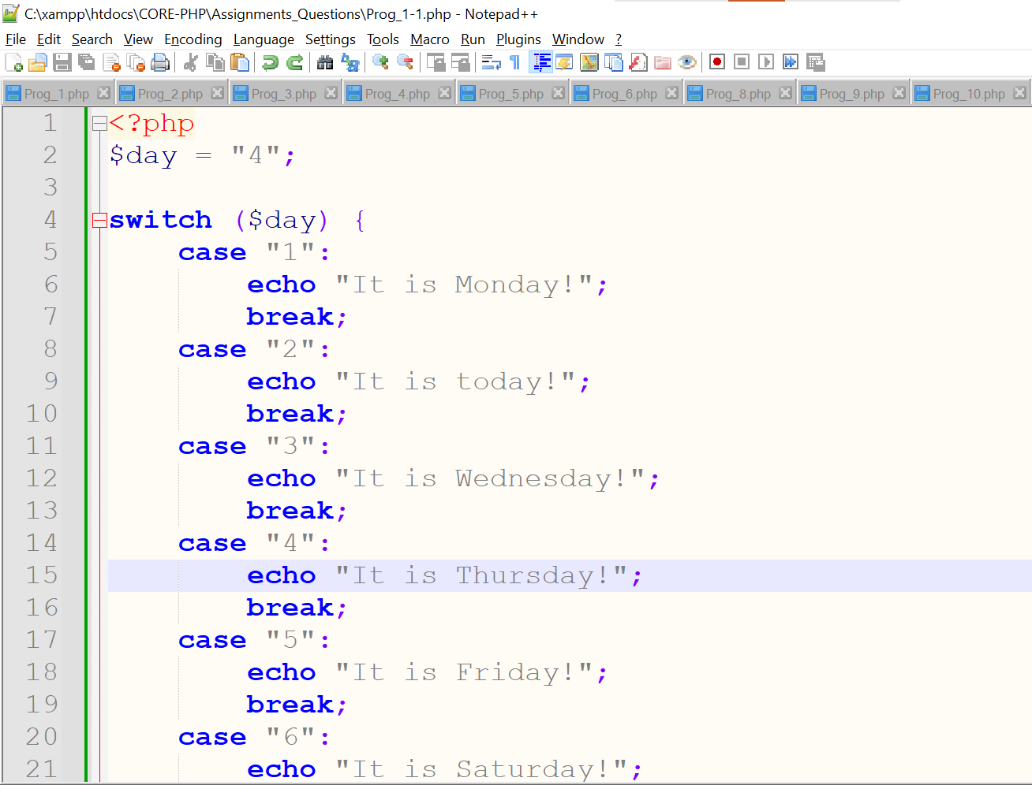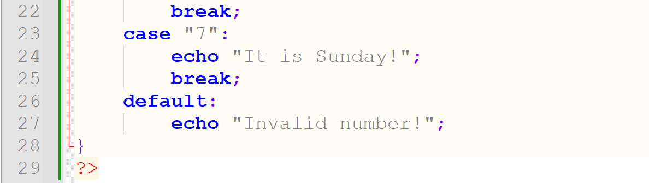

**Output:-**

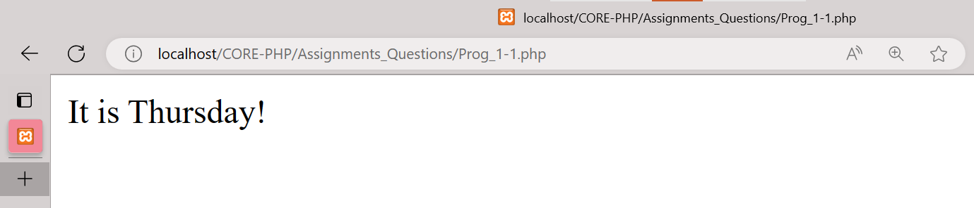

**2) Write a PHP program to check Leap years between 1901 to 2016 Using nested if.**

**Code:-**

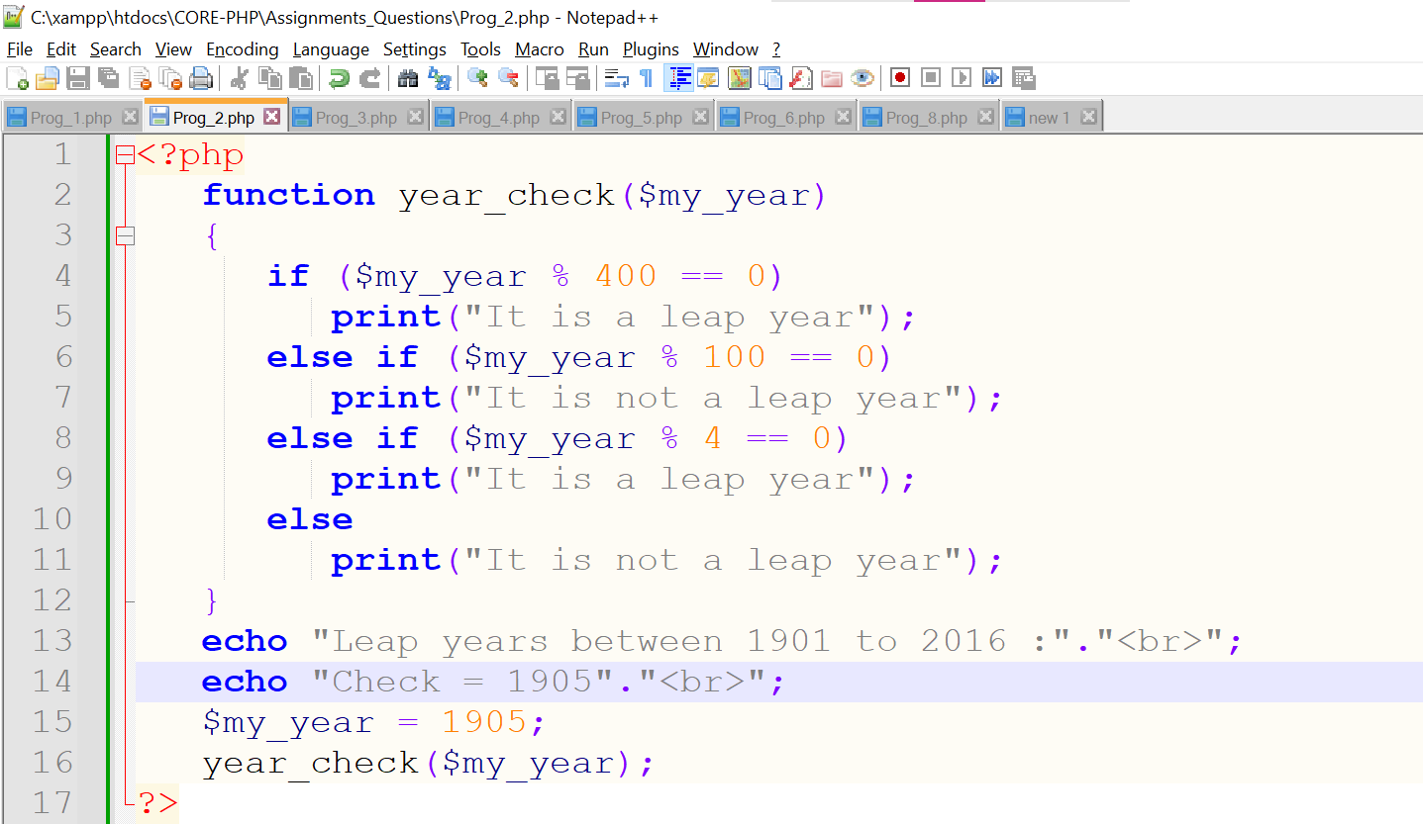

**Output:-**

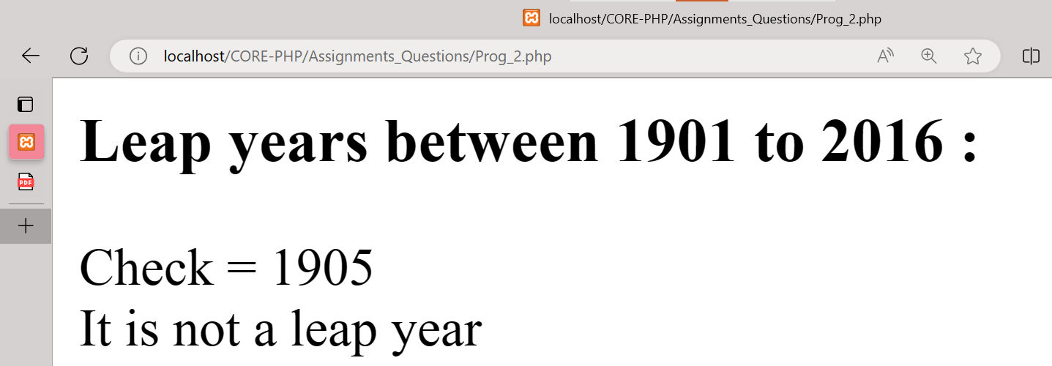

**3) Write a PHP program to find the largest of three numbers using ternary Operator.**

**Code:-**

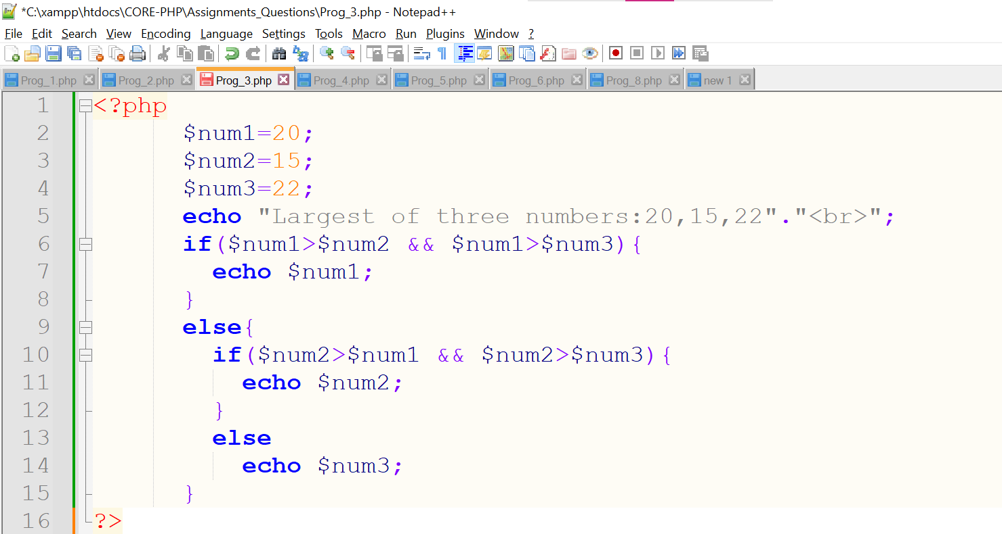

**Output:-**

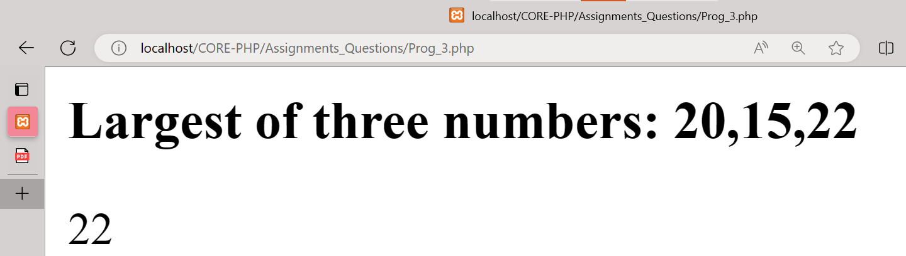

**4) Write a program in PHP to print Fibonacci series. 0, 1, 1, 2, 3, 5, 8, 13, 21, 34.**

**Code:-**

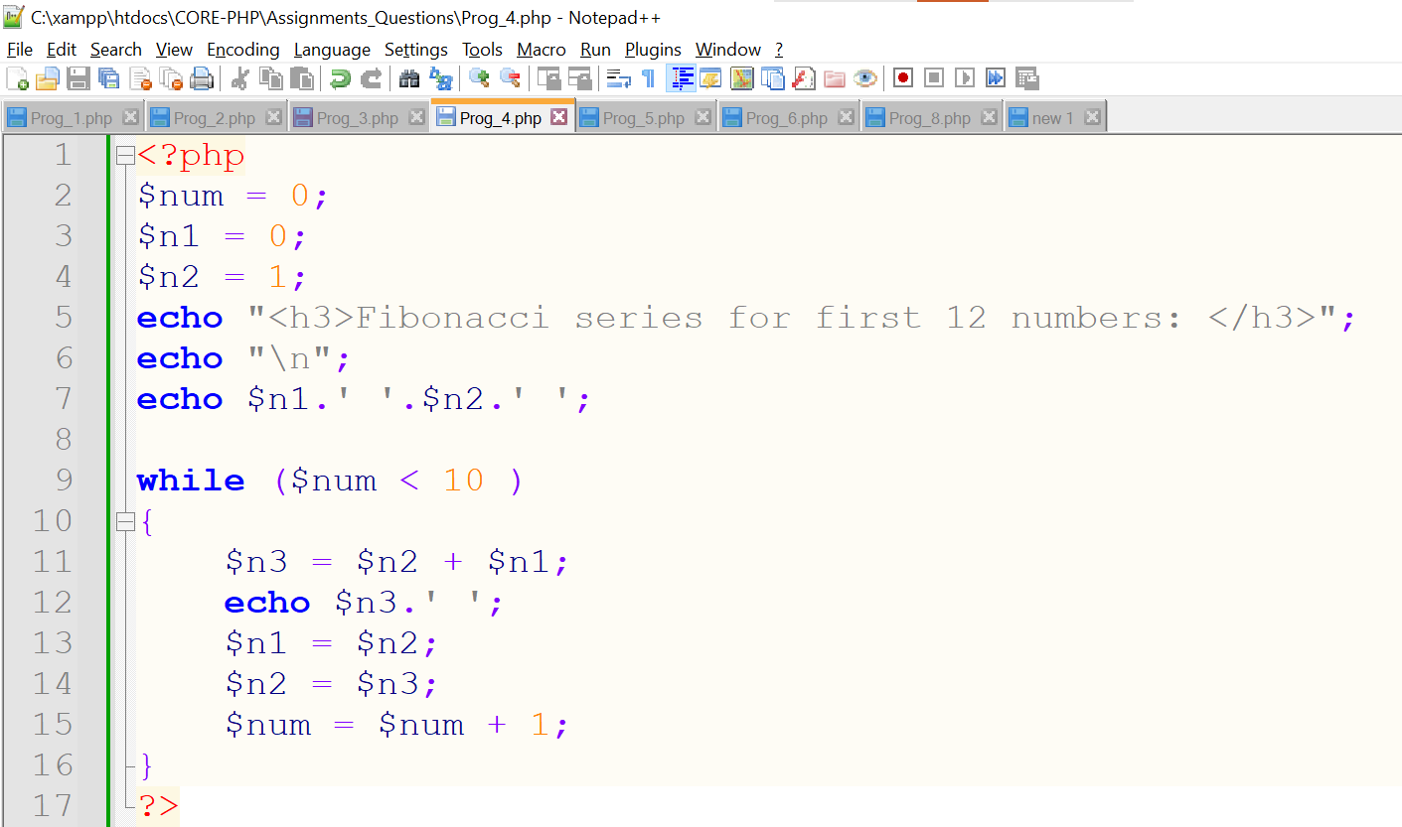

**Output:-**

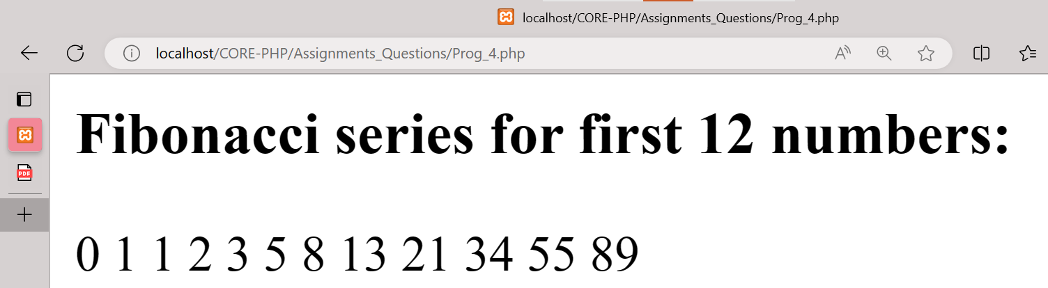

**5) Write a program to find whether a number is Armstrong or not Write a program to print the below format:**  **5, 9, 2610, 3711, 4812.**

**Code:-**

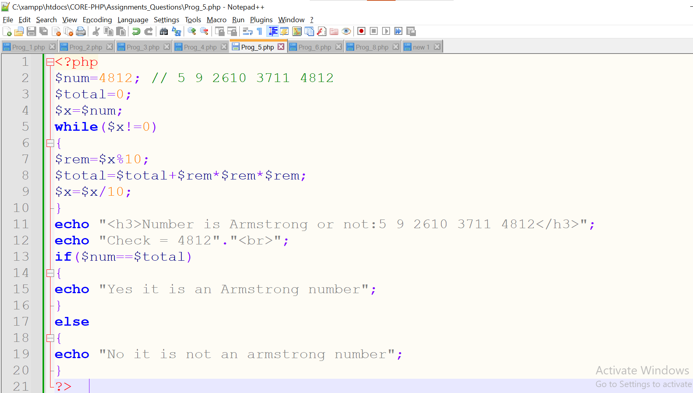

**Output:-**

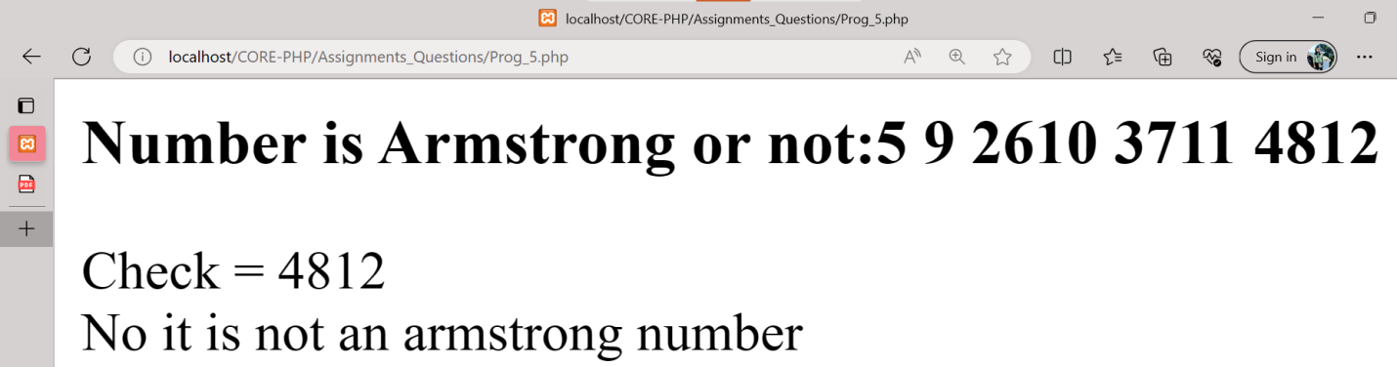

**6) Write a program for this Pattern:**

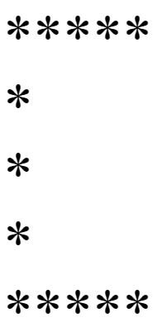

**Code:-**

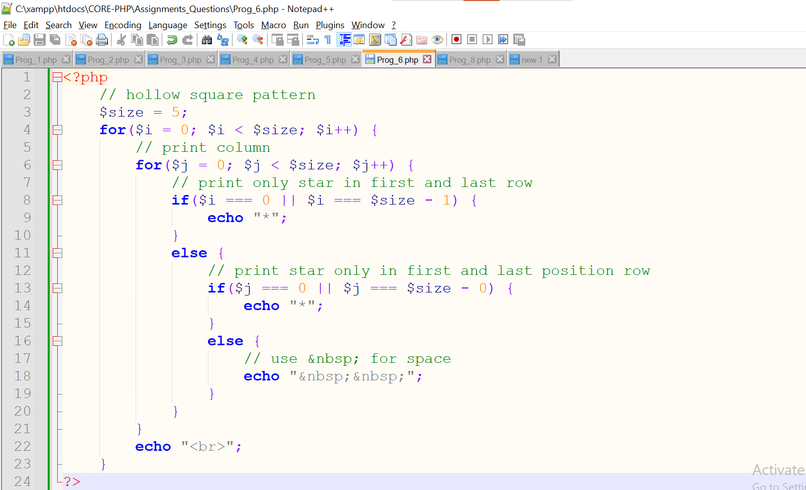

**Output:-**

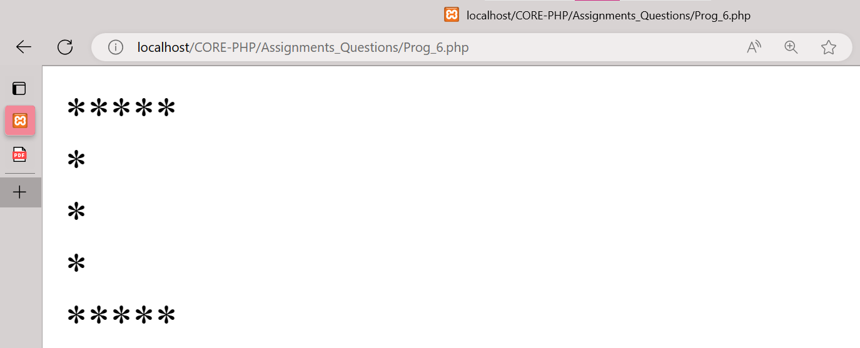

**7) What will be the values of $a and $b after the code below is executed? Explain your answer.**

**$a = '1';**

**$b = &$a;**

**$b = "2$b";**

**Code:-**

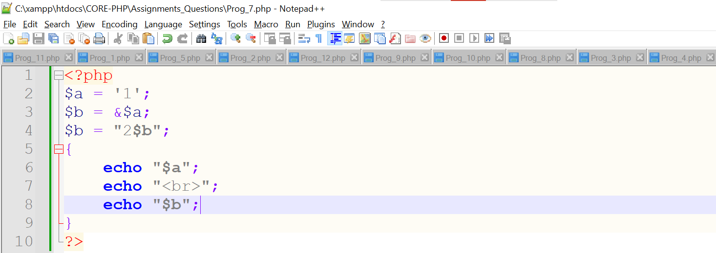

**Output:-**

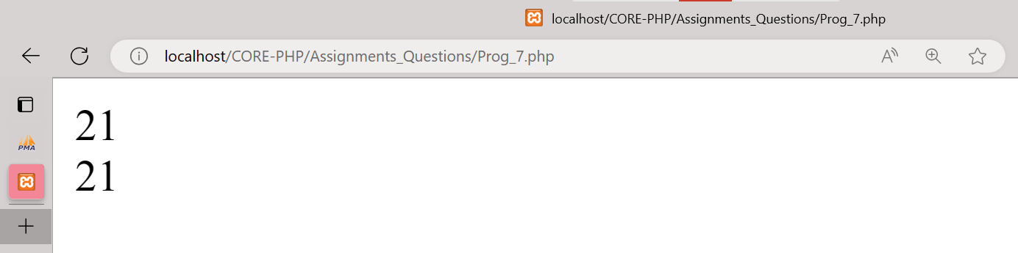

**8) How can you tell if a number is even or odd without using any Condition or loop?**

**Code:-**

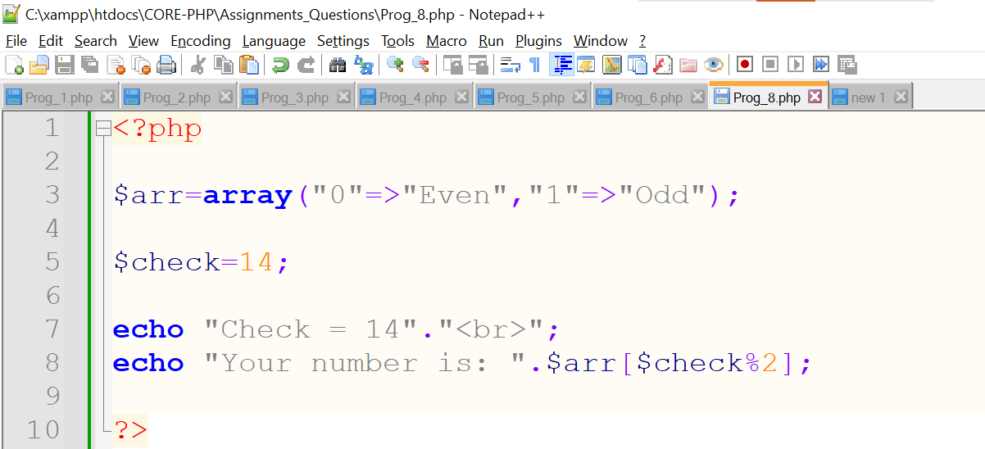

**Output:-**

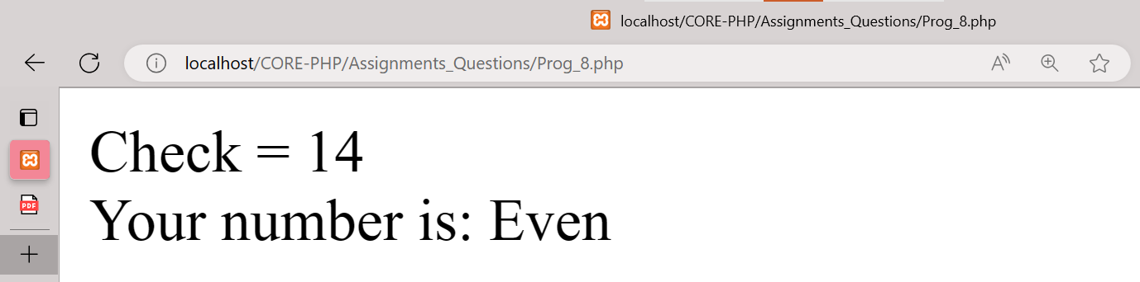

**9) How can you declare the array (all type) in PHP? Explain with example Covert a JSON string to array.**

**Code:-**

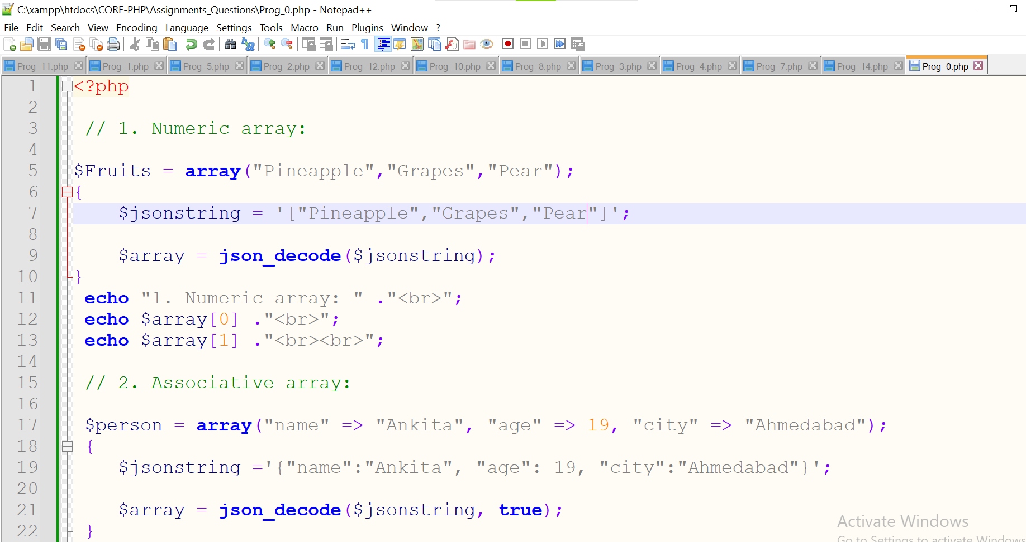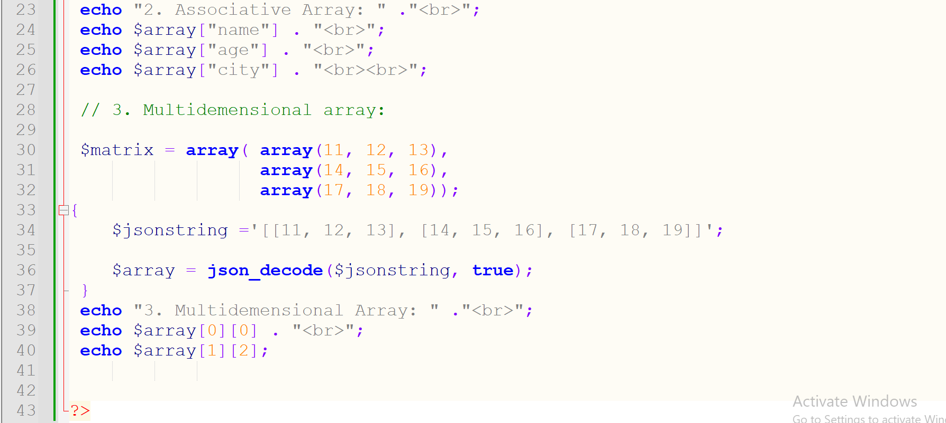

**Output:-**

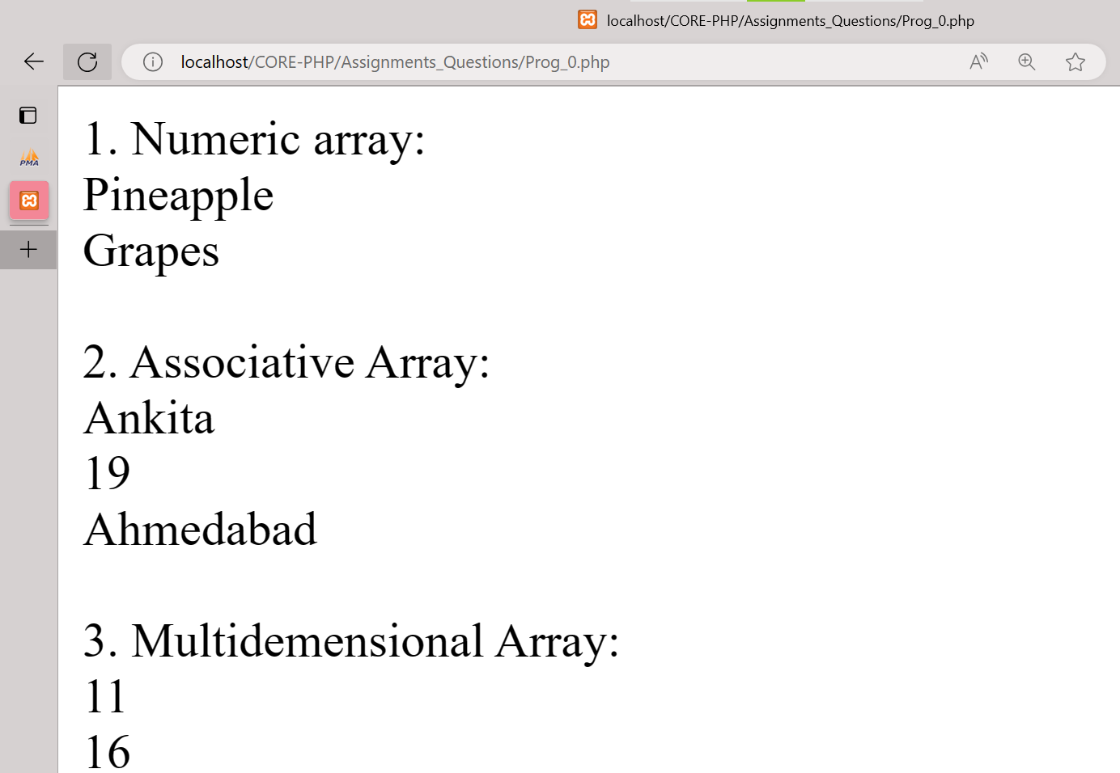

**10) Write program to remove duplicate values from array.**

**Code:-**

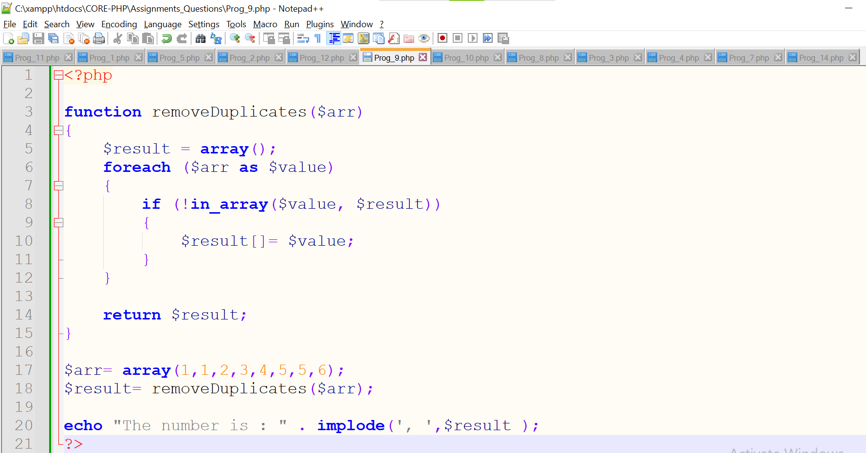

**Output:-**

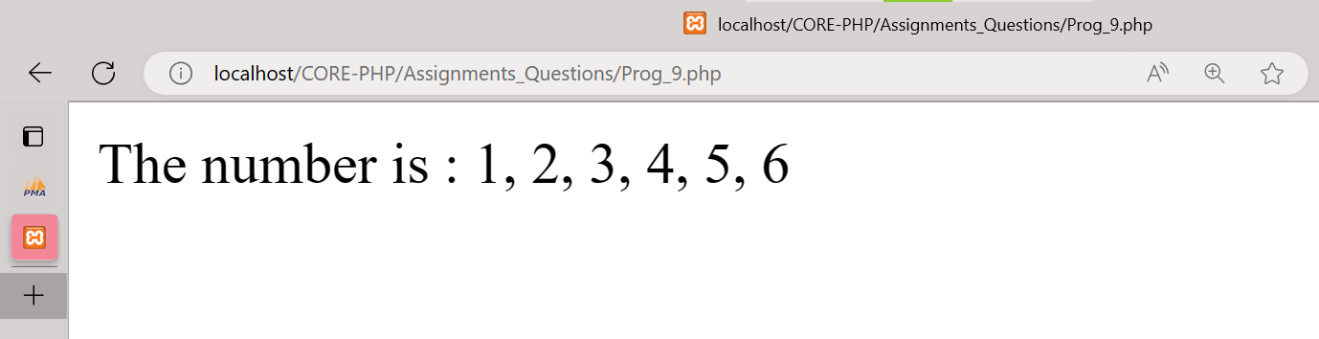

**11) Get random values from array.**

**Code:-**

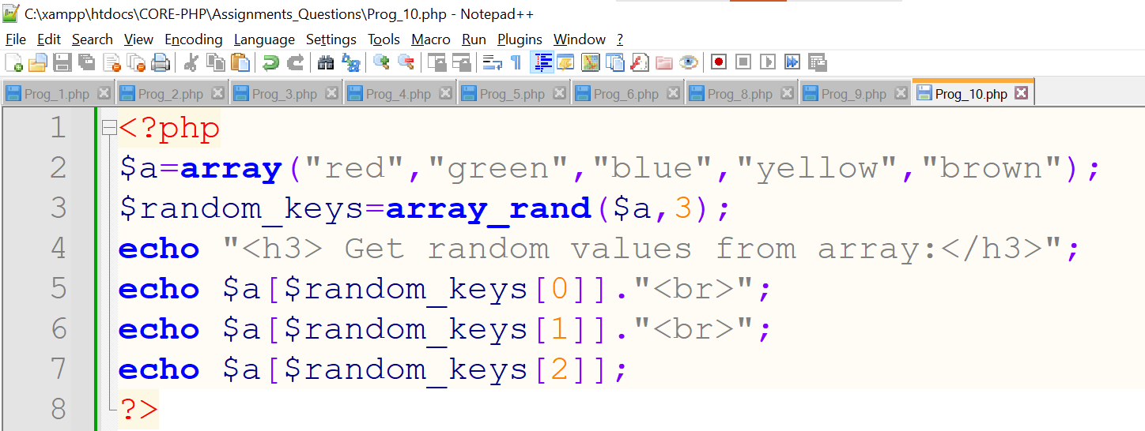

**Output:-**

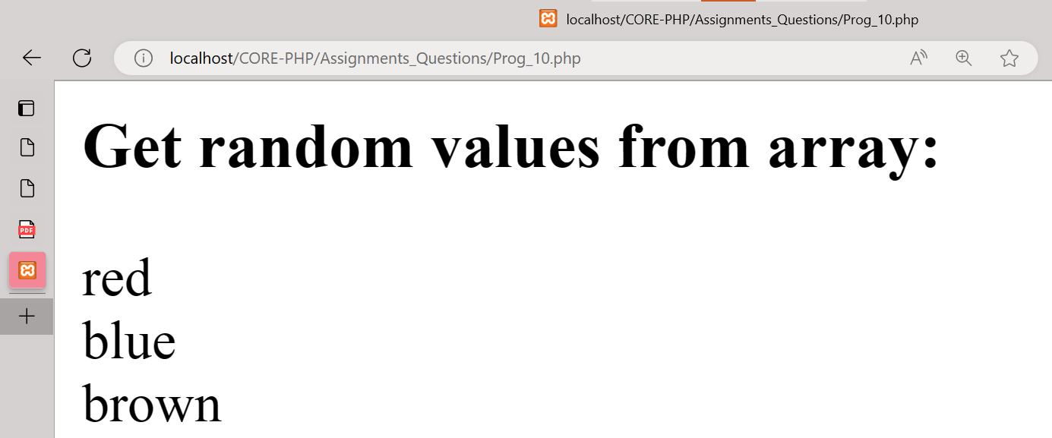

**12) Write a PHP script which decodes the following JSON string.**

**Code:-**

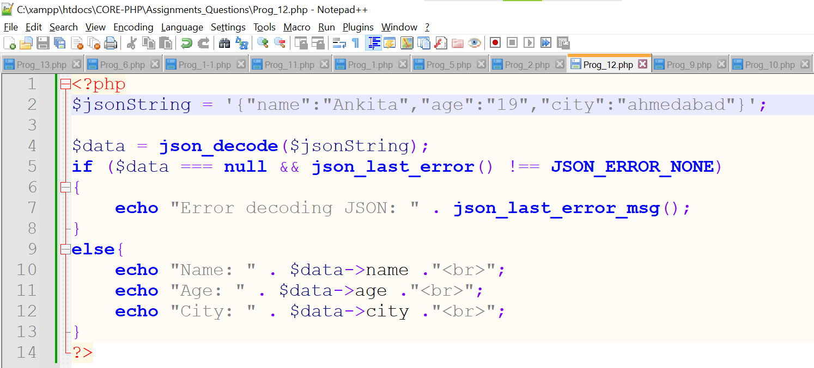

**Output:-**

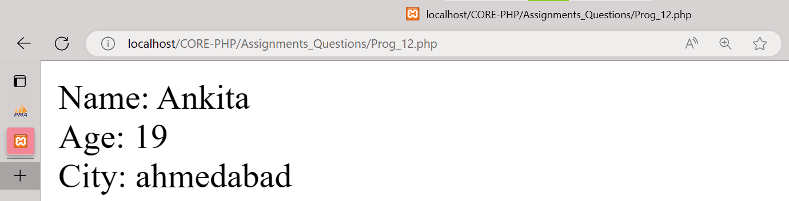

**13) Use a for loop to total the contents of an integer array called numbers which has five elements. Store the result in an integer called total.**

**Code:-**

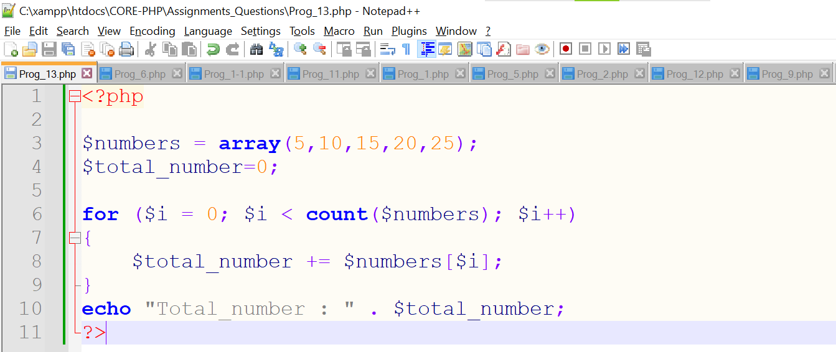

**Output:-**

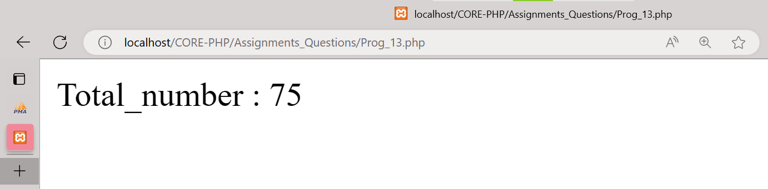

**14) Declare a Multi Dimensioned array of floats called balances having three rows and five columns.**

**Code:-**

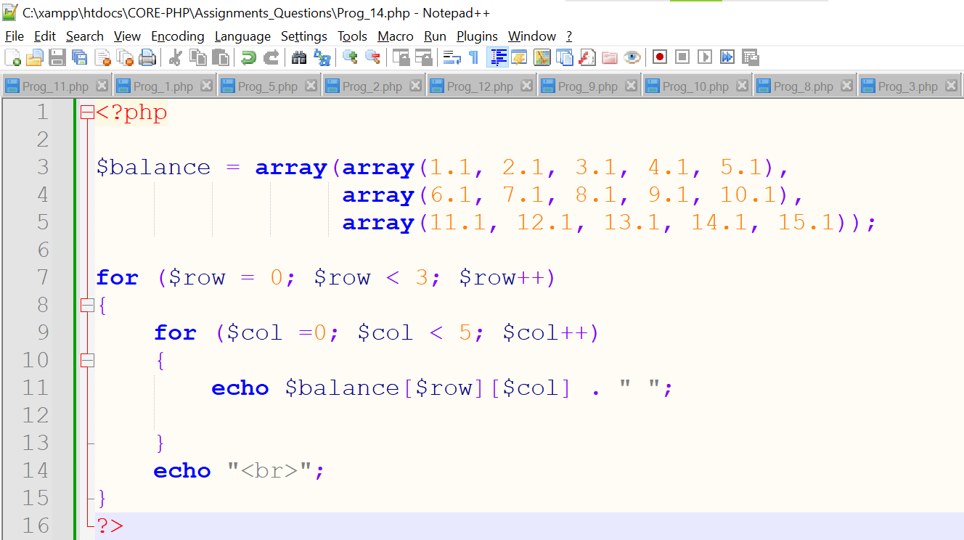

**Output:-**

