JavaScript Essentials And Advanced

**MODULE-1**

AdvanceJAVASCRIPT

(Introduction and Code Quality)

**Submitted To:-**

**Rajesh Nagar Sir**

**Submitted By:-**

**Ankita Sahu**

MODULE: 1 (Introduction and Code Quality)

**1. Write a program to Show an alert?**

**Ans:-**

**Code:**

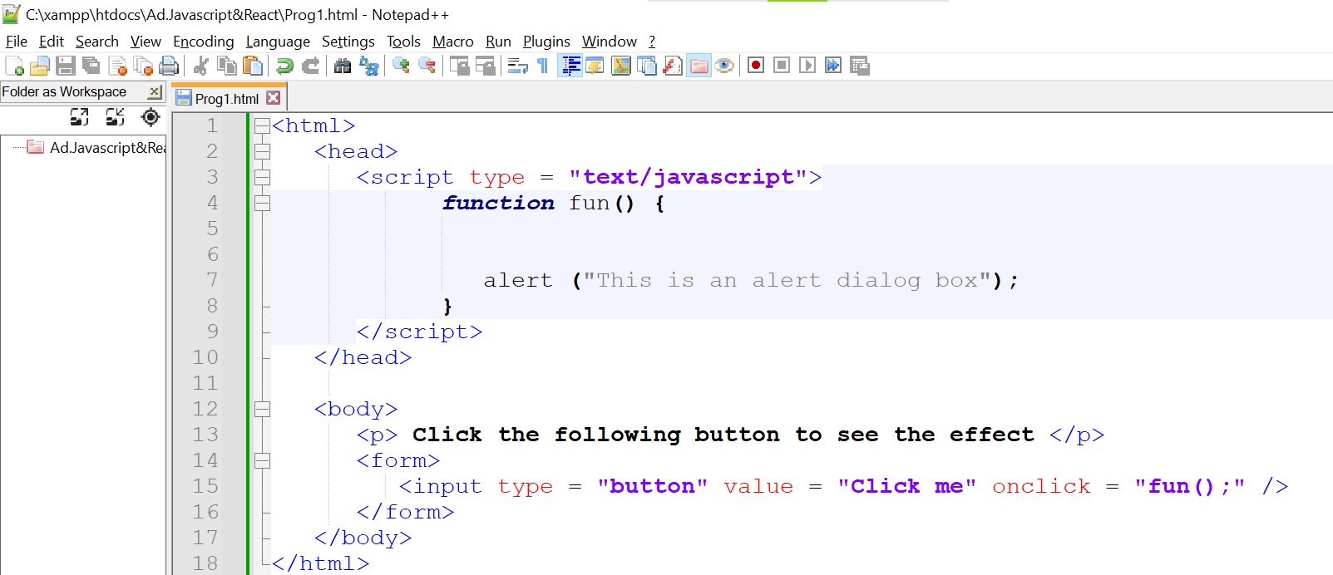

**Output:**

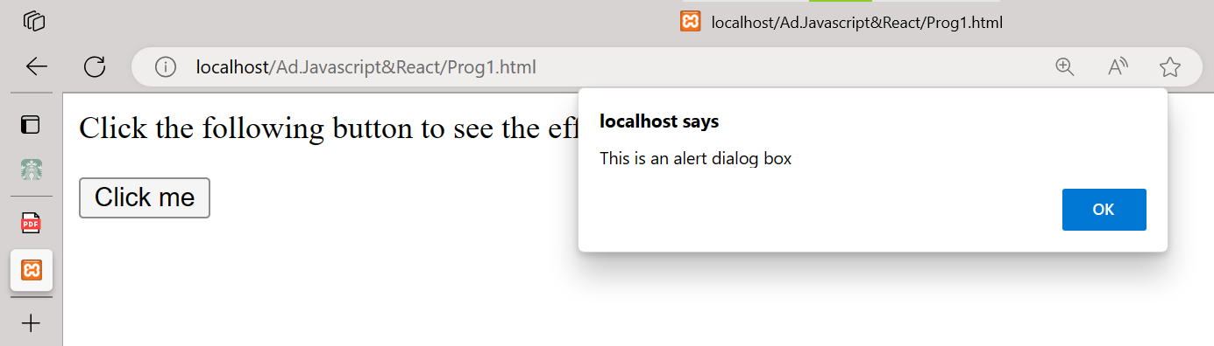

**2. What will be the result for these expressions?**

**1. 5 > 4**

**2. "apple" > "pineapple"**

**3. "2" > "12"**

**4. undefined == null**

**5. undefined === null**

**6. null == "\n0\n"**

**7. null === +"\n0\n"**

**Ans:-**

**1. 5 > 4**

**Code:**

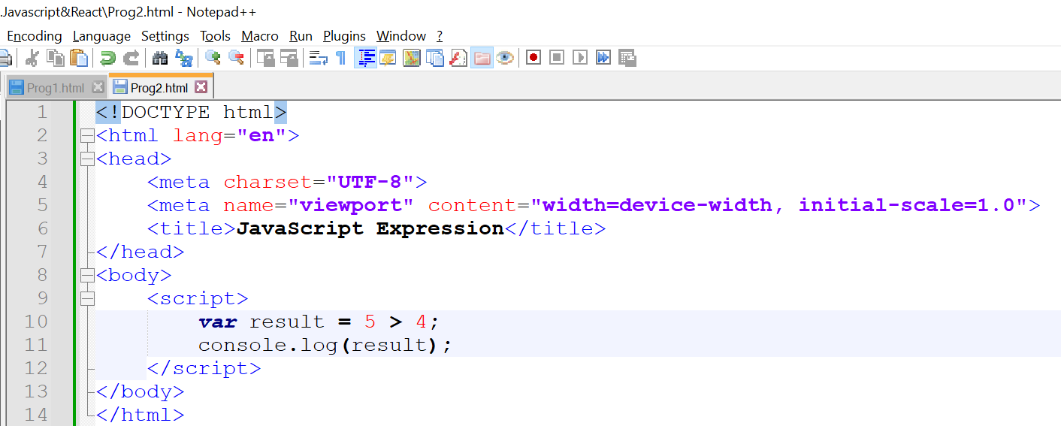

**Output:**

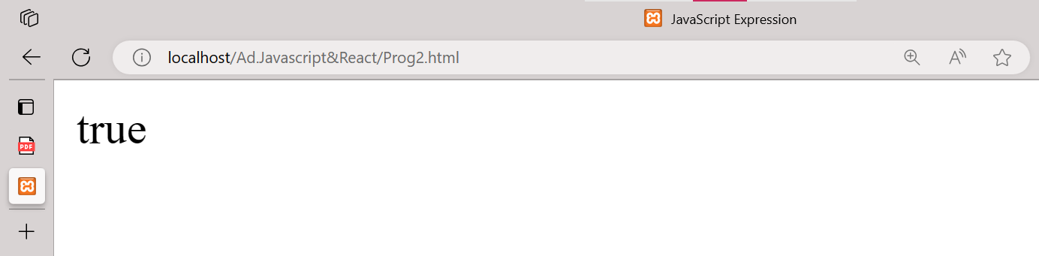

**2. "apple" > "pineapple"**

**Code:**

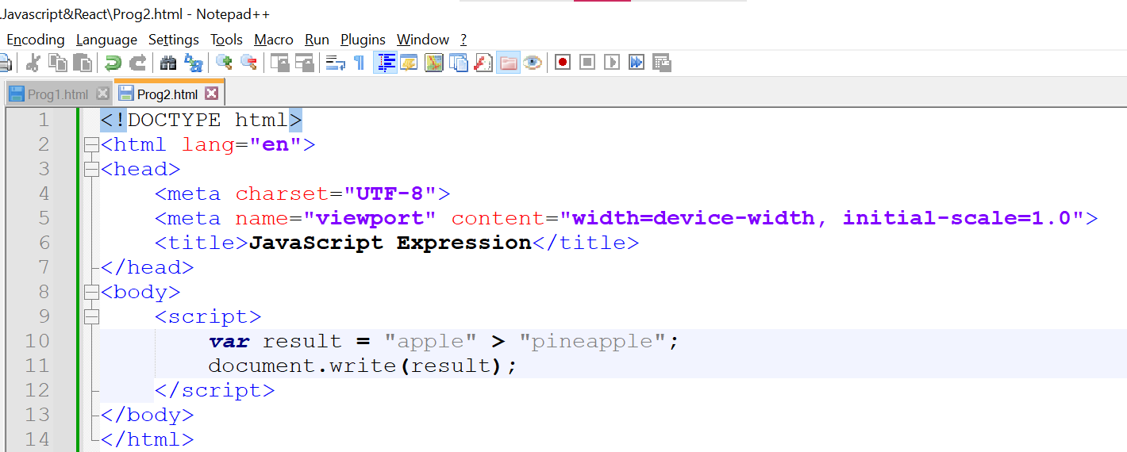

**Output:**

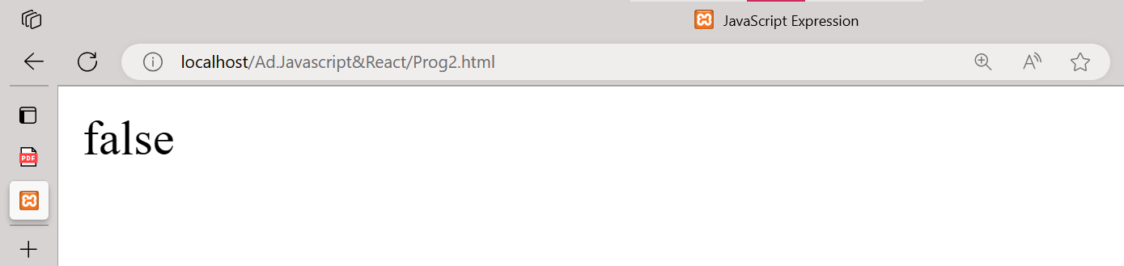

**3. "2" > "12"**

**Code:**

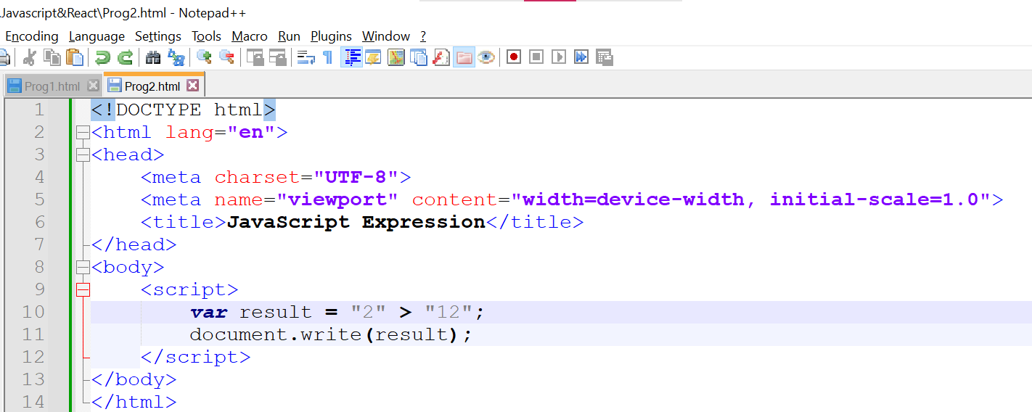

**Output:**

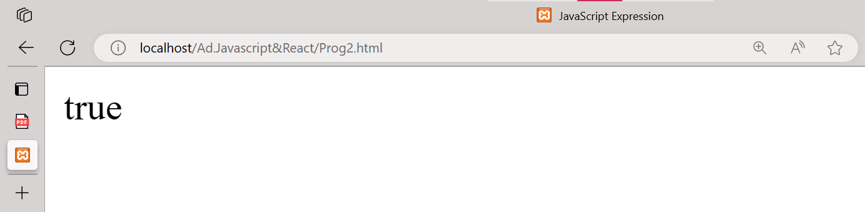

**4. undefined == null**

**Code:**

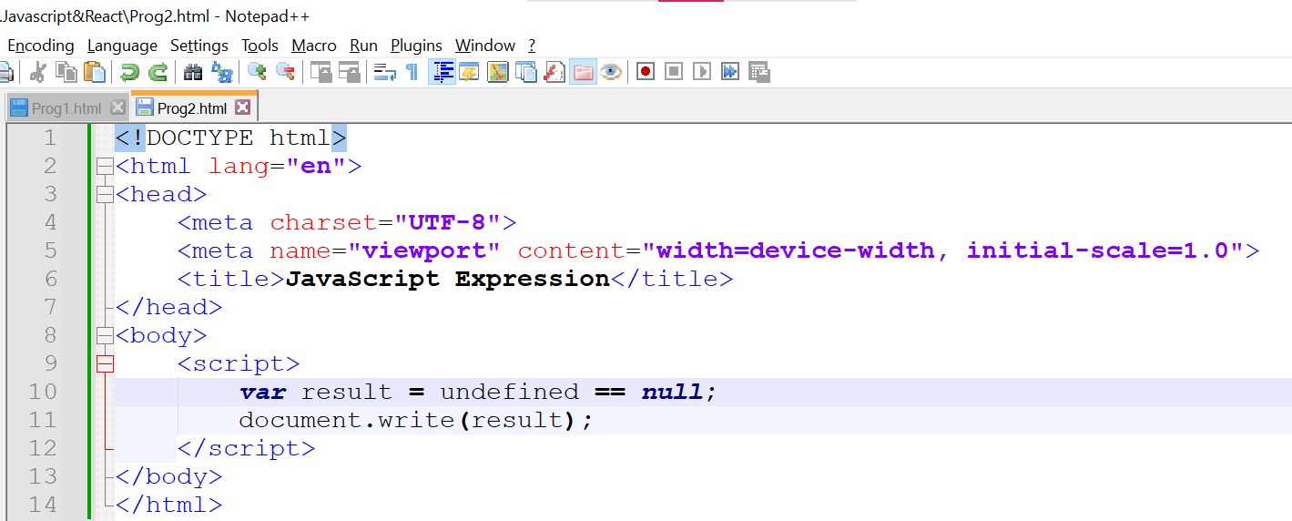

**Output:**

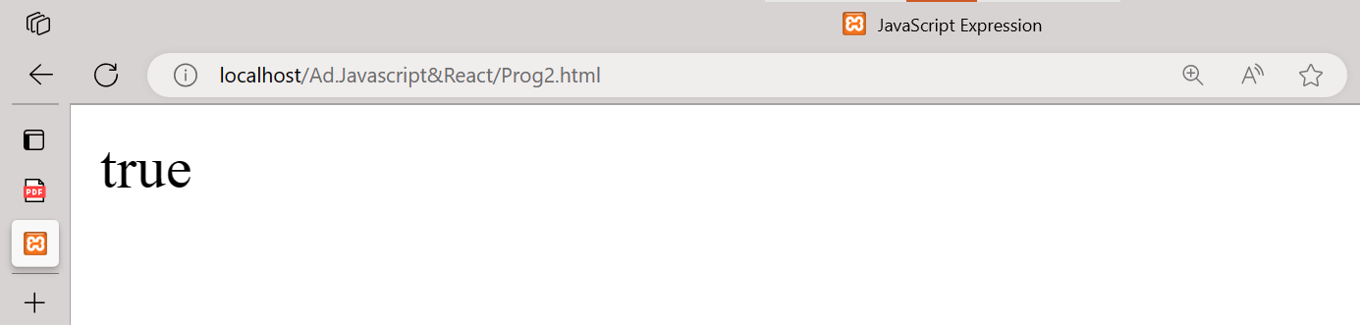

**5. undefined === null**

**Code:**

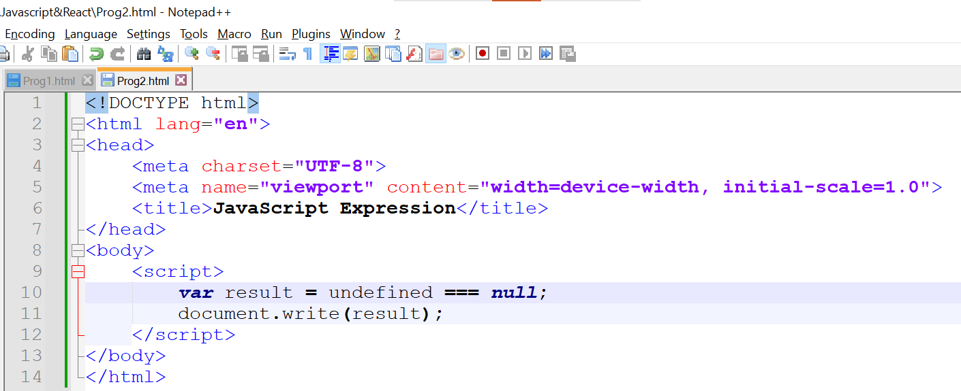

**Output:**

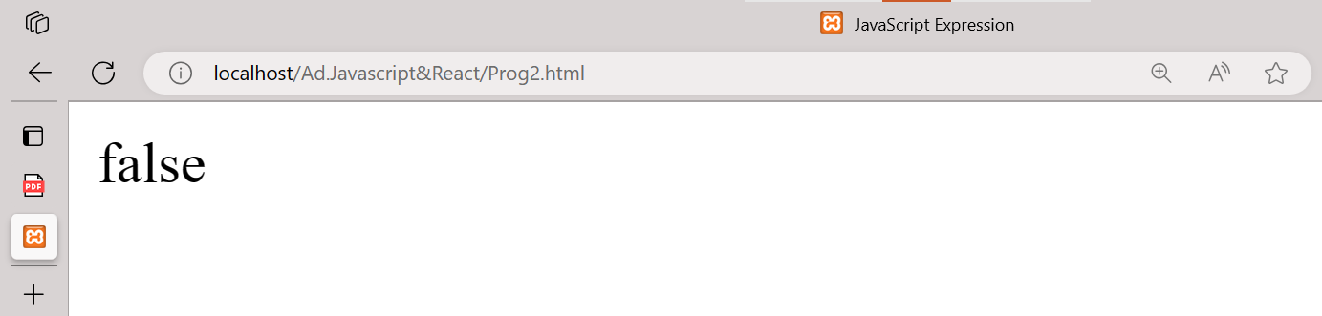

**6. null == "\n0\n"**

**Code:**

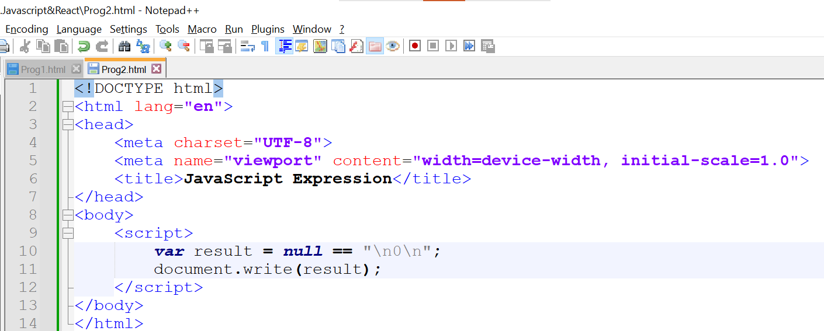

**Output:**

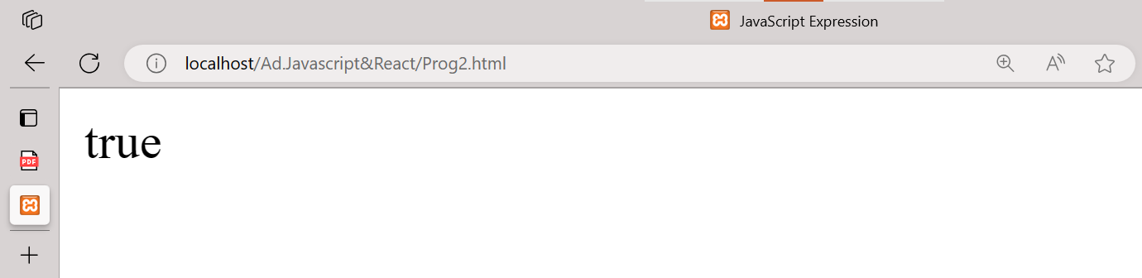

**7. null === +"\n0\n"**

**Code:**

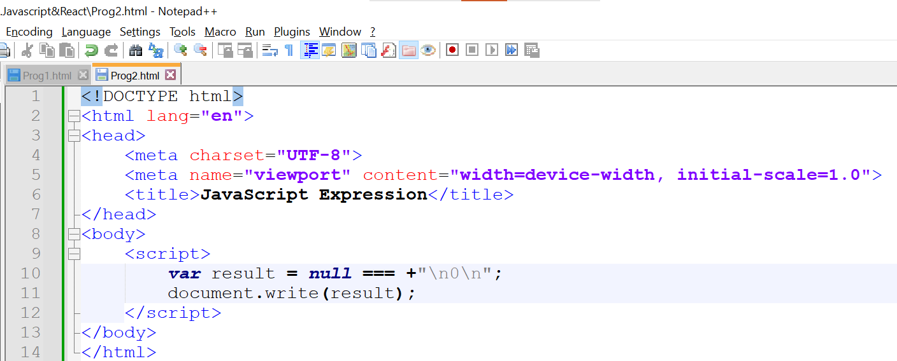

**Output:**

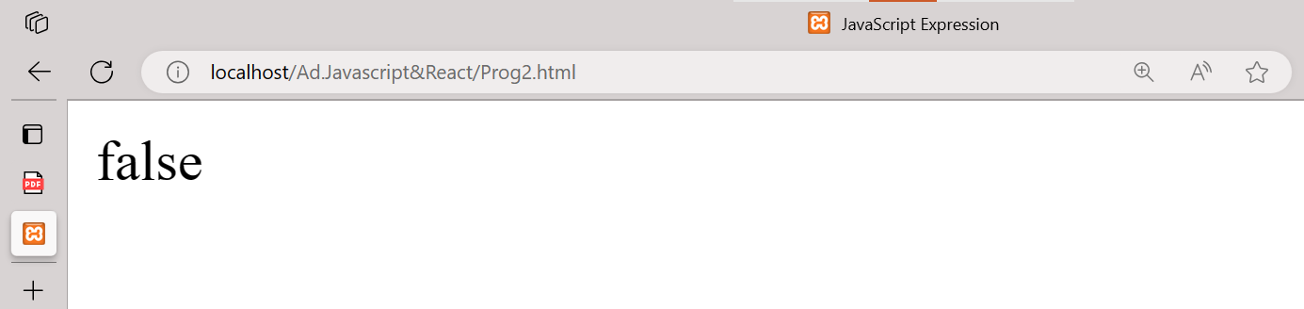

**3. Will alert be shown?**

**if ("0") { alert( 'Hello'); }**

**Ans:-**

Yes, the **alert** will be shown. In JavaScript, when you use a non-empty string in a conditional statement, the string is considered truthy. Therefore, in your example, **if ("0")** evaluates to **true**, and the code inside the **if** block will be executed. As a result, the **alert('Hello')** statement will be executed, and you will see an alert with the message 'Hello'.

**Code:**

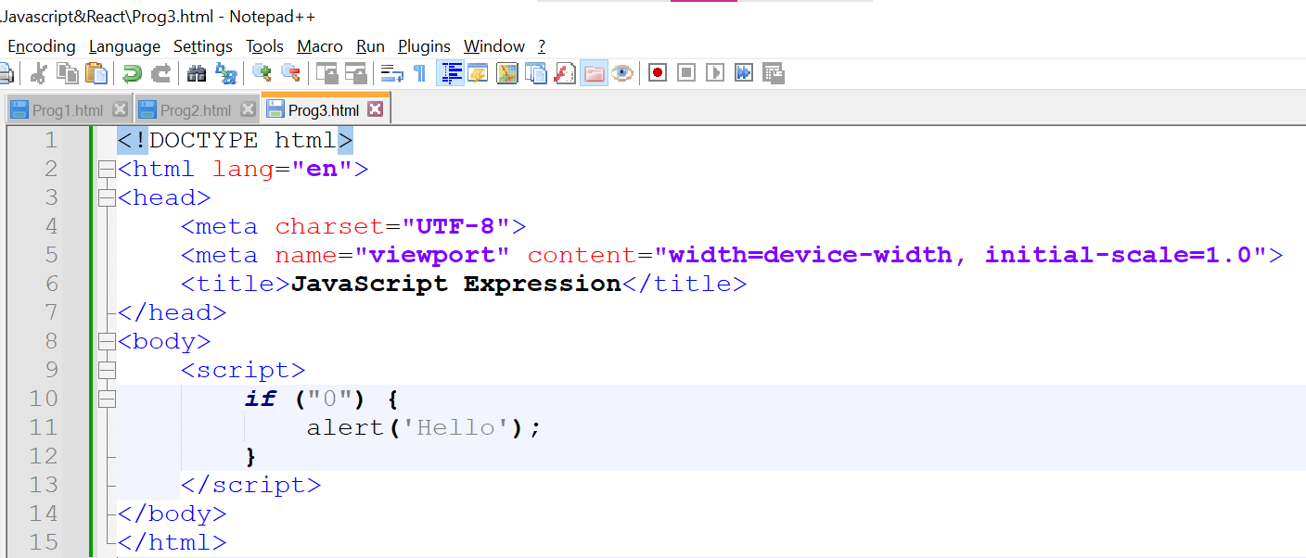

**Output:**

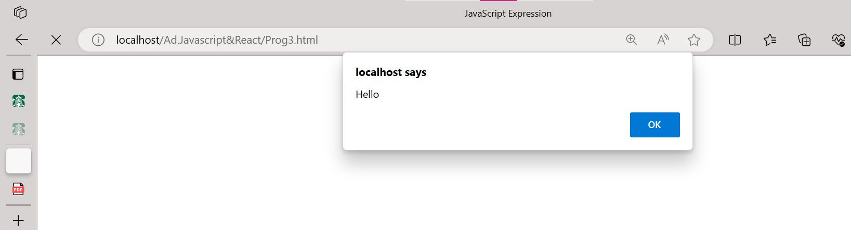

**4. What is the code below going to output?**

**alert ( null || 2 || undefined );**

**Ans:-**

**Code:**

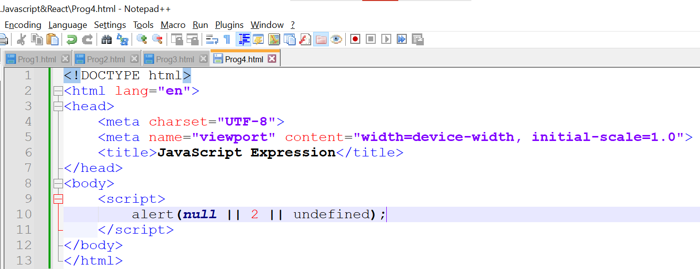

**Output:**

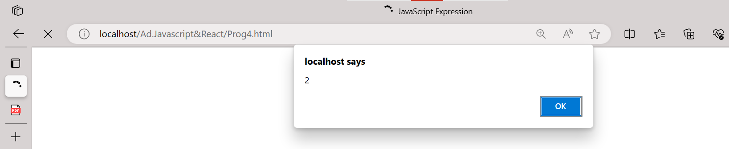

**5. The following function returns true if the parameter age is greater than 18. Otherwise it asks for a confirmation and returns its result:**

**function checkAge(age)**

**{**

**if (age> 18)**

**{ return true;**

**}**

**Else**

**{**

**// ...return confirm (‘did parents allow you?');**

**}**

**}**

**Ans:-**

See the answer in Prog5.html **.**

**6. Replace Function Expressions with arrow functions in the code below:**

**Function ask(question, yes, no)**

**{if (confirm(question))yes();**

**else no();**

**}**

**ask("Do you agree?", function()**

**{ alert("You agreed."); },**

**function() {**

**alert("You canceled the execution."); }**

**}**

**Ans:-**

See the answer in Prog6.html **.**