React- Components, State, Props

REACT

Module- 3 & Module-5

**React - Styling & Advance React**

**Submitted To:-**

**Rajesh Nagar Sir**

**Submitted By:-**

**Ankita Sahu**

**Ankita Sahu**

Module – 3 ReactJs

**1. What is React Js?**

**Ans:- ReactJS is a JavaScript library** used for building **reusable UI components**.

According React, sometimes referred to as a frontend JavaScript framework, is a JavaScript library created by **Facebook**.

React is a tool for building UI components.

Instead of manipulating the browser's DOM directly, React creates a **virtual DOM** in memory, where it does all the necessary manipulating, before making the changes in the browser DOM.

React is a JavaScript library for building user interfaces.

React is used to build **single-page applications.**

React allows us to create reusable UI components.

**2. What is NPM in React Js?**

**Ans:-** NPM, the Node package manager is used for managing and sharing the packages for either React or Angular. NPM will be installed along with Nodejs. Node. js can be downloaded and installed from the official NodeJs website.

**3. What is Role of Node Js in react Js?**

**Ans:-** High Server Load: Using Node JS with React can help in handling requests and maintaining server load balance. JSON APIs: You can easily build JSON APIs for your application using Node JS. The reusability of the code enables sharing within React JS.

**4. What is CLI command In React Js?**

**Ans:-** React has its own command-line interface (CLI) commands. However, these CLI commands are currently only used to create a passable version of a react application using the command line.

**5. What is Components in React Js?**

**Ans:-** Components are independent and reusable bits of code. They serve the same purpose as JavaScript functions, but work in isolation and return HTML. Components come in two types, Class components and Function components, in this tutorial we will concentrate on Function components.

**6. What is Header and Content Components in React Js?**

**Ans:-** Headers are compositions that extend standard navbar functionalities. They contain additional components like a jumbotron, sub-navbar, or image covers which serve as a containers for extra navigation elements - usually links, forms, or call-to-action buttons.

**7. How to install React Js on Windows, linux Operating System? How to install NPM and How to check version of NPM?**

**Ans:-**

* **Windows :**

npm -g install create-react-app

npm Start

* **Install NPM:**

npm Install

* **Check version of NPM:**

Cmd: npm –v

**8. How to check version of React Js?**

**Ans:-**

Cmd: create-react-app --version

**9. How to change in components of React Js?**

**Ans:-** setState() enqueues changes to the component state and tells React that this component and its children need to be re-rendered with the updated state. This is the primary method you use to update the user interface in response to event handlers and server responses.

**10. How to Create a List View in React Js?**

**Ans:-**

Code:-

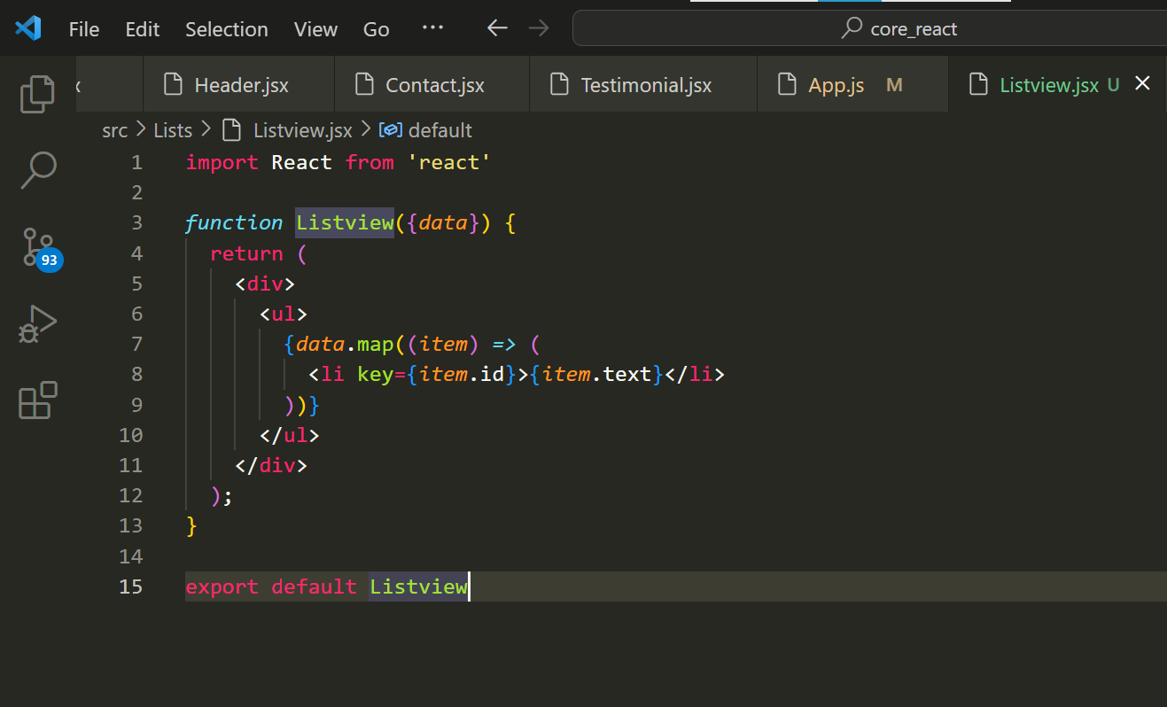

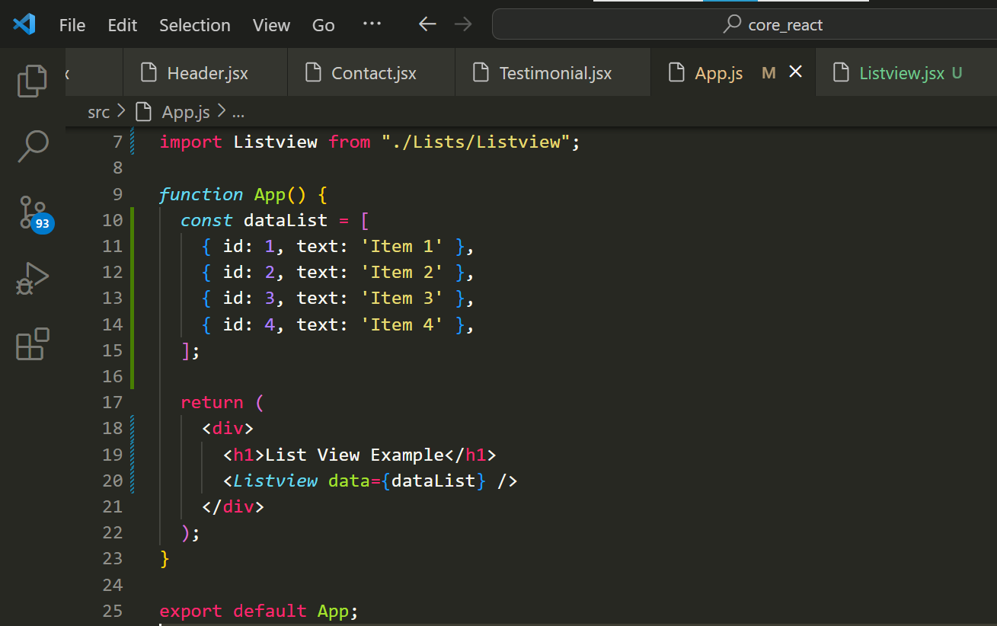

Output:-

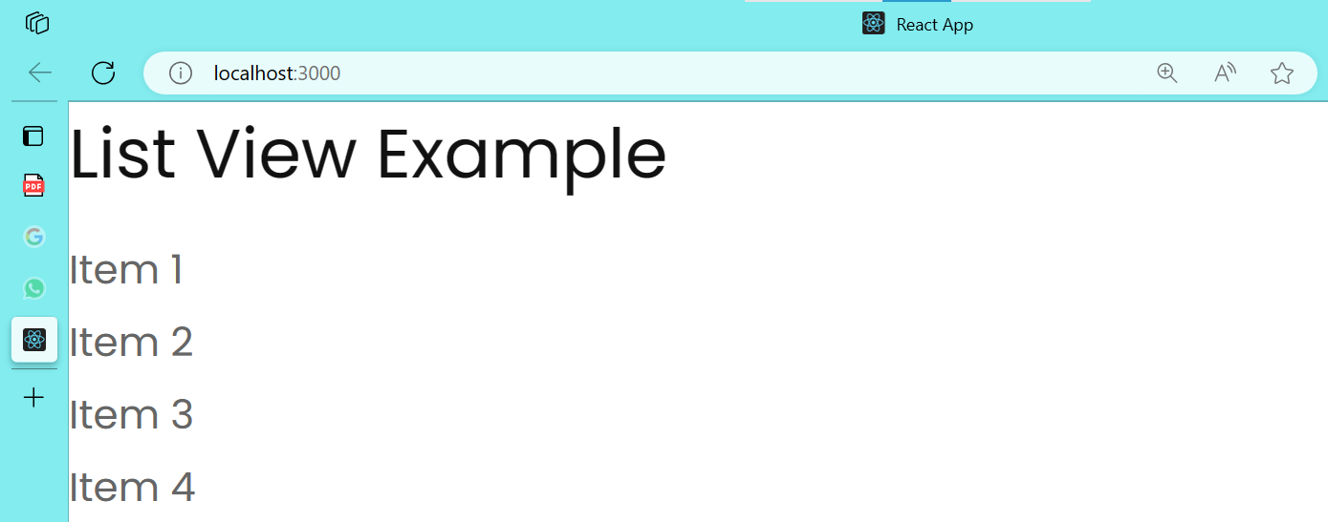

**11. Create Increment decrement state change by button click?**

**Ans:-**

Code:-

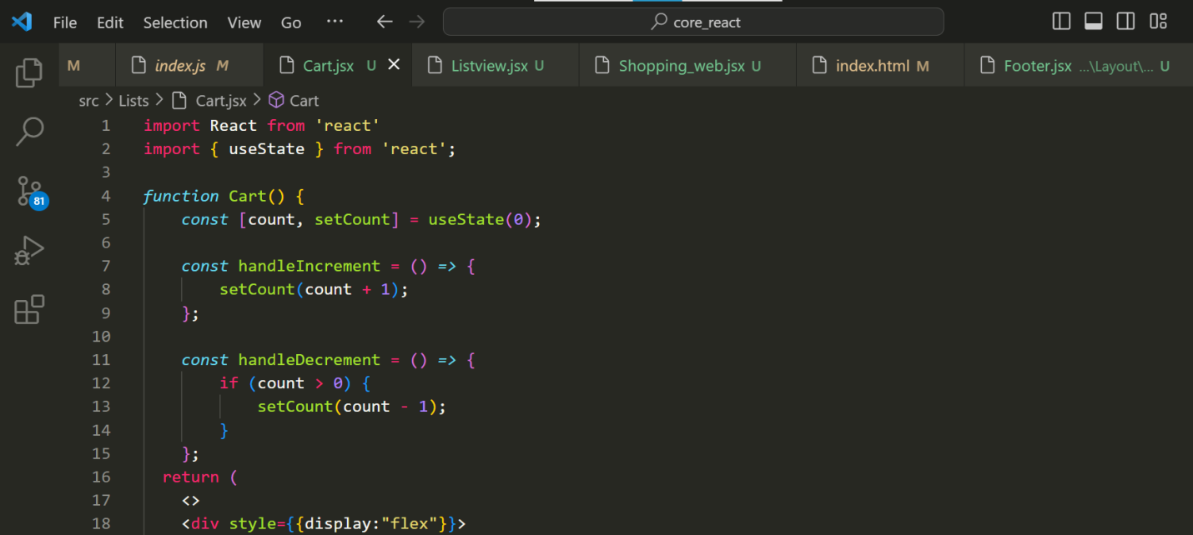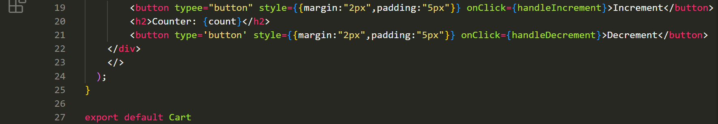

Output:-

Increment

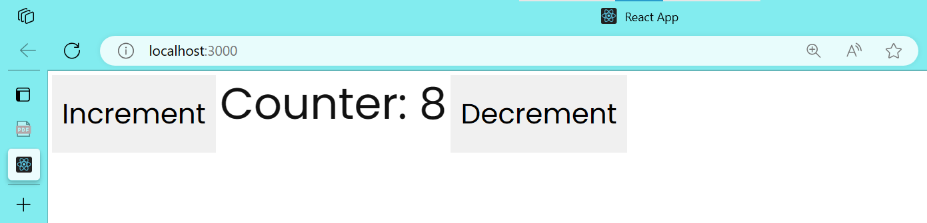

Decrement

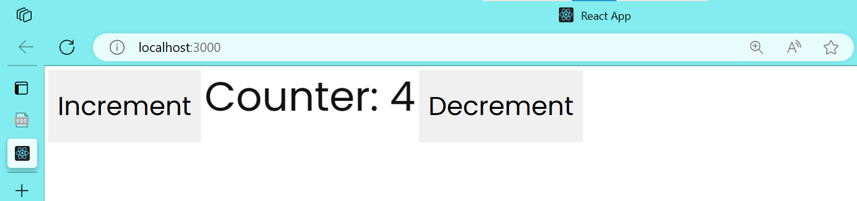

**XOXOXOXOXOX**