**WD - Bootstrap Basic & Advanced**

Module-06

Bootstrap Basic & Advanced

**Submitted To:-**

**Heet Modh Sir**

**Submitted By:-**

**Ankita Sahu**

Module – 6(Bootstrap Basic & Advanced)

1. What are the advantages of Bootstrap?

**Ans:-** **Bootstrap offers many advantages for web designers and developers, such as saving time and effort by providing ready-made components and styles that can be customized and combined. It also ensures consistency and compatibility, as it follows a standard design and coding convention, and uses a mobile-first approach. Additionally, Bootstrap supports accessibility and performance, as it follows web accessibility guidelines and best practices, and uses a modular and lightweight structure to improve the speed and performance of your website.**

* **What are the challenges of using Bootstrap?**

**Ans:-** **Bootstrap is not a perfect solution and comes with some drawbacks and limitations. It can be overwhelming and confusing, with a lot of components and options that can be difficult to learn and use, especially for beginners. You may need to use additional tools and plugins to extend its functionality and integrate it with other frameworks and libraries. Additionally, Bootstrap has a predefined style and structure, which can limit creativity and flexibility. You may also end up with a website that looks similar to many others that use Bootstrap, unless you customize it extensively and add your own flair and identity. Furthermore, Bootstrap can add a lot of unnecessary code and files to your website, which can affect its loading time and performance. It may also not support the latest web standards and features, as it takes time to update and maintain.**

## How to use Bootstrap effectively?

**Ans:- Bootstrap is a powerful and versatile tool, but it also requires some skill and strategy to use it properly. To get the most out of Bootstrap for responsive web design, plan your design and layout before coding. Sketch out your wireframes and mockups, and decide which components and features you will use and how you will customize them. Consider creating a custom theme or using a ready-made template to make your website more unique and appealing. Utilize the grid system and breakpoints to create a responsive and fluid layout that adapts to different devices and resolutions. Take advantage of the responsive utilities and classes to control the visibility, alignment, spacing, and sizing of your elements. Finally, test and optimize your website for speed and performance, by removing any unused code, files, or components.**

**2. What is a Bootstrap Container, and how does it work?**

**Ans:-** **container is used to set the content's margins dealing with the responsive behaviors of your layout. It contains the row elements and the row elements are the container of columns (known as grid system).** **The** **container class** **is used to create boxed content.**

**There are two container classes in Bootstrap:**

1. **Container**
2. **Container-fluid**

**Code:**

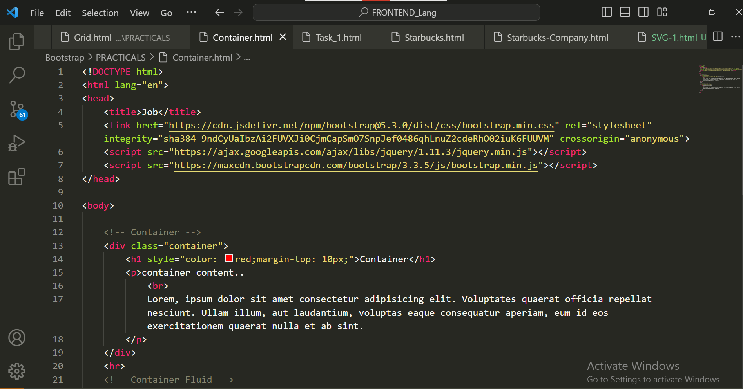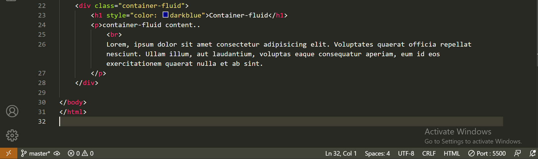

**Output:**

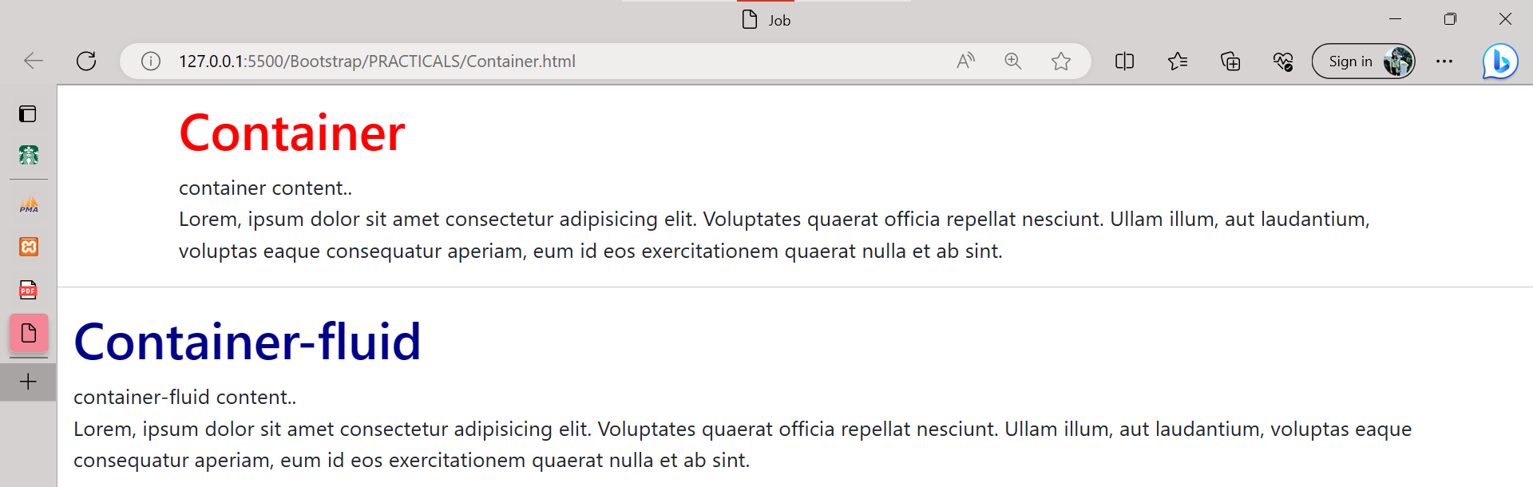

**3. What are the default Bootstrap text settings?**

**Ans:-** **Bootstrap 4 uses a default font-size of 16px, and its line-height is 1.5.The default font-family is "Helvetica Neue", Helvetica, Arial, sans-serif.In addition, all <p> elements have margin-top: 0 and margin-bottom: 1rem (16px by default).**

**Code:**

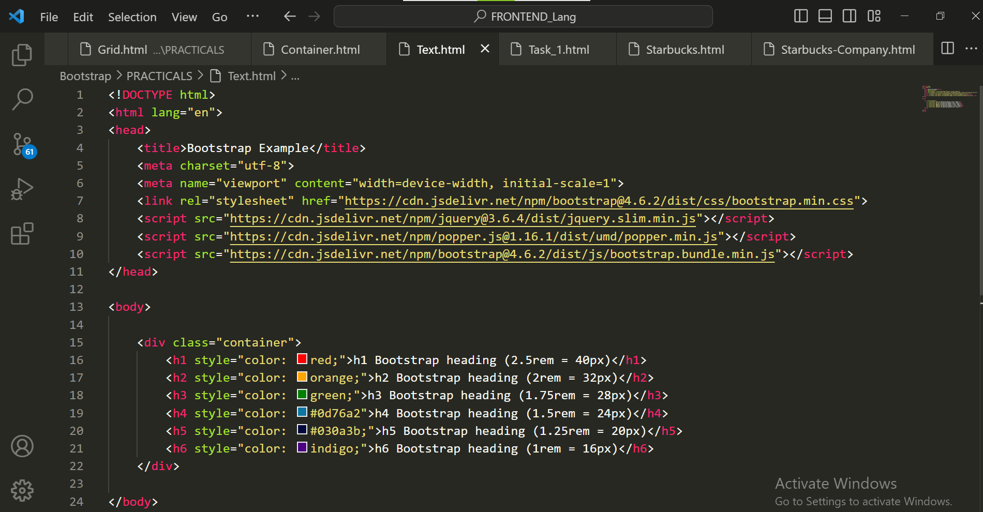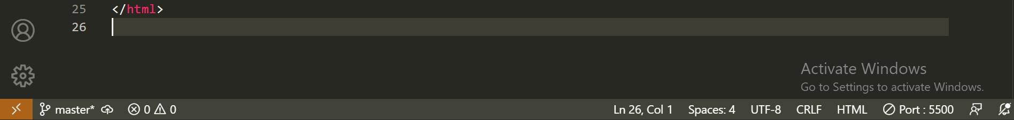

**Output:**

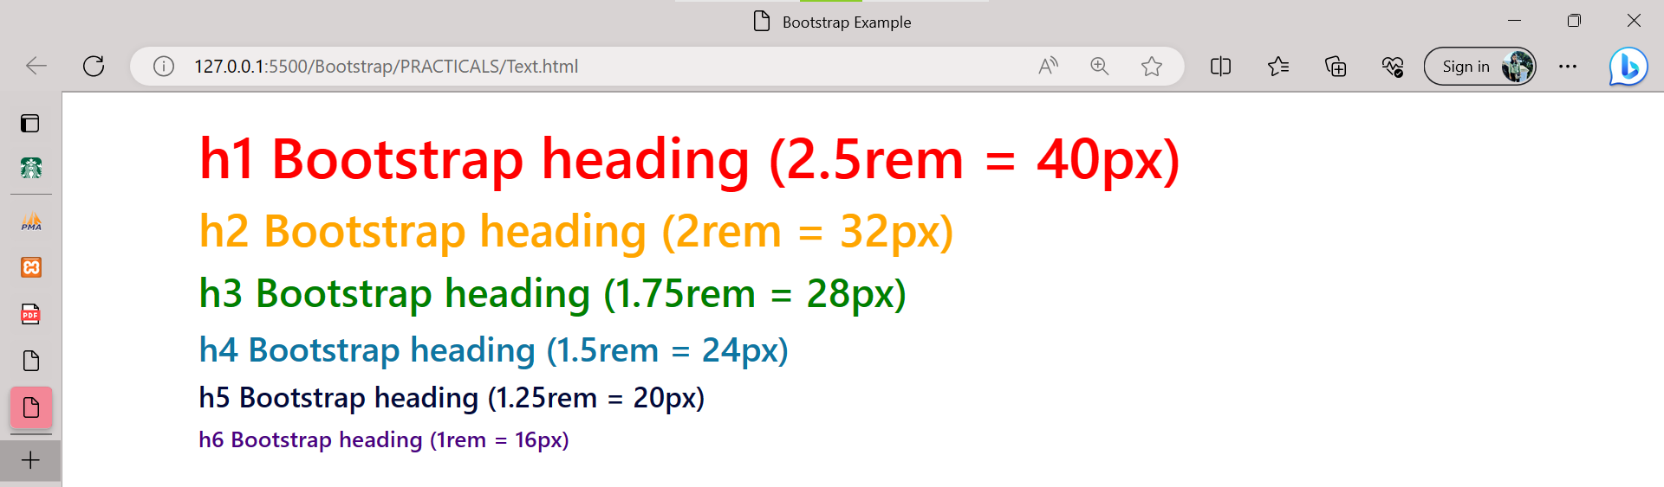

**4. What do you know about the Bootstrap Grid System?**

**Ans:-** **Bootstrap's grid system uses a series of containers, rows, and columns to layout and align content. It's built with flexbox and is fully responsive. Below is an example and an in-depth look at how the grid comes together.**

**Code:**

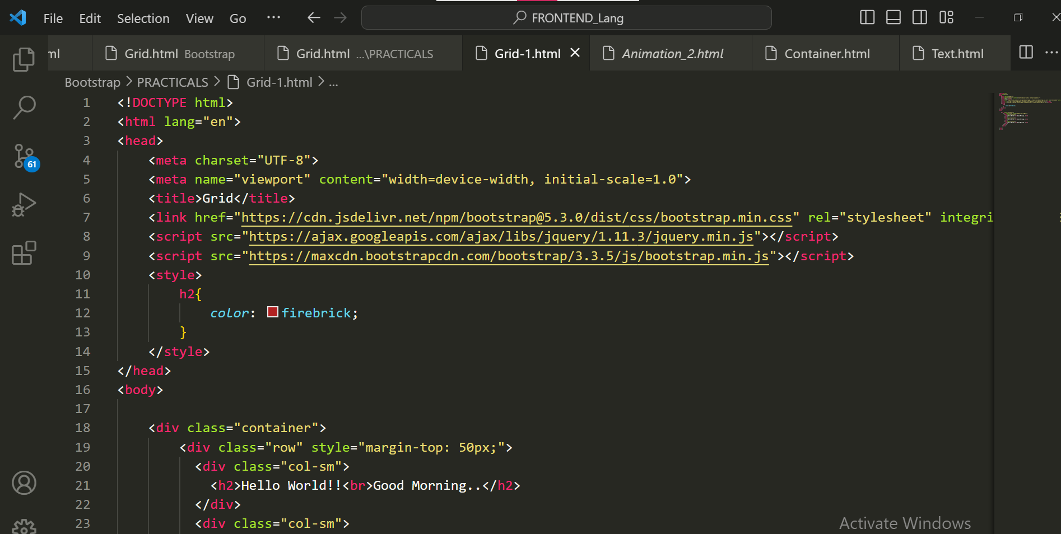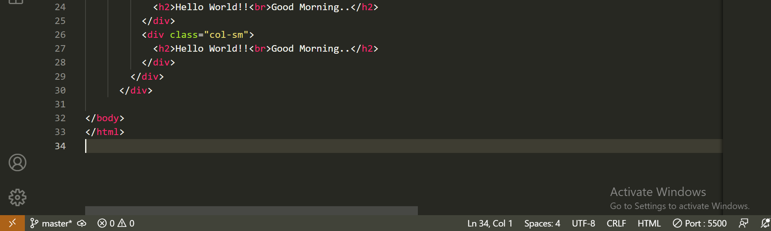

**Output:**

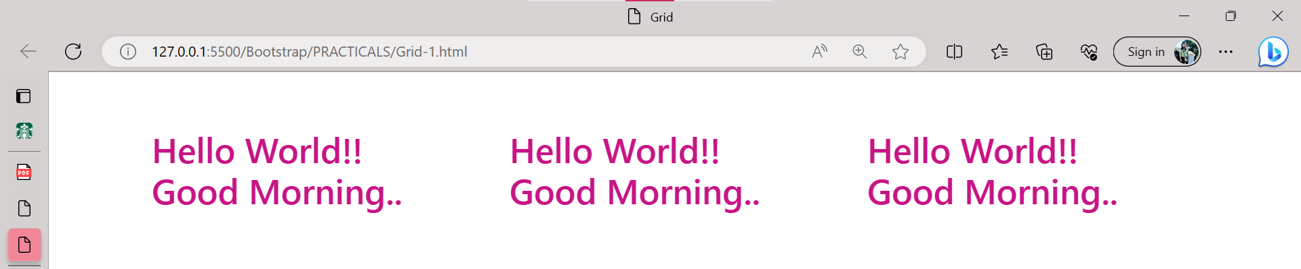

**5. What is the difference between Bootstrap 4 and Bootstrap 5?**

**Ans:-** **Bootstrap is a free and open-source toolkit for developing responsive web pages and online apps. HTML, CSS, and the JavaScript framework make it simple to create responsive, mobile-first websites. Its primary goal is to address the cross-browser compatibility issue. Bootstrap is at the heart of any website optimized for all screen sizes and looks great in all modern browsers.**

**In bootstrap 5, some classes remove, which is available in the bootstrap 4 versions.**

* a "row form"
* a "form inline"
* a "list inline"
* a "form inline"

**In bootstrap 5, some classes are not available in the bootstrap 4 versions.**

* gx-* : the horizontal/column gutters width
* gy-* :the vertical/row gutters width
* g-* :the horizontal & vertical gutter width
* rows-cols-auto

| **BASIS** | **BOOTSTRAP 4** | **BOOTSTRAP 5** |
| --- | --- | --- |
| **Grid System** | It has 5 tier (xs, sm, md, lg, xl). | It has 6 tier (xs, sm, md, lg, xl, xxl). |
| **Color** | It has limited colors. | Extra colors added with the looks, A card improved color palette. there are various shades available to choose. |
| **Jquery** | It has jquery and all related plugins. | Jquery is removed and switched to vanilla JS with some working plugins |
| **Form elements** | Radio buttons, checkboxes have different look in different OS and browsers. The form uses whatever default browsers provide. | The look of form elements will not change, on different OS or browser. The forms can be customized and form controls can be added, they would not depend on browser. |
| **Gutter** | We use .glutter with fontsize in px | We use .g* with fontsize in rem |
| **Vertical Classes** | Columns can be positioned relative | Columns cannot be positioned relative |
| **Bootstrap Icons** | Bootstrap 4 doesn’t have its own SVG icons, we have to use font-awesome for icons. | Bootstrap 5 have its own SVG icons |
| **Jumbotron** | It supports. | It doesn’t support jumbotron. |
| **Card deck** | The card deck is used to create a set of cards with equal width and height. | Card deck class in removed in bootstrap |
| **Navbar** | We have inline-block property and we will get white dropdown as default for dropdown-menu-dark class. | Inline-block property is removed and we will get black dropdown as default for dropdown-menu-dark class. |
| **flexbox grid** | This makes easier to implement vertical designs, and the columns and rows can easily be implemented. The classes justify-center-content can directly be used to align according to the requirement. | Advanced grid system is made available , also columns don’t have relative positions. |

**6. What is a Button Group, and what is the class for a basic Button Group?**

**Ans:-** **“Button Groups” in Bootstrap is a class of name “btn-group” which is used to create a series of buttons in groups (without spaces) vertically or horizontally. Syntax:**

**Code:**

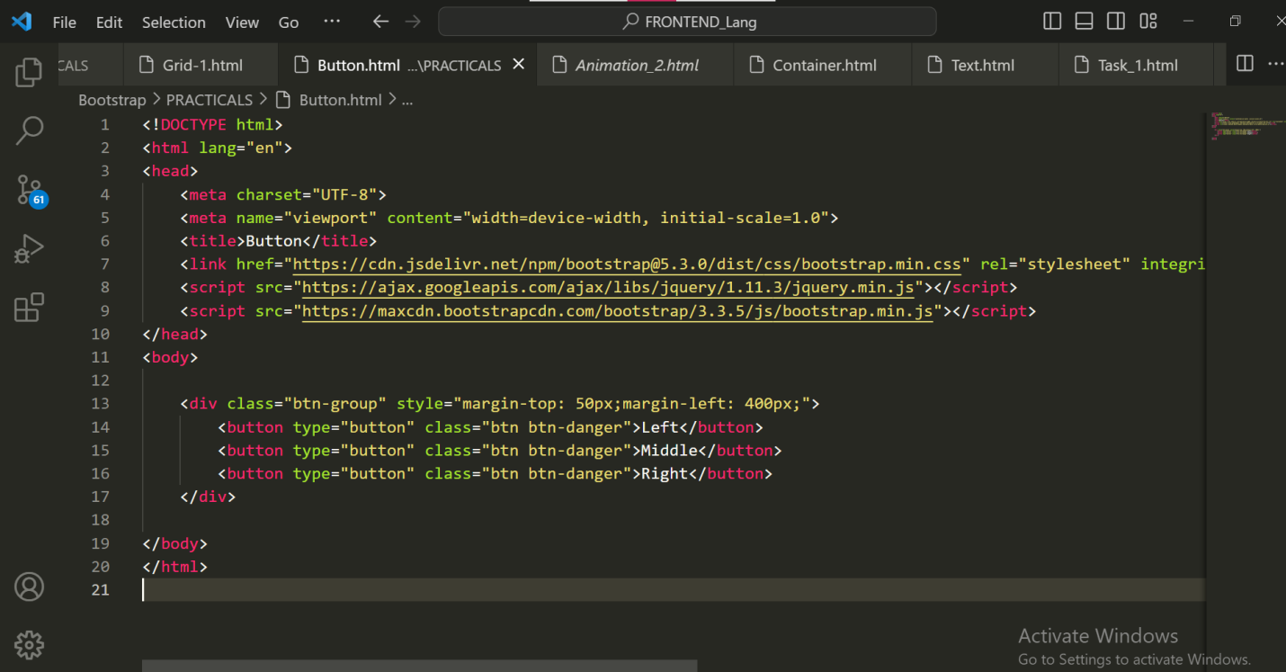

**Output:**

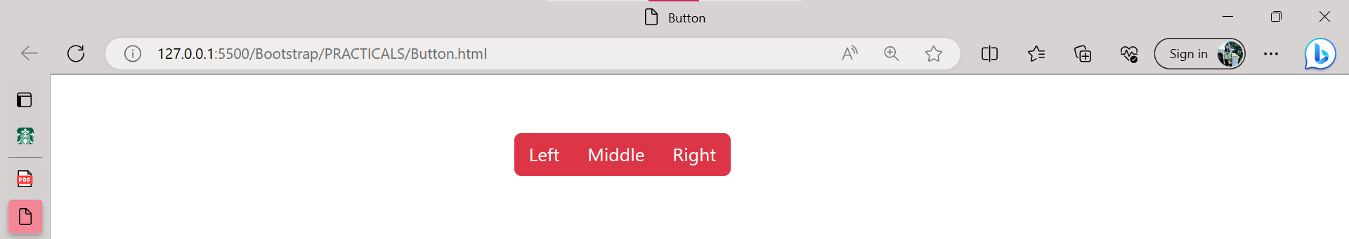

**This is the basic syntax of the button group class where each button has its own class of “btn”.**

**7. How can you use Bootstrap to make thumbnails?**

**Ans:-**

**Code:**

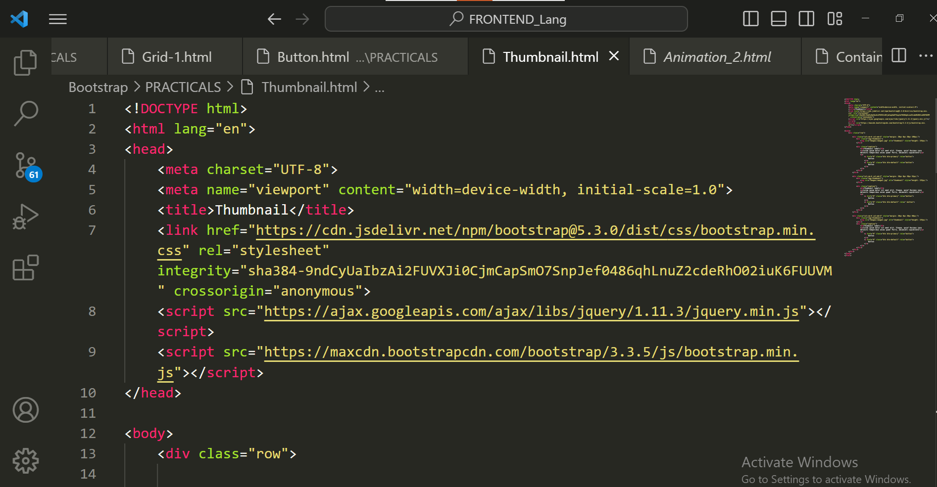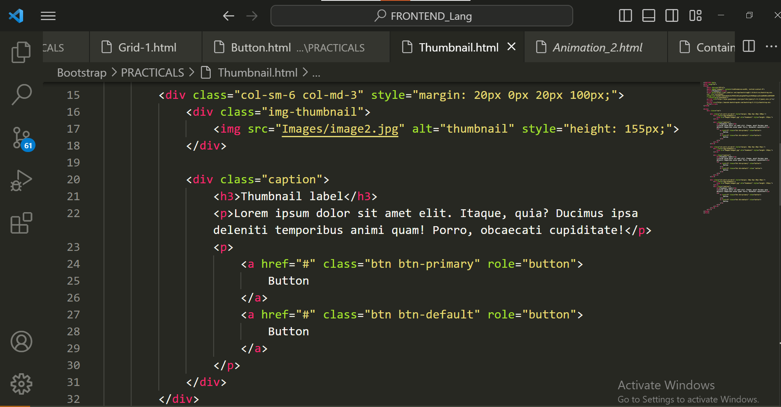

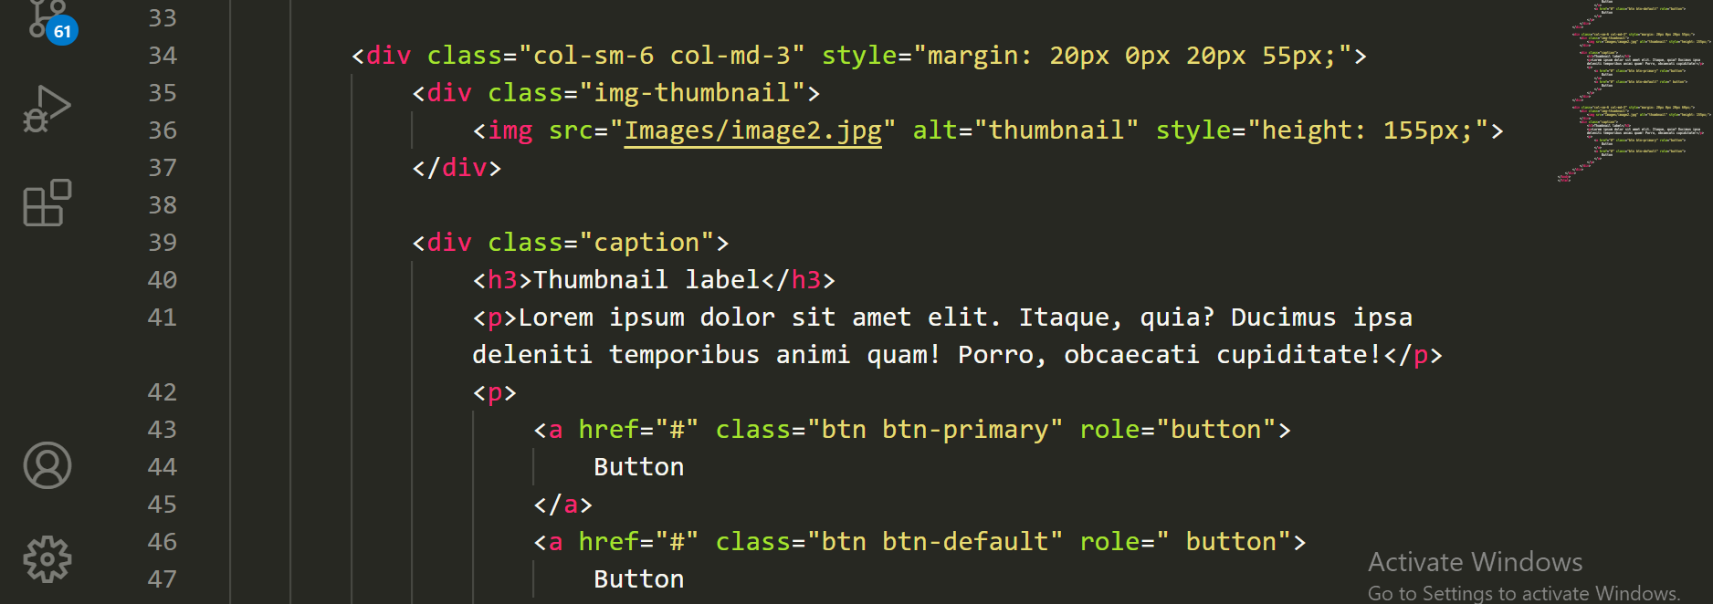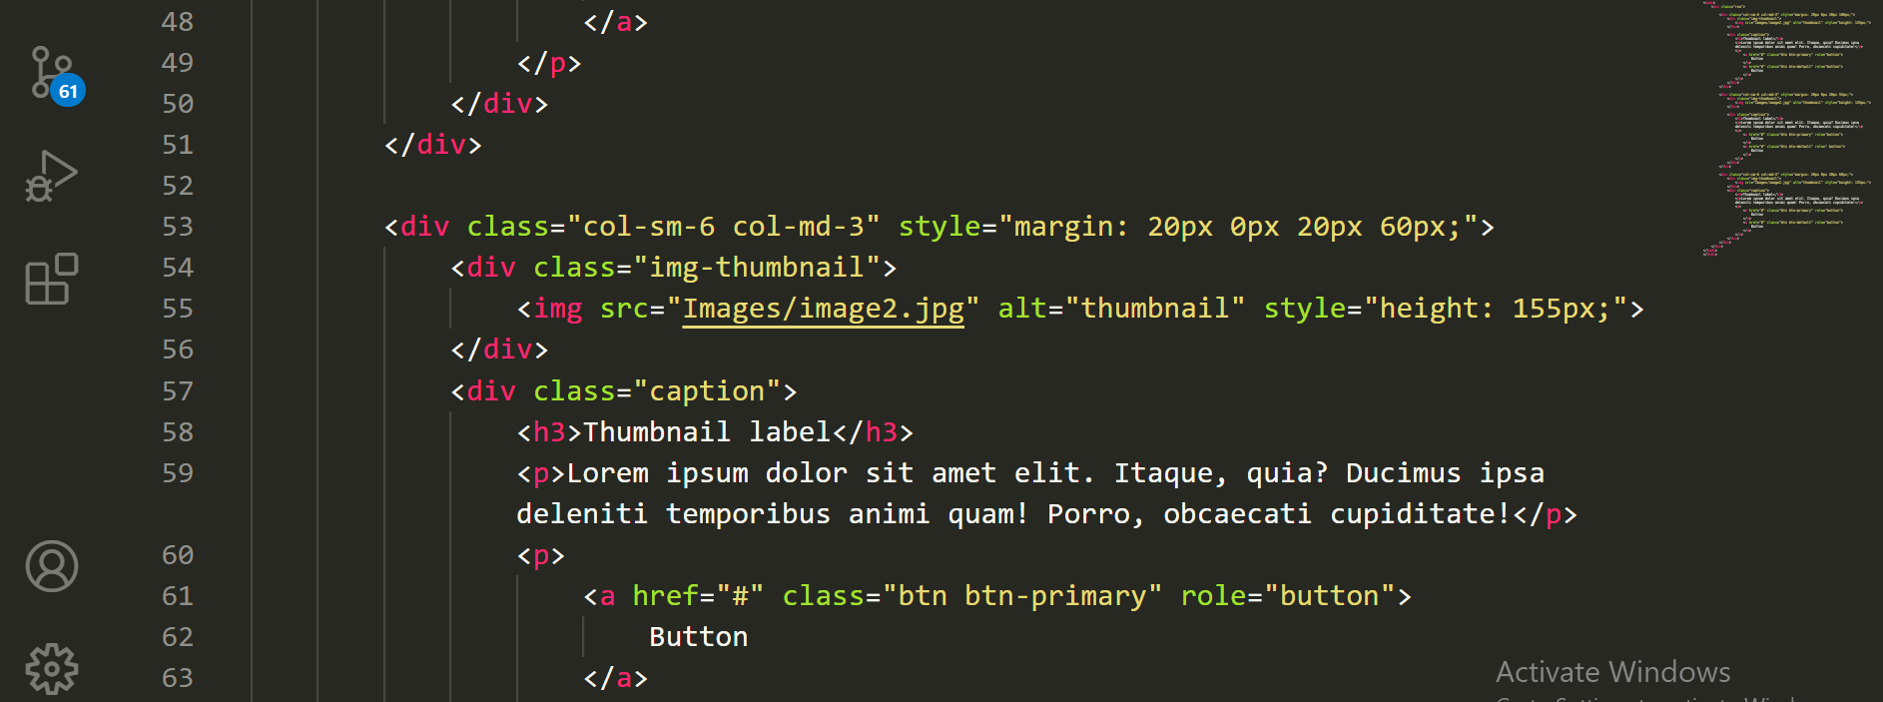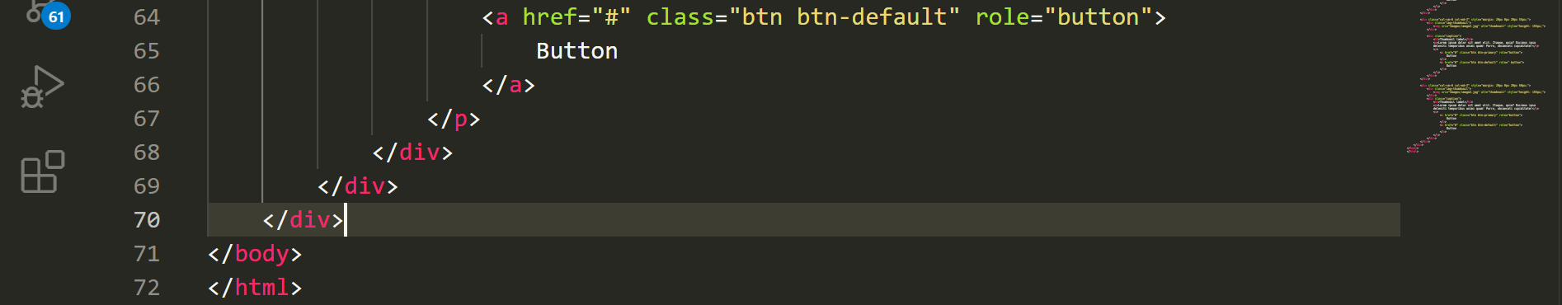

**Output:**

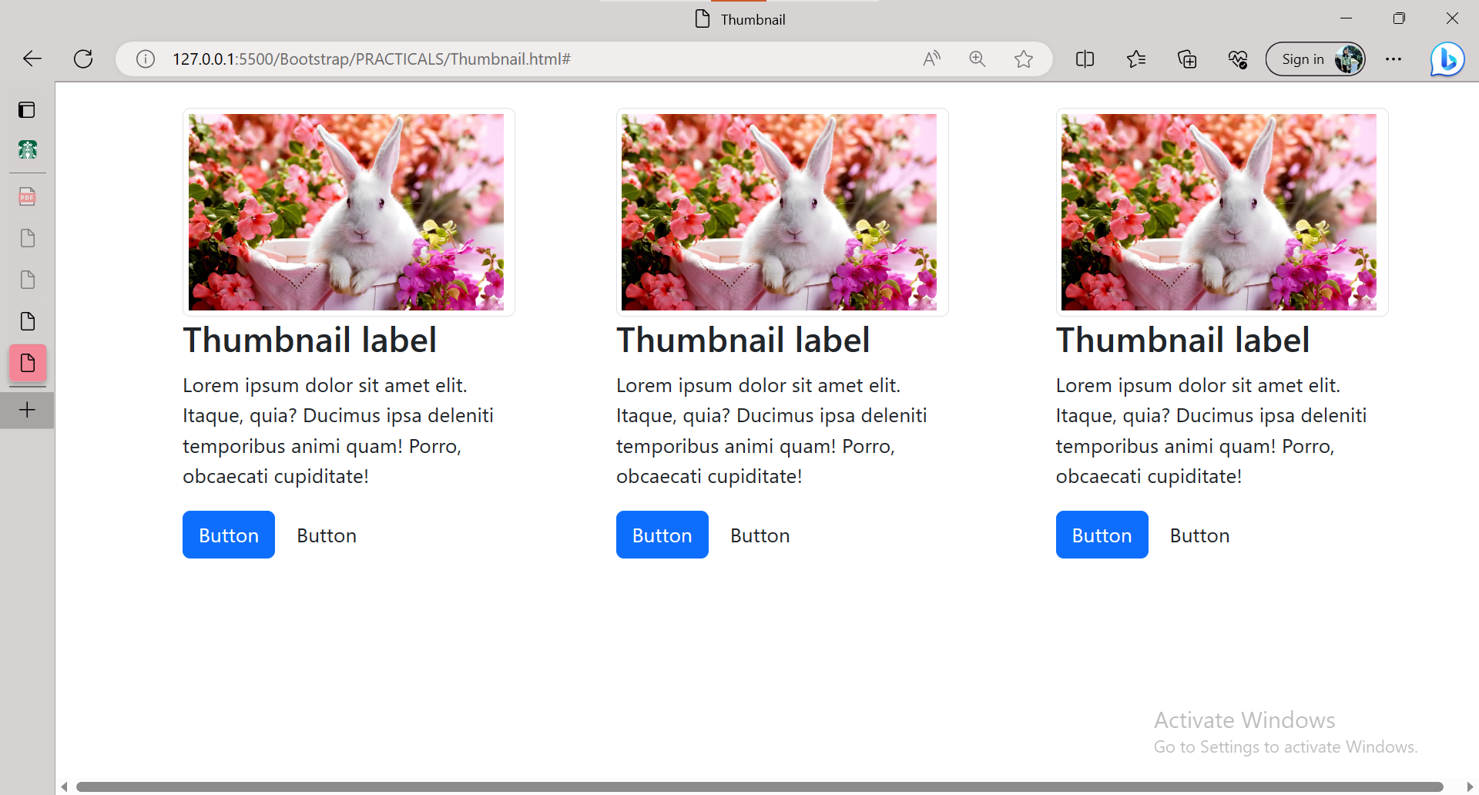

**8. In Bootstrap 4, what is flexbox?**

**Ans:-** **The biggest difference between Bootstrap 3 and Bootstrap 4 is that Bootstrap 4 now uses flexbox, instead of floats, to handle the layout.The Flexible Box Layout Module, makes it easier to design flexible responsive layout structure without using float or positioning.**

**Code:**

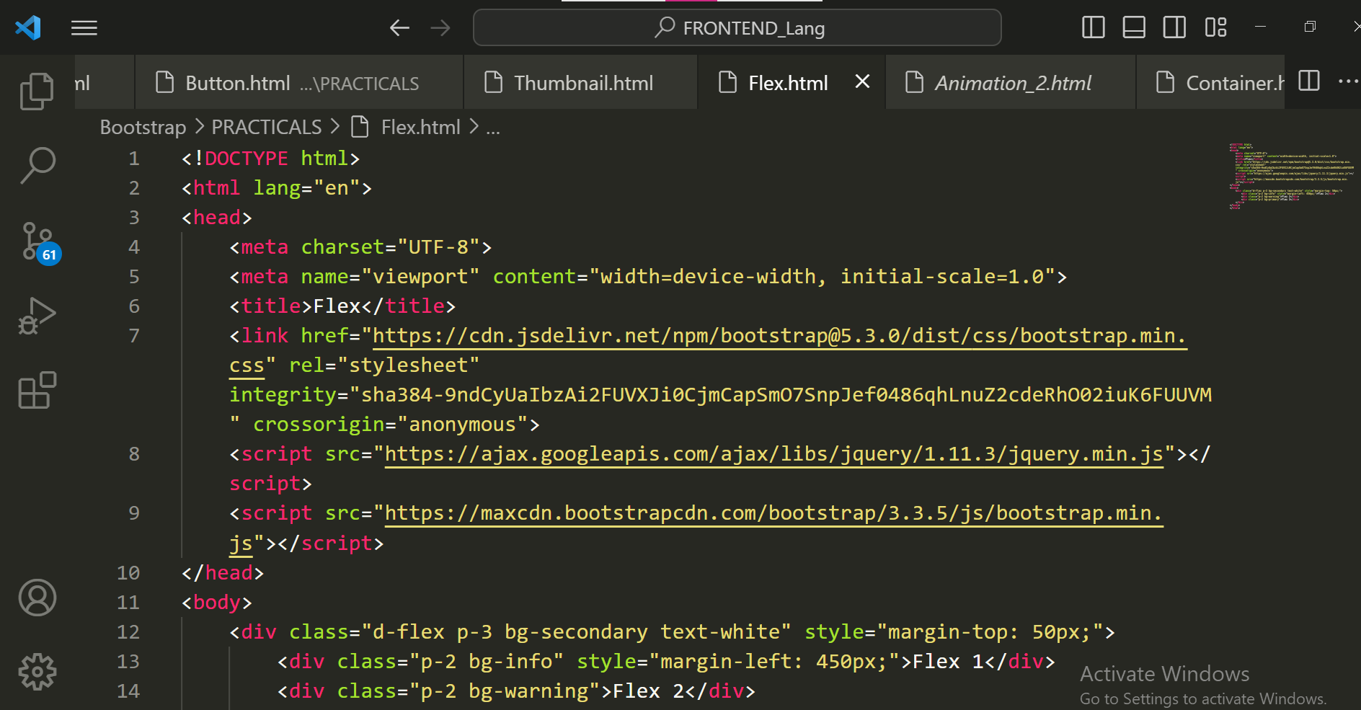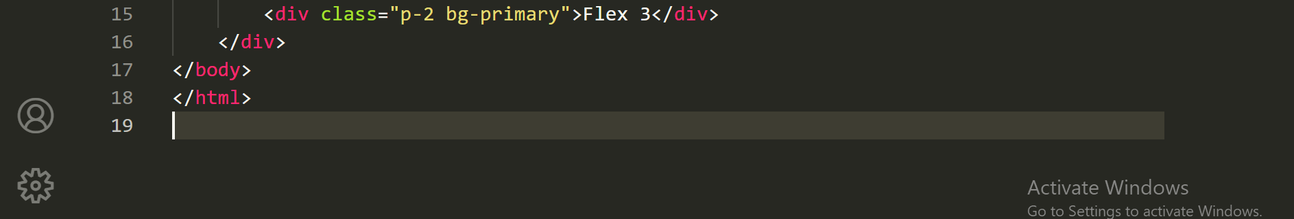

**Output:**

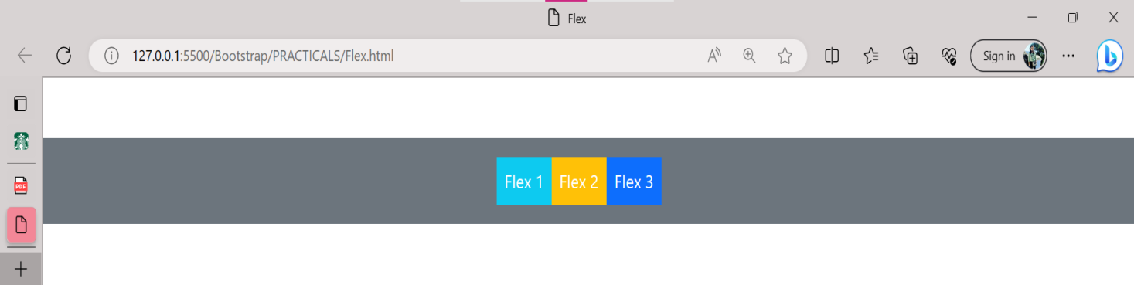

**9. How can one create an alert in Bootstrap?**

**Ans:-**

**Code:**

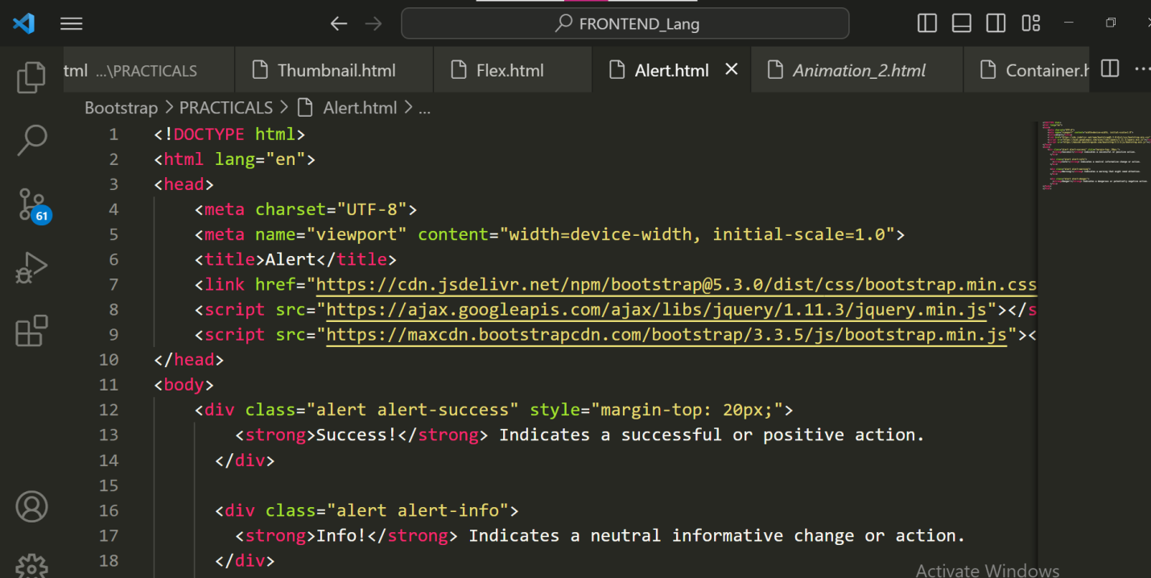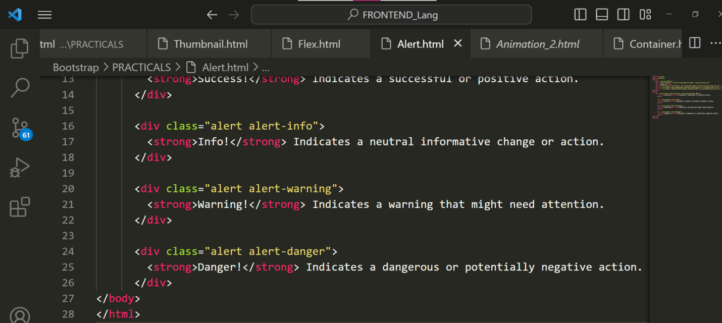

**Output:**

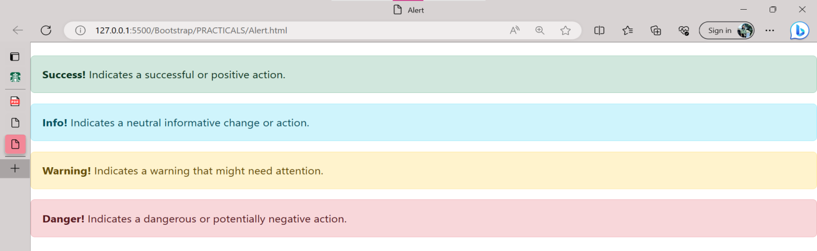

**10. What is a bootstrap card and how would you create one?**

**Ans:-**

**Code:**

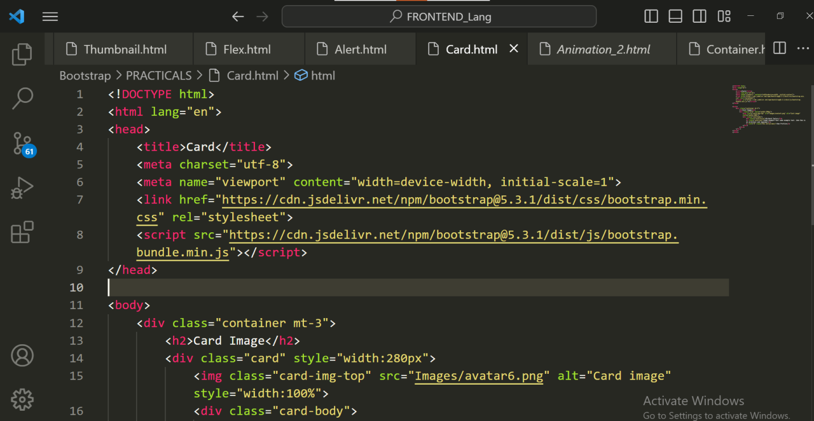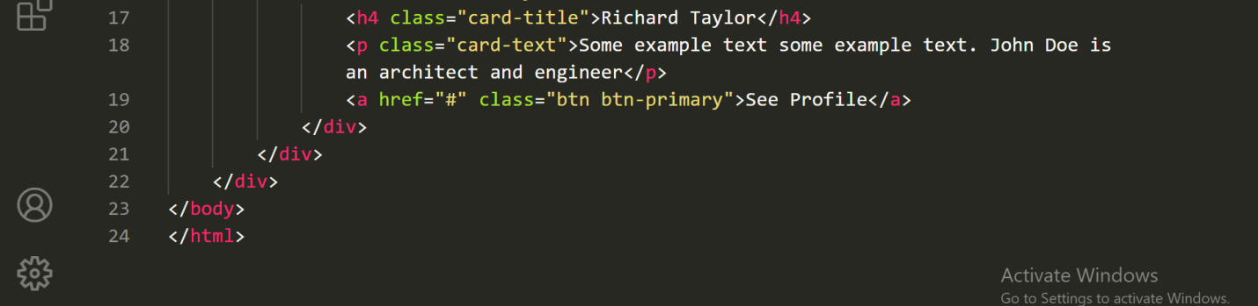

**Output:**

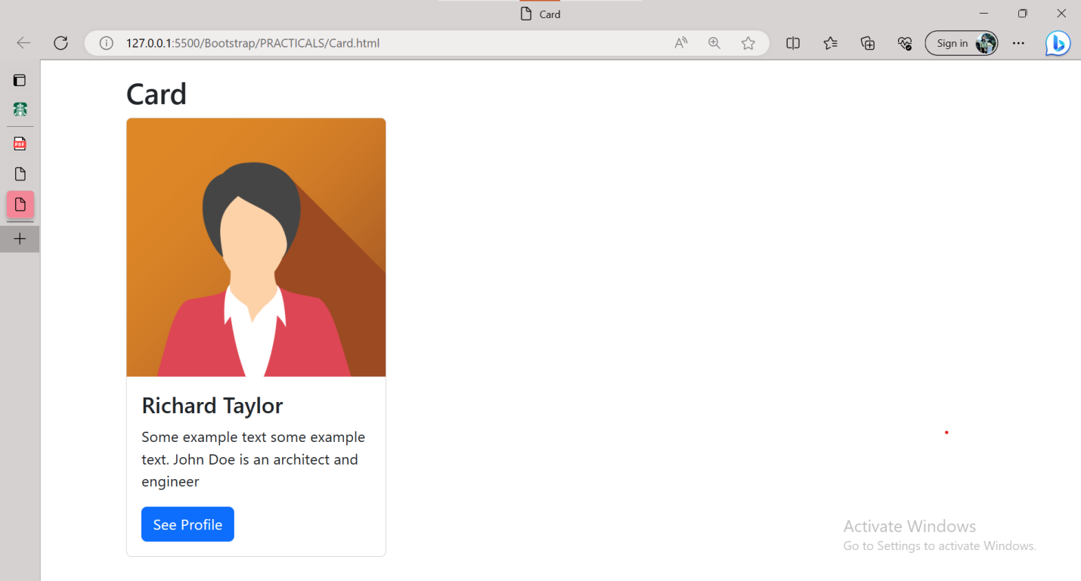

**XOXOXOXOXOXOXO**