Website Designing - HTML5 –

Full stack and Back end

**HTML5**

**MODULE-5**

**Submitted To:-**

**Heet Modh Sir**

**Submitted By:-**

**Ankita Sahu**

Module: 5 HTML5

**1) What are the new tags added in HTML5?**

**Ans:** These are the new tags added in HTML5

**<audio> :** Defines an audio file.

**<video> :** Defines a video file.

**<canvas> :** This is used for rendering dynamic bitmap graphics on the fly, such as graphs or games.

**<article>** **:** Represents an independent piece of content of a document, such as a blog entry or newspaper article.

**<aside> :** Represents a piece of content that is only slightly related to the rest of the page.

**<figure> :** Represents a piece of self-contained flow content, typically referenced as a single unit from the main flow of the document.

**<footer> :** Represents a footer for a section and can contain information about the author, copyright information, et cetera.

**<header> :** Represents a group of introductory or navigational aids.

**<nav> :** Represents a section of the document intended for navigation.

**<section> :** Represents a generic document or application section.

**2) How to embed audio and video in a webpage?**

**Ans: Audio:-**

**Syntax:**

**<audio>**

**<source src="file_name" type="audio_file_type">**

**</audio>**

**Code:**

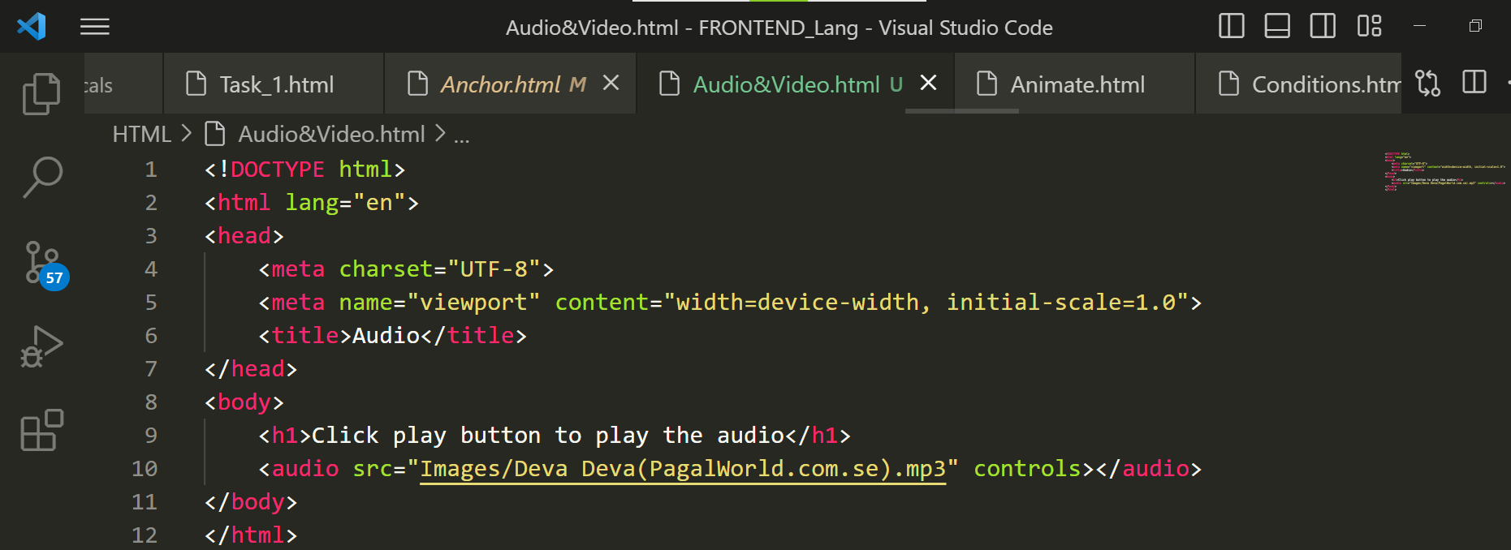

**Output:**

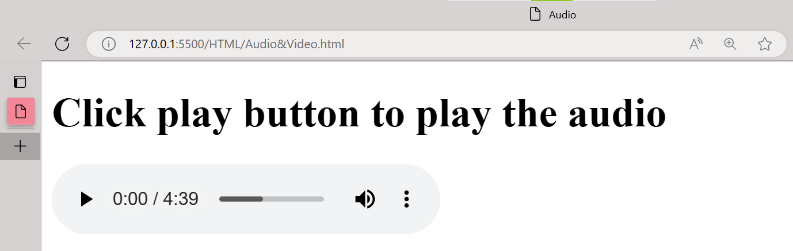

**Video:-**

**Syntax:**

<video>

<source src="file_name" type="video_file_type">

</video>

**Code:**

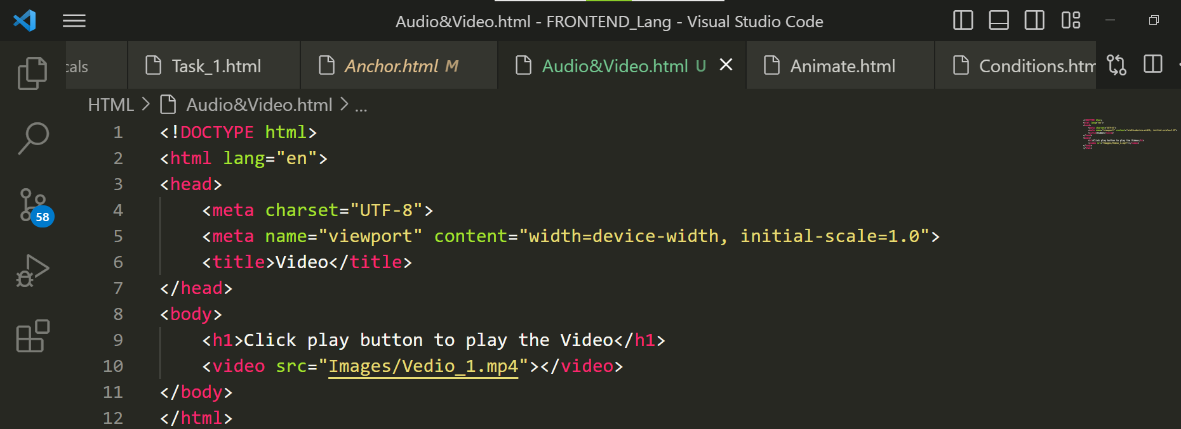

**Output:**

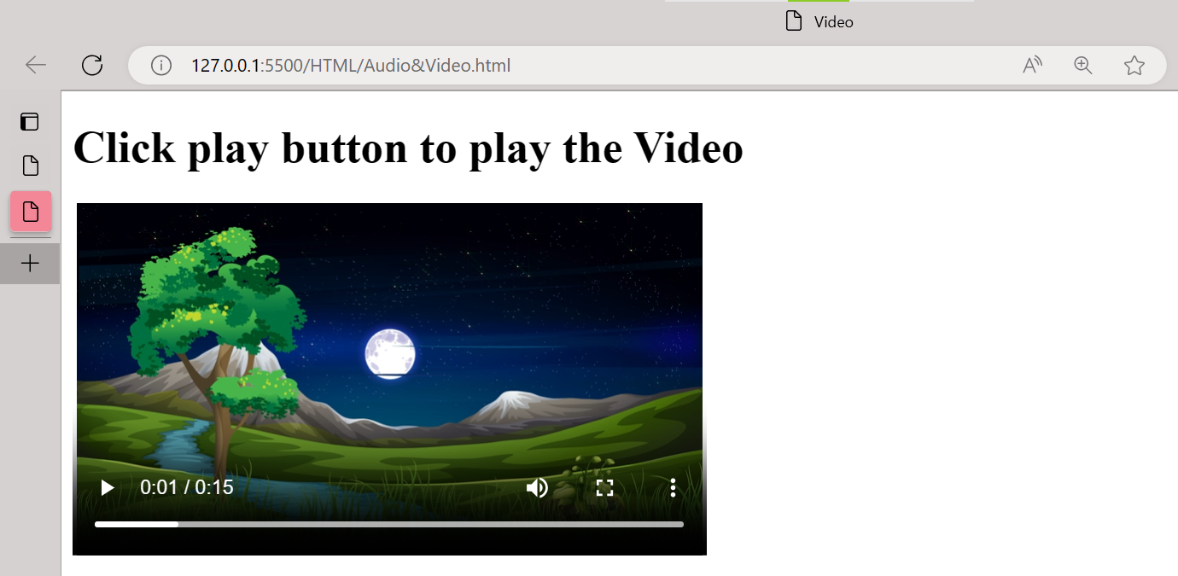

**3) Semantic element in HTML5?**

**Ans:**

[**<Header>**](https://www.w3schools.com/tags/tag_header.asp) **:**  Specifies a header for a document or section**.**

[**<Footer>**](https://www.w3schools.com/tags/tag_header.asp) **:**  Specifies a footer for a document or section**.**

[**<Section>**](https://www.w3schools.com/tags/tag_header.asp) **:**  Defines a section in a document**.**

[**<Aside>**](https://www.w3schools.com/tags/tag_header.asp) **:**  Defines content aside from the page content**.**

[**<Figure>**](https://www.w3schools.com/tags/tag_header.asp) **:**  Specifies self-contained content, like illustrations, diagrams, photos, code listings, etc**.**

[**<Figurecaption>**](https://www.w3schools.com/tags/tag_header.asp)**:** Defines additional details that the user can view or hide**.**

[**<Artical>**](https://www.w3schools.com/tags/tag_header.asp) **:**  Defines independent, self-contained content**.**

**4) Canvas and SVG tags?**

**Ans:**

**SVG:-**

**Code:**

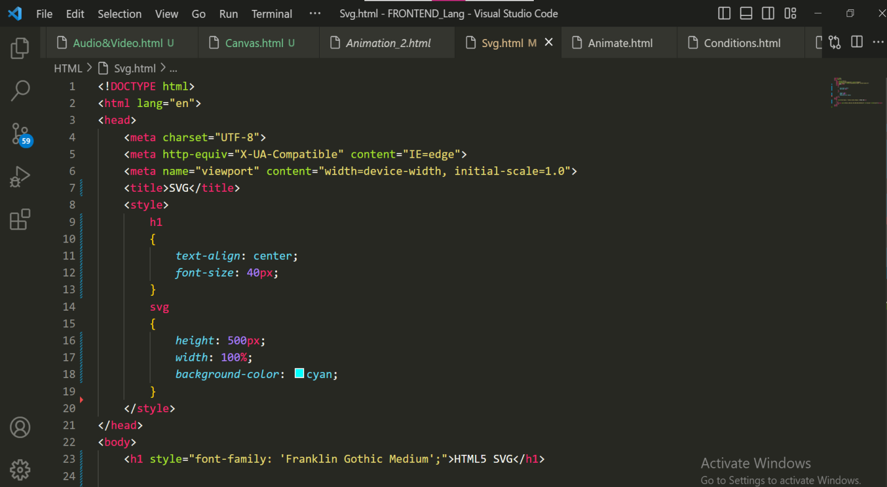

**Output:**

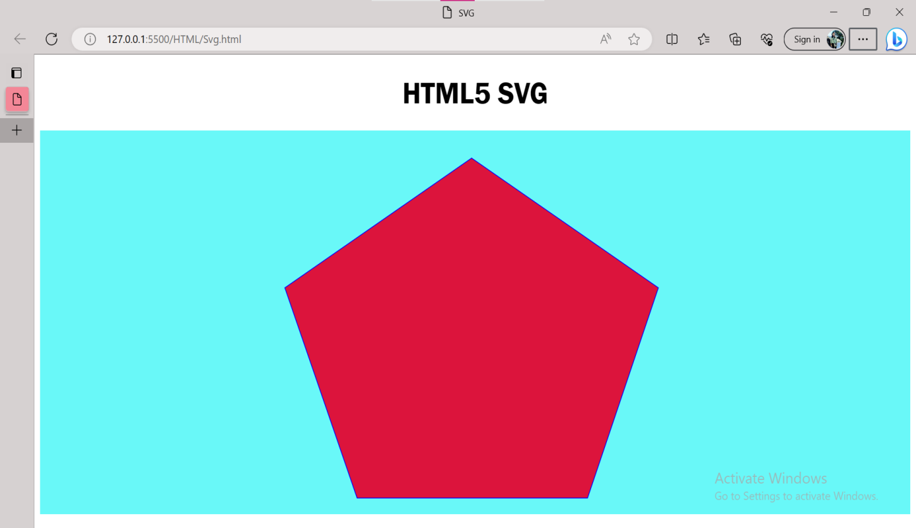

**CANVAS:-**

**Code:**

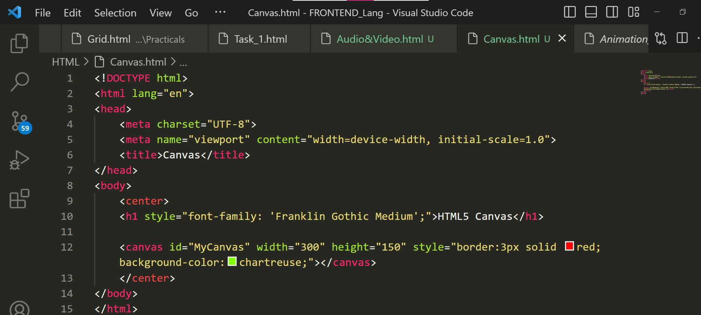

**Output:**

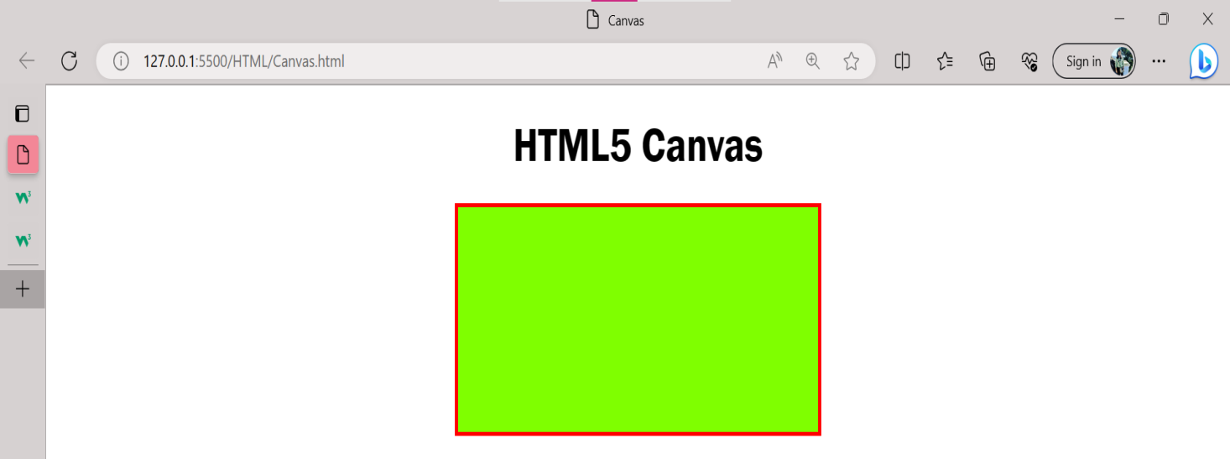

**XOXOXOXOXOXOXO**