EVRP Report: 9/03 - 26/03

Predicting current energy usage (in kWh)
To estimate the energy consumption of electric vehicles, we implemented several machine learning regression models. The objective was to predict the energy usage (kWh) based on features such as distance travelled, speed, slope, and other driving conditions.
Model performance was evaluated using the following metrics:
- Mean Squared Error (MSE)
- Root Mean Squared Error (RMSE)
- Mean Absolute Error (MAE)
- Mean Absolute Percentage Error (MAPE)
- R² Score (coefficient of determination)

The performance comparison of the models is shown in Fig. 1.

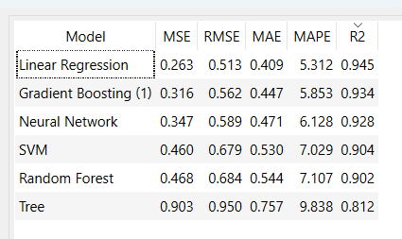
Fig. 1. Models’ performance.
Linear Regression achieved the best performance, with the lowest error values and the highest R² score (0.945).
We used the database from Kaggle [1] for training our models.

Finding routes (Python programs)
During this phase of the project, we focused on developing a Vehicle Routing Problem (VRP) model as a foundation for the Electric Vehicle Routing Problem (EVRP).

Map generating
- Randomly generated destinations
- Distance matrix (Manhattan distance)
- Visualisation of the map
- Ready to use by algorithms

Clarke-Wright Algorithm
- It is able to find efficient routes for standard VRP
- Minimizes distance
- We are working on implementing EVRP elements

Using Google OR-Tools
- It uses Google OR-Tools, which is an external library
- Using Discretised Kaggle database [1].
- Graph based optimisation
- Minimizes total energy cost and distance
- Key components:
  - RoutingIndexManager → maps nodes
  - RoutingModel → defines the optimization problem
  - Callback function → computes energy cost
  - Solver → finds optimal routes
- We are working on implementing EVRP elements

Other potential solutions
We found review papers saying that using machine learning in VRP-related problems provides.

Neural-network computational model
- We found Scientific paper [3] proving that neural network model (NNM) patterned after LeBaron׳s use of a NNM in his stock-market model performs significantly better than traditional heuristics.
- LeBaron’s NNM is a simplified neural network originally meant for financial applications. It is an agent-based system which makes decisions based on the current state and the learned patterns. It is rule based neural decision making system, so it doesn’t directly complete the route.

Memetic algorithm
We found a paper [4] using Dynamic Memory Memetic Algorithm to solve vehicle routing problem with pickup and delivery. We suspect that similar methods can be used to solve EVRP.
- Memetic algorithms are extensions of evolutionary algorithms.
- Uses local heuristics and Lamarckian learning.
!!! The paper uses Hungarian searches, but when I googled it I got holocaust database. If you wind anythong more about it , you can write it here.

To-do list

Bibliography
[2] - https://www.sciencedirect.com/science/article/pii/S2405959522000200?via%3Dihub
[3] - https://www.sciencedirect.com/science/article/abs/pii/S0925527316000049
[4] - https://ieeexplore.ieee.org/abstract/document/9194245

