Determining current energy usage (kWh)
We tried to make a machine learning classifier to determine current energy usage. The performance of various classifiers can be seen in a figure below.
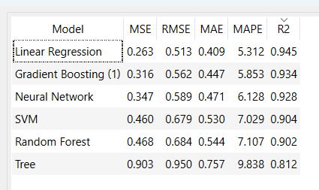
Fig. 1. Classifiers’ performance.
We used the database from Kaggle [1] for training our models.

Bibliography
- https://www.kaggle.com/datasets/ziya07/ev-energy-consumption-dataset

