Custom BP Estimation Analysis Report
Research and technical audit of ML and DL pipelines

Executive Summary
- The repository implements a multimodal physiology pipeline over Empatica E4 signals and archived videos.
- The custom target is a BP proxy score, not cuff-measured SBP/DBP; direct BP ground truth for the custom pipeline was Not Found in Repository.
- Classical ML uses grouped subject-aware splitting with imputation, standardization, and XGBoost where available, otherwise Random Forest fallback.
- The custom DL model is a PyTorch multimodal network with video, BVP, physiology, static-feature, temporal-fusion, HR, cardiovascular-load, and BP-proxy heads.

Repository Evidence Base
Artifact | Status
Source modules | src\models\ml_models.py, src\models\dl_models.py, src\models\dl_training.py, src\models\datasets.py, src\features\build_features.py, src\features\pseudo_targets.py
Notebooks | 9 notebooks found
Saved models | bp_proxy_regressor.joblib, cv_load_classifier.joblib, hr_regressor.joblib, multimodal_physio_net.pt
Prediction outputs | dl_random_sample_predictions.csv, ml_random_sample_predictions.csv

Dataset Analysis
CSV | Rows | Columns | Column sample
outputs\features\trial_features.csv | 10 | 38 | subject_id, trial_id, hr_mean, hr_std, hr_min, hr_max, eda_mean, eda_std
outputs\features\dl_windows.csv | 74 | 10 | subject_id, trial_id, aligned_path, start_row, end_row, video_path, hr_target, cv_load_index
outputs\predictions\ml_random_sample_predictions.csv | 2 | 11 | subject_id, trial_id, actual_hr, actual_cv_load, actual_bp_proxy, predicted_hr, predicted_cv_load, predicted_cv_load_proba_0
outputs\predictions\dl_random_sample_predictions.csv | 8 | 15 | subject_id, trial_id, start_row, end_row, actual_hr, predicted_hr, predicted_hr_model_scale, actual_cv_load_class

Trial-level feature table contains 10 rows and 7 unique subjects. Grouped train/test splitting is implemented in source code with GroupShuffleSplit(test_size=0.3, random_state=42).

CSV Column Dictionary

outputs\features\trial_features.csv
Column Name | Data Type | Description | Usage
subject_id | str | Identifier used for grouped splitting and traceability. | Feature/target/prediction as implied by name and code
trial_id | str | Identifier used for grouped splitting and traceability. | Feature/target/prediction as implied by name and code
hr_mean | float64 | Heart-rate-derived feature or target. | Feature/target/prediction as implied by name and code
hr_std | float64 | Heart-rate-derived feature or target. | Feature/target/prediction as implied by name and code
hr_min | float64 | Heart-rate-derived feature or target. | Feature/target/prediction as implied by name and code
hr_max | float64 | Heart-rate-derived feature or target. | Feature/target/prediction as implied by name and code
eda_mean | float64 | Electrodermal activity feature related to sympathetic arousal. | Feature/target/prediction as implied by name and code
eda_std | float64 | Electrodermal activity feature related to sympathetic arousal. | Feature/target/prediction as implied by name and code
eda_min | float64 | Electrodermal activity feature related to sympathetic arousal. | Feature/target/prediction as implied by name and code
eda_max | float64 | Electrodermal activity feature related to sympathetic arousal. | Feature/target/prediction as implied by name and code
temp_mean | float64 | Peripheral temperature feature related to perfusion and optical stability. | Feature/target/prediction as implied by name and code
temp_std | float64 | Peripheral temperature feature related to perfusion and optical stability. | Feature/target/prediction as implied by name and code
temp_min | float64 | Peripheral temperature feature related to perfusion and optical stability. | Feature/target/prediction as implied by name and code
temp_max | float64 | Peripheral temperature feature related to perfusion and optical stability. | Feature/target/prediction as implied by name and code
optical_stability_score | float64 | Repository column; semantic description not explicitly documented. | Feature/target/prediction as implied by name and code
motion_mean | float64 | Accelerometer or motion-derived artifact/context feature. | Feature/target/prediction as implied by name and code
motion_std | float64 | Accelerometer or motion-derived artifact/context feature. | Feature/target/prediction as implied by name and code
motion_min | float64 | Accelerometer or motion-derived artifact/context feature. | Feature/target/prediction as implied by name and code
motion_max | float64 | Accelerometer or motion-derived artifact/context feature. | Feature/target/prediction as implied by name and code
rmssd | float64 | Inter-beat interval / HRV feature. | Feature/target/prediction as implied by name and code
sdnn | float64 | Inter-beat interval / HRV feature. | Feature/target/prediction as implied by name and code
pnn50 | float64 | Inter-beat interval / HRV feature. | Feature/target/prediction as implied by name and code
lf_hf | float64 | Repository column; semantic description not explicitly documented. | Feature/target/prediction as implied by name and code
bvp_pulse_amplitude_mean | float64 | Blood volume pulse waveform feature from Empatica BVP. | Feature/target/prediction as implied by name and code
bvp_pulse_amplitude_std | float64 | Blood volume pulse waveform feature from Empatica BVP. | Feature/target/prediction as implied by name and code
bvp_pulse_width_mean | float64 | Blood volume pulse waveform feature from Empatica BVP. | Feature/target/prediction as implied by name and code
bvp_peak_interval_mean | float64 | Blood volume pulse waveform feature from Empatica BVP. | Feature/target/prediction as implied by name and code
bvp_peak_interval_std | float64 | Blood volume pulse waveform feature from Empatica BVP. | Feature/target/prediction as implied by name and code
bvp_pulse_skewness | float64 | Blood volume pulse waveform feature from Empatica BVP. | Feature/target/prediction as implied by name and code
bvp_dominant_frequency | float64 | Blood volume pulse waveform feature from Empatica BVP. | Feature/target/prediction as implied by name and code
bvp_spectral_entropy | float64 | Blood volume pulse waveform feature from Empatica BVP. | Feature/target/prediction as implied by name and code
bvp_snr | float64 | Blood volume pulse waveform feature from Empatica BVP. | Feature/target/prediction as implied by name and code
cv_load_index | float64 | Pseudo cardiovascular-load target/index. | Feature/target/prediction as implied by name and code
cv_load_class | int64 | Pseudo cardiovascular-load target/index. | Feature/target/prediction as implied by name and code
signal_reliability_score | float64 | Repository column; semantic description not explicitly documented. | Feature/target/prediction as implied by name and code
stress_recovery_index | float64 | Repository column; semantic description not explicitly documented. | Feature/target/prediction as implied by name and code
bp_proxy_score | float64 | Synthetic blood-pressure proxy target derived from load, motion, and reliability. | Feature/target/prediction as implied by name and code
hr_baseline_deviation | float64 | Heart-rate-derived feature or target. | Feature/target/prediction as implied by name and code

outputs\features\dl_windows.csv
Column Name | Data Type | Description | Usage
subject_id | str | Identifier used for grouped splitting and traceability. | Feature/target/prediction as implied by name and code
trial_id | str | Identifier used for grouped splitting and traceability. | Feature/target/prediction as implied by name and code
aligned_path | str | Repository column; semantic description not explicitly documented. | Feature/target/prediction as implied by name and code
start_row | int64 | Repository column; semantic description not explicitly documented. | Feature/target/prediction as implied by name and code
end_row | int64 | Repository column; semantic description not explicitly documented. | Feature/target/prediction as implied by name and code
video_path | str | Repository column; semantic description not explicitly documented. | Feature/target/prediction as implied by name and code
hr_target | float64 | Heart-rate-derived feature or target. | Feature/target/prediction as implied by name and code
cv_load_index | float64 | Pseudo cardiovascular-load target/index. | Feature/target/prediction as implied by name and code
cv_load_class | int64 | Pseudo cardiovascular-load target/index. | Feature/target/prediction as implied by name and code
bp_proxy_target | float64 | Synthetic blood-pressure proxy target derived from load, motion, and reliability. | Feature/target/prediction as implied by name and code

outputs\predictions\ml_random_sample_predictions.csv
Column Name | Data Type | Description | Usage
subject_id | str | Identifier used for grouped splitting and traceability. | Feature/target/prediction as implied by name and code
trial_id | str | Identifier used for grouped splitting and traceability. | Feature/target/prediction as implied by name and code
actual_hr | float64 | Heart-rate-derived feature or target. | Feature/target/prediction as implied by name and code
actual_cv_load | int64 | Pseudo cardiovascular-load target/index. | Feature/target/prediction as implied by name and code
actual_bp_proxy | float64 | Synthetic blood-pressure proxy target derived from load, motion, and reliability. | Feature/target/prediction as implied by name and code
predicted_hr | float64 | Heart-rate-derived feature or target. | Feature/target/prediction as implied by name and code
predicted_cv_load | int64 | Pseudo cardiovascular-load target/index. | Feature/target/prediction as implied by name and code
predicted_cv_load_proba_0 | float64 | Pseudo cardiovascular-load target/index. | Feature/target/prediction as implied by name and code
predicted_cv_load_proba_1 | float64 | Pseudo cardiovascular-load target/index. | Feature/target/prediction as implied by name and code
predicted_cv_load_proba_2 | float64 | Pseudo cardiovascular-load target/index. | Feature/target/prediction as implied by name and code
predicted_bp_proxy | float64 | Synthetic blood-pressure proxy target derived from load, motion, and reliability. | Feature/target/prediction as implied by name and code

outputs\predictions\dl_random_sample_predictions.csv
Column Name | Data Type | Description | Usage
subject_id | str | Identifier used for grouped splitting and traceability. | Feature/target/prediction as implied by name and code
trial_id | str | Identifier used for grouped splitting and traceability. | Feature/target/prediction as implied by name and code
start_row | int64 | Repository column; semantic description not explicitly documented. | Feature/target/prediction as implied by name and code
end_row | int64 | Repository column; semantic description not explicitly documented. | Feature/target/prediction as implied by name and code
actual_hr | float64 | Heart-rate-derived feature or target. | Feature/target/prediction as implied by name and code
predicted_hr | float64 | Heart-rate-derived feature or target. | Feature/target/prediction as implied by name and code
predicted_hr_model_scale | float64 | Heart-rate-derived feature or target. | Feature/target/prediction as implied by name and code
actual_cv_load_class | int64 | Pseudo cardiovascular-load target/index. | Feature/target/prediction as implied by name and code
predicted_cv_load_class | int64 | Pseudo cardiovascular-load target/index. | Feature/target/prediction as implied by name and code
actual_bp_proxy | float64 | Synthetic blood-pressure proxy target derived from load, motion, and reliability. | Feature/target/prediction as implied by name and code
predicted_bp_proxy | float64 | Synthetic blood-pressure proxy target derived from load, motion, and reliability. | Feature/target/prediction as implied by name and code
predicted_bp_proxy_model_scale | float64 | Synthetic blood-pressure proxy target derived from load, motion, and reliability. | Feature/target/prediction as implied by name and code
predicted_cv_load_proba_0 | float64 | Pseudo cardiovascular-load target/index. | Feature/target/prediction as implied by name and code
predicted_cv_load_proba_1 | float64 | Pseudo cardiovascular-load target/index. | Feature/target/prediction as implied by name and code
predicted_cv_load_proba_2 | float64 | Pseudo cardiovascular-load target/index. | Feature/target/prediction as implied by name and code

Exploratory Data Analysis
Column | Missing Count | Missing %
All inspected columns | 0 | 0.0%

Feature | Outlier Count | Method
hr_mean | 1 | IQR 1.5x rule
eda_mean | 2 | IQR 1.5x rule
eda_std | 2 | IQR 1.5x rule
eda_max | 2 | IQR 1.5x rule
motion_min | 1 | IQR 1.5x rule
rmssd | 1 | IQR 1.5x rule
pnn50 | 1 | IQR 1.5x rule
bvp_pulse_amplitude_mean | 1 | IQR 1.5x rule
bvp_pulse_width_mean | 1 | IQR 1.5x rule
cv_load_index | 2 | IQR 1.5x rule
signal_reliability_score | 1 | IQR 1.5x rule
stress_recovery_index | 3 | IQR 1.5x rule
hr_baseline_deviation | 4 | IQR 1.5x rule

Feature | Absolute correlation with BP proxy
cv_load_index | 0.879
signal_reliability_score | 0.769
hr_mean | 0.750
motion_mean | 0.717
cv_load_class | 0.703
rmssd | 0.672
pnn50 | 0.626
bvp_spectral_entropy | 0.620
bvp_snr | 0.595
stress_recovery_index | 0.595
sdnn | 0.580
bvp_peak_interval_mean | 0.571
hr_baseline_deviation | 0.556
temp_std | 0.387
optical_stability_score | 0.381

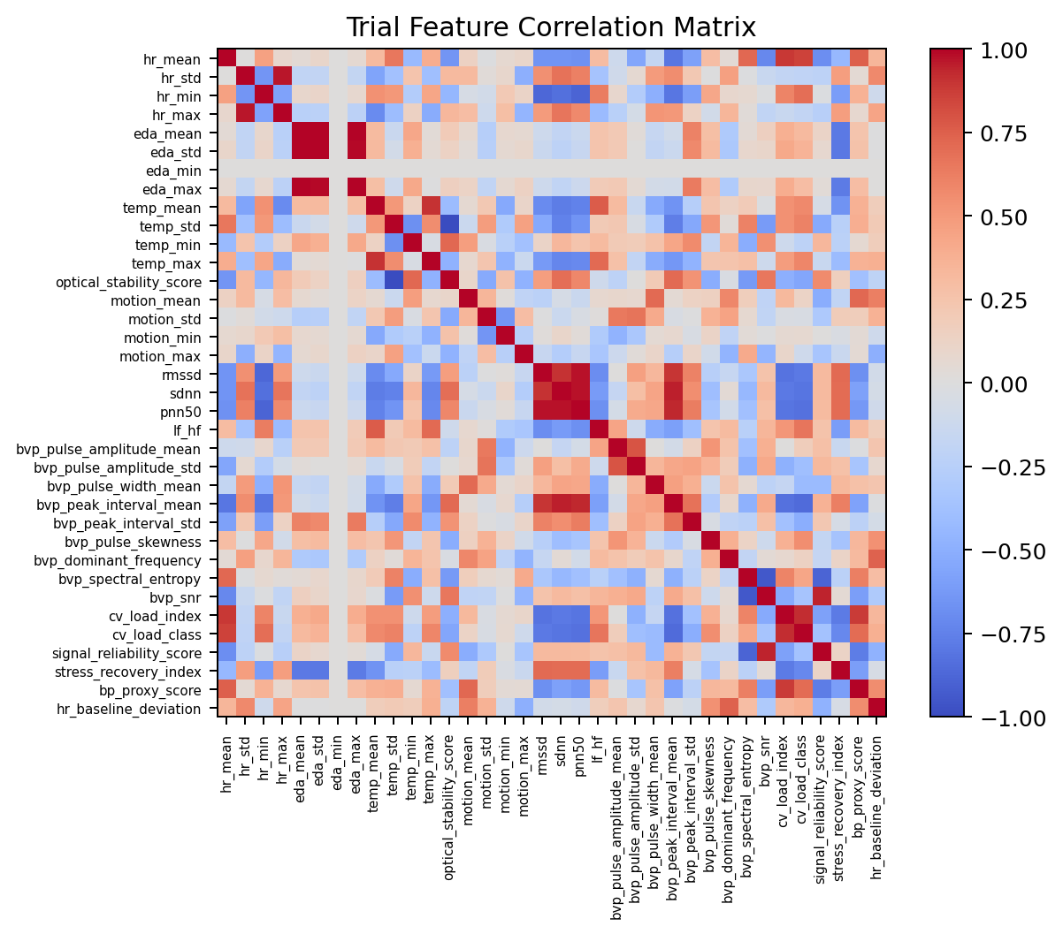
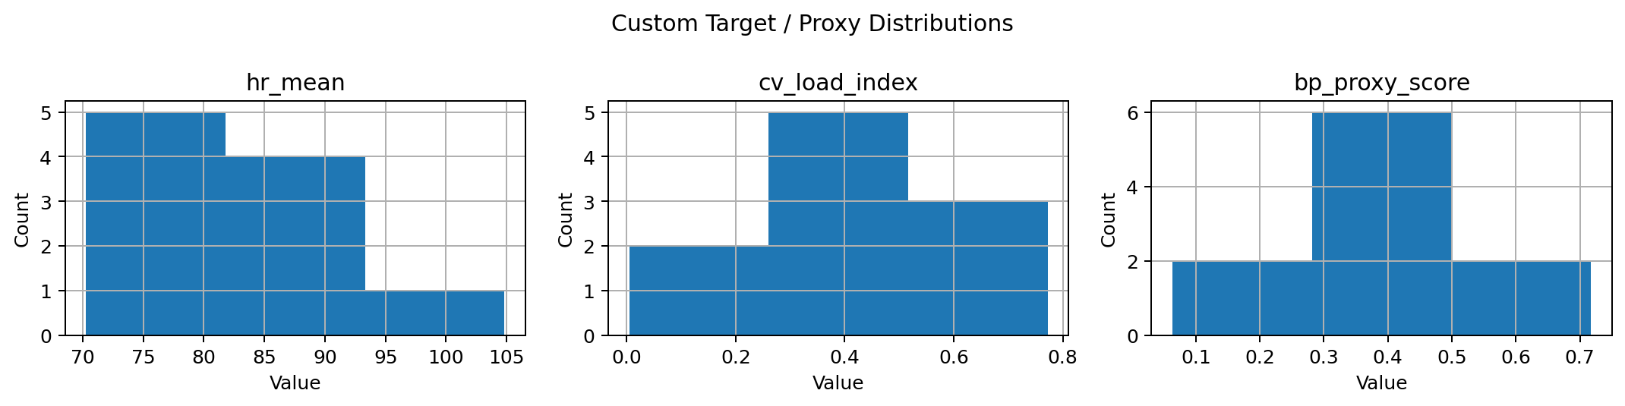
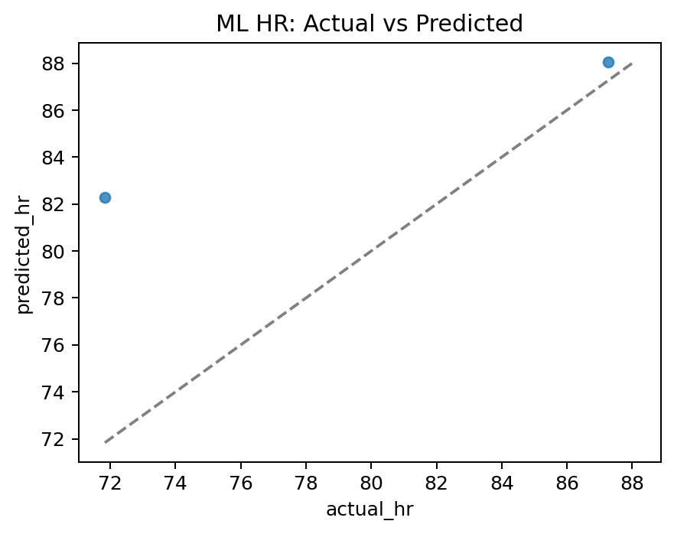
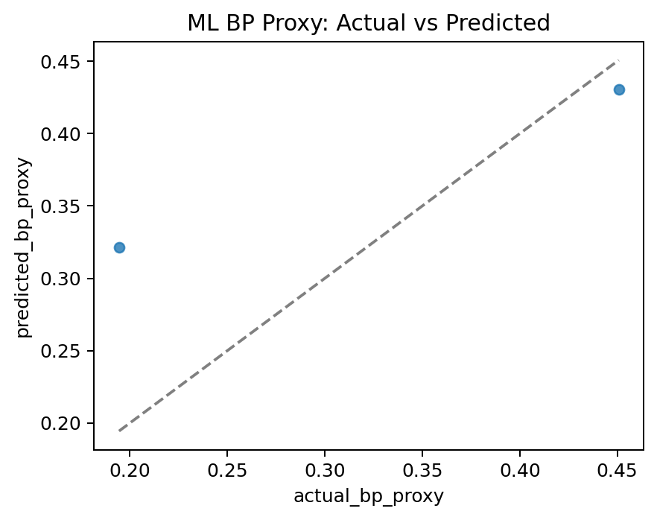
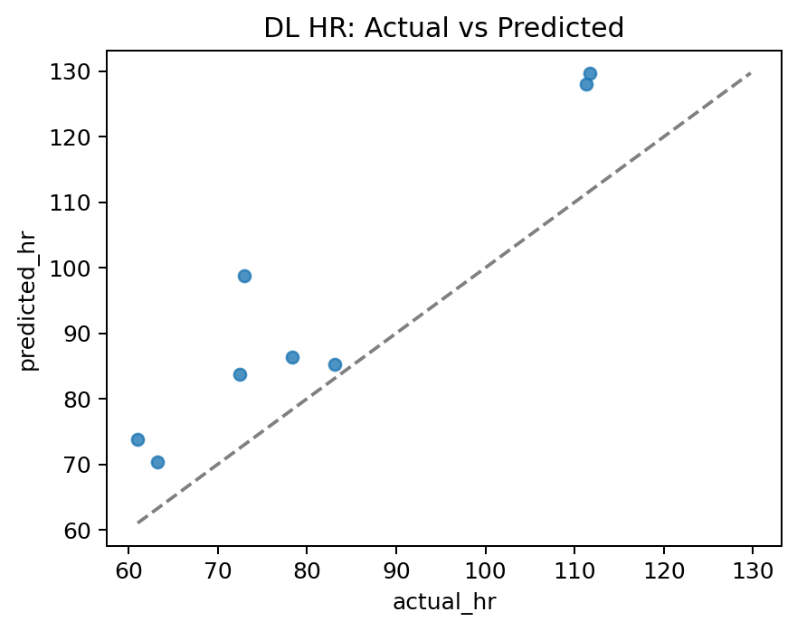
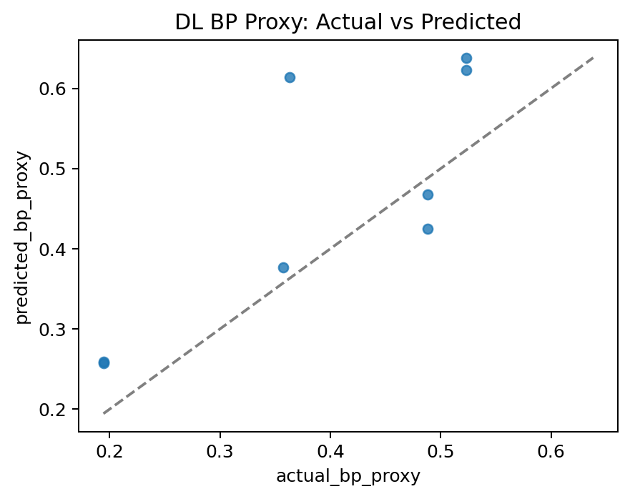

Feature Engineering Analysis
Feature Family | Actual Features Found | Meaning
Signal summaries | hr_mean/std/min/max, eda_mean/std/min/max, temp_mean/std/min/max | Central tendency and variability across trial signals.
Motion | motion_mean/std/min/max | Magnitude of ACC channels used as motion context and artifact proxy.
HRV | rmssd, sdnn, pnn50 and related IBI-derived outputs when computable | Autonomic regulation and beat-to-beat variability.
BVP | bvp_* plus bvp_snr | Pulse morphology and signal quality from contact PPG.
Pseudo targets | cv_load_index/class, signal_reliability_score, stress_recovery_index, bp_proxy_score, hr_baseline_deviation | Constructed labels for first-phase modeling.

Machine Learning Model Analysis
Component | Repository Evidence
Algorithms | XGBRegressor/XGBClassifier with n_estimators=100, max_depth=3, learning_rate=0.05, subsample=0.9; RandomForest fallback with n_estimators=200.
Preprocessing | SimpleImputer(strategy='median') and StandardScaler in sklearn Pipeline.
Splitting | GroupShuffleSplit by subject_id when possible, test_size=0.3, random_state=42.
Targets | HR regression, cardiovascular-load classification, BP proxy regression.

hr_regressor.joblib: Pipeline(steps=[('imputer', SimpleImputer(strategy='median')),
('scaler', StandardScaler()),
('model',
RandomForestRegressor(n_estimators=200, random_state=42))])
cv_load_classifier.joblib: Pipeline(steps=[('imputer', SimpleImputer(strategy='median')),
('scaler', StandardScaler()),
('model',
RandomForestClassifier(n_estimators=200, random_state=42))])
bp_proxy_regressor.joblib: Pipeline(steps=[('imputer', SimpleImputer(strategy='median')),
('scaler', StandardScaler()),
('model',
RandomForestRegressor(n_estimators=200, random_state=42))])

Deep Learning Model Analysis
Class | Base
DLModelConfig | object
VideoROIEncoder | object
BVPEncoder | object
PhysiologyEncoder | object
StaticFeatureEncoder | object
TemporalFusionCNN | object
MultimodalPhysiologyNet | object

Training/Checkpoint Item | Value
Checkpoint config | {"video_channels": 3, "bvp_channels": 1, "physiology_channels": 6, "static_dim": 33, "hidden_dim": 64, "temporal_dim": 64, "n_load_classes": 3, "dropout": 0.15}
History rows | 10
Optimizer/loss in code | AdamW lr default 1e-3, weight_decay=1e-4; SmoothL1 HR/BP losses and CrossEntropy cardiovascular-load loss.
Default epochs | fit_multitask_model default epochs=5; notebook may override if present.

epoch | train_loss | train_hr_loss | train_load_loss | train_bp_loss | val_loss | val_hr_loss | val_load_loss | val_bp_loss | val_load_accuracy
1 | 1.1256 | 0.3928 | 1.0588 | 0.4069 | 1.0107 | 0.355 | 1.1323 | 0.1791 | 0.0
2 | 0.9276 | 0.3018 | 0.925 | 0.3265 | 1.0106 | 0.3963 | 1.0516 | 0.177 | 0.1622
3 | 0.9427 | 0.3291 | 0.9139 | 0.3134 | 0.761 | 0.2164 | 0.8972 | 0.1919 | 0.7838
4 | 0.8098 | 0.2687 | 0.7402 | 0.3419 | 0.7404 | 0.2186 | 0.8509 | 0.1926 | 0.5946
5 | 0.5546 | 0.1537 | 0.5553 | 0.2465 | 0.6891 | 0.1529 | 0.8523 | 0.2201 | 0.5676
6 | 0.589 | 0.1872 | 0.5069 | 0.2967 | 0.9364 | 0.3921 | 0.8142 | 0.2745 | 0.5676
7 | 0.5038 | 0.1963 | 0.4752 | 0.1397 | 0.806 | 0.3009 | 0.7717 | 0.2386 | 0.5135
8 | 0.3498 | 0.1315 | 0.3053 | 0.1312 | 0.942 | 0.3176 | 0.9713 | 0.2774 | 0.4595
9 | 0.3684 | 0.1222 | 0.4006 | 0.0919 | 0.6179 | 0.1083 | 0.7307 | 0.2885 | 0.6216
10 | 0.5902 | 0.2447 | 0.4191 | 0.2719 | 0.7447 | 0.2595 | 0.7247 | 0.2456 | 0.6486

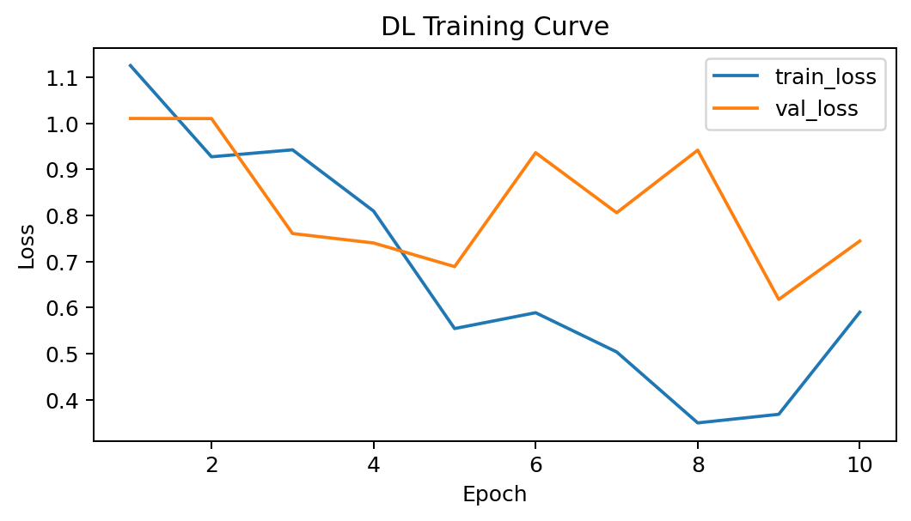

Prediction Result Analysis
Model/Target | N | MAE | RMSE | R2
ML HR | 2 | 5.6156 | 7.4064 | 0.0795
ML BP proxy | 2 | 0.0735 | 0.0909 | 0.4965
DL HR | 8 | 12.7458 | 14.5038 | 0.3817
DL BP proxy | 8 | 0.0870 | 0.1112 | 0.2554

Comparative Analysis
ML is more transparent and less computationally demanding on the current small tabular feature set. DL is architecturally richer and ready for video/physiology fusion, but its generalization is limited by the small number of available subjects and the absence of direct cuff BP targets in the custom pipeline.

Discussion and Limitations
- Direct SBP/DBP custom-model labels were Not Found in Repository; the custom task estimates a BP proxy.
- The archive contains a small subject/trial count, so model metrics should be treated as first-pass engineering validation.
- Feature definitions are traceable in code, but several notebook-level results are not persisted as formal experiment logs.

Conclusion
The best-supported conclusion is that the repository successfully builds a modular first-phase multimodal physiology pipeline. The classical ML pipeline is the most auditable current model; the DL model is a credible experimental architecture but requires more subjects and real BP labels for publication-strength BP estimation claims.

Dataset Sample –
https://www.kaggle.com/datasets/ashfakyeafi/rppg-dataset

Result csv –
https://drive.google.com/drive/folders/1if3e6qdPHOvg-ulx8VbgrW9G_LDoteWB?usp=drive_link

