Pretrained Model Analysis Report
Evaluation and comparison of V-BPE and Open-rPPG inference systems

Executive Summary
- rppg_inference_vbpe is a video-based blood pressure estimation pipeline using MediaPipe face/hand landmarks, DeepPhys-style PPG extraction, demographic/vessel-length terms, and SBP/DBP calculation.
- open_rppg_inference is a general rPPG toolbox for HR/HRV and BVP extraction with a model zoo including FacePhys, PhysMamba, RhythmMamba, PhysFormer, TSCAN, PhysNet, and EfficientPhys.
- Only V-BPE contains explicit BP prediction outputs. Open-rPPG BP estimation outputs were Not Found in Repository; it should be treated as a physiological-signal extractor unless paired with a BP model.

Codebase Inspection
Folder | Framework / Dependencies | Model Type | Primary Output
rppg_inference_vbpe | Python, OpenCV, MediaPipe, PyTorch checkpoint can2d_pytorch.pth | Face/hand PTT + PPG-based analytical BP estimator | SBP_new.csv, DBP_new.csv
open_rppg_inference | Python, JAX-style model loaders, ONNXRuntime face detector, PyAV, HeartPy, SciPy | rPPG deep model zoo and BVP/HR/HRV extraction | HR, SQI, HRV, BVP; BP Not Found in Repository

Open-RPPG Notebook and Result File Inspection
The notebook open_rppg_inference.ipynb installs open-rppg, initializes the default rppg.Model(), and runs offline process_video inference on the same sample identifiers used by the V-BPE folder. The default model maps to FacePhys.rlap in open_rppg_inference/rppg/main.py, which loads FacePhys.rlap.weights.h5 and uses a 30 FPS, 36 x 36 face input.
Sample Video | Notebook Path | Estimated HR (BPM) | Total Frames | Key Frames | Non-Key Frames | Skipped | Forward Filled | No Face | Warnings
SL377.mkv | /content/SL377.mkv | 152.82 | 1392 | 6 | 1340 | 0 | 46 | 0 | Detected non-key frames
SL421.mp4 | /content/SL421.mp4 | 76.95 | 2238 | 367 | 4033 | 2162 | 0 | 0 | Frame rate mismatch; Detected non-key frames
SL428.mp4 | /content/SL428.mp4 | 100.44 | 3307 | 552 | 6061 | 3306 | 0 | 0 | Frame rate mismatch; Detected non-key frames
SL413.mp4 | /content/SL413.mp4 | 82.26 | 3628 | 605 | 6650 | 3627 | 0 | 0 | Frame rate mismatch; Detected non-key frames

Markdown Case | Estimated HR (BPM) | Total Frames | Key Frames | Non-Key Frames | Skipped | Forward Filled | No Face
1 | 152.82 | 1392 | 1340 | 1340 | 0 | 46 | 0
2 | 76.95 | 2238 | 4033 | 4033 | 2162 | 0 | 0
3 | 100.44 | 3307 | 6061 | 6061 | 3306 | 0 | 0

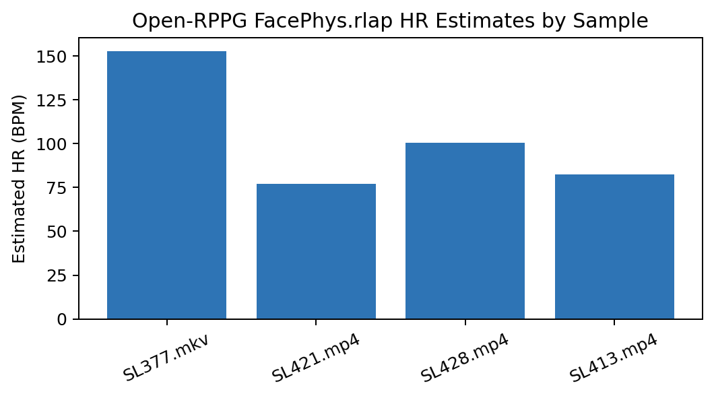
Interpretation: Open-RPPG detected faces in all notebook cases because No Face Detected Frames is 0 for each logged run. However, 4 of 4 notebook runs include video-quality warnings. The SL377 case reports heavy non-key-frame use and forward filling; SL421, SL428, and SL413 additionally report frame-rate mismatch and large skipped-frame counts. These warnings matter because Open-RPPG estimates HR from temporal BVP frequency content, so irregular sampling and inter-frame compression can distort the pulse waveform.

Architecture and Pipeline Diagrams
System | Workflow
V-BPE | Input video -> MediaPipe face/hand landmarking -> cropped face/hand videos -> MP4 conversion -> DeepPhys PPG extraction -> face/hand PTT -> vessel/demographic terms -> SBP and DBP CSV outputs.
Open-rPPG | Input video/tensor -> ONNX face detection -> face crop buffering/resampling -> selected pretrained model inference -> BVP filtering/normalization -> HR, SQI, and HRV metrics.

Dataset Analysis
Data Source | Count / Status
V-BPE input videos | 5
V-BPE input photos | 5
V-BPE PPG CSVs | 15
Open-RPPG notebook inference cases | 4
Open-rPPG direct BP labels | Not Found in Repository

rppg_inference_vbpe\SBP_new.csv
Column Name | Data Type | Description | Usage
# SBP | float64 | Systolic blood pressure value or prediction. | Pretrained pipeline data/result field

rppg_inference_vbpe\DBP_new.csv
Column Name | Data Type | Description | Usage
# DBP | float64 | Diastolic blood pressure value or prediction. | Pretrained pipeline data/result field

rppg_inference_vbpe\Input_Data\Demographic_Data.csv
Column Name | Data Type | Description | Usage
ID | str | Repository column; semantic description not explicitly documented. | Pretrained pipeline data/result field
SpO2 | float64 | Repository column; semantic description not explicitly documented. | Pretrained pipeline data/result field
Temperature | float64 | Peripheral temperature feature related to perfusion and optical stability. | Pretrained pipeline data/result field
BPS | int64 | Repository column; semantic description not explicitly documented. | Pretrained pipeline data/result field
BPD | int64 | Repository column; semantic description not explicitly documented. | Pretrained pipeline data/result field
Pulse | int64 | Repository column; semantic description not explicitly documented. | Pretrained pipeline data/result field
Age | int64 | Repository column; semantic description not explicitly documented. | Pretrained pipeline data/result field
Height | int64 | Repository column; semantic description not explicitly documented. | Pretrained pipeline data/result field
Weight | float64 | Repository column; semantic description not explicitly documented. | Pretrained pipeline data/result field
Gender | str | Repository column; semantic description not explicitly documented. | Pretrained pipeline data/result field
BMI | float64 | Repository column; semantic description not explicitly documented. | Pretrained pipeline data/result field

rppg_inference_vbpe\Results\PPG\Face\Result_SL377_face_output.csv
Column Name | Data Type | Description | Usage
-2.061197757720947266e-01 | float64 | Repository column; semantic description not explicitly documented. | Pretrained pipeline data/result field

rppg_inference_vbpe\Results\PPG\Face\Result_SL413_face_output.csv
Column Name | Data Type | Description | Usage
-2.150163650512695312e-01 | float64 | Repository column; semantic description not explicitly documented. | Pretrained pipeline data/result field

rppg_inference_vbpe\Results\PPG\Face\Result_SL421_face_output.csv
Column Name | Data Type | Description | Usage
1.870848774909973145e+00 | float64 | Repository column; semantic description not explicitly documented. | Pretrained pipeline data/result field

rppg_inference_vbpe\Results\PPG\Face\Result_SL426_face_output.csv
Column Name | Data Type | Description | Usage
1.789748907089233398e+00 | float64 | Repository column; semantic description not explicitly documented. | Pretrained pipeline data/result field

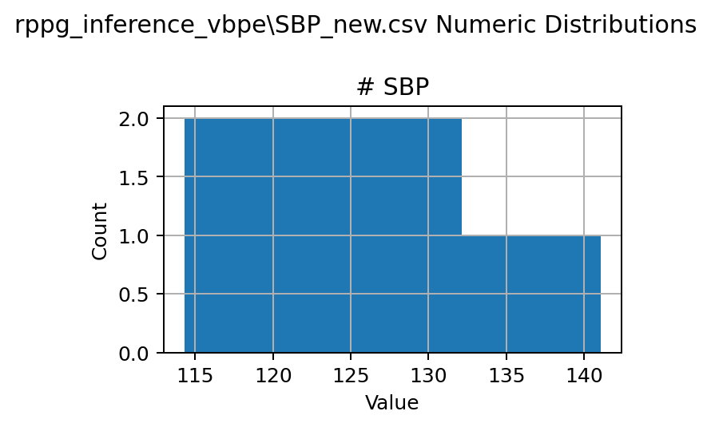
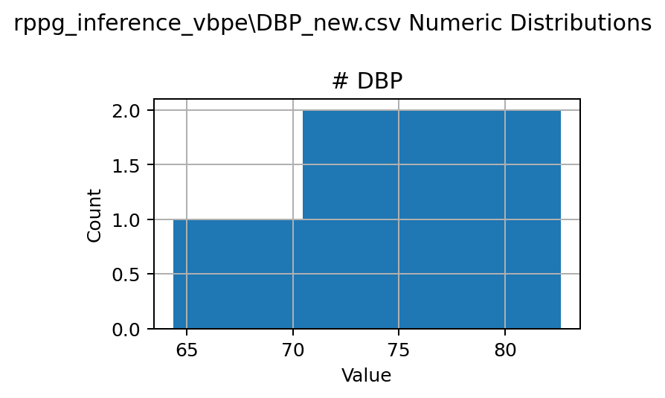
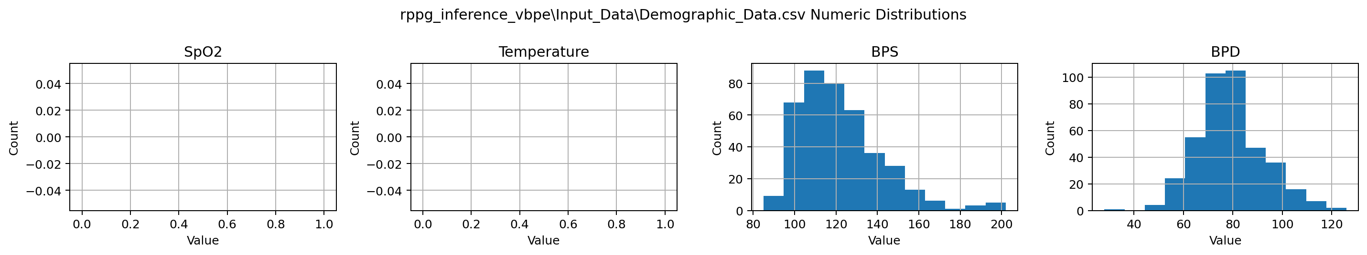

rPPG Pipeline Analysis
Stage | V-BPE | Open-rPPG
Face Detection / Tracking | MediaPipe face landmarker; separate hand capture. | ONNX BlazeFace detector with Kalman-smoothed boxes.
ROI Selection | Face and hand cropped regions saved as videos. | Detected face crop resized to model input resolution.
Signal Extraction | can2dshare.py invokes DeepPhys/CAN-like PPG extraction. | Selected pretrained rPPG model emits BVP-like signal.
Filtering | PPG CSV generation and downstream BP scripts; details partly in source. | Bandpass 0.5-3 Hz, detrending, normalization, SQI.
BP Estimation | SBP and DBP scripts present and CSV outputs saved. | Not Found in Repository.

Open-RPPG Inference Workflow Details
Step | Code / Notebook Evidence | Technical Interpretation
Model initialization | model = rppg.Model() in every notebook sample; main.py default is FacePhys.rlap. | All reported notebook outputs use the same default pretrained FacePhys.rlap model unless the notebook was edited outside the stored cells.
Video decoding | Model.process_video opens the file with PyAV and iterates decoded frames. | Input format can be mp4/mkv; timestamps are read from decoded frames.
Face localization | FaceDetector uses ONNX BlazeFace and updates face boxes every 5 frames with Kalman smoothing. | The output logs show 0 no-face frames in stored cases, so face detection did not fail in these runs.
Face resampling | Detected face crops are resized to the model input size from metadata. | For FacePhys.rlap, local code reports input=(1, 36, 36, 3), enabling low-latency frame-wise inference.
Signal processing | bvp() applies optional cumulative handling, detrending, bandpass filtering, and normalization. | The final HR is computed from the Welch frequency-domain peak in the 30-180 BPM band.
Quality checks | process_video logs frame-rate mismatch, non-key frames, skipped frames, filled frames, and no-face frames. | The stored results should be interpreted as HR estimates under imperfect video encoding conditions, not validated BP predictions.

Model Architecture Analysis
Folder | Architectures Found
rppg_inference_vbpe | can2dshare.py and can2d_pytorch.pth indicate a CAN/DeepPhys-style PPG extractor; bp_calc.py/dbp.py implement BP formulas; MediaPipe task files support landmarking.
open_rppg_inference | Supported model list includes FacePhys, ME chunk/flow, PhysMamba, RhythmMamba, PhysFormer, TSCAN, PhysNet, EfficientPhys. Local weights are present for pure/rlap variants.

Output Analysis
Output | Rows | Statistics
rppg_inference_vbpe\SBP_new.csv | 5 | # SBP: mean=126.89, std=10.04
rppg_inference_vbpe\DBP_new.csv | 5 | # DBP: mean=75.31, std=7.42
rppg_inference_vbpe\Input_Data\Demographic_Data.csv | 400 | SpO2: mean=nan, std=nan; Temperature: mean=nan, std=nan; BPS: mean=121.92, std=20.04; BPD: mean=78.74, std=13.60

Open-RPPG HR Statistic | Value
Samples analyzed in notebook | 4
Mean estimated HR | 103.12 BPM
Minimum estimated HR | 76.95 BPM
Maximum estimated HR | 152.82 BPM
Direct SBP/DBP output | Not Found in Repository
Ground-truth HR/BP comparison for Open-RPPG cases | Not Found in Repository

V-BPE results markdown excerpt:
Open-rPPG results markdown excerpt: # Open-rppg &nbsp; Open-rppg is a comprehensive Python toolbox designed for Remote Photoplethysmography (rPPG) inference. It provides a unified interface for state-of-the-art deep learning models, enabling physiological signal measurement (such as heart rate and heart rate variability) from facial videos. The toolkit supports both offline video processing and low-latency real-time inference using JAX. > API document https://kegangwangccnu.github.io/open-rppg/ [<img width="948" height="250" alt="image" src="../_resources/529483746-5c945368-67bf-4ccb-882.LDVgMpCgDQRr2n31Gggu" class="js-gh-image-fallback jop-noMdConv" style="box-sizing: content-box; border-style: none; max-width: 100%; height: auto; max-height: 250px; aspect-ratio: 948 / 250; background-color: rgb(21, 27, 35); border-radius: 6px;">](https://private-user-images.githubusercontent.com/132054009/529483746-5c945368-67bf-4ccb-882

Comparative Analysis
Criterion | V-BPE | Open-rPPG
BP relevance | Direct SBP/DBP pipeline and outputs. | No BP estimator found; HR/HRV/BVP only.
Architecture breadth | Focused face/hand PTT BP estimation. | Broader model zoo with modern rPPG architectures.
Robustness controls | Demographics/vessel length plus face/hand regions. | SQI, face tracking, frame-rate checks, multiple pretrained models.
Inference complexity | Multi-stage video preprocessing plus BP scripts. | Unified API; complexity depends on selected model.
Best use in this repository | BP prediction/evaluation. | Reusable rPPG feature extractor and comparator.

Final Findings
- Better pretrained BP model in this repository: rppg_inference_vbpe, because it actually produces SBP/DBP outputs.
- Stronger general rPPG architecture suite: open_rppg_inference, because it packages multiple modern pretrained rPPG networks.
- Best combined path: use Open-rPPG for robust BVP/quality features and V-BPE-style calibration/ground-truth BP evaluation for BP-specific modeling.
- Missing information: formal runtime benchmarks, memory usage, and direct shared BP error metrics against cuff labels were Not Found in Repository.

Dataset Sample and Result csv -
https://drive.google.com/drive/folders/1GHuhb5G_VM_f5-MZKFyvxxF0MH2-uuvW?usp=drive_link

