Manual for Using The Product

1. Start File OpenUp.py using Python2.7 . Run it Up and select the proper file.

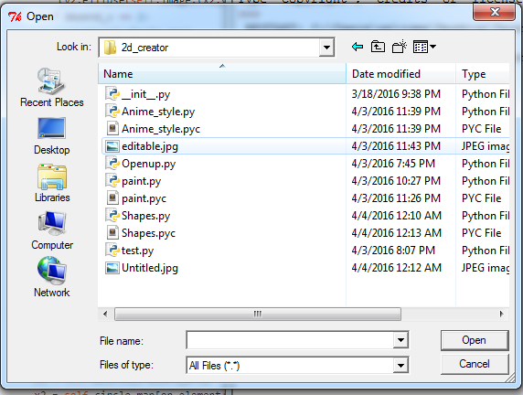

2. Select From The Buttons to chose from.

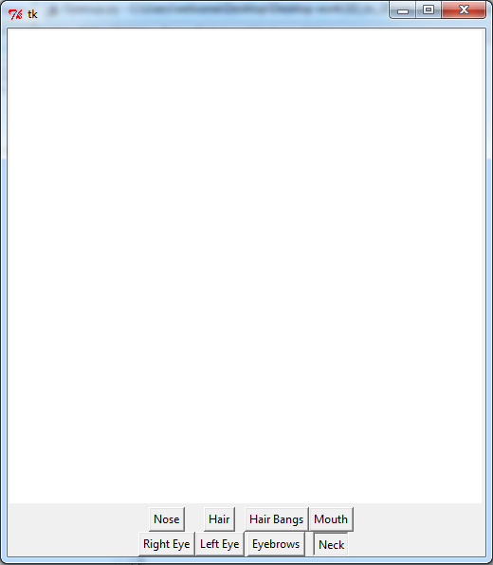

3. Respective points and figure will appear.

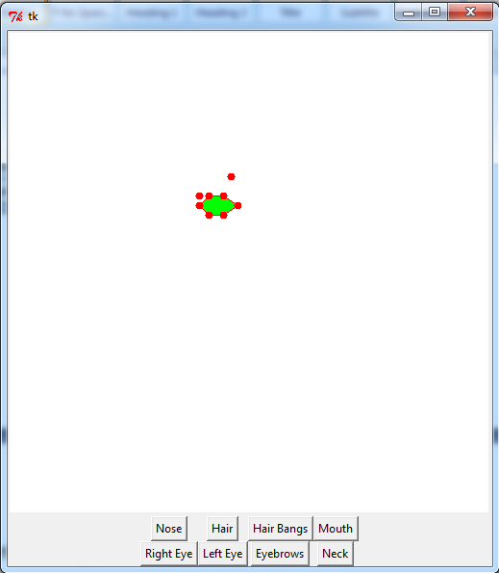

Figure is editable i.e. Red dots in Figure are movable You can move them according to Your style.

4. Move Red Dots Accordingly. You can click on the dot then click on place you want it to move to. Or you can drag the dot to move. Shape or green figure would be changed accordingly.

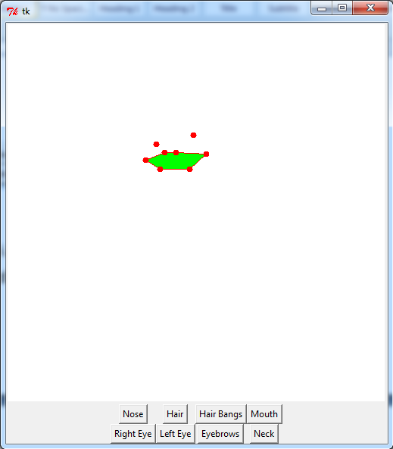

5. Triple Click Left Mouse button to generate shape. In above case a right Eyelid would be generated. If it is not visible just readjust window.(It is currently in Fix)

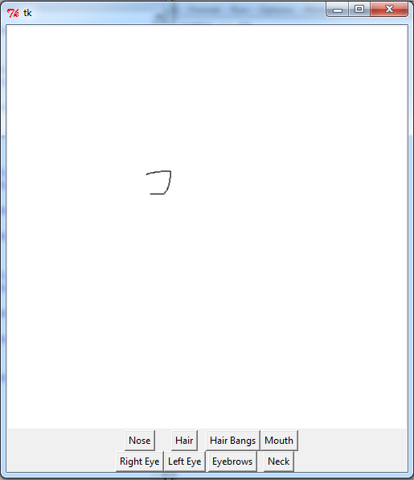

6. Eye is special case where Eyeball is also to be made, After triple clicking just single click and circular shape will appear. Drag the circle to increase/decrease its radius. Triple click again to place it there.(Remember only part inside eyelid will be visible)

This will create Right Eye.

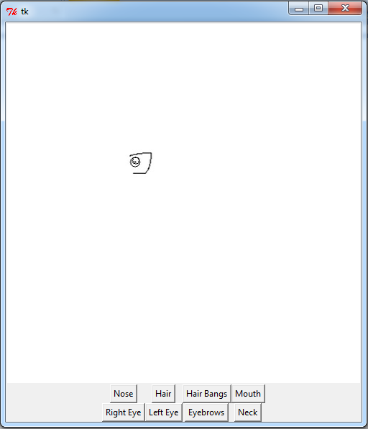

7. Various Other Button can be used in the similar ways such as Hair can be used to create to create triangle like structure.

single click creates base. Right click after that increase base length and motion creates hair.

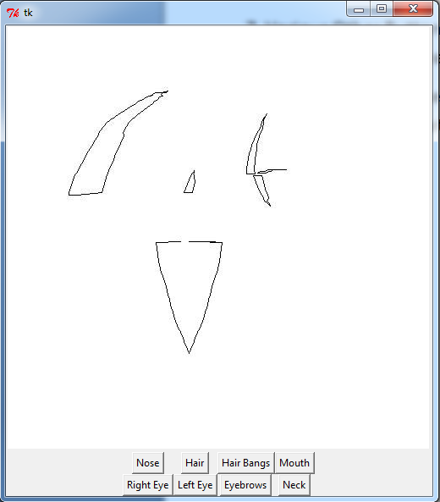

Try Using It to create different kind of shape in different styles.

HAVE FUN :D.