Ip config

**ipconfig** is a command-line utility primarily utilized on Unix-like operating systems to manage and present details regarding network interfaces. It serves the purpose of viewing and adjusting network interface configurations, including IP addresses, netmasks, and interface statuses.

Top of Form

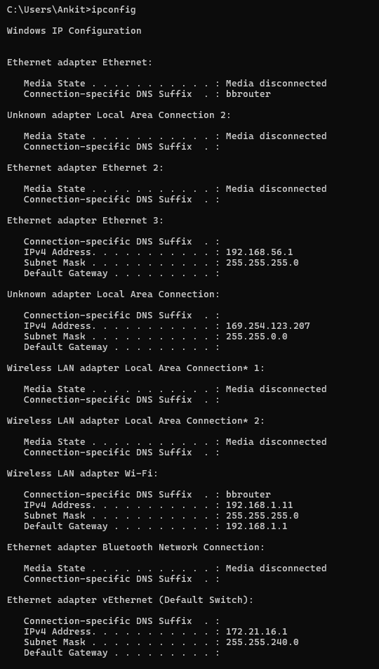

nslookup

(Name Server Lookup) is a command-line utility designed to request information from Domain Name System (DNS) servers, enabling the retrieval of domain names or IP addresses. It facilitates troubleshooting of DNS-related problems and allows manual execution of DNS queries.

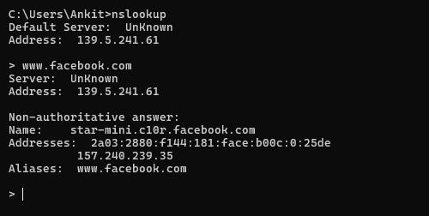

PING

A fundamental network tool utilized to assess the accessibility of a host on an Internet Protocol (IP) network. It dispatches ICMP Echo Request messages to the designated host and awaits ICMP Echo Reply messages in response.

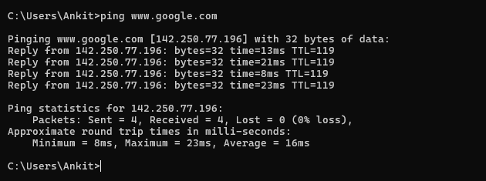

tracert

A network diagnostic utility that illustrates the path traversed by packets across an IP network. It reveals the IP addresses of the routers (hops) between the source and destination, along with the corresponding packet transit times for each hop.

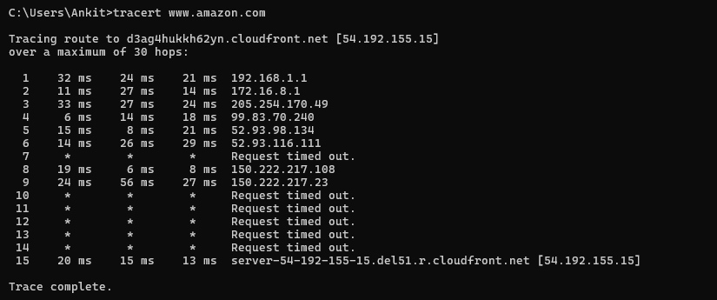

netstat

Netstat, short for Network Statistics, is a command-line utility that showcases various network-related details including active network connections, routing tables, interface statistics, masquerade connections, and multicast memberships. It offers insights into active network connections, listening ports, and other pertinent network information.

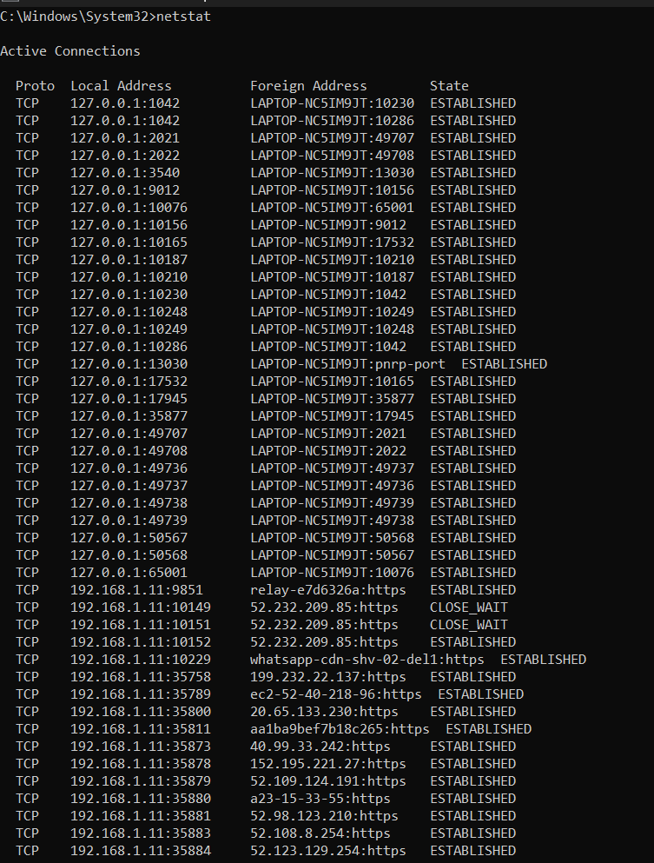

arp

The Address Resolution Protocol (ARP) is a network protocol utilized for associating an IP address with a physical machine address, also known as a MAC address, within a local network. The **arp** command enables users to view and manage the ARP cache, which holds mappings of IP addresses to MAC addresses.

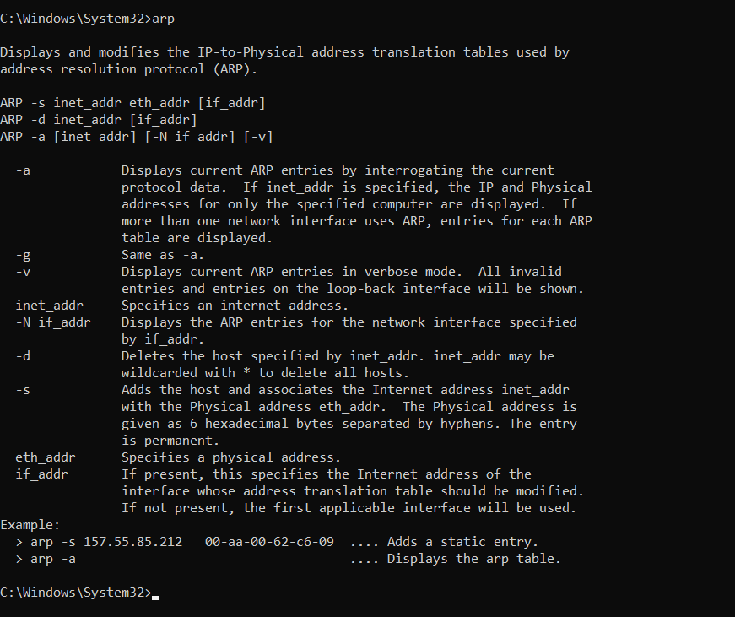

systeminfo

Windows-specific command used to display detailed information about the system's hardware, software, and configuration.

