Bus topology

Step 1

Set up 4 pc and 4 switches in a grid

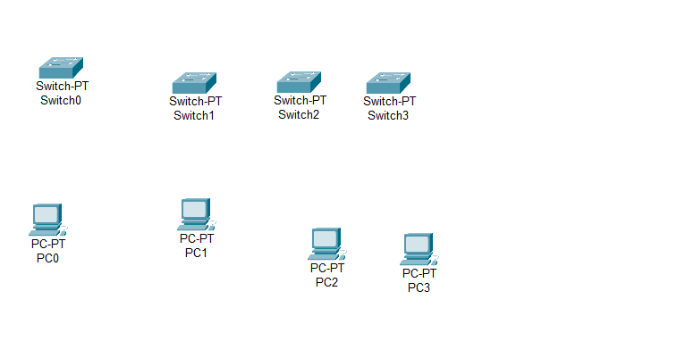

Step 2

connect each switch with 1 pc and connect all switches together in 1 line one after another

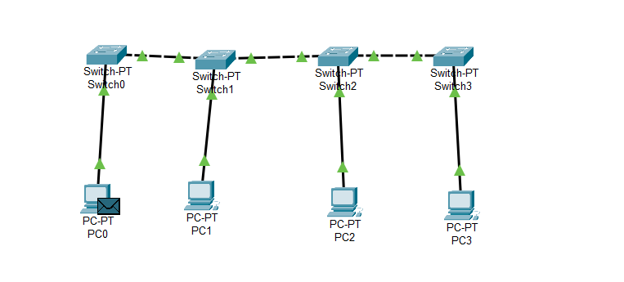

Step 3

Assign ip

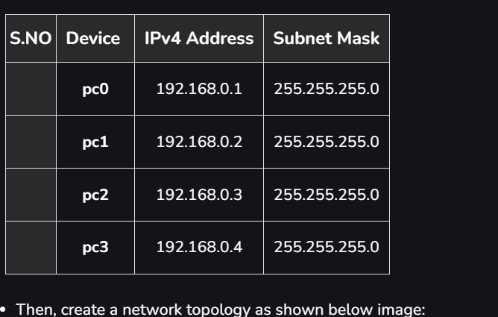

Step 4

Send a message to confirm the setup



RING TOPOLOGY

Step 1 : Select PC’s and Switches and connect them

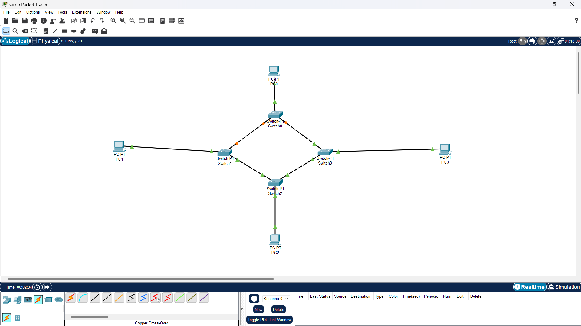

Step 2 : Assign IP address

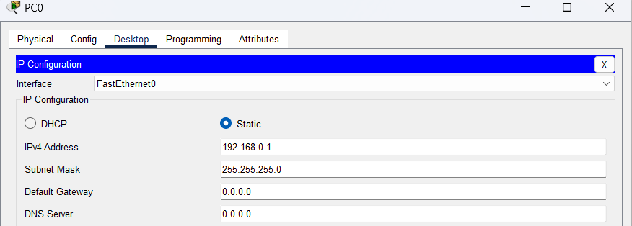

Step 3 : verify connection using ping command

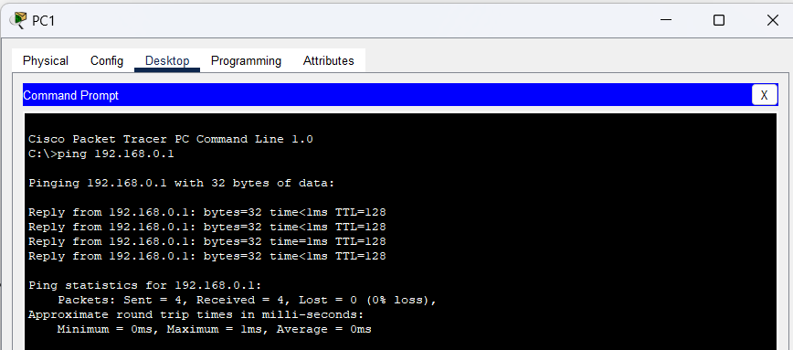

Step 4 : Send two PDU packets one targeted from PC0 to PC2 and another targeted from PC2 to PC1.

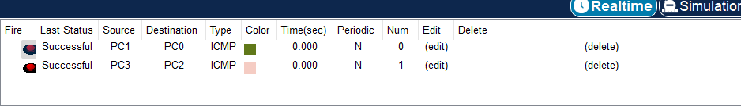

TREE TOPOLOGY

Step 1 : Select PC’s and Switches and connect them

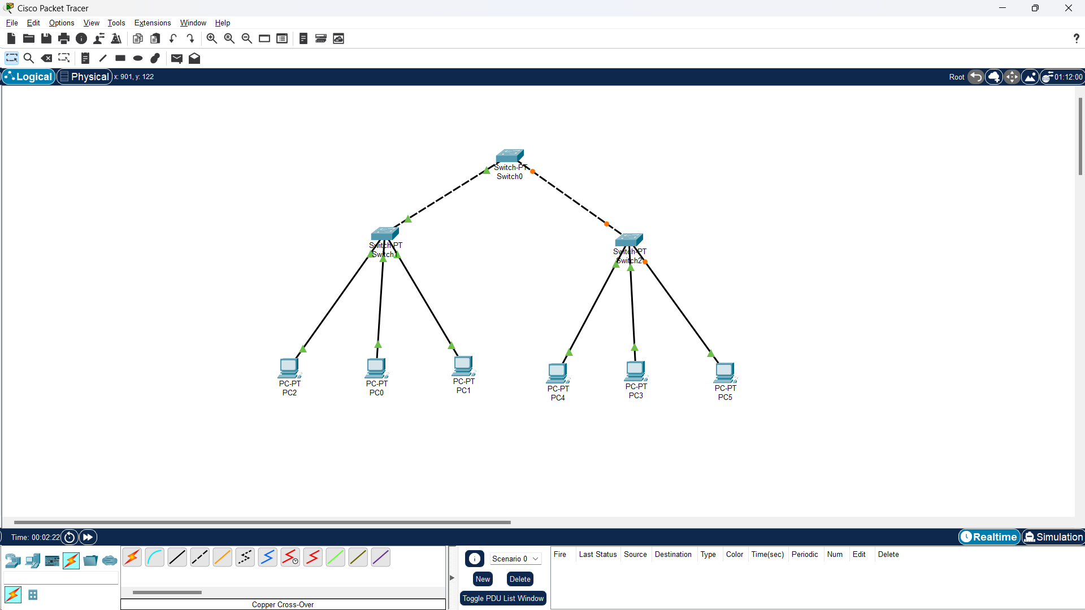

Step 2 : Assign IP address



Step 3 : verify connection using ping command



Step 4 : Send PDU packets one targeted from PC0 to PC3 and another targeted from PC2 to PC4.

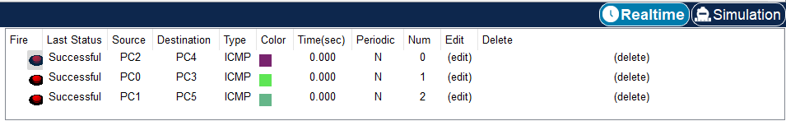

MESH TOPOLOGY

Step 1 : Select PC’s and Switches and connect them

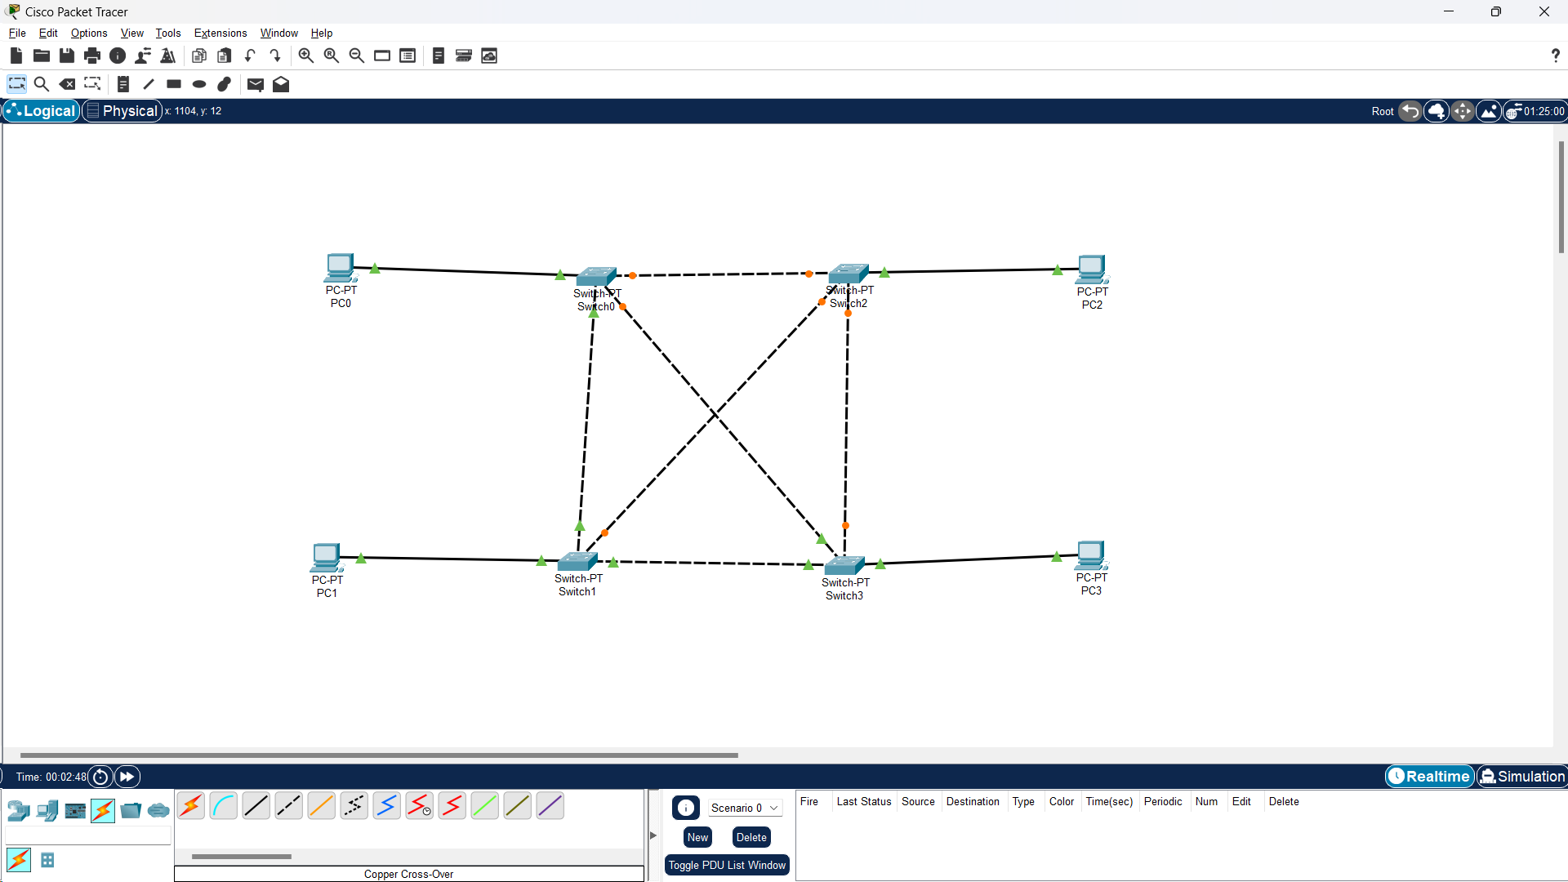

Step 2 : Assign IP address



Step 3 : verify connection using ping command



Step 4 : Send PDU packets one targeted from PC0 to PC3 and another targeted from PC1 to PC2.



HYBRID TOPOLOGY

Step 1 : Select PC’s and Switches and connect them

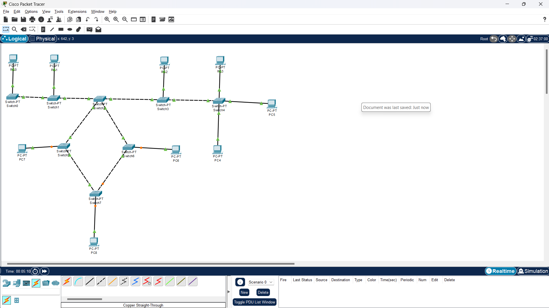

Step 2 : Assign IP address



Step 3 : verify connection using ping command



Step 4 : Send PDU packets one targeted from PC0 to PC3 and another targeted from PC1 to PC2.

