Pc to pc

Connection:-

1.In end devices selects 2 pcs

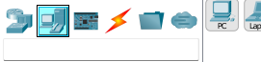

2.Then go to connection and select copper crossover cable and connect with Fast Ethernet port of pc1 to pc2

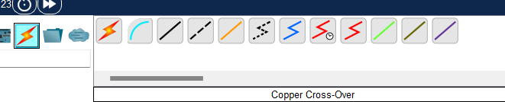

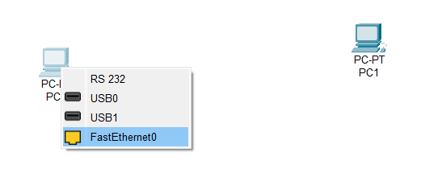

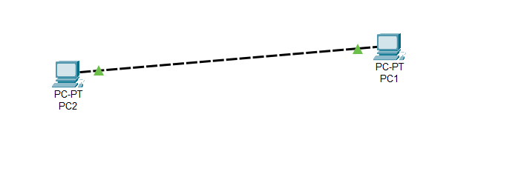

3.Assign the Ip addresses by clicking on pc then going to desktop and then ip config

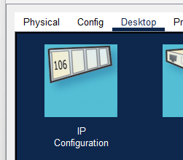

1st pc ip address:- 192.168.1.1

2nd pc ip address:- 192.168.1.2

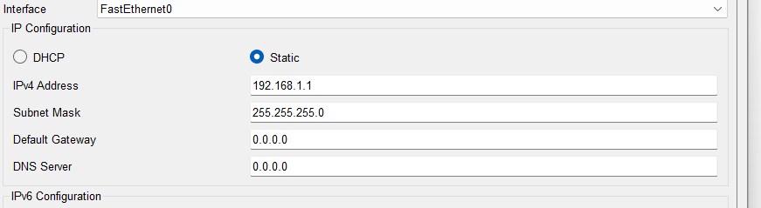

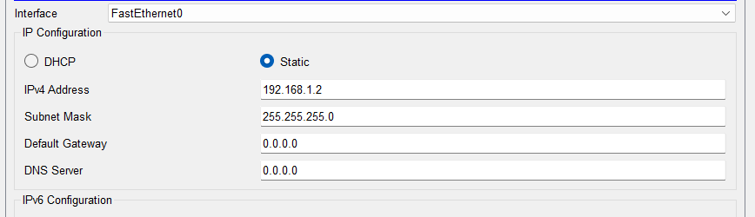

4. Now to check the connection on top left select the option with message icon(add simple pdu) and then click on pc 1 and then pc 2

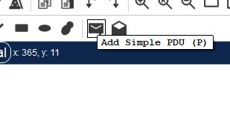

5. Now on bottom right you can see whether the message sent successfully from pc1 to pc2 or not not

