Client to Server

Connection:-

1. Click End Devices and Then Select PC The Drag Into them In the Screen. Again Click End Devices And After that click on a server.

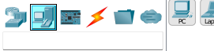

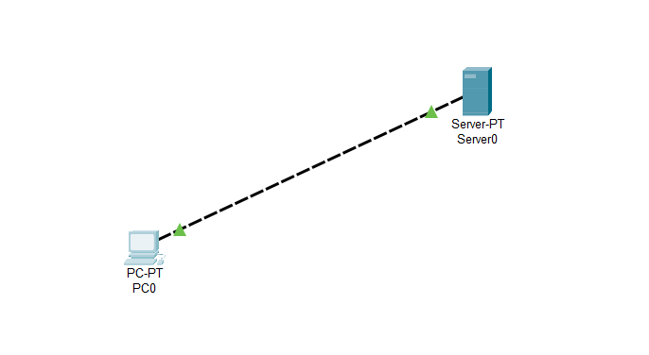

3.Assign IP Addresses to Client as 192.168.10.2 and Server as 192.168.10.1

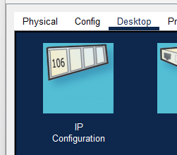

4. Now go to Services and add some HTML code to check whether the server is working or not.

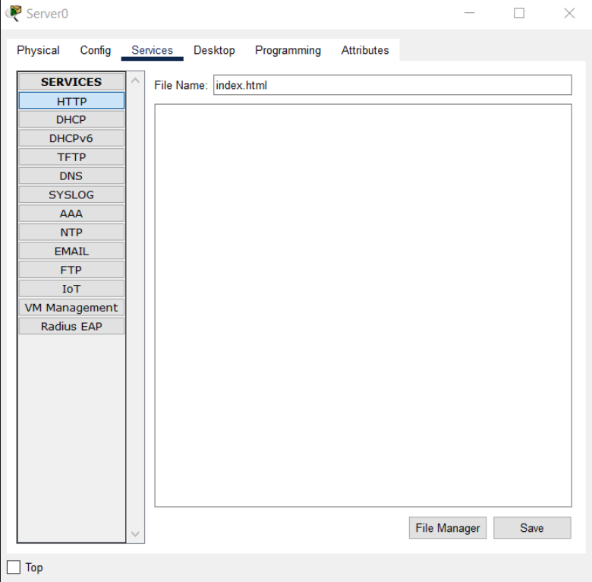

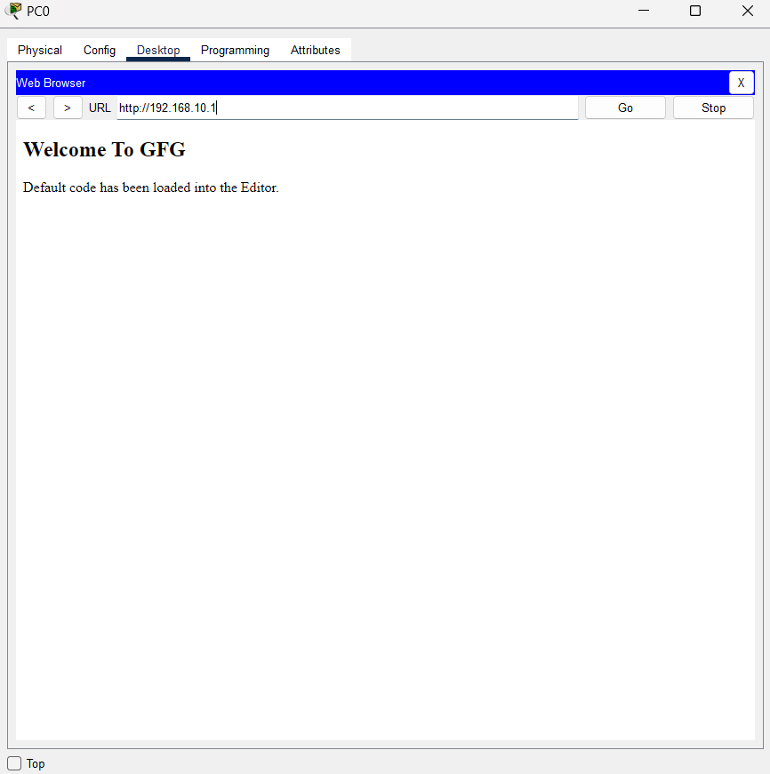5. Go to PC0 Click on Desktop and then open Web Browser. Remember the IP that we are given to the web server enter the same ip to the address bar. click on go.