HUB to PC

Connection:-

1.In Hub tab from network devices select A Hub and Select desired no of PCs from the end devices

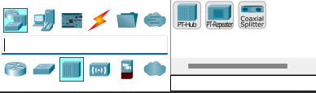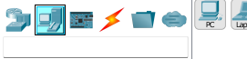

2. Connect all PCs and hub with copper straight cable by selecting it through the cables menu from the bottom left menus in the simulator. Green signal in the wire shows they’re ready to communicate.

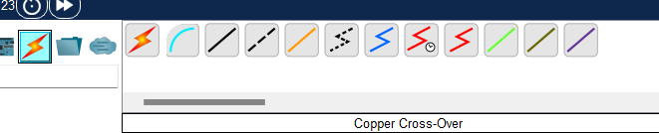

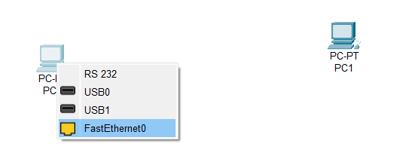

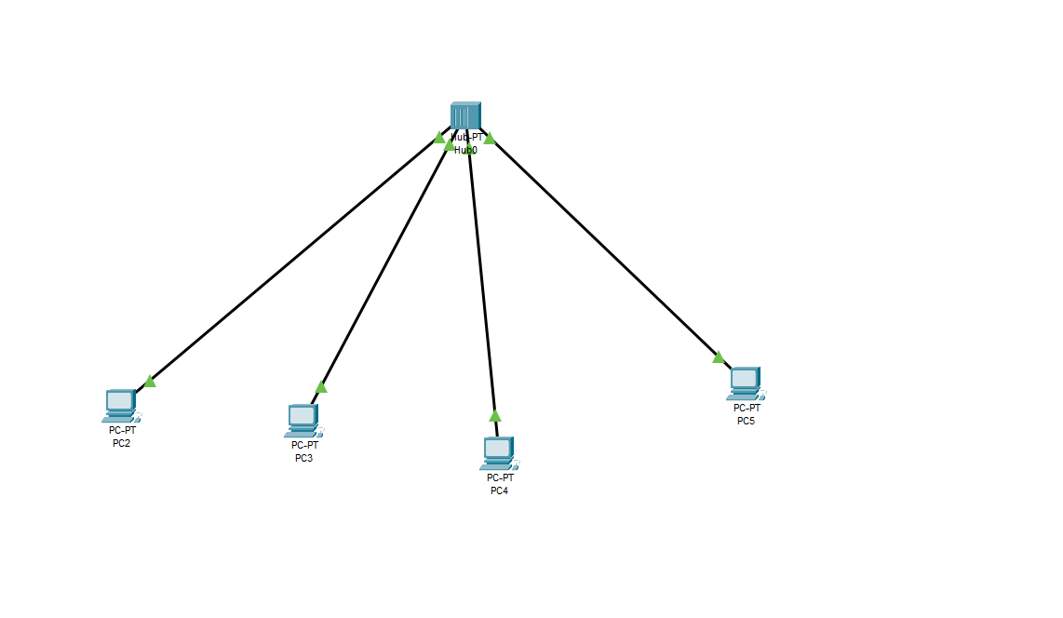

3.Assign Different IP addresses to all PCs by clicking on PC then going to desktop and then IP Configuration

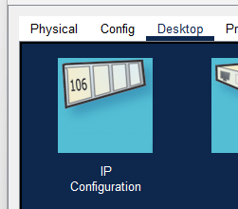

1st pc IP address:- 192.168.1.1

2nd pc IP address:- 192.168.1.2

3rd pc IP address:- 192.168.1.3

4th pc IP address:- 192.168.1.4

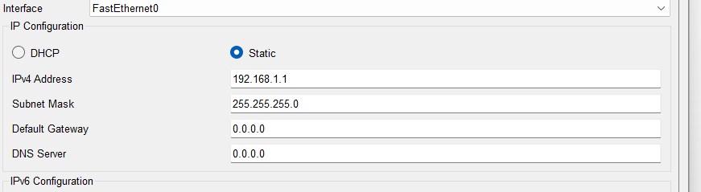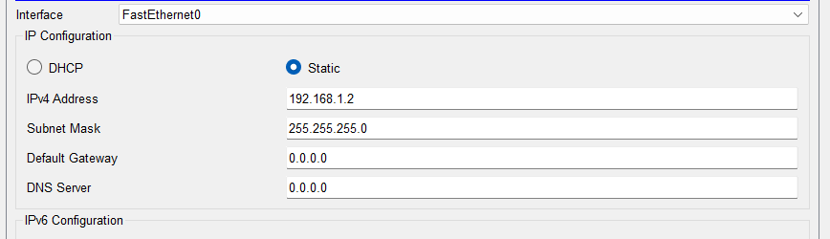

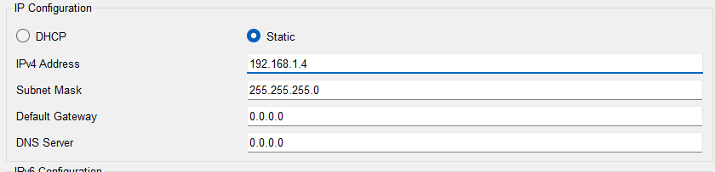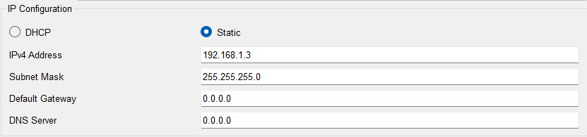

4. Click on a PC, go to Desktop and then click on Command prompt.

5. After that test the ping command in command prompt to check the connectivity between these PCs.

