Efficient Sprinkler Irigation Control System for Optimal Water Management

Ankith SR
School of Computer Science and Engineering
Vellore Institute of Technology, Chennai
Bengaluru, India
ankithsr20@gmail.com

Govind G Krishnan
School of Computer Science and Engineering
Vellore Institute of Technology, Chennai
Delhi, India
govind.gkrishnan03@gmail.com
Manobhi Sri Ram
School of Computer Science and Engineering
Vellore Institute of Technology, Chennai
Gudiwada, India
manobhisriram@gmail.com

Vangala Hemalatha
School of Computer Science and Engineering
Vellore Institute of Technology, Chennai
Kurnool, India
hema210903@gmail.com

Abstract—Ever since civilization has boomed, irrigation has been the root cause which led towards, the so-called bloom of civilization. In the early days irrigation would be ever so simple, unlike today, where there are multiple techniques, each having their own benefits. In this paper we isolate one such techniques, which is the sprinkler irrigation, and try to analyze its effect, as well as its productivity. Altogether we try to find the perfect conditions, such as soil type, humidity and temperature and duration for which the sprinkler can be used.
Keywords—Keypad, Liquid Crystal Display, Arduino, Password, Security, Safety

Introduction
Irrigation- An important aspect of a civilization. Throughout the major civilizations, that have risen during the course of history are the ones which have an intricate irrigation system. There are many such evidences which point to the importance of irrigation, which is all the more relevant in today’s world. Today there are multiple methods/types of irrigation, each unique to their region and the type of plant used to grow. The following are the types of irrigation methods being used all over the globe-

Sprinkler irrigation [1]
Sprinkler water system, an advanced rural strategy, effectively conveys water over areas through a organize of channels and sprinkler heads. It optimizes water utilization, diminishes soil disintegration, and upgrades trim yields. Its versatility to different scenes and climates makes it priceless, particularly in dry districts. By empowering exact water conveyance, it advances supportability and versatility in horticulture, exemplifying humanity's capacity for development and natural stewardship. A perfect type of irrigation to be analyzed.

Drip irrigation [2]
Trickle water system, a progressed rural strategy, conveys water specifically to plant roots through a arrange of tubing and emitters. This exact strategy moderates’ water, minimizes soil disintegration, and upgrades edit yields by keeping up ideal dampness levels. Its versatility to differing crops and landscapes makes it vital for economical farming, especially in water-scarce districts. Dribble water system embodies advancement and asset effectiveness in cutting edge cultivating hones, guaranteeing nourishment security whereas minimizing natural affect.

Surface irrigation [3]
Surface water system could be a conventional strategy of watering crops by flooding or furrowing areas, permitting water to stream over the soil surface. Whereas basic and cost-effective, it can lead to water wastage, soil disintegration, and uneven dispersion. In any case, with appropriate administration, surface water system can still be viable for certain crops and landscapes, serving as a foundational method in agrarian hones around the world.

Localized irrigation [4]
Localized water system targets water conveyance straightforwardly to the root zone of plants, minimizing squander and maximizing productivity. This strategy, frequently accomplished through trickle lines or soaker hoses, diminishes water utilization and advances sound plant development. Its accuracy makes it perfect for zones with restricted water assets or where water preservation may be a need. Localized water system speaks to a economical approach to cultivating, guaranteeing ideal plant hydration whereas minimizing natural affect.

Lateral move irrigation [5]
Lateral move water system includes a framework of mechanized hardware that moves along a field's length, dispersing water equally through sprinklers or other water system strategies. This strategy effectively covers expansive regions, guaranteeing uniform water application and maximizing trim surrender. It offers adaptability in water administration and is appropriate for a assortment of crops and territories. Sidelong move water system speaks to a cutting edge, mechanized approach to farming, improving productivity and efficiency whereas moderating water assets.
Other than these, there are a few such as hose-end irrigation and micro irrigation which are not used in a large scale. However, choosing the irrigation method depends on the crop type, soil type and many other factors including the availability of soil. This very topic interested Burt Charles M and his colleagues which led to the publication of a book in 1999 [6], which explores the idea of choosing a method of irrigation based on external factors. Today. Irrigation has come a long way; it is the very foundation that holds agriculture as the essential need for the development of human civilization.

Literature Review
The development of irrigation dates back to the early years of human civilization. While the very first "papers" or formal documentation might not be readily available as modern scientific articles, early writings and manuals on irrigation can be traced back to ancient civilizations, including those in Mesopotamia, Egypt, China, and India. However, formal scientific investigation and documentation began much later. One of the earliest mentions of irrigation dates back to 1557, a book published by Thomas Tusser “The Book of Husbandry”. The Book was published in the 16th century, it provides one of the earliest accounts of agricultural practices in England, including sections on the management of water and irrigation for farming. “The Complete Surveyor” was one of the very first guides for effective irrigation methods, it included the methods for measuring land and managing water. The book was published in the year 1653 and gained popularity throughout the 17th century. As the world progressed irrigation techniques did as well. During the industrial revolution, engineering was at the initial stage of development. India was a land of richness, not in money but in nature. The British colonial period had drained most of India’s wealth. However, it was during this period that Sir Athur Cotton published the book “Irrigation works by India” in the year 1858. The book covers the major engineering aspects of irrigation in India and how it affects agriculture. One of the first few papers to be published in the field of irrigation was Irrigation Principles and Practices [7] by Hansen Vaughn E et al. As seen earlier, there are multiple practices being used in irrigation.
However, this paper mainly focuses on the use of Sprinkler irrigation. Initially sprinklers were mostly used in gardens rather than for agricultural purposes. Sprinkling devices were used as early as the 16th century in European nations for gardening. There was a significant innovation in the 19th century marking a shift towards more systematic water distribution methods in horticulture and small-scale agriculture. In the year 1871, J. Lesser was granted the patent for lawn sprinkler, which drove experiments to be related to overhead sprinklers for orchards. These were found to be one of the very first uses in agricultural context, which were initially aimed at improving water distribution and also protecting crops for frost. However, later the motive deviated towards the optimal use of water. The progress eventually led to the innovation of Center Pivot Irrigation by Frank Zybach, 1948 [8], which was granted patent in the year 1952. Moreover, there have been much advance developments in recent years, which mainly focus on automation and precision. One such example is the Low Energy Precision Application Irrigation System., by Lyle W M et al, 1981 [9]. The LEPA system, considers all conditions including the water loss from evaporation, water loss due to wind and tries to optimize the water consumption for minimal power consumption.
Further advancement in this field brings us to machine learning algorithms and logical automation in order to further optimize resources. In this specific implementation we use two algorithms fuzzy logic and linear regression. Fuzzy Logic, by Lotfi Zadeh et al [10], 1996, was developed to represent and manipulate and represent imprecise and vague information, in form called as fuzzy sets. Despite, its vagueness fuzzy logic has been used for a variety of applications. There have been other efforts made to use fuzzy logic, much like the one made by Mattar, Mohamed Abdel-Aziz et al, 2017, Modelling Sprinkler Irrigation infiltration based on fuzzy logic approach.
Linear Regression however, is slightly different from fuzzy logic. Linear regression, Sir Francis Galton, 1886 [11], was invented much earlier than the fuzzy logic. However, due to the nature of its complexity, it took a while for the concept to get introduced to automation. In our implementation, linear regression has been used to predict the duration for which sprinkler should be turned on for. However, there have not been any similar uses for liner regression ever before. Nonetheless, there have been other publishes not straying further from the topic, like the one made by Al-Ghobari, Hussein M., et al, 2018, [12], in which it is tried to predict the wind drift and evaporation loss of water during sprinkler irrigation.

Tools and Simulator
Jupyter Notebook
It is an interactive environment for developing and running Python code. Jupyter Notebook allows you to write your code, visualize results and explanation all in one document.

NumPy
It is a fundamental library for scientific computing with Python. It provides efficient arrays and linear algebra operations. While not explicitly used in the code for this project, NumPy is often used behind the scenes in other libraries like pandas and scikit-learn for numerical computations.

Pandas
A powerful library for data analysis and manipulation. It offers data structures like DataFrames (similar to spreadsheets) and Series (one-dimensional labeled arrays).
In our code pandas is used extensively for:
Loading the data from a CSV file (pd.read_csv).
Creating DataFrames to store and organize the data.
Selecting and manipulating data columns (e.g., dropping columns and creating new DataFrames).

scikit-learn (sklearn)
A popular library for machine learning tasks. It provides a variety of algorithms for classification, regression, clustering, and more.
In this specific case, the code uses scikit-learn for:
Splitting data into training and testing sets (train_test_split) for model training and evaluation.
Building and training a linear regression model (LinearRegression) to predict sprinkler duration.
Evaluating the model's performance using mean squared error (mean_squared_error).

Matplotlib (imported as plt)
A versatile library for creating various visualizations like plots, charts, and histograms.
In this case, the code uses matplotlib (imported as plt) to create:
A histogram to visualize the distribution of sprinkler durations (plt.hist).
A scatter plot to explore the relationship between temperature and humidity (plt.scatter).

Seaborn (not explicitly used):
A built-on top of matplotlib, offering a higher-level interface for creating statistical graphics.
While not directly imported or used in the provided code, Seaborn is commonly used for creating more visually appealing and informative plots based on Matplotlib.

Methodology
The primary aim of this study was to develop an intelligent irrigation controller system capable of optimizing water usage while maintaining optimal soil moisture levels for enhanced crop growth.

Data Acquisition and Characterization
Relevant data concerning weather conditions, including temperature and humidity, were collected from weather stations. Additionally, soil moisture sensors were utilized to gather soil moisture levels. Luckily for us however the dataset was readily available in Kaggle. These variables were crucial for modeling the irrigation process.

Algorithm Selection and Design
Considering the nature of the data collected, two distinct algorithms, fuzzy logic, and linear regression, were identified as suitable candidates for predicting the duration of sprinkler operation based on temperature and humidity. Fuzzy logic was chosen for its ability to handle linguistic variables and uncertainty in decision-making, while linear regression offered a data-driven approach for predicting soil moisture levels based on historical observations.

Fuzzy Logic
The fuzzy logic controller was designed based on expert knowledge of irrigation principles and domain-specific rules. Input variables, such as temperature and humidity, were linguistically characterized using appropriate membership functions. A rule base was formulated to map linguistic variables to sprinkler operation durations, incorporating expert knowledge and empirical observations.

Linear Regression
A linear regression model was developed to predict the duration of sprinkler operation based on temperature and humidity. Feature selection techniques were employed to identify significant predictors, and the model was trained using supervised learning algorithms. Model performance was evaluated using cross-validation techniques to ensure reliability and generalizability.

Implementation
Fuzzy Logic

Image

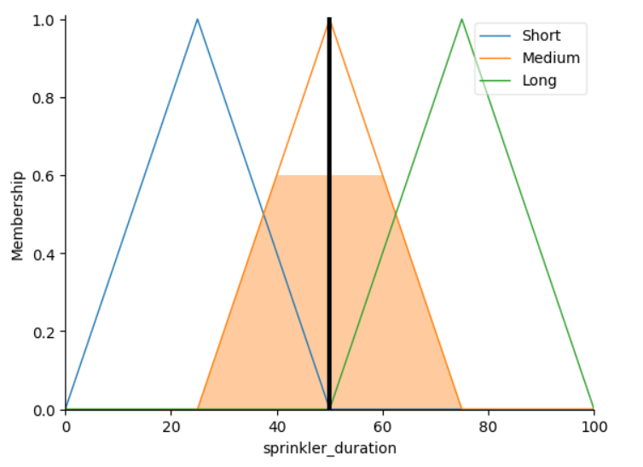

Code:

%%shell
pip3 install scikit-fuzzy
import numpy as np
import skfuzzy as fuzz
from skfuzzy import control as ctrl
HUMIDITY = 'humidity'
SPRINKLER_DURATION = 'sprinkler_duration'
TEMPRATURE = 'temperature'

# Temperature's fuzzy linguistics
COLD = 'Cold'
COOL = 'Cool'
NORMAL = 'Normal'
WARM = 'Warm'
HOT = 'Hot'

# Humidity's fuzzy linguistics
DRY = 'Dry'
MOIST = 'Moist'
WET = 'Wet'

# Sprinkler duration's fuzzy linguistics
SHORT = 'Short'
MEDIUM = 'Medium'
LONG = 'Long'

temperature = ctrl.Antecedent(np.arange(-10,55,5), TEMPRATURE)
humidity = ctrl.Antecedent(np.arange(0,105,5), HUMIDITY)
sprinkler_duration = ctrl.Consequent(np.arange(0,105,5), SPRINKLER_DURATION)
cold_parameter = [-10,0,10]
cool_parameter = [0,10,20]
normal_parameter = [10,20,30]
warm_parameter = [20,30,40]
hot_parameter = [30,40,50]

temperature[COLD] = fuzz.trimf(temperature.universe, cold_parameter)
temperature[COOL] = fuzz.trimf(temperature.universe, cool_parameter)
temperature[NORMAL] = fuzz.trimf(temperature.universe, normal_parameter)
temperature[WARM] = fuzz.trimf(temperature.universe, warm_parameter)
temperature[HOT] = fuzz.trimf(temperature.universe, hot_parameter)
temperature.view()
dry_parameter = [0,25,50]
moist_parameter = [25,50,75]
wet_parameter = [50,75,100]

humidity[DRY] = fuzz.trimf(humidity.universe, dry_parameter)
humidity[MOIST] = fuzz.trimf(humidity.universe, moist_parameter)
humidity[WET] = fuzz.trimf(humidity.universe, wet_parameter)
humidity.view()
short_parameter = [0,25,50]
medium_parameter = [25,50,75]
long_parameter = [50,75,100]

sprinkler_duration[SHORT] = fuzz.trimf(sprinkler_duration.universe, short_parameter)
sprinkler_duration[MEDIUM] = fuzz.trimf(sprinkler_duration.universe, medium_parameter)
sprinkler_duration[LONG] = fuzz.trimf(sprinkler_duration.universe, long_parameter)
sprinkler_duration.view()
rule1 = ctrl.Rule(humidity[DRY] & temperature[COLD], sprinkler_duration[SHORT])
rule2 = ctrl.Rule(humidity[DRY] & temperature[COOL], sprinkler_duration[SHORT])
rule3 = ctrl.Rule(humidity[DRY] & temperature[NORMAL], sprinkler_duration[MEDIUM])
rule4 = ctrl.Rule(humidity[DRY] & temperature[WARM], sprinkler_duration[LONG])
rule5 = ctrl.Rule(humidity[DRY] & temperature[HOT], sprinkler_duration[LONG])
rule6 = ctrl.Rule(humidity[MOIST] & temperature[COLD], sprinkler_duration[SHORT])
rule7 = ctrl.Rule(humidity[MOIST] & temperature[COOL], sprinkler_duration[SHORT])
rule8 = ctrl.Rule(humidity[MOIST] & temperature[NORMAL], sprinkler_duration[MEDIUM])
rule9 = ctrl.Rule(humidity[MOIST] & temperature[WARM], sprinkler_duration[MEDIUM])
rule10 = ctrl.Rule(humidity[MOIST] & temperature[HOT], sprinkler_duration[LONG])
rule11 = ctrl.Rule(humidity[WET] & temperature[COLD], sprinkler_duration[SHORT])
rule12 = ctrl.Rule(humidity[WET] & temperature[COOL], sprinkler_duration[SHORT])
rule13 = ctrl.Rule(humidity[WET] & temperature[NORMAL], sprinkler_duration[SHORT])
rule14 = ctrl.Rule(humidity[WET] & temperature[WARM], sprinkler_duration[MEDIUM])
rule15 = ctrl.Rule(humidity[WET] & temperature[HOT], sprinkler_duration[LONG])
rule_list = [
rule1, rule2, rule3, rule4, rule5,
rule6, rule7, rule8, rule9, rule10,
rule11, rule12, rule13, rule14, rule15
]
sprinkler_ctrl = ctrl.ControlSystem(rule_list)
sprinkler_analysis = ctrl.ControlSystemSimulation(sprinkler_ctrl)
sprinkler_analysis.input[TEMPRATURE] = 30
sprinkler_analysis.input[HUMIDITY] = 65

sprinkler_analysis.compute()
print(f'Evaluated Result: {str(round(sprinkler_analysis.output[SPRINKLER_DURATION], 2))} Min')
sprinkler_duration.view(sim=sprinkler_analysis)

Linear Regression

Image

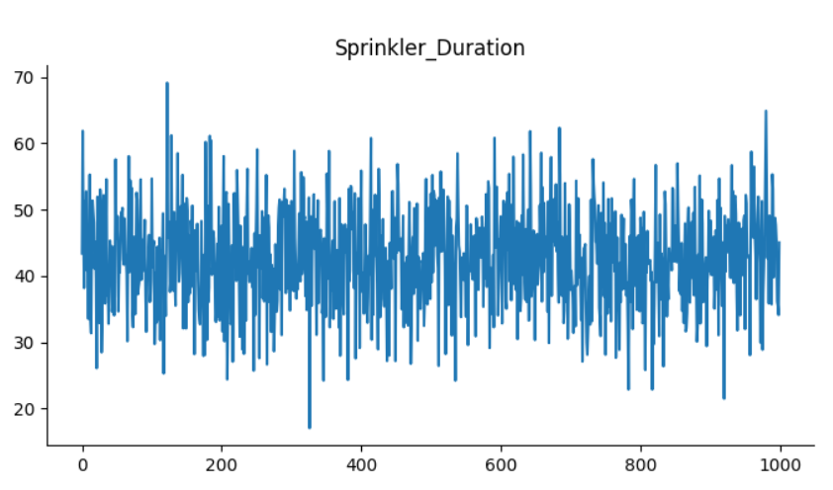

Code:

import pandas as pd
from sklearn.model_selection import train_test_split
from sklearn.linear_model import LinearRegression
from sklearn.metrics import mean_squared_error
data = pd.read_csv('sprinkler_dataset.csv')
data
from matplotlib import pyplot as plt
data['Sprinkler_Duration'].plot(kind='hist', bins=20, title='Sprinkler_Duration')
plt.gca().spines[['top', 'right',]].set_visible(False)
# @title Humidity vs Temperature

import matplotlib.pyplot as plt
plt.scatter(data['Temperature'], data['Humidity'], c=data['Temperature'], cmap='jet')
plt.xlabel('Temperature')
plt.ylabel('Humidity')
_ = plt.title('Humidity vs Temperature')
X = data.drop('Sprinkler_Duration',axis=1)
y = data['Sprinkler_Duration']
X_train, X_test, y_train, y_test = train_test_split(X, y, test_size=0.2)
model = LinearRegression()
model.fit(X_train, y_train)
y_predicted = model.predict(X_test)
mse = mean_squared_error(y_test, y_predicted)
print("Mean Squared Error:", mse)
# Assigning feature names to the new data for prediction
new_data = pd.DataFrame([[21, 80]], columns=["Temperature", "Humidity"])
predicted_time = model.predict(new_data)
print("Predicted running time for 21 degrees Celsius and 80 % humidity:", predicted_time[0])

Results and Discussions
Humidity | Temperature | Fuzzy Logic | Linear Regression
50 % | 35 º C | 62.5 min | 42.586 min
70 % | 40º C | 75 min | 51.079 min
79 % | 41º C | 75 min | 61.881 min

The study aimed to predict the duration required for sprinkler irrigation using two different methods: fuzzy logic and linear regression.
The fuzzy logic approach leveraged linguistic variables to model the imprecise nature of irrigation requirements, considering factors such as humidity and temperature. Fuzzy logic systems are well-suited for handling uncertainty and vagueness in real-world data, making them applicable to irrigation scheduling.
On the other hand, linear regression employed statistical modelling techniques to establish relationships between input variables (such as humidity, temperature etc.) and the duration of sprinkler operation. Linear regression assumes a linear relationship between predictors and the target variable, providing insights into the direct impact of each factor on irrigation duration.
Results from both methods were compared and discussed to evaluate their accuracy and reliability in predicting irrigation durations, as displayed in the table above. The fuzzy logic approach demonstrated its ability to capture the complex and non-linear relationships inherent in irrigation scheduling, particularly when dealing with imprecise input data. However, the interpretability of fuzzy logic models may vary depending on the complexity of linguistic rules and membership functions.
In contrast, linear regression offered a more straightforward interpretation of the relationship between input variables and irrigation duration. While it may not capture the full complexity of irrigation requirements as effectively as fuzzy logic, it provides valuable insights into the relative importance of different factors affecting irrigation scheduling.
Each have their own strengths and weaknesses; Future research directions may involve combining fuzzy logic and regression techniques to leverage their respective strengths and improve prediction accuracy. Additionally, incorporating real-time data from sensors and weather forecasts could enhance the robustness of predictive models for sprinkler irrigation scheduling.

References
[1] C. H. Pair, Sprinkler irrigation. Sprinkler Irrigation Association, 1969.
[2] S. Dasberg and E. Bresler, Drip irrigation manual. International Irrigation Information Center, 1985.
[3] W. R. Walker and G. V Skogerboe, Surface irrigation. Theory and practice. Prentice-Hall, 1987.
[4] L. Vermeiren and G. A. Jobling, Localized irrigation: design, installation, operation, evaluation. 1980.
[5] J. Laffan, Irrigation: Centre pivot and lateral move, vol. 4. NSW Agriculture, 2016.
[6] C. M. Burt, A. J. Clemmens, R. Bliesner, J. L. Merriam, and L. Hardy, Selection of irrigation methods for agriculture. American Society of Civil Engineers, 1999.
[7] V. E. Hansen, O. W. Israelson, and G. E. Stringham, “Irrigation principles and practices,” Irrig. Princ. Pract. 4th Ed., 1980.
[8] W. E. Splinter, “Center-pivot irrigation,” Sci. Am., vol. 234, no. 6, pp. 90–99, 1976.
[9] W. M. Lyle and J. P. Bordovsky, “Low energy precision application (LEPA) irrigation system,” Trans. ASAE, vol. 24, no. 5, pp. 1241–1245, 1981.
[10] L. A. Zadeh, G. J. Klir, and B. Yuan, Fuzzy sets, fuzzy logic, and fuzzy systems: selected papers, vol. 6. World scientific, 1996.
[11] F. Galton, “Regression towards mediocrity in hereditary stature.,” J. Anthropol. Inst. Gt. Britain Irel., vol. 15, pp. 246–263, 1886.
[12] H. M. Al-Ghobari, M. S. El-Marazky, A. Z. Dewidar, and M. A. Mattar, “Prediction of wind drift and evaporation losses from sprinkler irrigation using neural network and multiple regression techniques,” Agric. Water Manag., vol. 195, pp. 211–221, 2018.

